# Approach

With recent advancements in Generative AI it is possible to do the Risk and Compliance analysis more simpler and effective way. Here we will be leveraging Gen AI capability and creating the report. This approach can be further enhanced by again doing indepth analysis on various websites and generating reports.

But as part of Hackathon we will be doing only high analysis and showing what could be achieved using latest technology.

Python Flask API and Generative AI models are backbone of this implementation.

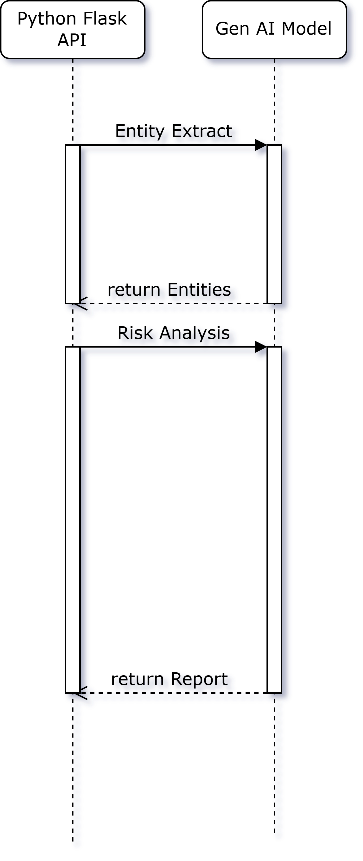

First we will get the input and extract entities like company and people from the transaction details. Also initial risk rating will be done based on notes and other details in transaction details. Later for each entity high level risk rating based on sources from internet.

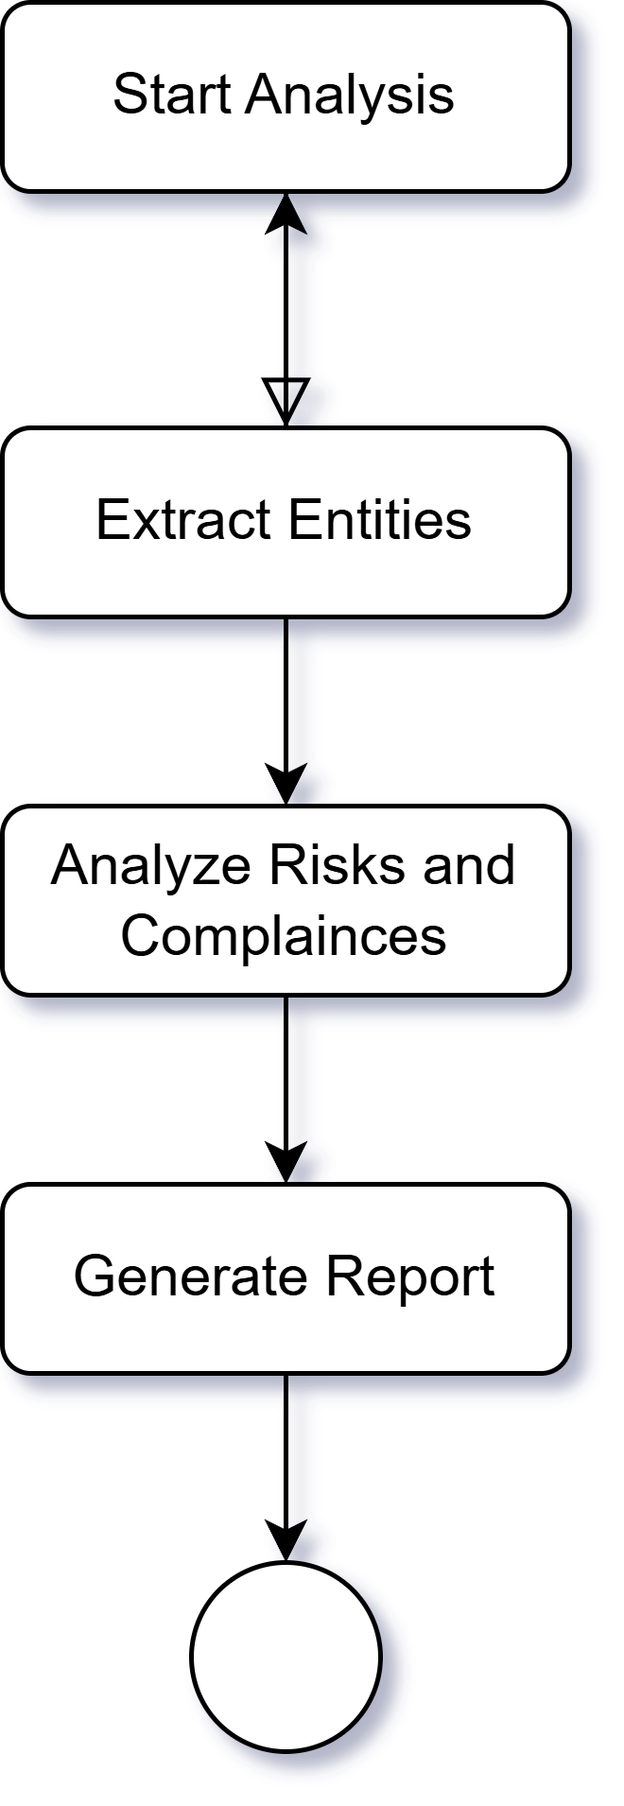

# Challenges

One major challenge was finding a reliable, free Generative AI API for entity risk analysis. Initially, we explored OpenAI and Meta AI APIs, but none offered suitable free-tier access.

After extensive testing, we found OpenRouter, which provided access to high-quality free models, including DeepSeek and NVIDIA Llama 3.1 70B. Many other free models fell short in delivering accurate risk assessments, but these models met our expectations, enabling effective entity recognition and risk evaluation within our API.

# Risk Scoring Methodology

We have used again ChatGPT Free version to generate Risk Scoring Strategy for a US Bank. You can find that document along with this document in same folder.

Please visit following page for more details:

[aidel-natural-intelligence-team/README.md at main · ewfx/aidel-natural-intelligence-team](https://github.com/ewfx/aidel-natural-intelligence-team/blob/main/README.md)