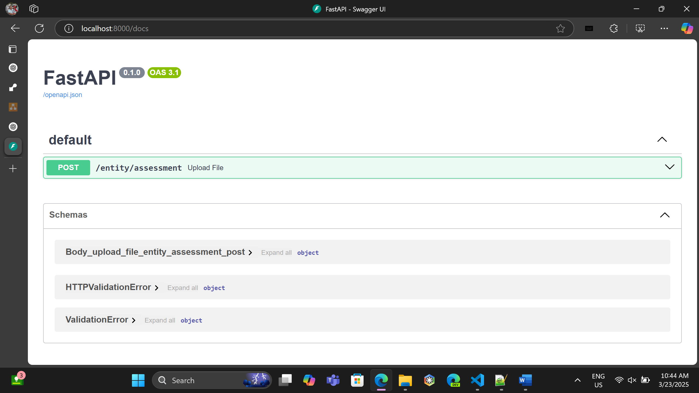

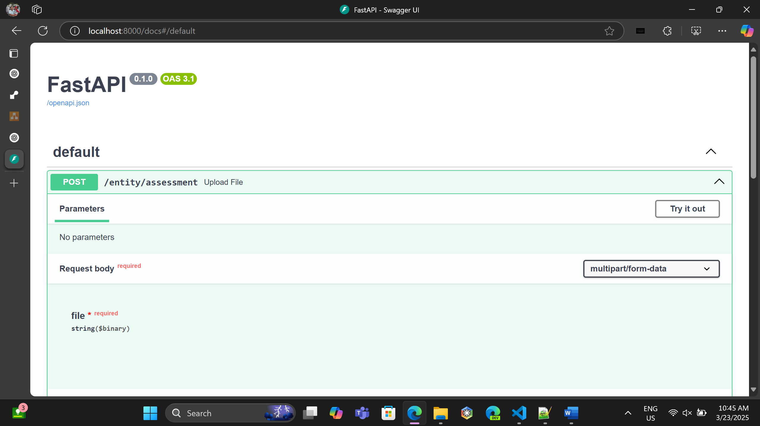

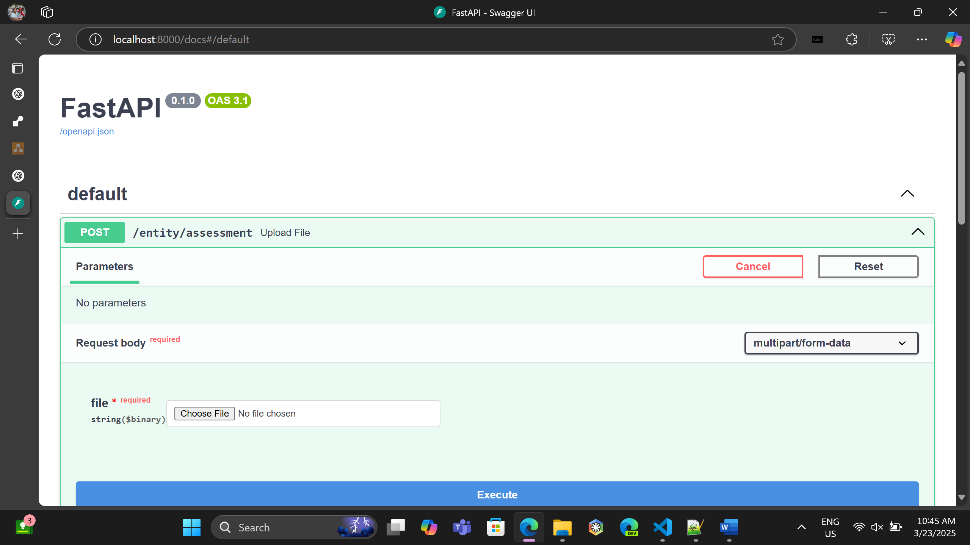

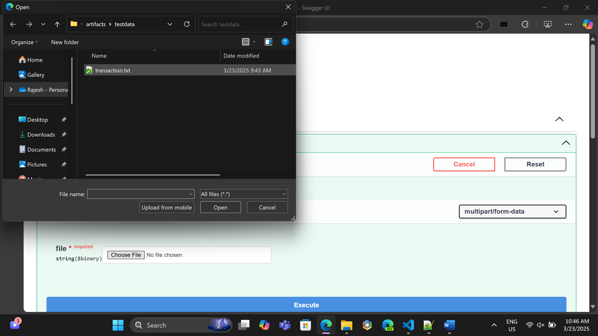

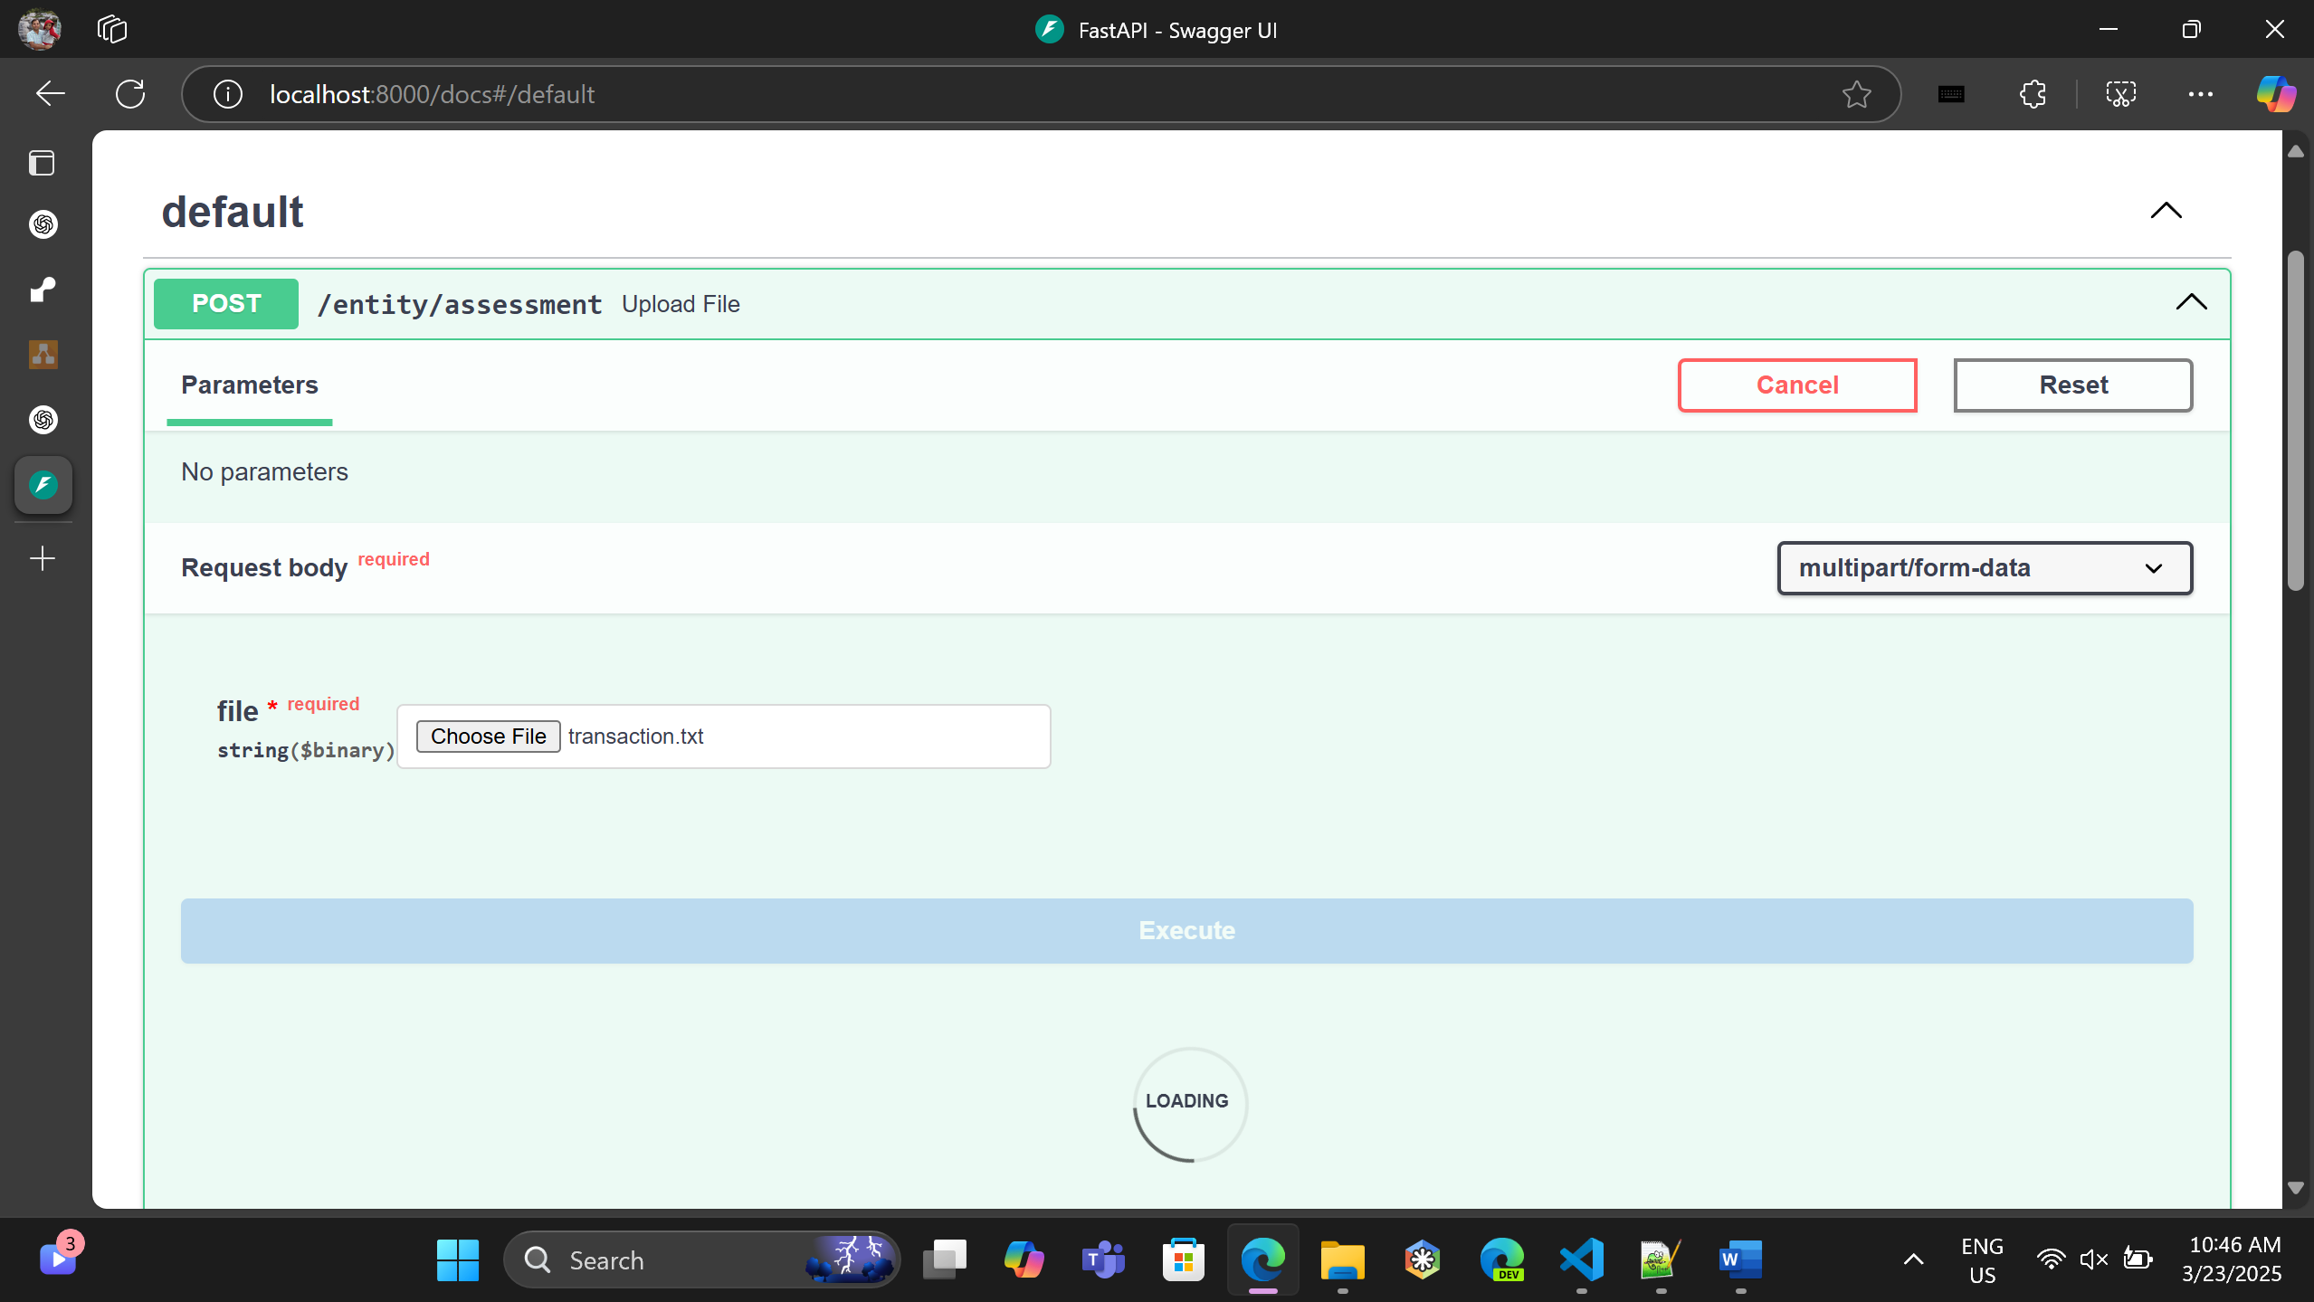

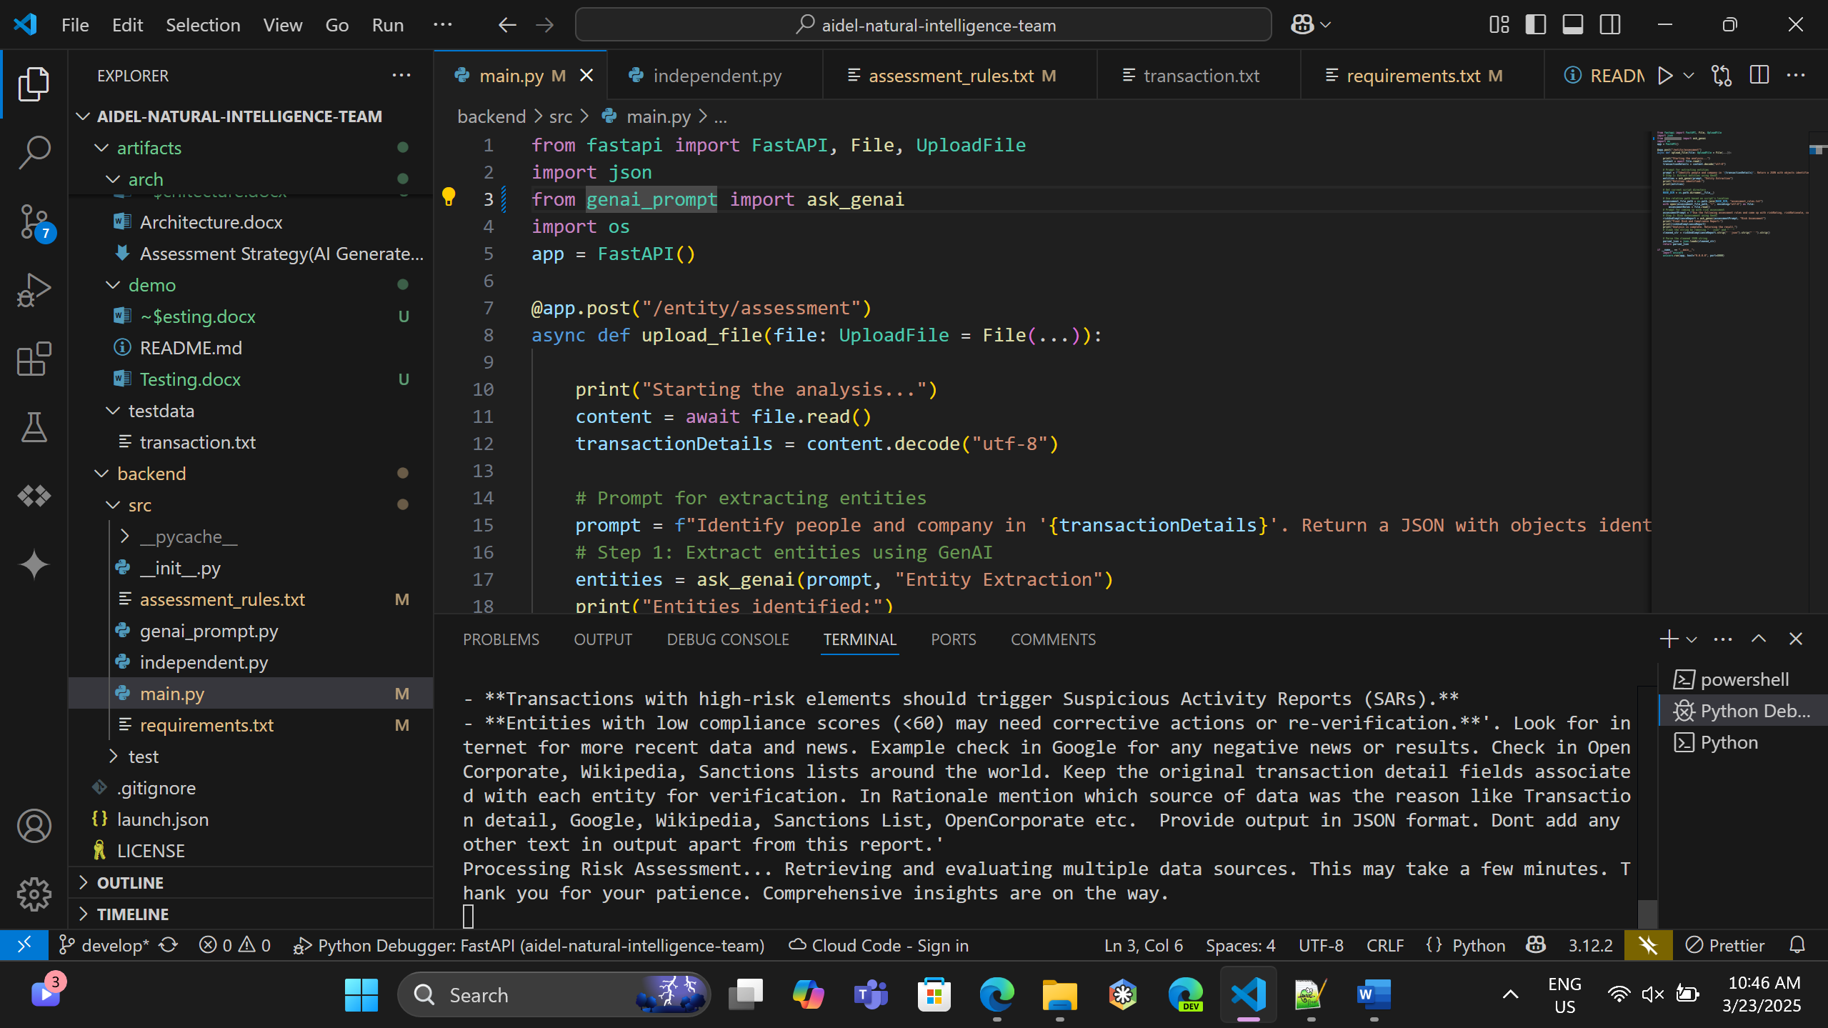

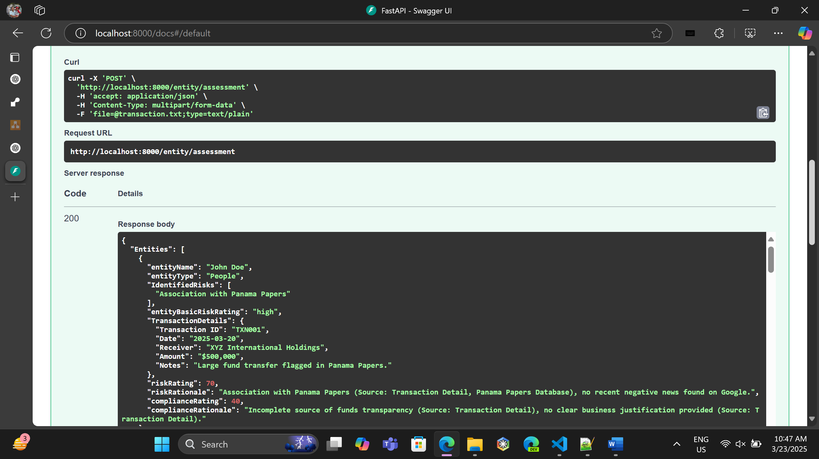

Response:

**{**

**"Entities": [**

**{**

**"entityName": "John Doe",**

**"entityType": "People",**

**"IdentifiedRisks": [**

**"Association with Panama Papers"**

**],**

**"entityBasicRiskRating": "high",**

**"TransactionDetails": {**

**"Transaction ID": "TXN001",**

**"Date": "2025-03-20",**

**"Receiver": "XYZ International Holdings",**

**"Amount": "$500,000",**

**"Notes": "Large fund transfer flagged in Panama Papers."**

**},**

**"riskRating": 70,**

**"riskRationale": "Association with Panama Papers (Source: Transaction Detail, Panama Papers Database), no recent negative news found on Google.",**

**"complianceRating": 40,**

**"complianceRationale": "Incomplete source of funds transparency (Source: Transaction Detail), no clear business justification provided (Source: Transaction Detail)."**

**},**

**{**

**"entityName": "ABC Ltd.",**

**"entityType": "Company",**

**"IdentifiedRisks": [**

**"Involvement with sanctioned entity",**

**"Suspicious cryptocurrency transaction"**

**],**

**"entityBasicRiskRating": "very high",**

**"TransactionDetails": {**

**"Transaction ID": "TXN002",**

**"Date": "2025-03-21",**

**"Receiver": "CryptoEx Offshore Services",**

**"Amount": "$250,000",**

**"Notes": "Suspicious cryptocurrency transaction involving a sanctioned entity."**

**},**

**"riskRating": 95,**

**"riskRationale": "Involvement with sanctioned entity and suspicious cryptocurrency transaction (Source: Transaction Detail), listed on OFAC Sanctions List (Source: OFAC Website).",**

**"complianceRating": 10,**

**"complianceRationale": "Non-compliant with AML regulations (Source: Transaction Detail), unlicensed cryptocurrency transactions (Source: FinCEN Website)."**

**},**

**{**

**"entityName": "Jane Smith",**

**"entityType": "People",**

**"IdentifiedRisks": [**

**"Association with entity linked to multiple financial fraud cases"**

**],**

**"entityBasicRiskRating": "very high",**

**"TransactionDetails": {**

**"Transaction ID": "TXN003",**

**"Date": "2025-03-22",**

**"Receiver": "Shadow Trust LLC",**

**"Amount": "$750,000",**

**"Notes": "Entity associated with multiple financial fraud cases."**

**},**

**"riskRating": 92,**

**"riskRationale": "Association with entity linked to multiple financial fraud cases (Source: Transaction Detail), negative news mentions on financial fraud (Source: Google News).",**

**"complianceRating": 30,**

**"complianceRationale": "Incomplete KYC compliance (Source: Transaction Detail), unclear business justification for large transaction (Source: Transaction Detail)."**

**},**

**{**

**"entityName": "DEF Corp.",**

**"entityType": "Company",**

**"IdentifiedRisks": [**

**"Transaction executed from a sanctioned location (North Korea)"**

**],**

**"entityBasicRiskRating": "very high",**

**"TransactionDetails": {**

**"Transaction ID": "TXN004",**

**"Date": "2025-03-23",**

**"Receiver": "Unregistered Charity Fund",**

**"Amount": "$1,000,000",**

**"Notes": "Executed from NordVPN 123.56.3.45 North Korea"**

**},**

**"riskRating": 98,**

**"riskRationale": "Transaction executed from sanctioned location (North Korea) (Source: Transaction Detail), listed on BIS Entity List (Source: BIS Website).",**

**"complianceRating": 5,**

**"complianceRationale": "Highly non-compliant with regulatory reporting (Source: Transaction Detail), no valid business operations evident (Source: OpenCorporate)."**

**},**

**{**

**"entityName": "Unknown",**

**"entityType": "Unknown/Unidentified",**

**"IdentifiedRisks": [**

**"Association with known financial crimes",**

**"Transaction with a blacklisted bank"**

**],**

**"entityBasicRiskRating": "very high",**

**"TransactionDetails": {**

**"Transaction ID": "TXN005",**

**"Date": "2025-03-24",**

**"Receiver": "High-Risk Bank (Blacklisted)",**

**"Amount": "$600,000",**

**"Notes": "Transaction flagged due to association with known financial crimes."**

**},**

**"riskRating": 99,**

**"riskRationale": "Association with known financial crimes (Source: Transaction Detail), transaction with blacklisted bank (Source: FinCEN Website).",**

**"complianceRating": 0,**

**"complianceRationale": "Completely non-compliant with all AML/KYC regulations (Source: Transaction Detail), anonymous transaction (Source: Transaction Detail)."**

**},**

**{**

**"entityName": "Rajesh Hegde",**

**"entityType": "People",**

**"IdentifiedRisks": [],**

**"entityBasicRiskRating": "very low",**

**"TransactionDetails": {**

**"Transaction ID": "TXN006",**

**"Date": "2025-03-24",**

**"Receiver": "Infosys Limited",**

**"Amount": "$600,000",**

**"Notes": "Transaction for IT Services advances."**

**},**

**"riskRating": 10,**

**"riskRationale": "No identified risks found (Source: Transaction Detail), clean record on Google search.",**

**"complianceRating": 90,**

**"complianceRationale": "Fully compliant with KYC (Source: Transaction Detail), clear business justification provided (Source: Transaction Detail)."**

**},**

**{**

**"entityName": "Infosys Limited",**

**"entityType": "Company",**

**"IdentifiedRisks": [],**

**"entityBasicRiskRating": "very low",**

**"TransactionDetails": {**

**"Transaction ID": "TXN006",**

**"Date": "2025-03-24",**

**"Sender": "Rajesh Hegde",**

**"Amount": "$600,000",**

**"Notes": "Transaction for IT Services advances."**

**},**

**"riskRating": 5,**

**"riskRationale": "No adverse mentions found (Source: Wikipedia, Google News), not listed on any sanctions list (Source: OFAC, BIS).",**

**"complianceRating": 95,**

**"complianceRationale": "Fully compliant with all regulatory requirements (Source: OpenCorporate), transparent business operations (Source: Company Website)."**

**},**

**{**

**"entityName": "XYZ International Holdings",**

**"entityType": "Company",**

**"IdentifiedRisks": [**

**"Involved in a large fund transfer flagged in Panama Papers"**

**],**

**"entityBasicRiskRating": "medium",**

**"TransactionDetails": {**

**"Transaction ID": "TXN001",**

**"Date": "2025-03-20",**

**"Sender": "John Doe",**

**"Amount": "$500,000",**

**"Notes": "Large fund transfer flagged in Panama Papers."**

**},**

**"riskRating": 60,**

**"riskRationale": "Involved in large fund transfer flagged in Panama Papers (Source: Transaction Detail, Panama Papers Database).",**

**"complianceRating": 50,**

**"complianceRationale": "Moderate compliance with AML regulations (Source: Transaction Detail), some transparency concerns in business operations (Source: OpenCorporate)."**

**},**

**{**

**"entityName": "CryptoEx Offshore Services",**

**"entityType": "Company",**

**"IdentifiedRisks": [**

**"Involved in suspicious cryptocurrency transactions with sanctioned entities"**

**],**

**"entityBasicRiskRating": "high",**

**"TransactionDetails": {**

**"Transaction ID": "TXN002",**

**"Date": "2025-03-21",**

**"Sender": "ABC Ltd.",**

**"Amount": "$250,000",**

**"Notes": "Suspicious cryptocurrency transaction involving a sanctioned entity."**

**},**

**"riskRating": 85,**

**"riskRationale": "Involved in suspicious cryptocurrency transactions with sanctioned entities (Source: Transaction Detail), adverse media mentions (Source: Google News).",**

**"complianceRating": 20,**

**"complianceRationale": "Non-compliant with FinCEN regulations (Source: Transaction Detail), unregistered cryptocurrency services (Source: FinCEN Website)."**

**},**

**{**

**"entityName": "Shadow Trust LLC",**

**"entityType": "Company",**

**"IdentifiedRisks": [**

**"Associated with multiple financial fraud cases"**

**],**

**"entityBasicRiskRating": "very high",**

**"TransactionDetails": {**

**"Transaction ID": "TXN003",**

**"Date": "2025-03-22",**

**"Sender": "Jane Smith",**

**"Amount": "$750,000",**

**"Notes": "Entity associated with multiple financial fraud cases."**

**},**

**"riskRating": 90,**

**"riskRationale": "Associated with multiple financial fraud cases (Source: Transaction Detail, negative news on Google).",**

**"complianceRating": 15,**

**"complianceRationale": "Highly non-compliant with AML/KYC (Source: Transaction Detail), no valid business license found (Source: OpenCorporate)."**

**},**

**{**

**"entityName": "Unregistered Charity Fund",**

**"entityType": "Company/Organization",**

**"IdentifiedRisks": [**

**"Received transaction from a sanctioned location (North Korea)"**

**],**

**"entityBasicRiskRating": "high",**

**"TransactionDetails": {**

**"Transaction ID": "TXN004",**

**"Date": "2025-03-23",**

**"Sender": "DEF Corp.",**

**"Amount": "$1,000,000",**

**"Notes": "Executed from NordVPN 123.56.3.45 North Korea"**

**},**

**"riskRating": 88,**

**"riskRationale": "Received transaction from sanctioned location (North Korea) (Source: Transaction Detail), no clear charitable purpose (Source: OpenCorporate).",**

**"complianceRating": 12,**

**"complianceRationale": "Non-compliant with regulatory reporting (Source: Transaction Detail), unregistered charity operations (Source: Charity Registry Website)."**

**},**

**{**

**"entityName": "High-Risk Bank (Blacklisted)",**

**"entityType": "Company",**

**"IdentifiedRisks": [**

**"Blacklisted, involved in known financial crimes"**

**],**

**"entityBasicRiskRating": "very high",**

**"TransactionDetails": {**

**"Transaction ID": "TXN005",**

**"Date": "2025-03-24",**

**"Sender": "Unknown",**

**"Amount": "$600,000",**

**"Notes": "Transaction flagged due to association with known financial crimes."**

**},**

**"riskRating": 100,**

**"riskRationale": "Blacklisted and involved in known financial crimes (Source: FinCEN Website, Transaction Detail).",**

**"complianceRating": 0,**

**"complianceRationale": "Completely non-compliant with all financial regulations (Source: FinCEN Website), severe AML/KYC violations (Source: Transaction Detail)."**

**}**

**]**

**}**