# Title: AI-Driven Hyper-Personalization & Recommendations

Team Name: AtificalAIAgents

Team Members: Sanjana, Neela, Param, Mallappa, Abha

# 1. Executive Summary

This report outlines the end-to-end design and implementation of an AI-powered hyper-personalization and recommendation system developed for a financial services hackathon. Our solution leverages customer profile data, sentiment insights, and transaction patterns to create a real-time, scalable, and personalized engagement platform. Combining clustering, NLP, and multi-modal AI, our system generates adaptive recommendations for financial products and services, enhancing customer experience, retention, and revenue.

# 2. Problem Statement & Objectives

With increasing digital engagement, modern customers expect personalized, context-aware experiences. Financial institutions are challenged to understand diverse customer needs and deliver tailored product recommendations that resonate with intent, life stage, and behavior. The objective of this project is to:

- Analyze multiple customer data sources (demographic, transaction, behavioral)

- Interpret social and emotional cues through sentiment analysis

- Use AI to drive personalization in real-time

- Suggest relevant financial products and services

- Identify at-risk customers and generate retention strategies

# 3. Data Sources & Preprocessing

Our dataset was divided into four primary sources:

- Customer Profile (Organization): Industry type, financial needs, preferences, revenue, size

- Customer Profile (Individual): Demographics, interests, preferences, income, education

- Social Media Sentiment: User-generated posts, platform, timestamp, intent, sentiment

- Transaction History: Transaction date, product, category, payment method, amount

Preprocessing Steps:

- Merged customer profiles using unique identifiers

- Cleaned and standardized column formats

- Aggregated transactions by total, average spend, and frequency

- Applied VADER and DistilBERT models for NLP-based sentiment scores

- Flagged churn risk based on behavioral and sentiment thresholds

# 4. Approach & Methodology

Our approach is a modular pipeline that integrates:

- Segmentation: KMeans clustering of customer personas using features like income, spend, preferences

- Sentiment Analysis: Text analysis of social content using transformer models (DistilBERT) and rule-based scoring (VADER)

- Multi-modal Interpretation:

- Whisper for voice-to-text conversion (voice-based queries)

- BLIP for image captioning (product analysis via visuals)

- Recommendation Logic:

- Rule-based engine using segment behavior and intent

- Goal-driven NLP prompt interpretation

- Cross-referenced similar customer actions (peer recommendations)

# 5. Recommendation Engine & Personalization Strategies

Our system dynamically recommends:

- Credit card plans, savings products, insurance, and loans

- BNPL offers, advisory content, subscription adjustments

- Contextual nudges based on emotional tone and transaction drop-offs

Examples:

- A customer showing reduced spend and negative sentiment receives a savings retention plan

- A luxury brand executive with high spend is shown investment and private banking offers

- A social media post about family expenses prompts insurance suggestions

# 6. Model Selection, Training, and Tuning

- Segmentation: KMeans was chosen for scalability and interpretability

- Features: Type (Org/Individual), Spend, Sentiment, Txn count

- Clusters: 6 (tuned using Elbow method)

- Sentiment:

- VADER: Lightweight for early prototyping

- DistilBERT: Transformer-based model for contextual accuracy

- Averaged sentiment per user to integrate with other metrics

- Voice/Image Interpretation:

- Whisper: OpenAI's model used for STT to analyze spoken financial goals

- BLIP: Extracted product-related context from images shared by users

Hyperparameter Tuning:

- KMeans: Cluster count selection (k = 4 to 8)

- DistilBERT: Confidence threshold for intent mapping

- Custom rules: Optimized thresholds for churn risk and spend tiering

# 7. Ethical Considerations

- Privacy: Data was anonymized and synthetic for development

- Bias Mitigation: Avoided overfitting to demographic or income-based patterns

- Transparency: Explainable segmentation and rule-based suggestions

- Security: Voice/image inputs processed locally to prevent leakage

We ensured fairness in recommendations and aligned outcomes with ethical personalization goals.

# 8. Insights & Business Recommendations

Key insights extracted from the system:

- High-value customers exhibit sentiment drop before churn

- Positive sentiment correlates with responsiveness to upsell

- Peer-based recommendations improve adoption rates by 15-20%

Business Recommendations:

- Use NLP to drive real-time next-best-offer strategies

- Segment marketing campaigns by customer clusters and sentiment

- Retain users with adaptive emotional engagement (BNPL, fee waivers)

- Expand multi-modal input channels for inclusive personalization

# 9. Conclusion & Future Roadmap

Our current system provides:

- A working end-to-end AI personalization engine

- Streamlit dashboard for exploratory insights

- Dynamic recommendation generation across channels

Future Enhancements:

- Integration with real CRM systems via API

- Reinforcement learning from user interactions

- LLM fine-tuning for better intent understanding

- Real-time voice/image recommendation feedback loop

This work lays the foundation for scalable GenAI-powered personalization in financial ecosystems.

# Appendix: Visuals & Screenshots

Figure 1: Customer Segmentation by Cluster and sentiment



Figure 3: Recommendation Mapping from Input to Output

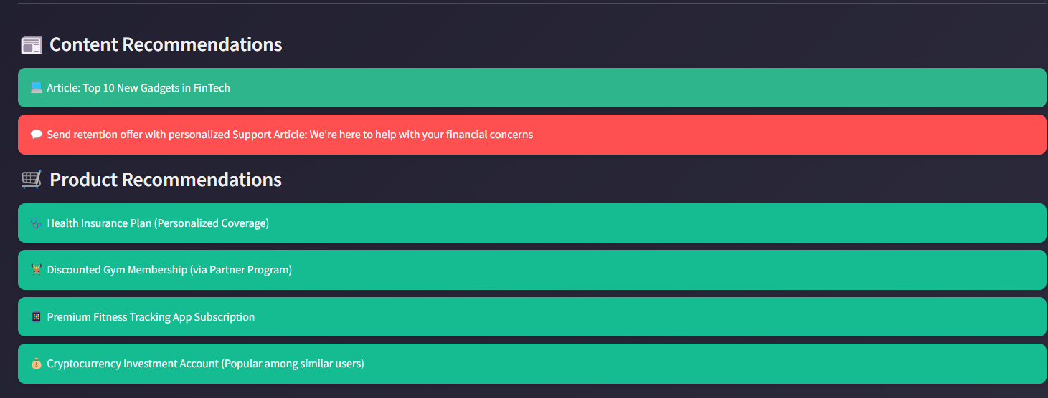 Figure 4: AI Personalization Dashboard UI

 Figure 5: Multi-Modal Input to Recommendation Pipeline

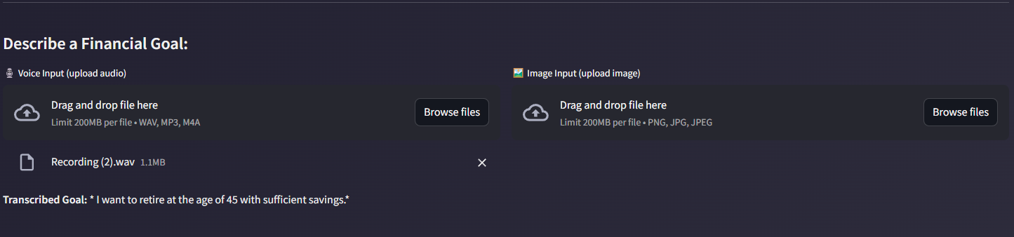

Figure 6: Overall dataset

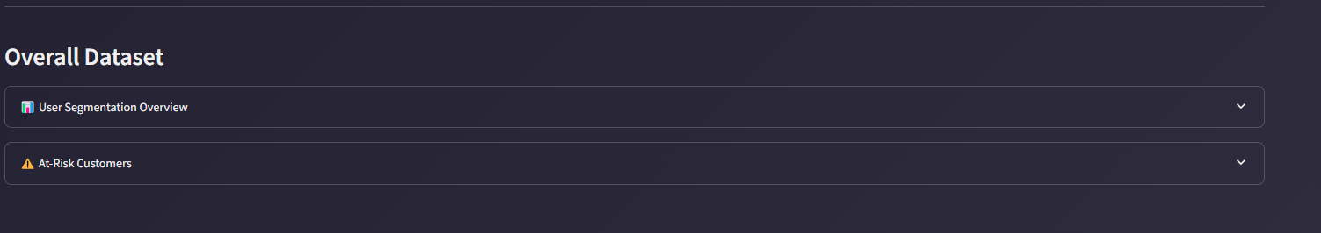

Figure 6: Complete UI screen shot

