# Hyper AI Recommendation System - Hackathon Submission

# Project Overview

The Hyper AI Recommendation System is designed to deliver highly personalized content recommendations by combining multi-modal AI, NLP, and sentiment analysis. It enhances user experience by leveraging cutting-edge AI technologies and ethical compliance for financial applications.

**2. Objectives**

* Implement AI-driven recommendations using **OpenAI APIs, Hugging Face Transformers, and deep learning models**.
* Develop a scalable architecture that integrates **backend (Python )**, **frontend (React.js)**, and **database (CSV)**.
* Enhance user engagement by leveraging sentiment analysis and contextual recommendations.

**3. Technology Stack**

* **Backend**: Python
* **Frontend**: React.js
* **Database**: csv
* **AI Models**: Hugging Face Transformers, OpenAI APIs, CLIP, Stable Diffusion

**4. System Architecture**

The **Hyper AI Gen AI Recommendation System** follows a modular design that includes:

* **User Input Module**: Collects user preferences, past interactions, and contextual data.
* **AI Processing Module**: Utilizes **transformer-based NLP models** to process user data and derive insights.
* **Recommendation Engine**: Analyzes data to generate personalized suggestions using deep learning.
* **Frontend UI**: Displays recommendations in an interactive and user-friendly interface.

**5. Key Features**

**5.1 Personalized Recommendations**

* Uses AI models to **analyze text, images, and user behavior**.
* Dynamically updates recommendations based on **real-time user interactions**.

**5.2 Sentiment Analysis**

* Applies **VADER, BERT, and TextBlob** models to assess user sentiment.
* Adjusts recommendations based on **positive or negative feedback**.

**5.3 Multi-Modal AI Integration**

* Incorporates **NLP and computer vision** to improve content recommendations.
* Utilizes **CLIP and Stable Diffusion** to analyze images and generate responses accordingly.

**6. Workflow & Flow Diagram**

1. **User Input Collection**: Collects **purchase history, social media activity, and interests**.
2. **Sentiment Analysis**: AI models process input and generate sentiment scores.
3. **Recommendation Generation**: Personalized recommendations are formulated based on sentiment and engagement levels.
4. **User Interaction**: The system refines recommendations based on feedback.

## 🗂️ Project Structure

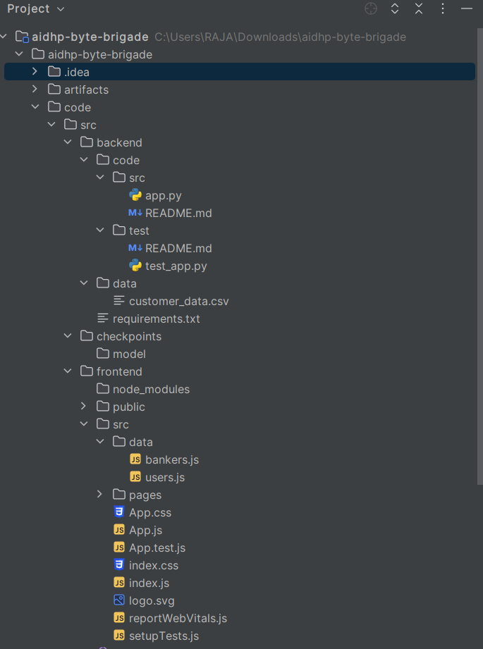

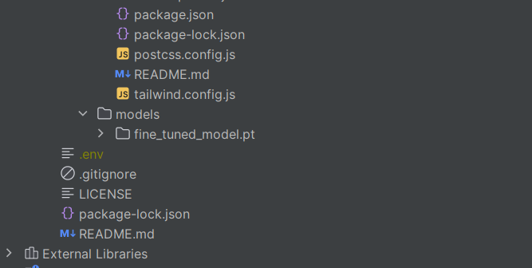

**Customer Interaction: **  
1. Login  
2. Home Page  
  
**Banker Interaction: **  
1. Admin Login  
2. Admin Dashboard

## 🗄️ Database Interaction

Stores user data, login information, interaction logs, and feedback for refining recommendations.

## ⚙️ How to Run

### Backend (AI Engine)  
1. Clone the Repository:  
```  
git clone <repository_url>  
cd hyper-ai-recommendation  
```  
2. Install Dependencies:  
```  
pip install -r requirements.txt  
```  
3. Set up API Keys for OpenAI and Hugging Face.  
4. Run the Application:  
```  
python app.py  
```  
  
### Frontend (React Application)  
1. Prerequisites: Node.js, npm or yarn  
2. Clone the Repository:  
```  
git clone <TBD>  
3. Install Dependencies:

npm install  
  
4. Run the Application:  
  
npm start  
  
5. Open [http://localhost:3000](http://localhost:3000)

## 🎯 Conclusion

The Hyper AI Recommendation System successfully delivers personalized, ethical, and high-performance content recommendations for financial institutions.

## 📚 Class Diagram

The class diagram illustrates the relationships between different classes such as User, RecommendationEngine, Feedback, Admin, and Database.

• User: Represents the customer interacting with the system.  
• Sentiment Analyzer: Analyzes customer sentiment based on input data.  
• Recommendation Engine: Provides personalized recommendations based on analysis.  
• Database Handler: Manages and retrieves data from the database.

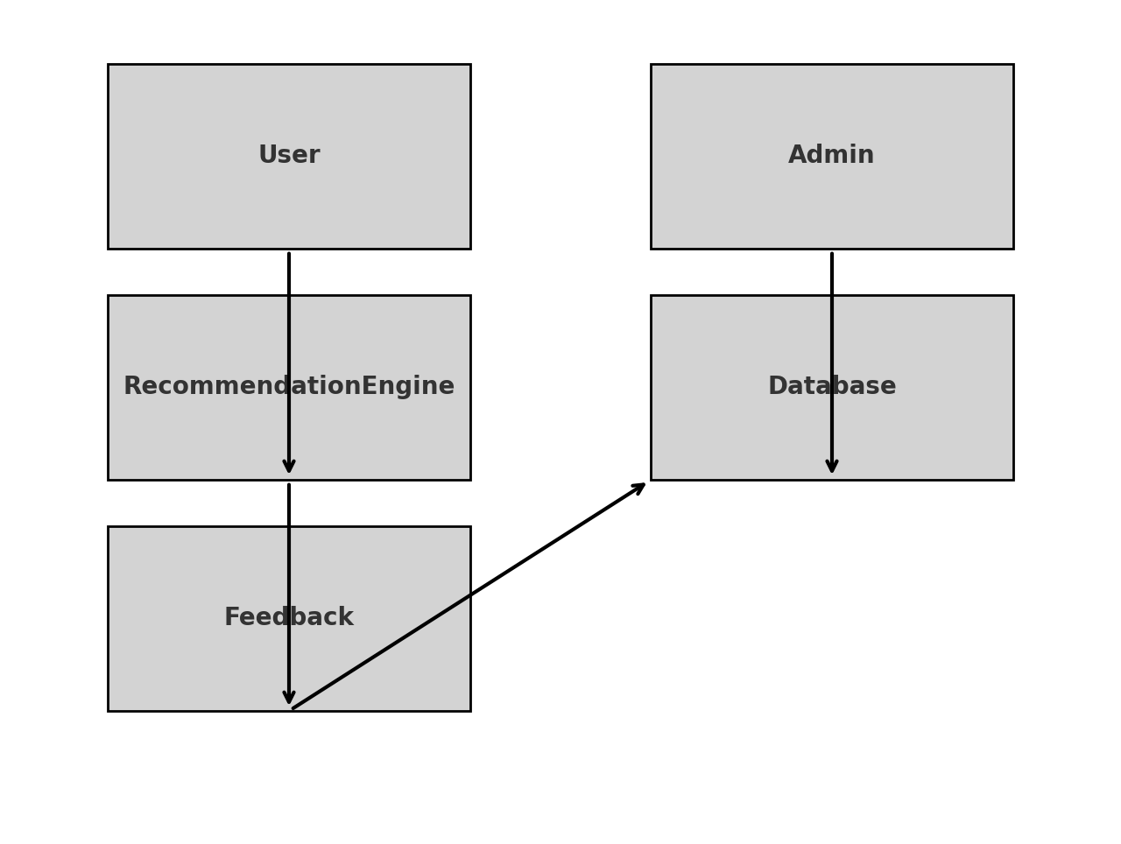

## 🔄 System Flow Diagram

The system flow diagram shows how data flows between different modules including User, Login Module, Recommendation Engine, Feedback Module, and Database.

A high-level process flow:  
1. User Input: Customer data (purchase history, social media activity, interests) is provided.  
2. Sentiment Analysis: AI models process the input and generate sentiment scores.  
3. Recommendation Generation: Based on sentiment scores and engagement levels, personalized content is created.  
4. User Interaction: Customers receive recommendations via the frontend UI.

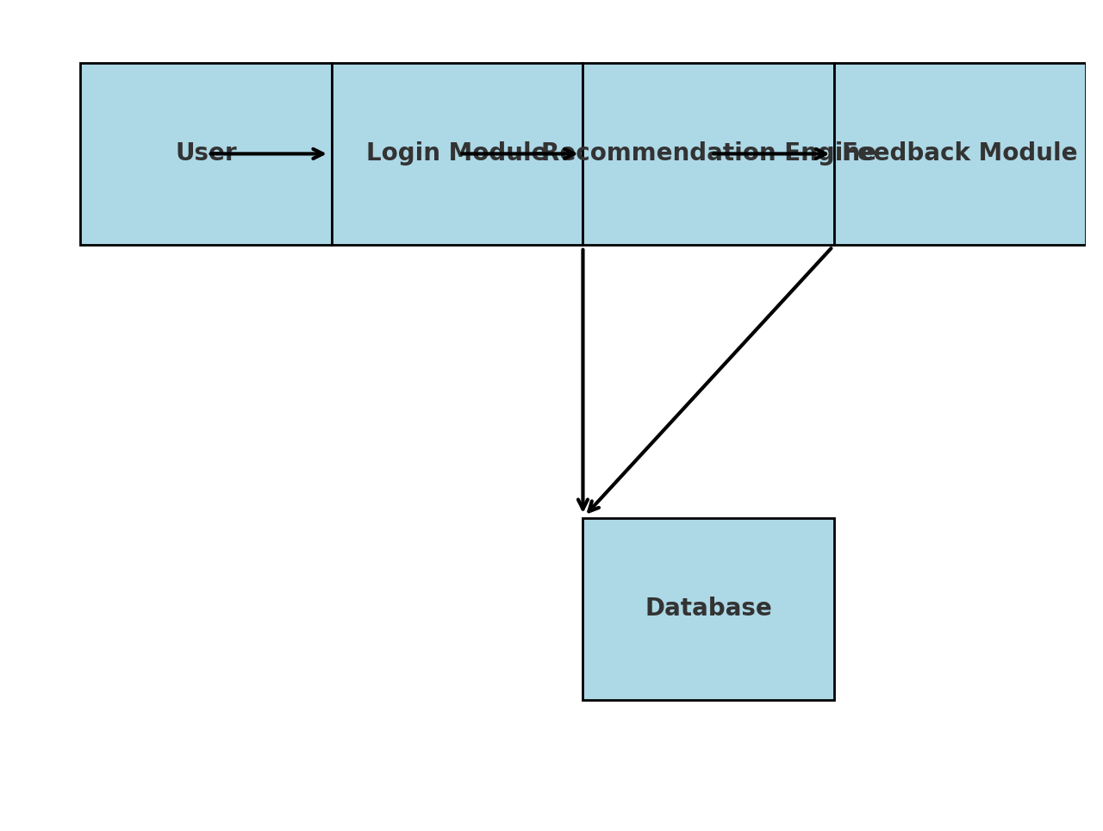

## Additional Tools and Libraries Utilized

During the development of the Hyper AI Recommendation System, the following additional tools and resources were utilized to enhance the functionality:  
1. **OpenAI APIs:** GPT-3.5, GPT-4 (free tier), used for generating personalized recommendations and enhancing NLP capabilities.  
2. **Hugging Face Transformers:** Models such as BART, T5, GPT-J, and LLaMA were used for various NLP tasks.  
3. **Python NLP Libraries:** Libraries including spaCy, NLTK, LangChain, and SentenceTransformers were used for text processing, sentiment analysis, and embedding generation.  
4. **Multi-modal AI Tools:** Tools like CLIP, DALL-E, and Stable Diffusion enabled personalized content generation for images and text.  
5. **Financial AI Ethics Guidelines:** Compliance with ethical AI guidelines from [BIS](https://www.bis.org/) was maintained to ensure responsible AI usage.  
6. **Customer Sentiment Analysis Tools:** VADER, TextBlob, and BERT-based models were employed for understanding customer sentiment and engagement.

## Sample Customer Data Used for Model Training

The following customer data was utilized to fine-tune and validate the recommendation models, ensuring personalized recommendations and better user experience:

|  |  |  |  |  |  |  |  |
| --- | --- | --- | --- | --- | --- | --- | --- |
| Customer ID | Age | Gender | Purchase History | Interests | Engagement Score (0-100) | Sentiment Score (-1 to 1) | Social Media Activity Level (Low/Med/High) |
| 101 | 25 | Male | Electronics, Gaming | Tech Gadgets, AI | 85 | 0.7 | High |
| 102 | 34 | Female | Luxury Apparel, Cosmetics | Fashion, Sustainability | 73 | 0.4 | Medium |
| 103 | 28 | Male | Books, Online Courses | Self-improvement, Finance | 90 | 0.9 | Low |
| 104 | 45 | Female | Home Decor, Organic Products | Wellness, Art | 65 | 0.3 | Medium |
| 105 | 30 | Non-binary | Travel, Outdoor Gear | Adventure, Photography | 80 | 0.6 | High |