**Capturing UI Design**

**Scenario 1:**

Customer whose area of interest is Banking & Investment

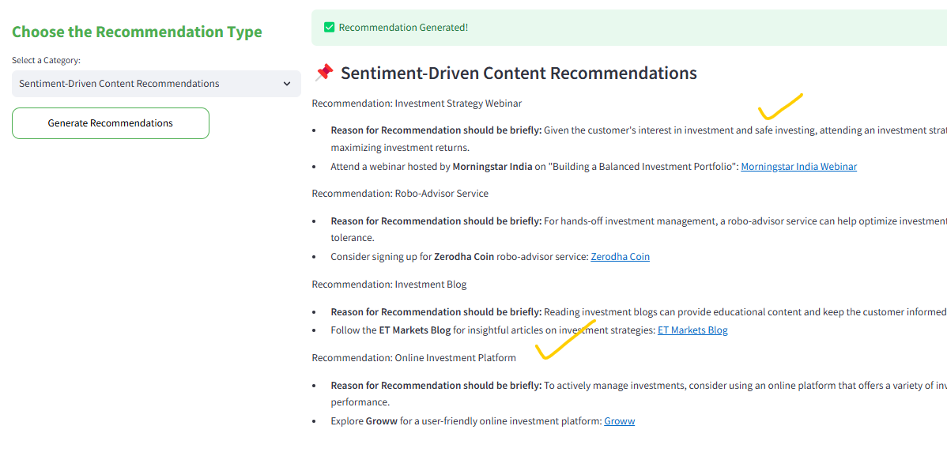

Scenario 3: Suppose a same profile is selected and the Country is changed to UK

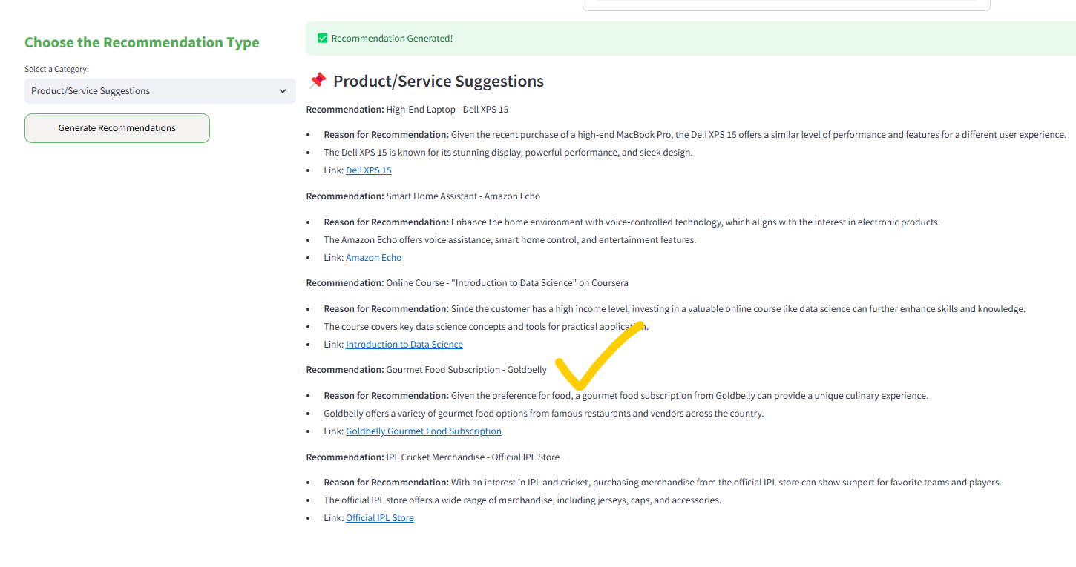

Scenario 4: Customer who is about to retire

Scenario 5: A customer who is interested in Beauty & Well being

**Existing Customer**

**Scneario 1:**

**Scenario 2:**

**Recommendo AI**

**Scenario 1: Enter your custom prompt to generate the response**

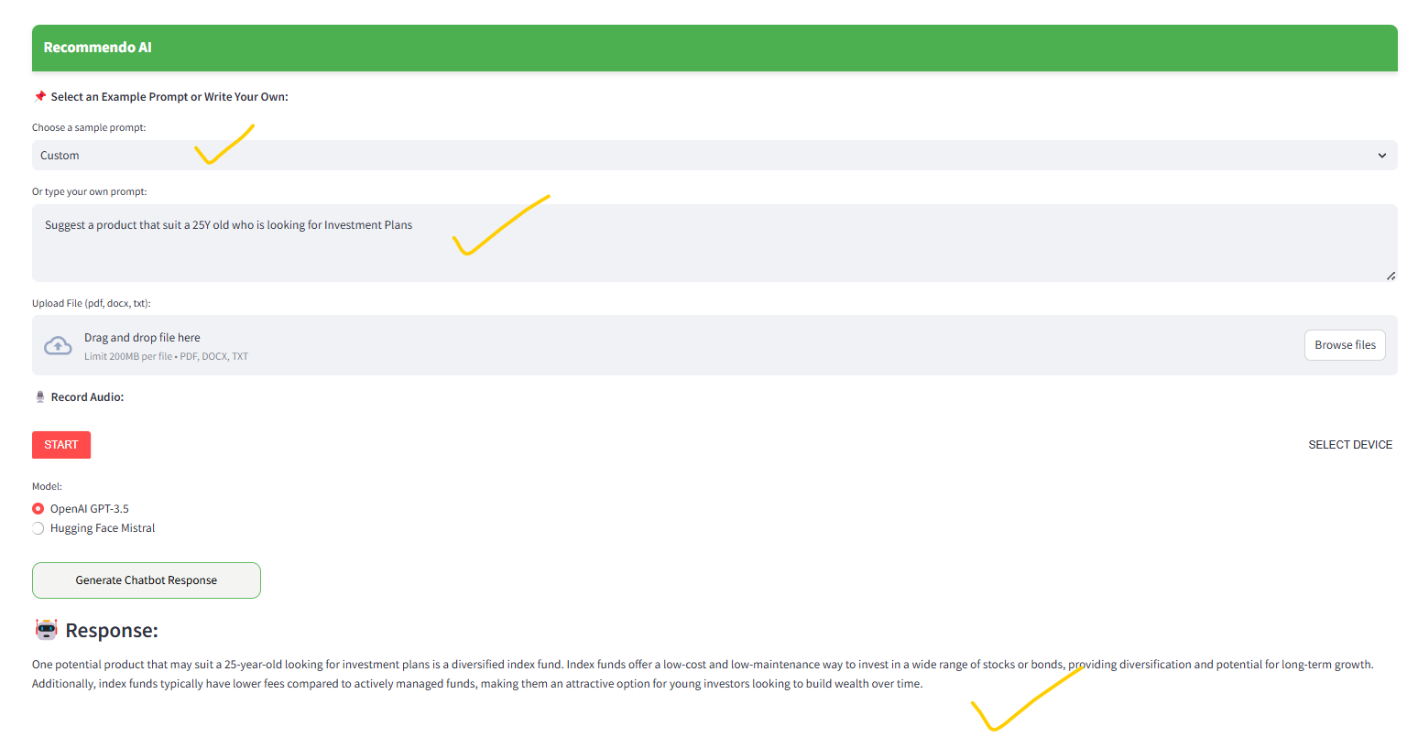

**Scenario 2 : Choose from existing list of prompts**

