**Echo Mind- Smart Recommendation System and** **GenAI Financial Recommendation Engine Architecture**

For AI driven hyper-personalization and recommendations, we have created two models with different approaches.

1. **Smart Recommendation System**

We have leveraged the electronics section of Amazon Reviews 2023 dataset to create a LightGCN model. LightGCN is an embedding-based model, which means it attempts to find the optimal embeddings (vectors) for users and items. In addition, it also seeks the optimal scoring function, denoted as f. This function assigns scores to new user-item pairs, and items with higher scores are recommended.

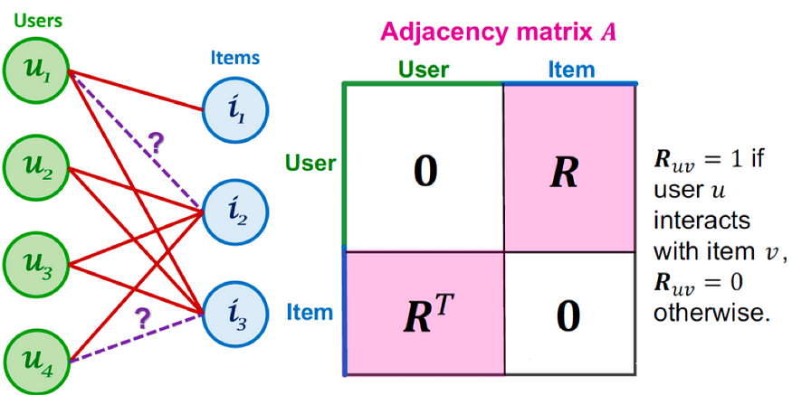

Once the user chooses items, we extract the embedding for those items from the model’s item embeddings, average out the embeddings of those items and compute cosine similarity of the averaged out embedding with the embeddings of all other items. and we recommend the top 5 items with the highest cosine similarity scores are recommended by the LightGCN model.

1. **GenAI Financial Recommendation Engine**

This project builds a **Retrieval-Augmented Generation (RAG) based QA system** that recommends company products based on open-source company product data, demographic (DEMOG) data, and bureau (BUREAU) data. It leverages **LangChain**, **Hugging Face embeddings,** and the **Zephyr 7B LLM** for intelligent recommendations.

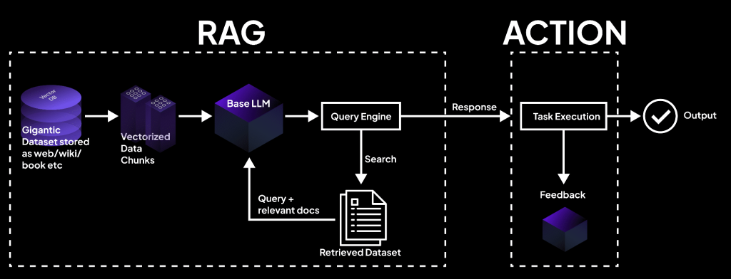

Components:

1. Data Ingestion & Preprocessing:
   * Load open-source company product, DEMOG, and BUREAU data.
   * Preprocess the data (cleaning, normalization, feature engineering).
   * Save the processed data into a CSV file.
2. Embedding & Vector Database:
   * Load the preprocessed CSV.
   * Convert text-based data into embeddings using a Hugging Face Embedding Model.
   * Store embeddings in a Vector Database (e.g., FAISS, ChromaDB, Pinecone).
3. Retrieval-Augmented Generation (RAG) Pipeline:
   * Utilize LangChain to retrieve relevant data from the vector DB.
   * Process queries using the Zephyr 7B LLM to generate contextual responses.
4. Evaluation of Recommended Products:
   * Check if the recommended products align with customer needs.
   * Validate outputs against business logic and predefined evaluation metrics.