AI-Driven Hyper-Personalization & Recommendations

Table of contents

1. Overview
2. Data Flow
3. Approach
4. Key-Technical considerations
5. Security Considerations
6. Ethical Considerations
7. Insights
8. Business recommendations based on AI-Driven findings

**Overview**

Hyper-personalization is key strategy for businesses to enhance customer experience, increase engagement. Businesses can create unique and engaging experiences for the customers, driving loyalty and growth.

To recommend the personalization choices to customer:

1. Reading Customer data, along with consent of the customer.
2. If consent is provided by customer,

* Uses customer tweets from file generated using Twitter API, conduct sentiment analysis with help of TextBlob.
* Construct personalized prompts using transaction history and sentiment data.
* Utilizes OpenAI API to generate recommendations.
* Converts the generated recommendations into Audio with pyttsx3, to incorporate subtitles, background music, and a watermark. Finalizes the video composition using Moviepy Python library.

**Data flow**

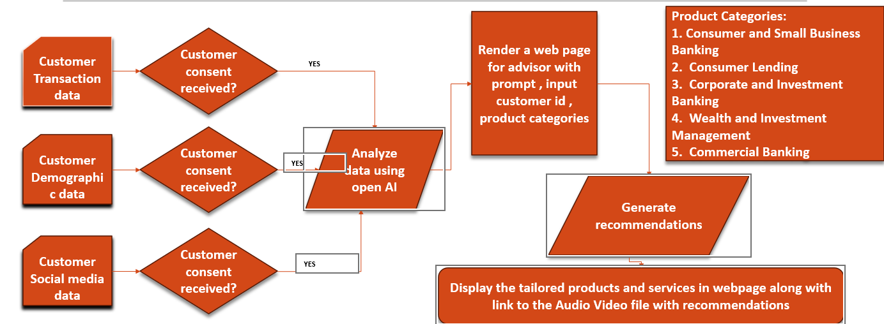

**Approach**

1. Initialization : Three inputs with customer transaction data, Profile data and Social media data
2. Data Handling :

* Verifies Consent for Transaction and Social_Media data.
* Password protect input data

1. Social Media Analysis:

* Perform sentiment analysis on Twitter data using TextBlob, provided consent is given

1. Recommendation Generation:

* Construct prompts with option to select product category from

1. Consumer and Small Business Banking

2. Consumer Lending

3. Corporate and Investment Banking

4. Wealth and Investment Management

5. Commercial Banking.

* Using Open API to generate recommendations, based on consent data.

1. Video Generation:

* Converts the generated recommendations into audio with pyttsx3.
* Incorporates subtitles, background music and a watermark.
* Finalizes the video composition using moviepy library.

1. Error Handling:

Manages missing files, API Issues, and rate limit errors effectively.

1. Scalability:

* Handles customer data in manageable batches to optimize performance.
* Utilizes modular functions to improve maintainability and scalability.

**Key-Technical considerations**

1. Prerequisite Checks

Validates dependencies, API keys and required files.

1. Error handling

Handles API errors, file not found, and rate limits gracefully.

1. Scalability

Batch Processing: Processes customer data in batches for efficiency.

Reusable Functions: Modular design for maintainability.

1. Compliance

Resource Cleanup: Deletes temporary files after use.

1. Logging

Comprehensive logging for debugging and monitoring.

1. Data Privacy and Security
   1. Used only consented data, and password protect input data
2. Ethical AI

Resource Cleanup: Deletes temporary files after use.

1. Customer Personas

Comprehensive logging for debugging and monitoring.

1. Prompt Engineering

Comprehensive logging for debugging and monitoring.

1. Video Generation

Dynamic Composition: Generates videos with subtitles, narration, and watermark.

Transparency: Watermark indicates only consented data is used.

1. Cleanup

Remove temporary files post-processing to prevent clutter and maintain efficiency.

**Business recommendations based on AI-Driven findings**

Here is one of Business recommendations provided using the created model:

Hello John, I am your Investment Advisor Jeremy Porter. Wells Fargo would like to recommend you a few products that can enhance your banking experience and support your financial goals.

* First, I recommend the Wells Fargo Home Mortgage. Understanding your recent concerns regarding the home loan application process, this mortgage offers tailored solutions that can ease your path to homeownership with competitive rates and flexible terms designed for your unique situation.
* Second, consider the Wells Fargo Personal Loan. With your strong income and positive banking history, this personal loan can provide you with the funds you need for any significant purchases or debt consolidation, all while enjoying fixed monthly payments and no prepayment penalties.
* Finally, I suggest the Wells Fargo Cash Back Rewards Card. This credit card allows you to earn cash back on your everyday purchases, including clothing, which has been a recent focus for you. With no annual fee and the ability to earn rewards, it will complement your spending habits while providing you with financial flexibility.
* These products not only align with your current needs but also set you on the path to achieving your financial aspirations. Let’s take the next steps together.

Visit wellsfargo.com for more details.