# **Technical Documentation: AI-Driven Hyper-Personalization & Recommendations Platform**

## **1. Executive Summary**

Our groundbreaking platform represents a transformative approach to financial product personalization, leveraging state-of-the-art artificial intelligence to create a dynamic, intelligent recommendation ecosystem. By integrating advanced multi-agent AI systems, real-time data processing, and sophisticated insight generation, we've developed a solution that goes beyond traditional marketing approaches, offering unprecedented levels of personalization and customer understanding.

System Architecture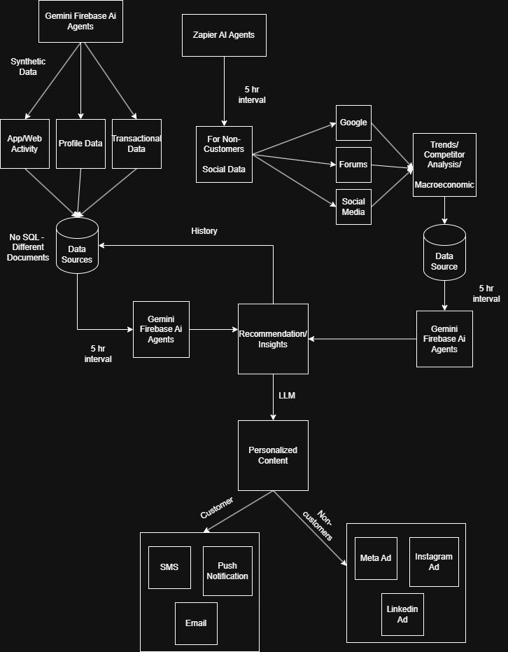

## **2. System Architecture**

### **2.1 Multi-Agent Data Gathering and Analysis Ecosystem**

#### **2.1.1 Data Collection Agents**

The foundation of our platform lies in its comprehensive data collection mechanism. Utilizing Zapier's integration capabilities and Firestore, we've created a robust network of data collection agents that seamlessly extract information from diverse sources. These agents are designed to aggregate data from social media platforms, bank customer interaction logs, bank transaction histories, and digital footprints (website analytics, app usage, internet activity), ensuring a 360-degree view of customer behavior and market trends.

**Key Technologies**:

* Zapier for cross-platform data integration
* Firebase for real-time data management
* Firestore for scalable, flexible document storage

#### **2.1.2 Trend Discovery Agents**

Our trend discovery agents represent the intellectual core of the platform. Powered by LangChain and Gemini, these sophisticated AI modules continuously analyze collected data (Company data, Social Media Data, Internet Data) to identify emerging patterns, consumer preferences, and market shifts. Deployed as Firebase Functions, they operate on a dynamic 5-hour update cycle, ensuring that insights remain current and actionable.

**Core Capabilities**:

* Continuous trend analysis for financial products
* Real-time insight generation from various social platforms, and online trends.
* Adaptive learning algorithms
* Specialized focus on credit cards, home loans, mortgages, and auto loans

### **2.2 Customer Insight Generation**

#### **2.2.1 Data Collection Methodology**

We go beyond surface-level data collection by implementing granular tracking of user interactions. Our system meticulously captures nuanced user behaviors, including:

* Precise time spent on different application tabs
* Detailed product page interaction patterns
* Navigation flow and user journey mapping
* Transactions done with different merchants and categories

This microscopic view of user behavior allows for unprecedented personalization and predictive modeling.

#### **2.2.2 Data Integration**

Our real-time data integration strategy is a key differentiator. Firestore documents are updated hourly, creating a living, breathing data ecosystem that responds instantaneously to changing user behaviors and market conditions. This approach ensures that recommendations are not just personalized, but contextually relevant and timely.

**2.2.3 Real-time Adaptive Analytic Engine**

2.2.3.1 Engine Overview- The Real-time Dynamic Adaptive Analytic Engine represents a sophisticated, intelligent system designed to continuously evolve customer insights through persistent data analysis and intelligent pattern recognition. This engine serves as the cognitive backbone of our hyper-personalization platform, enabling dynamic and responsive customer understanding.

2.2.3.2 Data Ingestion and Processing- The engine operates on a daily data ingestion cycle, systematically collecting and analyzing:

* Recent bank transactions
* Digital application activity logs
* Customer interaction metrics
* Spending pattern variations
* Macroeconomic data such as Unemployment, Inflation, Fed Policies

Data Collection Mechanism:

* Daily data ingestion from Firestore
* Granular tracking of individual customer interactions
* Comprehensive capture of transaction-level details
* Secure, anonymized data processing

2.2.3.3 Change Detection Algorithms- Our proprietary algorithms employ advanced statistical techniques to identify significant behavioural and spending pattern shifts:

Key Detection Capabilities:

* Anomaly detection in spending patterns
* Long term change in spending patterns
* Customer Life Stage Detection (College student, new professional, newlywed, first child etc.)
* Detection of Major Life Events in a Customer (Job loss, Financial Stress, New family/child, Wedding, Health Crisis etc.)
* Retention and Churn Risk

Detection Methodology:

1. Statistical Baseline Establishment
   * Initial customer profile creation
   * Multi-dimensional statistical modelling
2. Comparative Analysis Framework
   * Daily data ingestion comparison
   * Machine learning-powered trend identification
3. Intelligent Pattern Recognition
   * Leveraging Gemini's advanced language model
   * Contextual understanding of behavioral nuances
   * Cross-referencing historical and current data patterns

2.3.3.4 Insight Generation and Adaptation

Insight Generation Process:

* LLM-powered comparative analysis
* Contextual interpretation of behavioral and spending pattern changes
* Dynamic customer profile refinement
* Adjustment in recommendations
* Gemini’s reasoning capabilities finds root cause in a customer’s change in spending

2.3.3.5 Recommendation Database Update Mechanism

Update Triggers:

* Statistically significant behavioral or spending shifts
* Detected spending pattern deviations
* Change in Life Stage of Customer
* Update of new major life events of customer
* Change in Retention and Churn risk
* Change in Product Recommendations

2.3.3.6 Update Workflow:

1. Data Collection
2. Statistical Analysis
3. Gemini Insight Generation
4. Customer Profile Refinement
5. Recommendation Database Update

### **2.3 Personalized Marketing Agent**

#### **2.3.1 Targeting Mechanisms**

Recognizing the diversity of user communication preferences, our platform employs a multi-channel targeting approach:

**Customer Targeting**:

* SMS for immediate, direct communication
* Phone notifications for urgent or personalized updates
* Email for detailed, comprehensive information

**Non-Customer Targeting**:

* Meta Ads for broad reach
* Instagram Ads for visually-driven engagement
* LinkedIn Ads for professional and B2B targeting

#### **2.3.2 Ad Generation**

Powered by LangChain and Gemini, our ad generation agents represent the cutting edge of AI-driven content creation. These agents don't just create ads; they craft personalized narratives that resonate with individual user profiles, leveraging multimodal content generation capabilities.

### **2.4 Feedback Analysis Agent**

#### **2.4.1 Social Media Monitoring**

Our feedback analysis agent provides unprecedented insights into brand perception and customer sentiment. By continuously monitoring platforms like Reddit and various social media channels, we extract nuanced understanding of:

* Specific customer pain points
* Emerging brand perceptions
* Detailed product feedback
* Potential areas of improvement

## **3. Technical Stack**

### **3.1 Backend**

The backend is engineered for performance, flexibility, and scalability:

* Python provides robust, efficient data processing capabilities
* Flask framework ensures lightweight, modular architecture
* Multi-agent AI systems enable complex, intelligent interactions
* Real-time data processing algorithms drive continuous improvement

### **3.2 Frontend**

Our frontend is a testament to modern web development best practices:

* TypeScript ensures type safety and reduces runtime errors
* Next.js provides server-side rendering and optimal performance
* Responsive, intuitive UI design
* Interactive data visualization components
* Comprehensive user control interfaces

## **4. Key Technical Innovations**

### **4.1 Advanced Generative AI Techniques**

We leverage cutting-edge AI technologies to push the boundaries of personalization:

* Large Language Models (LLMs) for complex understanding
* Transformer architectures for sophisticated pattern recognition
* Fine-tuned models for domain-specific accuracy
* Retrieval-augmented generation for contextually rich outputs

### **4.2 Multi-Modal Personalization**

Our approach transcends traditional single-channel personalization:

* Integrated text, image, and voice input processing
* Advanced sentiment analysis across modalities
* Cross-channel recommendation generation
* Holistic user profile understanding

### **4.3 Ethical AI Considerations**

Responsible AI is at the core of our platform:

* Comprehensive data privacy management
* Stringent financial compliance integration
* Proactive consent management
* Advanced bias detection and mitigation strategies

## **5. Performance and Scalability**

### **5.1 Real-time Adaptability**

Our system is designed for continuous evolution:

* Dynamic recommendation adjustment
* Instant persona-based personalization
* Continuous learning and improvement mechanisms

### **5.2 Technological Flexibility**

We've built an ecosystem that embraces technological diversity:

* Seamless integration with open-source tools
* Direct compatibility with Google Gemini APIs
* Flexible cloud-based NLP framework integration

## **6. Future Roadmap**

Our vision extends beyond the current implementation:

* Enhanced multi-modal personalization techniques
* Continuous bias detection improvements
* Expanded and more diverse data source integration
* Machine learning model refinement
* Enhanced predictive capabilities

## **7. Conclusion**

Our AI-driven hyper-personalization platform is more than a technological solution—it's a paradigm shift in intelligent, adaptive financial product recommendations. By combining state-of-the-art AI technologies with a profound understanding of user needs, we've created a platform that doesn't just recommend products, but understands and anticipates customer needs and desires.