**The Solution:**

The solution has leveraged several machine learning techniques to deliver hyper-personalized insights and recommendations. These include:

**Clustering:**

The K means clustering algorithm is used to segment customers based on their financial data. This unsupervised learning technique helps classify customers into distinct groups based on their characteristics such as age, salary and loan amount.

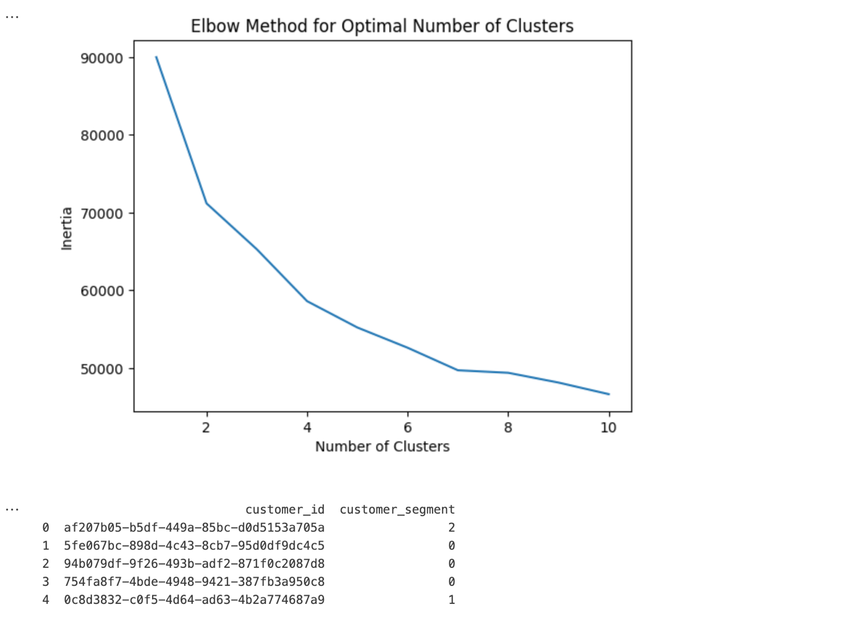

**Multi-Target Classification:**

A multi-target classification model is employed to predict the probability of a customer opting for different financial products such as credit cards, personal loans or home loans. This approach enables the simultaneous prediction of multiple product categories.

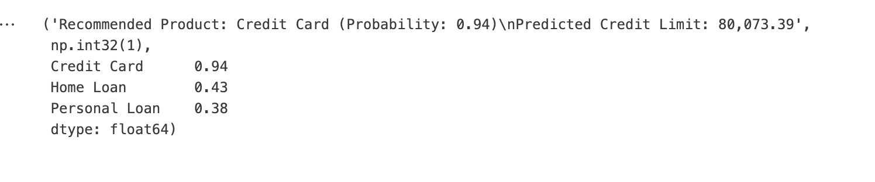

**Random Forest Regression:**

Three Random Forest models are used for the predicting loan amounts or credit limits based on the customer’s profile. These models are individually trained to predict specific financial parameters: Personal loan amounts, home loan amounts and credit card limits.



**Deep Learning with Hugging Face LLM:**

An LLM from the Hugging Face, based on the **AutoModelForCasualLM**, generates personalized insights about the customer, using natural language processing (NLP) techniques. This allows for a rich, text-based interaction that adapts to each customer’s unique profile.

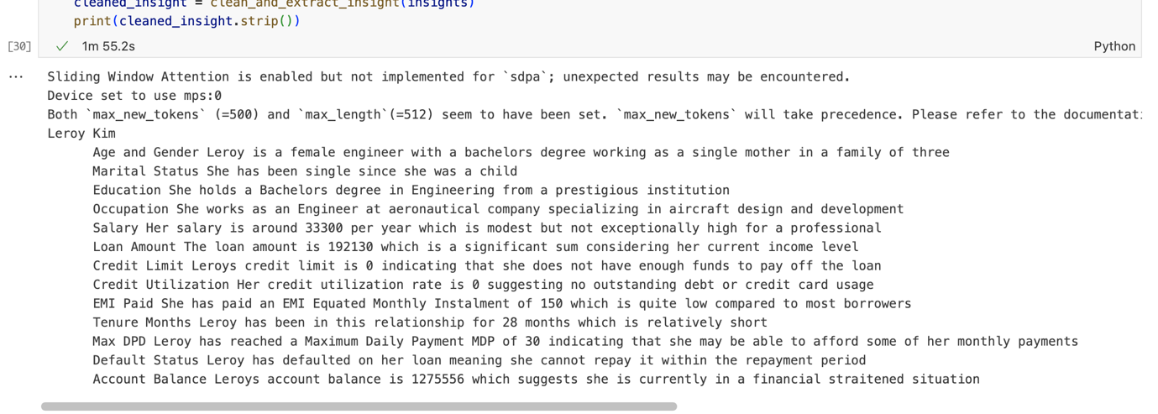

**App Architecture:**

**Model Layer:**

The model layer loads the machine learning models (KMeans, Multi_Target Classifier, Random Forest Regressors and LLM) during app startup. The joblib library is used to handle the loading of these models, while Hugging Face AutoModelForCausalLM is used for the LLM.

**Data Processing Layer:**

This layer handles the transformation of customer data into a suitable format for model predictions. Customer data is scaled using a pre-trained scaler, and then predictions are made using the KMeans model, classifiers and regression models.

**Business Logic Layer:**

**Product Recommendation:** The app predicts product preferences based on the customer’s segment and financial profile using the multi-target classifier.

**Loan Prediction:** Once a product is recommended, the app uses Random Forest models to determine the specific loan amount or credit card limit that should be offered.

**Insight Generation:** Using the Hugging Face LLM, the app generates personalized text-based insights about each customer’s financial standing

**View Layer:** The app uses Flask routes to serve a web interface where users can input customer data and view the resulting recommendations and insights.

**Screenshots**

**Product Recommendations:**

**Insights**

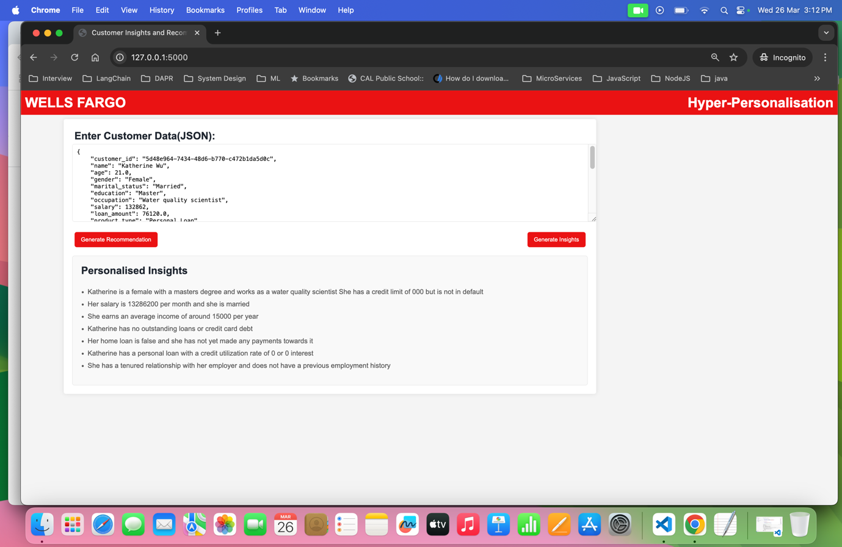

**Future scope of work:**

* Integrate with sentiment analysis to recommend products to the users.
* Inclusion of AI Agentic frameworks(Langraph) to create workflows to summarize the product recommendations and proactively send out notifications to users.
* Using Local LLM( like Ollama) to address security or risk compliance issues.