**RecomMind AI**

Banks face unique challenges that RecomMind AI can address:

1. Generic financial product recommendations that don't account for individual financial health
2. Inability to anticipate customer financial needs before they arise
3. Poor timing of offers leading to low conversion rates
4. High customer acquisition costs and churn rates
5. Regulatory compliance in personalization efforts

# Tech Stack

### Backend

* Python with Flask (simpler than FastAPI for quick setup)
* PostgreSQL (single database approach)
* Scikit-learn (for basic ML models)
* Pandas (for data manipulation)

### Frontend

* React with Bootstrap (for rapid UI development)
* Chart.js (easier than D3 for quick visualizations)
* React Router (for basic navigation)

### Deployment

* Local deployment for demo
* Alternative: Quick deploy to Heroku or similar PaaS

# Architecture

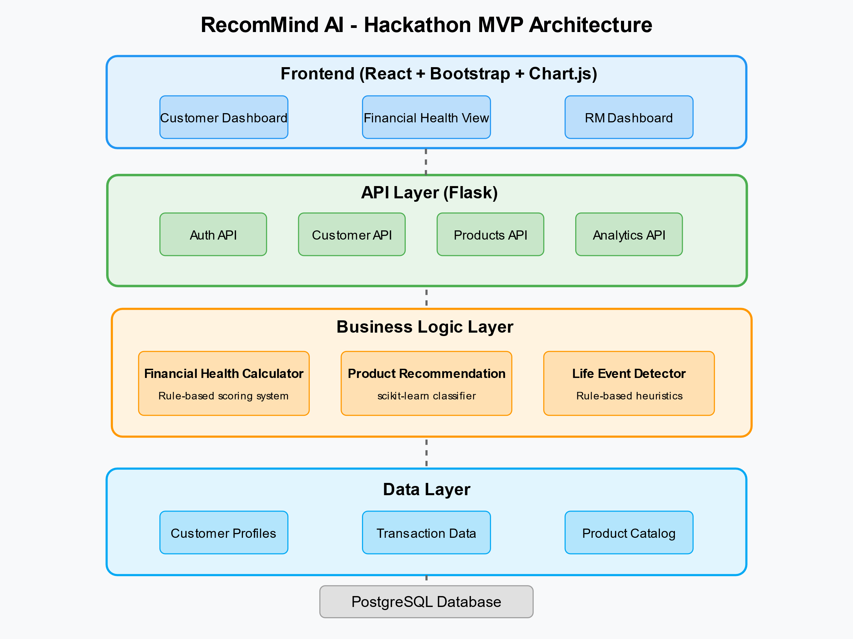

# User Flow

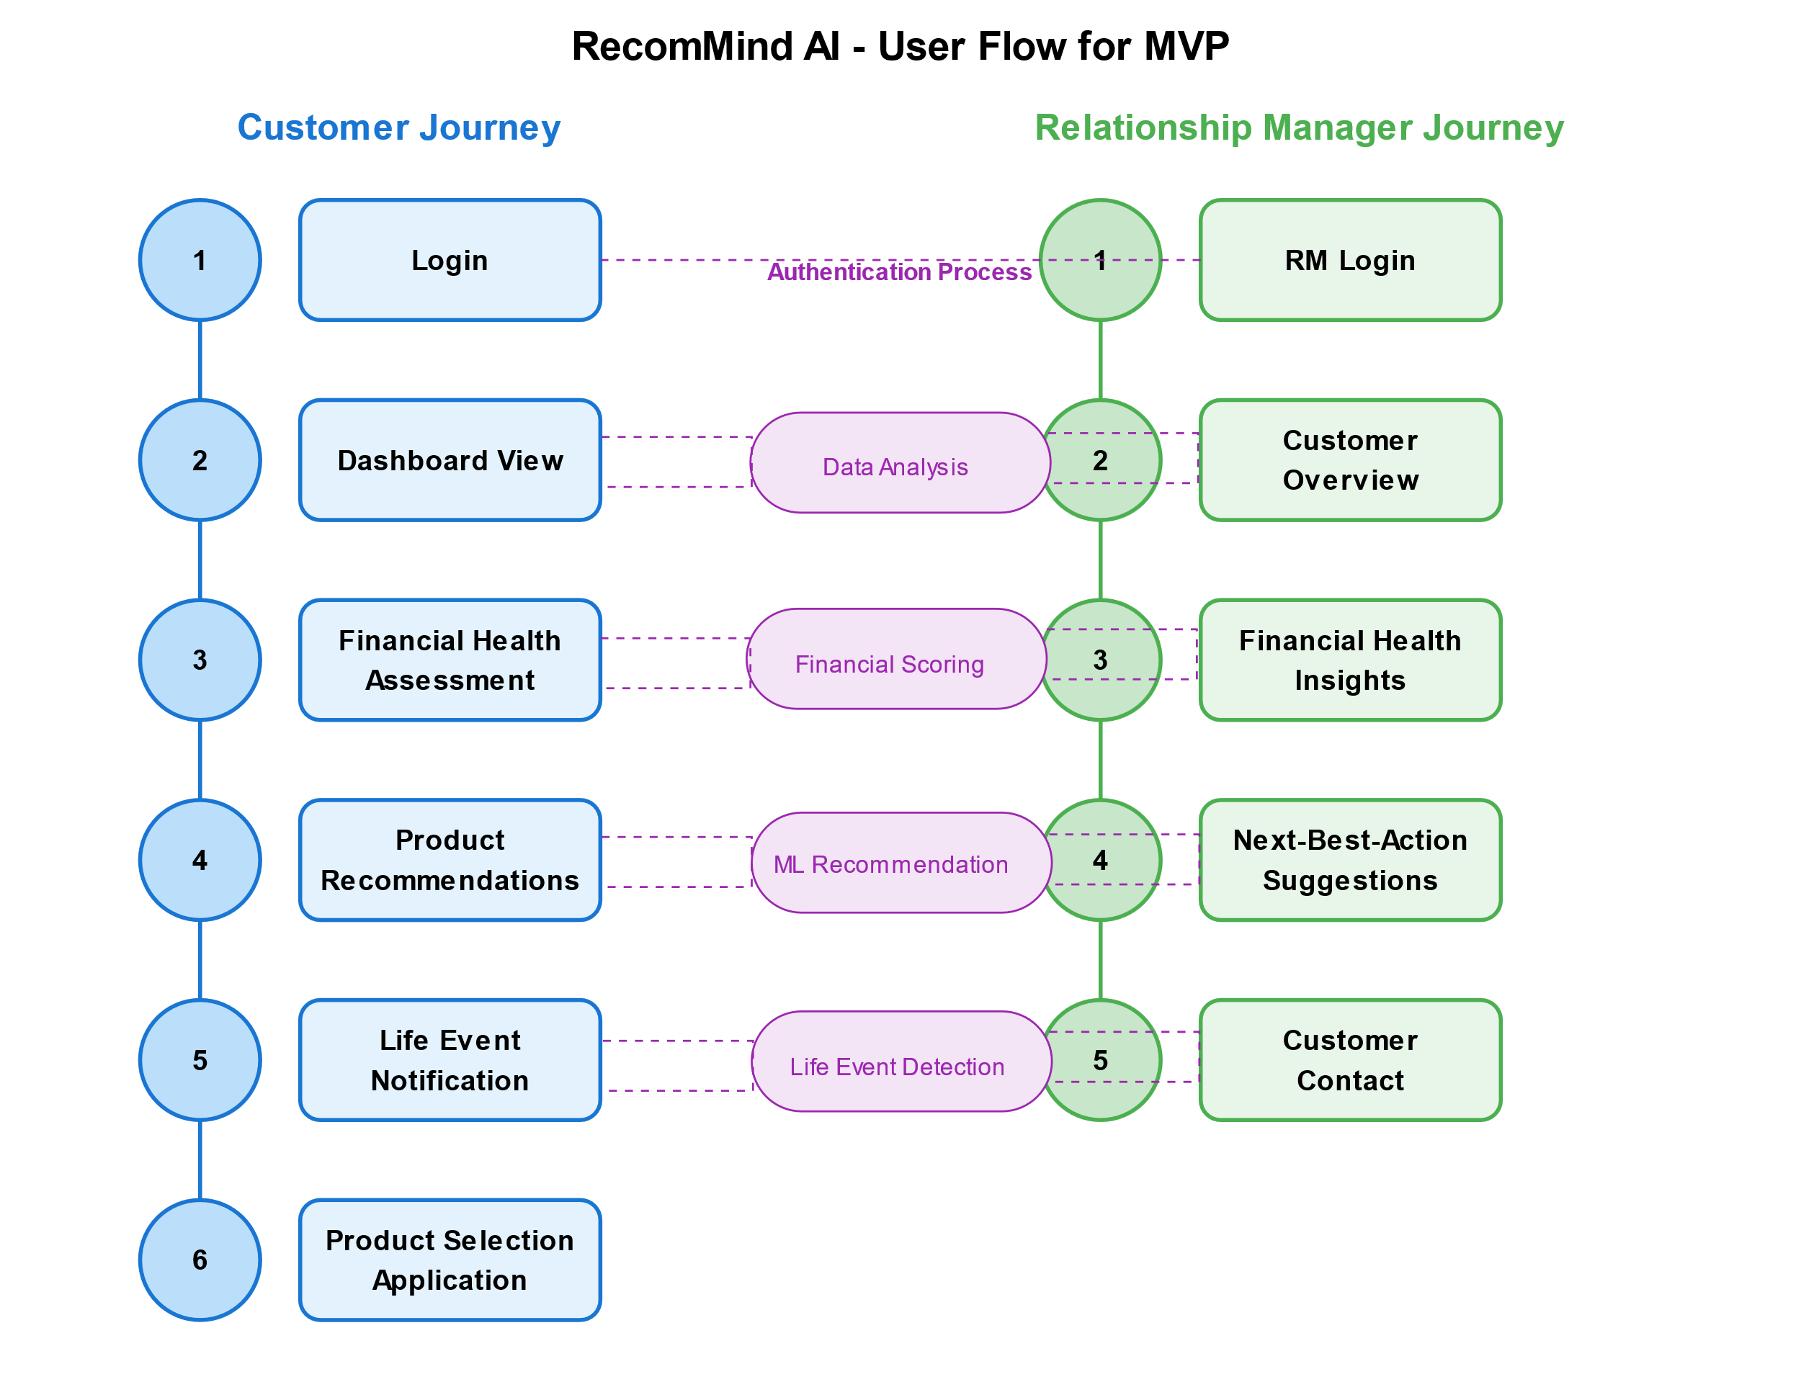

### Customer Journey

1. **Login**: Customer authentication
2. **Dashboard View**: Overview of accounts and financial status
3. **Financial Health Assessment**: Displays health score with breakdown
4. **Product Recommendations**: Personalized banking products suggestions
5. **Life Event Notification**: Alerts for detected life events (like home purchase)
6. **Product Selection & Application**: Simplified application flow

### Relationship Manager Journey

1. **RM Login**: Dedicated portal for bank staff
2. **Customer Overview**: List of customers with key metrics
3. **Financial Health Insights**: Detailed view of customer financial status
4. **Next-Best-Action Suggestions**: Recommended products and talking points
5. **Customer Contact**: Simplified outreach workflow

UI Screens

Customer UI Dashboard screen

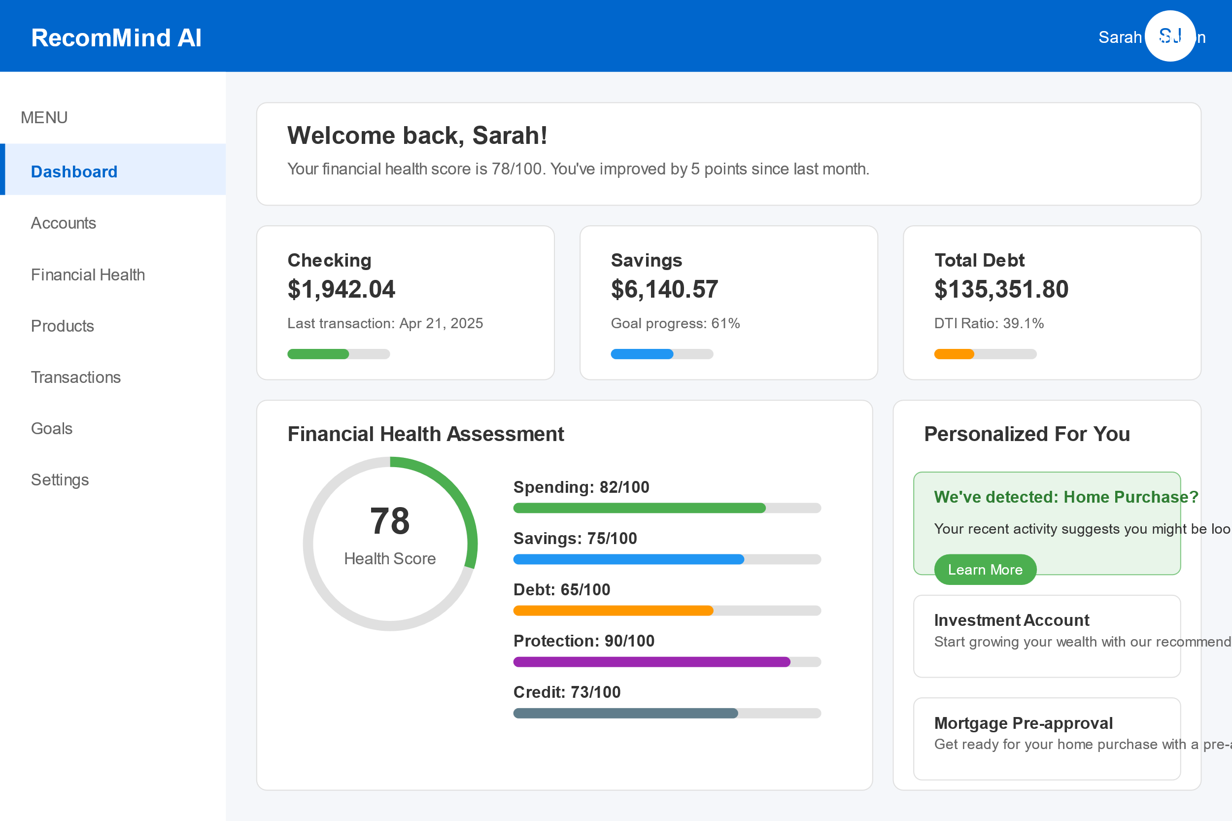

## Key Features of the Customer Dashboard:

### 1. Navigation System

* Left sidebar menu with quick access to Dashboard, Accounts, Financial Health, Products, Transactions, Goals, and Settings
* Top header with RecomMind AI branding and customer profile information

### 2. Welcome Section

* Personalized greeting with financial health score
* Progress indicator showing improvement over time

### 3. Financial Summary Cards

* Account overview showing checking balance ($1,942.04)
* Savings overview showing balance ($6,140.57) and goal progress
* Debt overview showing total debt ($135,351.80) and debt-to-income ratio (39.1%)
* Visual indicators showing relative financial health in each area

### 4. Financial Health Assessment Panel

* Comprehensive financial health score (78/100) with visual gauge
* Breakdown of score components:
  + Spending: 82/100
  + Savings: 75/100
  + Debt: 65/100
  + Protection: 90/100
  + Credit: 73/100
* Visual progress bars showing strengths and areas for improvement

### 5. Personalized Recommendations Panel

* Life Event Detection card highlighting potential home purchase
  + Based on the detected life event from the context data
* Product recommendations aligned with financial needs:
  + Investment Account (matches the "next_best_action" from the context data)
  + Mortgage Pre-approval (aligned with detected home purchase intent)

This design aligns with the Customer Journey described in the context:

* Dashboard View: Overview of accounts and financial status
* Financial Health Assessment: Displays health score with breakdown
* Product Recommendations: Personalized banking products suggestions
* Life Event Notification: Alerts for detected life events

Accounts Page

### Main Content Layout

1. **Page Header**
   * Clear "Your Accounts" heading with a brief description
   * "Add Account" button for easy account addition
2. **Account Cards**
   * **Checking Account ($1,942.04)**
     + Account number and last transaction date displayed
     + Visual progress indicator showing account status
     + Direct access to account details
   * **Savings Account ($6,140.57)**
     + Displays progress toward savings goal (61%)
     + Visual indicator of goal progress
     + Quick access to account details
   * **Mortgage ($100,361.60)**
     + Next payment date (May 15, 2025) and amount ($875.30)
     + Account identification information
     + Details button for accessing full mortgage information
   * **Auto Loan ($34,990.20)**
     + Next payment date (May 10, 2025) and amount ($428.50)
     + Account identification information
     + Details access button

Financial Dashboard UI Screen

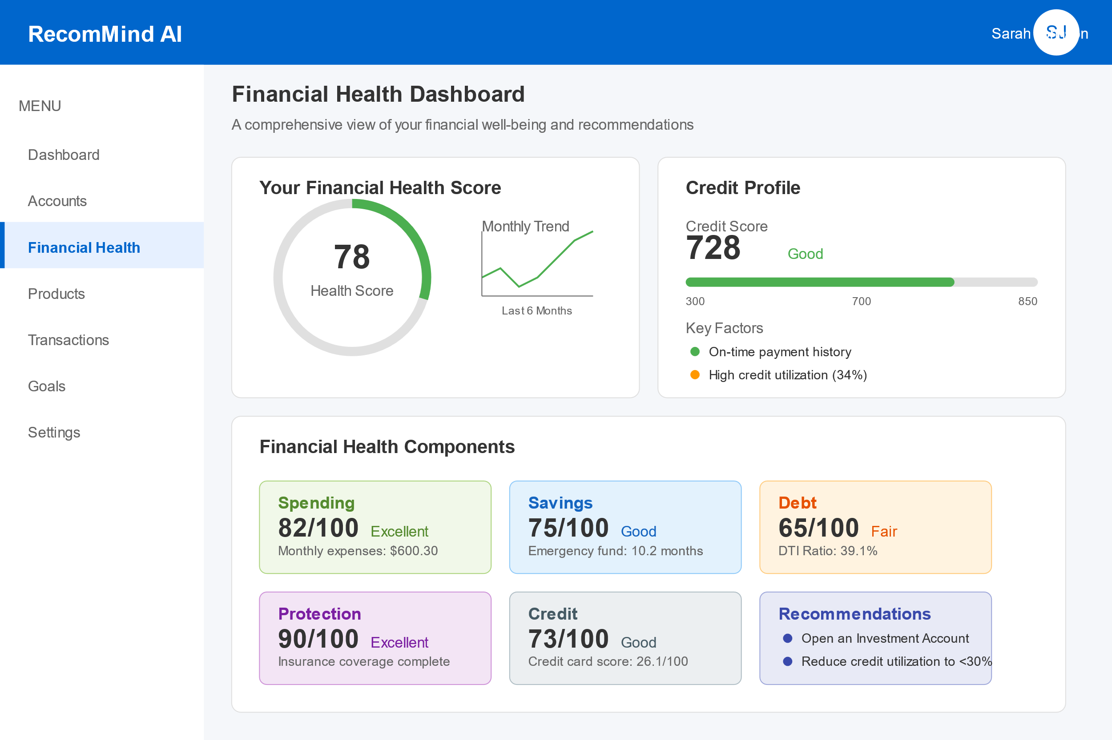

## Key Features of the Financial Dashboard:

### 1. Navigation System

* Consistent with the main dashboard, featuring the same left sidebar menu
* "Financial Health" option is highlighted, indicating the current page

### 2. Financial Health Score Section

* Prominently displays the overall financial health score (78/100)
* Visual gauge showing the score in an easy-to-understand circular progress indicator
* Trend chart showing score improvements over the last 6 months

### 3. Credit Profile Section

* Displays credit score (728) based on the data in the context
* Visual meter showing where this score falls in the credit score range
* "Good" rating to provide context for the numerical score
* Key factors affecting the credit score, highlighting strengths and areas for improvement

### 4. Financial Health Components

* Detailed breakdown of the five key components that make up the overall financial health score:
  + **Spending (82/100)**: Rated "Excellent" with monthly expenses of $600.30 (from the context data)
  + **Savings (75/100)**: Rated "Good" with emergency fund calculation
  + **Debt (65/100)**: Rated "Fair" with debt-to-income ratio of 39.1% (matching the context data)
  + **Protection (90/100)**: Rated "Excellent" for complete insurance coverage
  + **Credit (73/100)**: Rated "Good" with note on credit card score of 26.1 (from the context data)

### 5. Recommendations Section

* Personalized recommendations based on the financial health analysis
* Primary recommendation to open an Investment Account (matches the "next_best_action" from the context data)
* Secondary recommendation to reduce credit utilization to improve credit score

Relationship Manager UI Dashboard screen

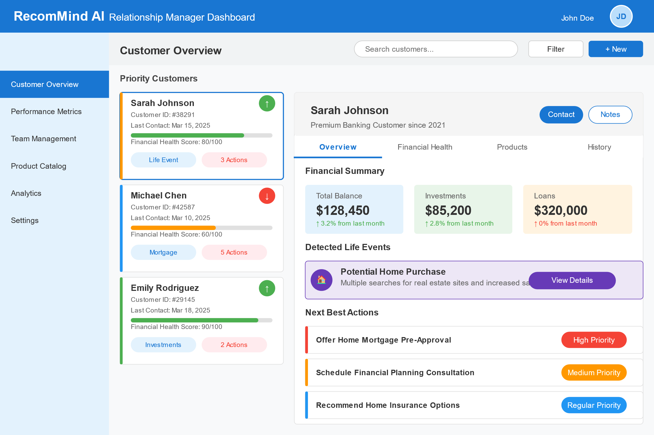

### Key Dashboard Components:

1. **Navigation System**:
   * Left sidebar with quick access to Customer Overview, Performance Metrics, Team Management, Product Catalog, Analytics, and Settings
   * Top header with RecomMind AI branding and RM profile information
2. **Customer List Section**:
   * Priority Customers panel showing the highest-priority clients
   * Visual indicators for financial health (color-coded progress bars)
   * Customer cards with essential information like ID, last contact date, and financial health score
   * Tag indicators for life events and pending actions
   * Performance trend indicators (up/down arrows)
3. **Customer Detail Panel**:
   * Comprehensive view of the selected customer (Sarah Johnson)
   * Tab navigation between Overview, Financial Health, Products, and History
   * Contact and Note-taking action buttons
   * Financial summary with key metrics (Total Balance, Investments, Loans)
4. **Life Event Detection**:
   * Highlighted panel showing potential home purchase detection
   * Information about the signals that triggered this detection
   * Action button to explore further details
5. **Next Best Actions**:
   * Prioritized list of recommended actions for the RM to take
   * Color-coded priority levels (High, Medium, Regular)
   * Clear action descriptions focusing on relevant financial products

# Checklist

## Day 1: Core Setup & Data Foundation

* Set up a simple Flask API backend with Python
* Create a basic PostgreSQL database with essential tables (customers, transactions, products)
* Build a simplified React frontend with 2-3 key screens
* Import and clean the sample data provided in the documentation
* Implement basic authentication (can use Auth0 or similar for speed)

## Day 2: Key ML Features

* Build a basic recommendation model using scikit-learn:
  + Focus on matching products based on customer financial profiles
  + Use a simple classifier (Random Forest or Gradient Boosting)
  + Train on the sample data
* Implement a financial health score calculator:
  + Simple rule-based scoring based on debt-to-income, savings ratio
  + Categorize customers into financial health segments
* Create a simplified life event detector:
  + Rule-based approach for identifying 1-2 key life events (home purchase, major expense)
  + Skip complex ML for this part, use heuristics instead

## Day 3: Integration & Demo Preparation

* Connect frontend to backend API endpoints
* Build a relationship manager dashboard showing:
  + Customer list with financial health scores
  + Product recommendations for each customer
  + Next-best-action suggestions
* Create a demo customer journey showing:
  + Initial customer profile and recommendations
  + Detection of a life event and changed recommendations
  + Intervention for financial stress
* Prepare compelling demo narrative for judges
* Polish UI and fix critical bugs

# Technical Implementation

# Code Related

# Input Data

### 1. Customer Profile Data

* Demographics (age, occupation, income, family status)
* Risk tolerance scores
* Financial goals and time horizons
* Banking relationship duration
* Customer segment classification

### 2. Transaction Data

* Transaction amounts, dates, and frequencies
* Merchant categories
* Spending patterns by category
* Income streams and regularity
* Bill payments and subscriptions

### 3. Product Usage Data

* Current banking products held
* Product usage frequency
* Product activation/dormancy status
* Fee structure and status
* Credit utilization rates

### 4. Interaction Data

* Channel preferences (mobile, web, branch)
* Customer service interactions
* Response to previous offers
* App usage patterns
* Session duration and feature engagement

### 5. Financial Health Indicators

* Savings-to-income ratio
* Debt-to-income ratio
* Emergency fund status
* Credit score trends
* Cash flow volatility

### 6. Life Event Signals

* Major deposit/withdrawal patterns
* Search behavior for life-event products
* Location changes
* Spending category shifts
* Age-related milestone triggers

|  |  |  |  |  |  |  |  |  |  |
| --- | --- | --- | --- | --- | --- | --- | --- | --- | --- |
| customer_id | age | gender | income | education | marital_status | family_size | homeownership | occupation | tenure_years |
| 1001 | 45 | Male | 17308 | Bachelor | Single | 2 | Owner | Professional | 5.5 |
| 1002 | 38 | Male | 15000 | High School | Single | 3 | Renter | Sales | 9.2 |

|  |  |  |  |  |  |  |
| --- | --- | --- | --- | --- | --- | --- |
| customer_id | channel_preference | email_open_rate | service_interactions_yearly | app_logins_monthly | website_visits_monthly | notification_opt_in |
| 1001 | Phone | 0.34 | 2 | 8 | 1 | 0 |
| 1002 | Website | 0.31 | 0 | 11 | 1 | 0 |

|  |  |  |  |  |  |  |  |  |  |  |  |  |  |  |  |  |  |  |  |  |  |  |  |
| --- | --- | --- | --- | --- | --- | --- | --- | --- | --- | --- | --- | --- | --- | --- | --- | --- | --- | --- | --- | --- | --- | --- | --- |
| customer_id | credit_score | checking_balance | savings_balance | investment_balance | has_checking | has_savings | has_credit_card | has_investment | has_mortgage | has_auto_loan | has_personal_loan | mortgage_amount | auto_loan_amount | personal_loan_amount | total_debt | debt_to_income | monthly_expenses | overdraft_frequency | late_payment_frequency | mobile_app_usage | branch_visits_monthly | atm_usage_monthly | financial_goal |
| 1001 | 728 | 1942.04 | 6140.57 | 0 | 1 | 1 | 1 | 1 | 1 | 1 | 0 | 100361.6 | 34990.2 | 0 | 135351.8 | 0.391 | 600.3 | 0 | 0 | Rarely | 3 | 1 | Home Purchase |
| 1002 | 850 | 1101.44 | 3920.75 | 5363.22 | 1 | 1 | 1 | 0 | 0 | 0 | 0 | 0 | 0 | 0 | 0 | 0 | 517.47 | 1 | 0 | Rarely | 0 | 3 | None Specified |

|  |  |  |
| --- | --- | --- |
| customer_id | event_type | event_date |
| 1002 | Home Purchase | 47:51.6 |
| 1002 | Graduation | 47:51.6 |

|  |  |  |  |  |  |
| --- | --- | --- | --- | --- | --- |
| customer_id | product_offered | offer_date | offer_channel | converted | days_to_conversion |
| 1001 | Credit Card Upgrade | 47:50.5 | Branch | 0 |  |
| 1001 | Mortgage Refinance | 47:50.5 | Branch | 0 |  |
| 1001 | Retirement Planning | 47:50.5 | Email | 0 |  |
| 1002 | Credit Card Upgrade | 47:50.5 | Email | 0 |  |
| 1002 | Retirement Planning | 47:50.5 | Branch | 0 |  |

|  |  |  |  |  |  |
| --- | --- | --- | --- | --- | --- |
| customer_id | date | amount | category | description | type |
| 1001 | 47:51.7 | 498.62 | Rent/Mortgage | Rent/Mortgage Purchase | debit |
| 1001 | 47:51.7 | 108.44 | Savings/Investment | Savings/Investment Purchase | debit |
| 1001 | 47:51.7 | 118.65 | Groceries | Groceries Purchase | debit |
| 1001 | 47:51.7 | 112.96 | Transportation | Transportation Purchase | debit |

|  |  |  |  |  |  |  |  |  |
| --- | --- | --- | --- | --- | --- | --- | --- | --- |
| customer_id | credit_card_score | savings_score | investment_score | mortgage_score | loan_score | next_best_action | engagement_probability | customer_lifetime_value |
| 1001 | 26.1 | 50 | 90 | 30 | 80 | Investment Account | 0.746 | 44.15 |
| 1002 | 40 | 50 | 90 | 30 | 100 | Personal Loan | 0.746 | 37.4 |