**Context Aware testing system for financial ecosystem**

Team Name: AI Problem Solvers

Auto generated test cases

Code : <https://github.com/ewfx/catfe-ai-problem-solver/blob/develop/src/tests/test_app.component.py> 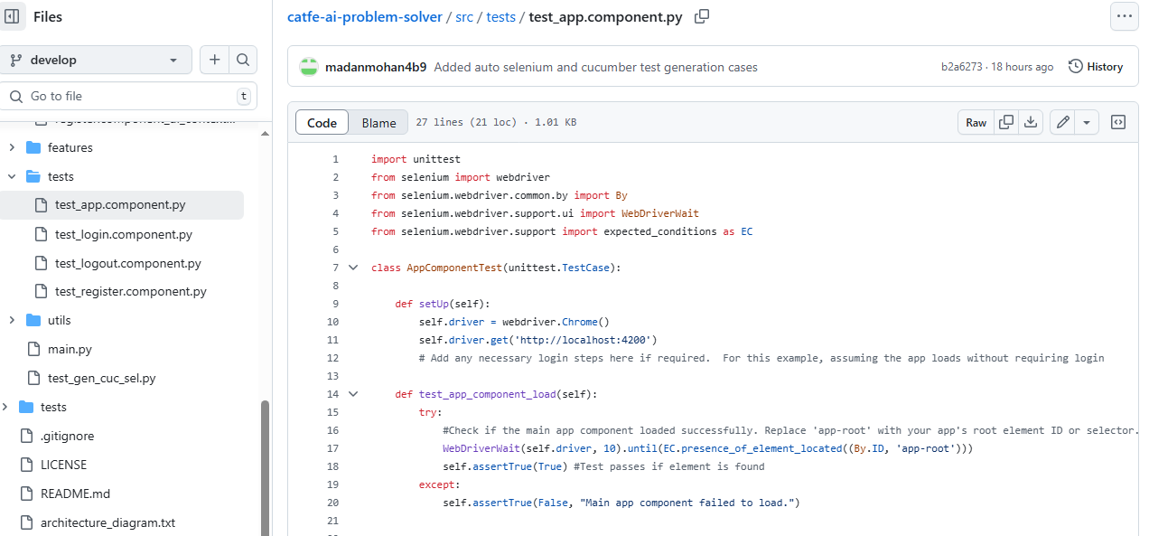

Runner Code: https://github.com/ewfx/catfe-ai-problem-solver/blob/develop/src/main.py

