Step 1: Flowise AI creating business cases & Context

Case 1: Generate business test cases

Link:

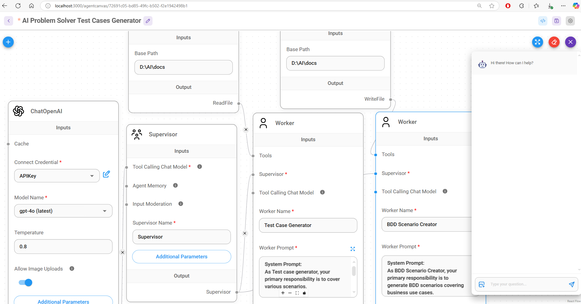

Case2: Create test cases based on query :

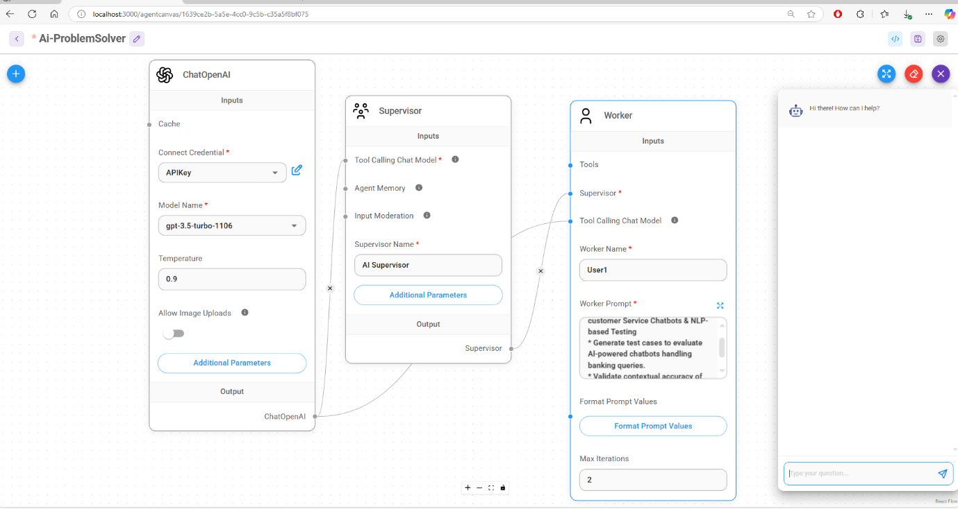

Step 2: Gemini getting context generated

Generated cases provided to Gemini Ai as json format

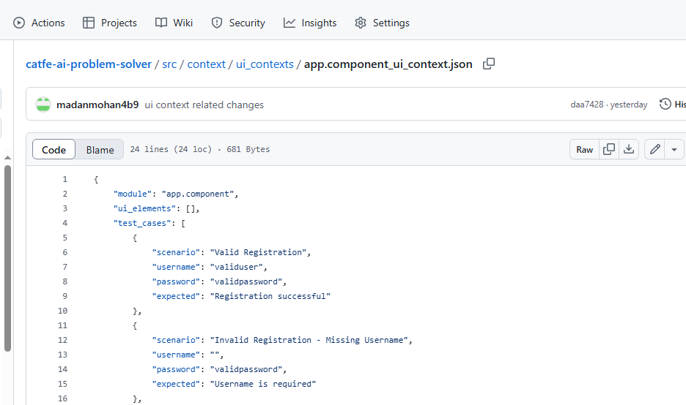. 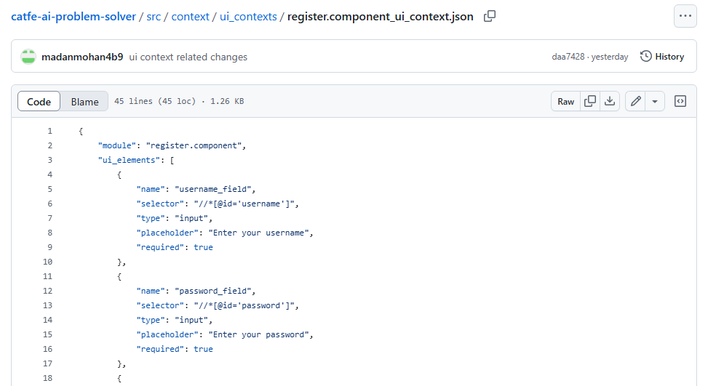

Step 3: Business logic banking Scenarios

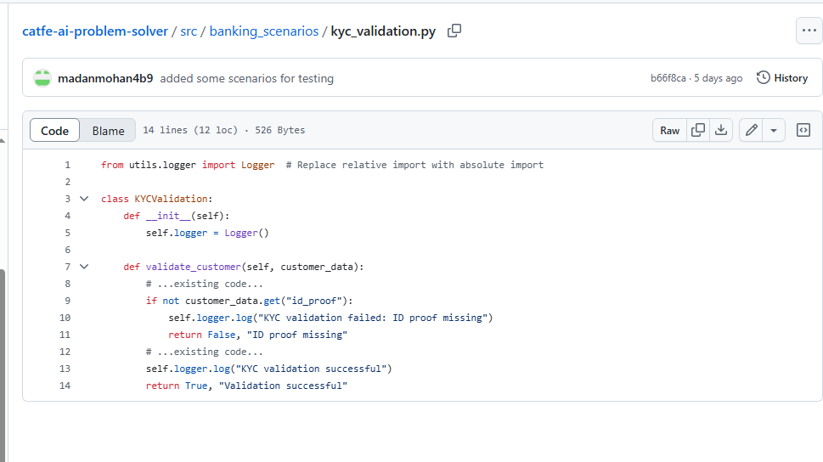 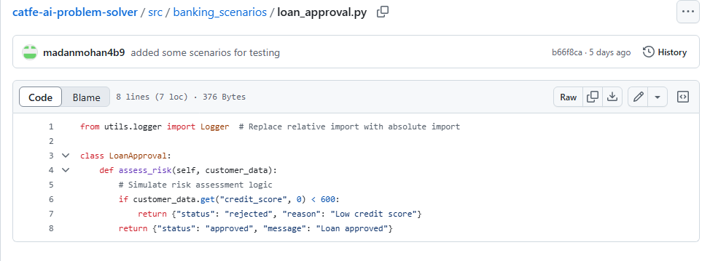

# Step 4: Python Program system monitors and test case generator from context

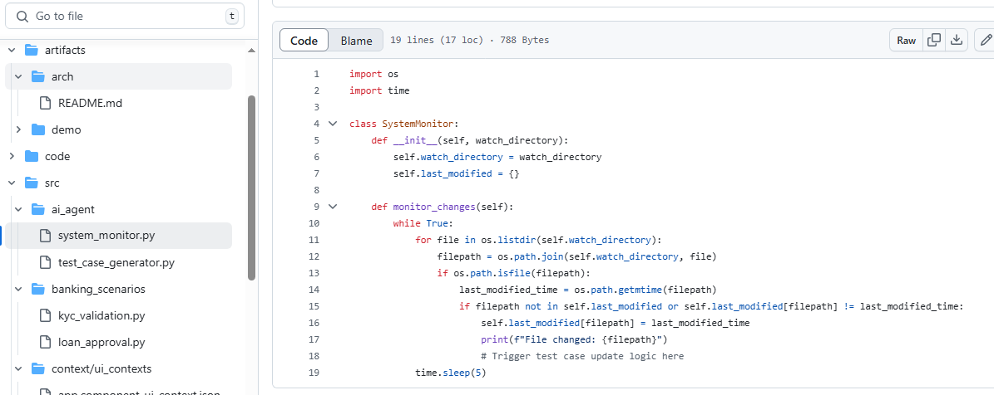

# Code: <https://github.com/ewfx/catfe-ai-problem-solver/blob/develop/src/ai_agent/test_case_generator.py>

# 

# Angular UI- Sample app to create business cases

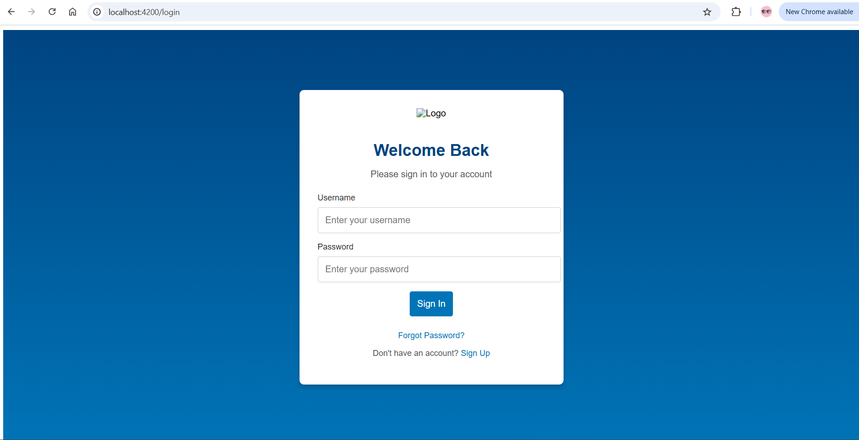

|  |  |
| --- | --- |
| APIs: |  |

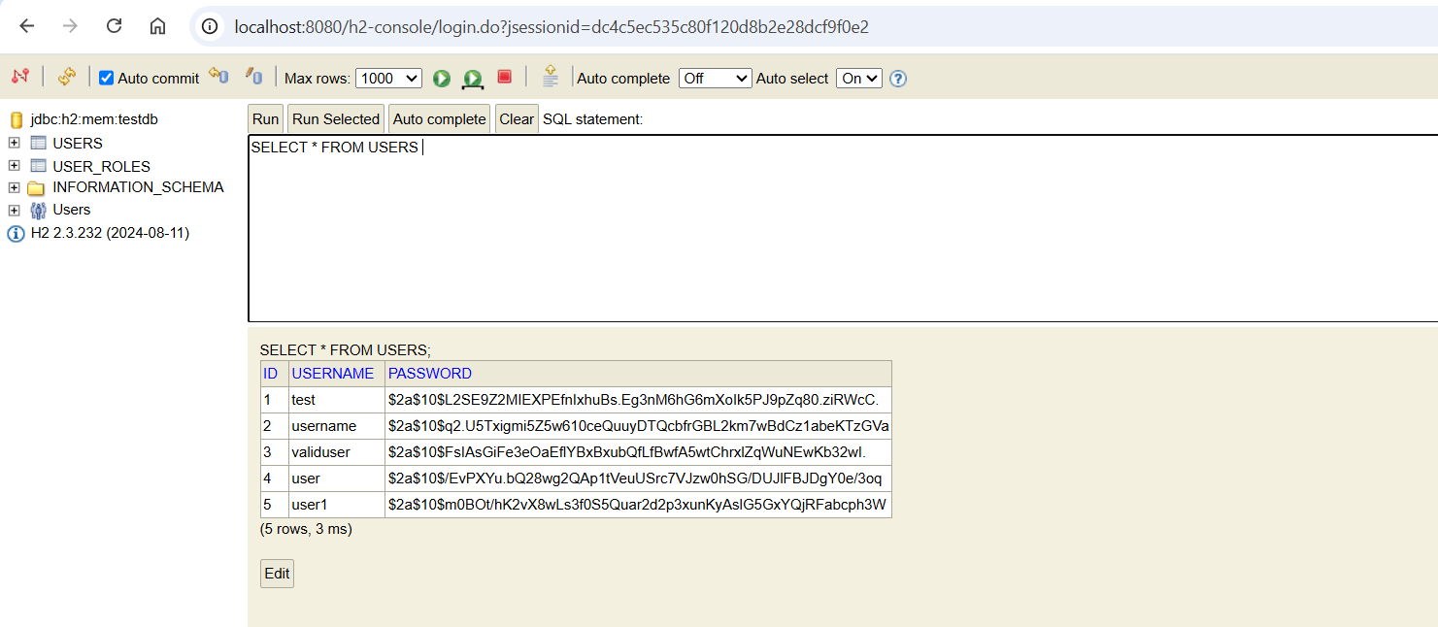

Step 5: Auto generated test cases

Code : <https://github.com/ewfx/catfe-ai-problem-solver/blob/develop/src/tests/test_app.component.py> 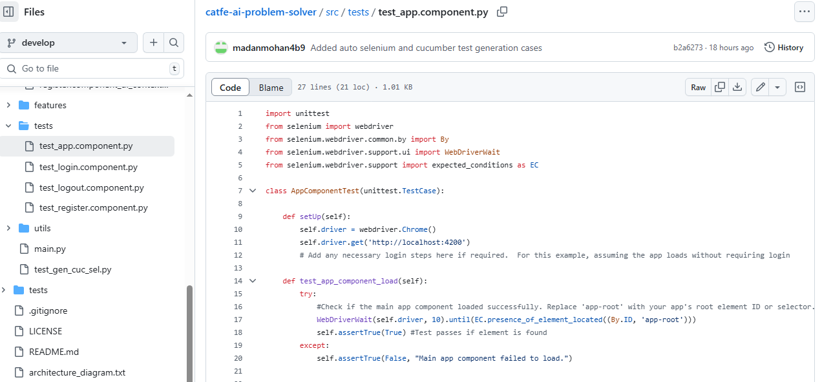

Runner Code: https://github.com/ewfx/catfe-ai-problem-solver/blob/develop/src/main.py

