**Architecture Flow :**

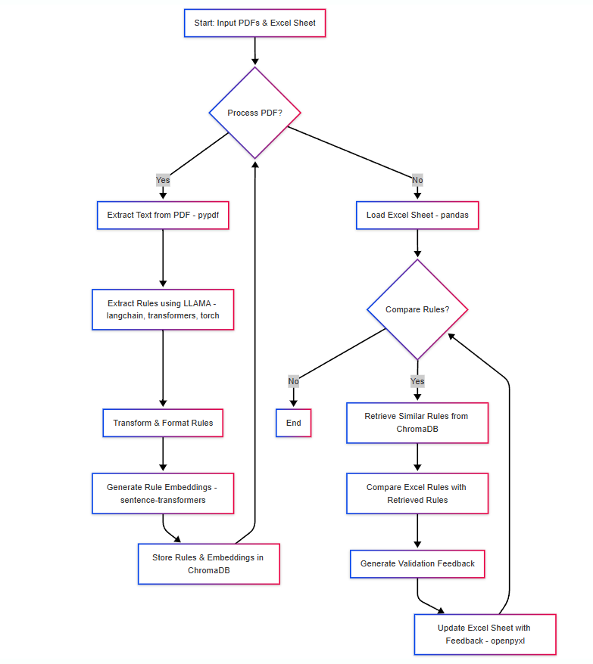

**Explanation of the Flowchart:**

1. **Start:** The process begins with input PDFs and an Excel sheet containing rules.
2. **Process PDF?:** The system checks if there are more PDFs to process.
3. **Extract Text from PDF (pypdf):** If there are PDFs, the text is extracted using pypdf.
4. **Extract Rules using LLAMA (langchain, transformers, torch):** The extracted text is passed to the Llama 2 model (managed by LangChain, Transformers, and PyTorch) to extract rules.
5. **Transform & Format Rules:** The extracted rules are formatted and cleaned.
6. **Generate Rule Embeddings (sentence-transformers):** The rules are converted into vector embeddings using sentence-transformers.
7. **Store Rules & Embeddings in ChromaDB:** The rules and embeddings are stored in the ChromaDB vector database.
8. **Load Excel Sheet (pandas):** If there are no more PDFs to process, the Excel sheet is loaded using pandas.
9. **Compare Rules?:** The system checks if rules from the excel sheet need to be compared.
10. **Retrieve Similar Rules from ChromaDB:** Similar rules are retrieved from ChromaDB based on the Excel sheet rules.
11. **Compare Excel Rules with Retrieved Rules:** The retrieved rules are compared with the rules from the Excel sheet.
12. **Generate Validation Feedback:** Validation feedback is generated based on the comparison.
13. **Update Excel Sheet with Feedback (openpyxl):** The Excel sheet is updated with the validation feedback using openpyxl.
14. **End:** The process ends.