WELLS FARGO TECHNOLOGY HACKATHON 2025

DATA PROFILING

**Title: AI-Driven Compliance Checker for Financial Transactions**

**1. Project Overview**

Financial institutions must comply with regulatory standards when processing transactions. This project leverages AI and rule-based validation to ensure transaction compliance with predefined profiling rules extracted from legal documents.

**2. Problem Statement**

Financial data compliance is crucial to prevent fraud and maintain regulatory adherence. Manual checks are time-consuming and error-prone. This project automates compliance validation using AI-based rule extraction and a validation engine.

**3. Architecture**

**FlowChart:**

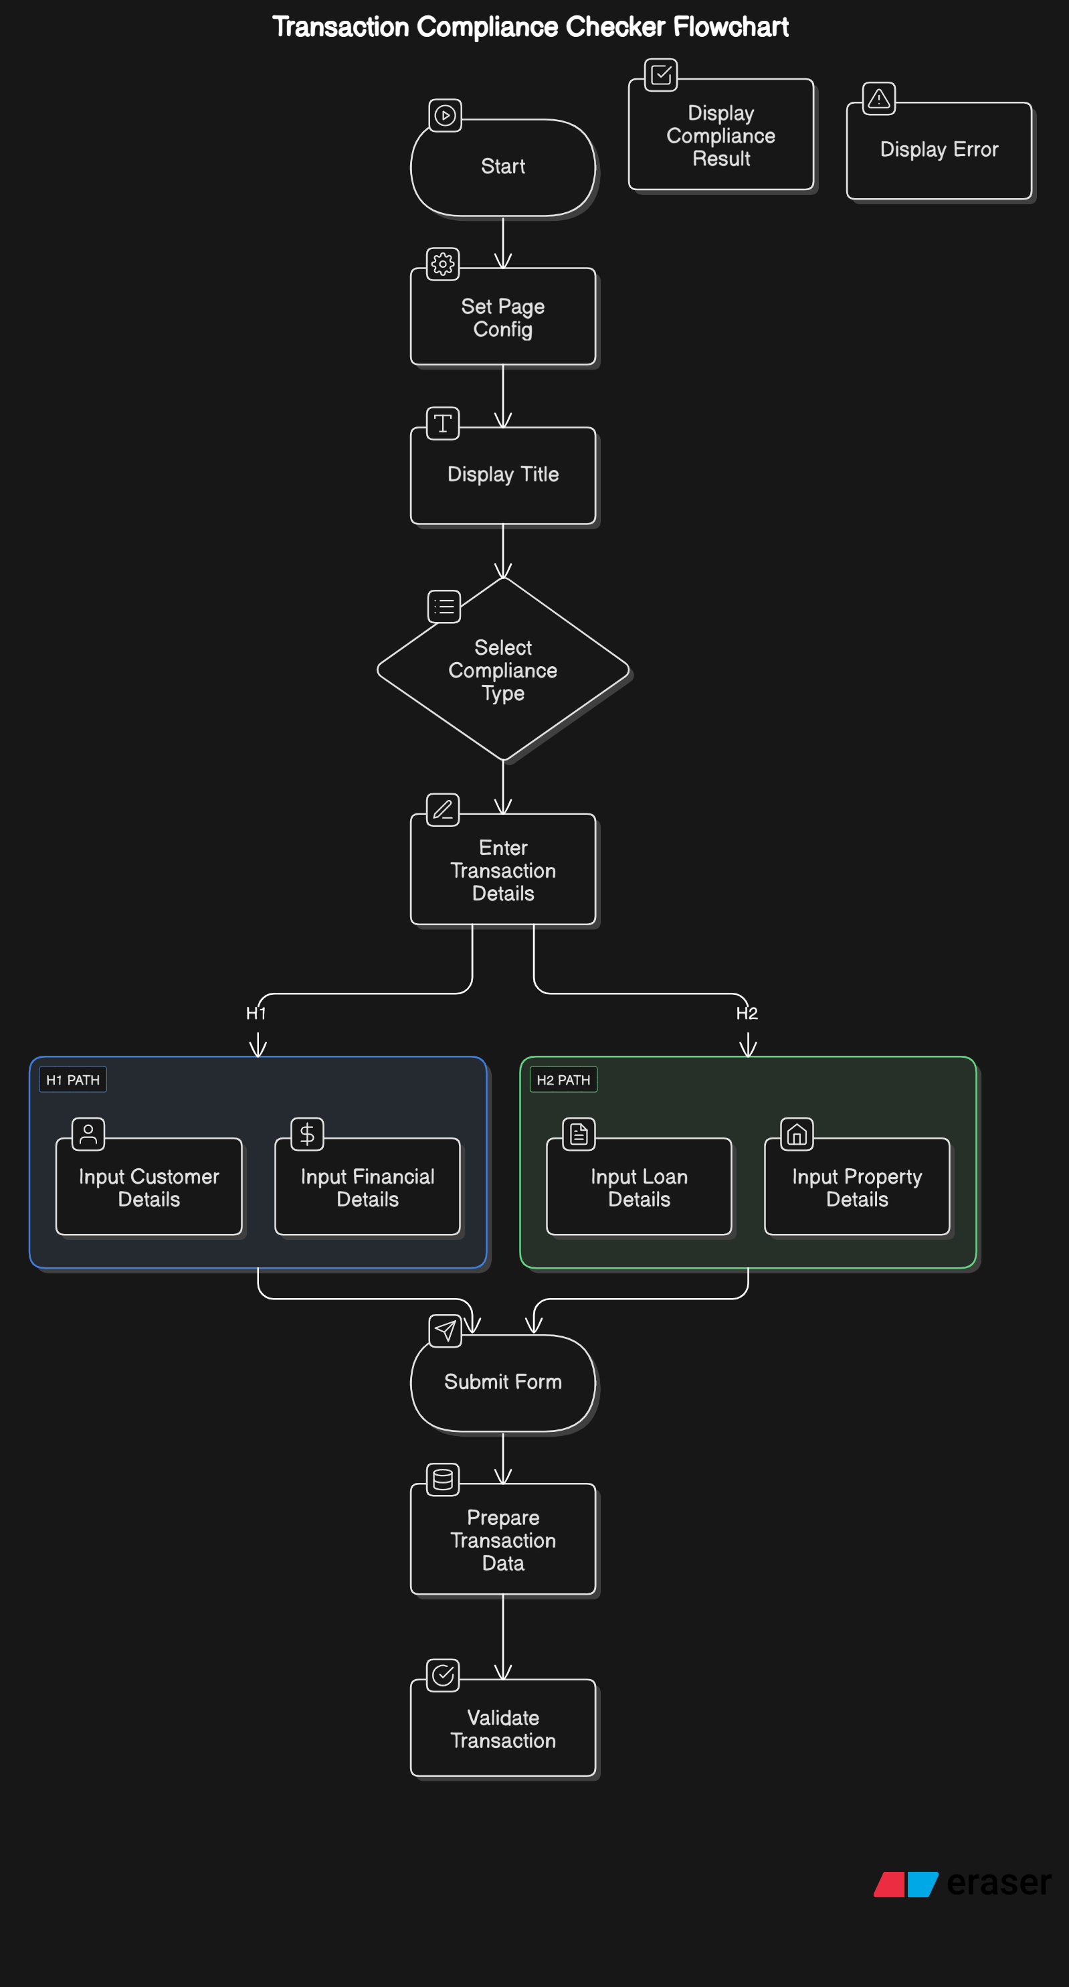

**Architecture Diagram**

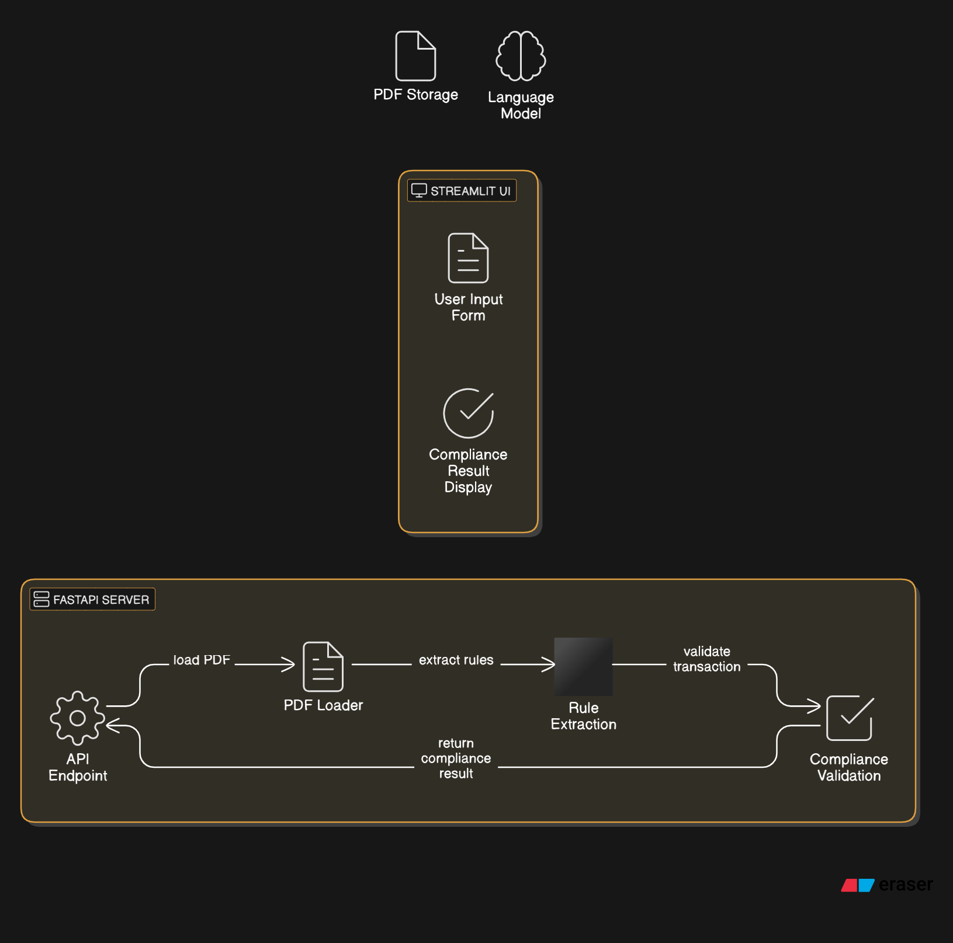

**High-Level Architecture:**

* **Frontend:** Streamlit-based UI for user interaction.
* **Backend:** FastAPI service for compliance validation.
* **Processing:** AI model extracts compliance rules from federal law PDFs.
* **Validation Engine:** Ensures transactions meet extracted compliance rules.

**Workflow:**

1. User selects compliance type (H1 or H2) in the Streamlit UI.
2. User inputs transaction details.
3. Backend validates data against compliance rules.
4. Response includes risk assessment, violations, and suggested remedies.

**4. Technologies Used and Justification**

**Frontend:**

* **Streamlit:** Easy-to-build interactive UI for compliance validation.
* **Python:** Simplifies UI logic and API integration.

**Backend:**

* **FastAPI:** High-performance API framework for handling validation requests.
* **Python:** Enables AI processing and integration with rule validation.

**AI:**

* **LLM (Large Language Model) / GenAI:** Extracts structured compliance rules from legal PDFs.

**5. Running the Project**

**Prerequisites:**

* Python 3.9+
* Virtual environment (recommended)
* Required dependencies installed

**Steps to Run the Project:**

**1. Clone the Repository:**

git clone <repository-url>

cd gaidp-bot-commandos

**2. Install Dependencies:**

pip install -r requirements.txt

**3. Start the Backend Server:**

uvicorn main:dataprofiler --reload

**4. Start the Frontend UI:**

streamlit run app.py

**API Endpoint:**

* POST /check_compliance/{section} (section = H1 or H2)
* Accepts JSON transaction data and returns compliance results.

**6. Conclusion**

This project provides an automated AI-driven compliance checker to ensure adherence to financial regulations. By leveraging AI for rule extraction and a robust validation engine, it streamlines the compliance process, reduces manual effort, and enhances accuracy.