**Model Name: gemini-1.5-pro-latest**

**Model Name: GPT-4-0**

**Test Email 1: Mixed Loan Modification and Payment Processing Requests**

**Email Subject: Request for Loan Modification and Payment Issues**

**Email Body:**

Dear Loan Servicing Team,

I would like to request a modification to my loan terms due to financial hardship. Specifically, I need an **interest rate adjustment** and a **term extension**.

* My new requested interest rate: **4.5%**
* Requested term extension: **5 years**
* Supporting document attached

Additionally, I made a **one-time payment** last week, but I don't see it reflected in my loan account. Here are the details:

* Payment Amount: **$5,000**
* Payment Date: **March 10, 2025**
* Transaction Reference ID: **TXN123456**

Please process my requests at your earliest convenience.

Regards,  
**John Doe**  
Account ID: **56789**

**Attachments:**

* **loan_mod_request.pdf** (Contains requested modifications)
* **payment_receipt.pdf** (Proof of payment)

**Expected Classification & Assignment:**

* **Loan Modification - Interest Rate Adjustment** → Loan-Team (High confidence)
* **Loan Modification - Term Extension** → Loan-Team (High confidence)
* **Payment Processing - One-Time Payment Issue** → Payments-Team (High confidence)

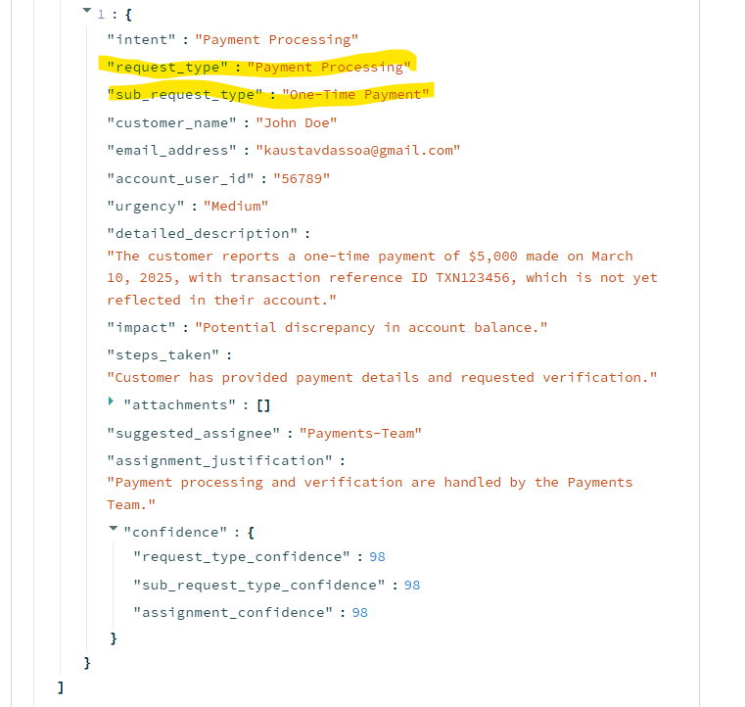

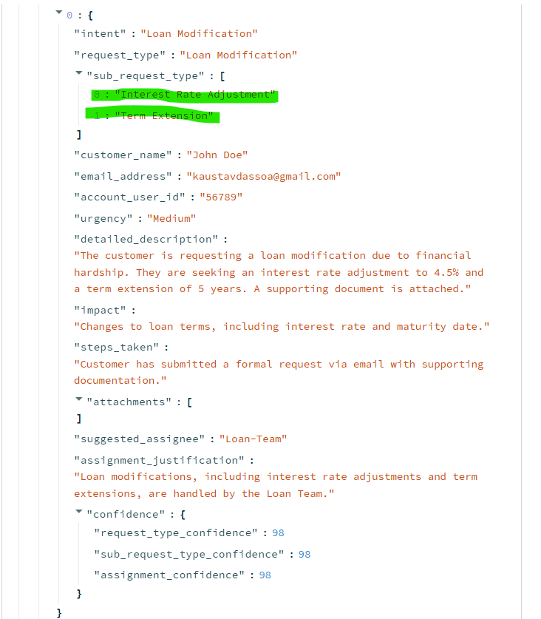

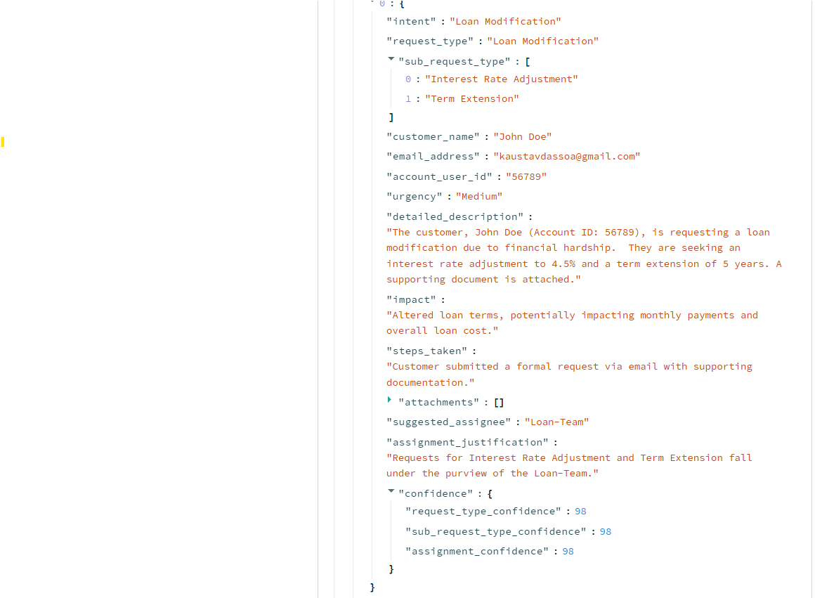

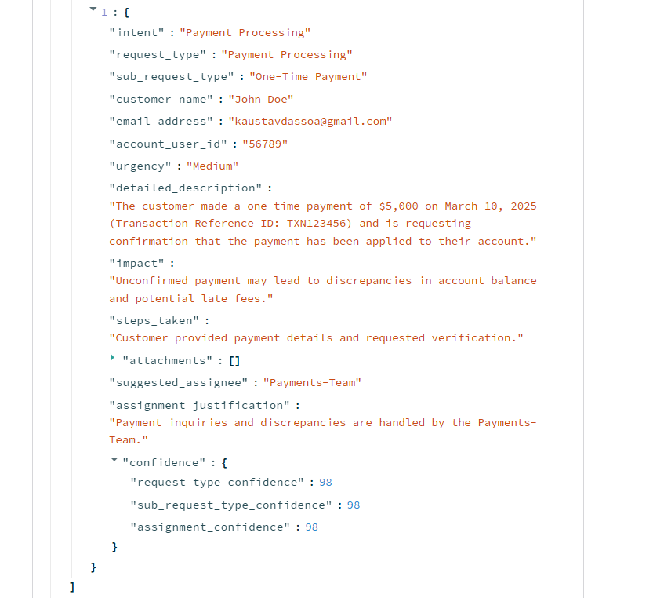

**Test Email 2: Multiple Requests with Unclear Classification**

**Email Subject: Account Issues & Payment Inquiry**

**Email Body:**

Hi,

I recently changed my **email address and phone number**, and I need my loan account updated. Also, I need help with **setting up recurring payments** from my new linked bank account.

* New email: **jane.doe@email.com**
* New phone: **(555) 123-4567**
* Recurrence Frequency: **Monthly**
* Start Date: **April 1, 2025**
* Linked Account Number: **XXXX-5678**

Additionally, I received a **default notice**, but I believe my account is in good standing. Can someone clarify why this notice was issued?

Thanks,  
**Jane Doe**  
Loan Account: **78901**

**Expected Classification & Assignment:**

* **Customer Info Update - Contact Information Update** → CSR Team (High confidence)
* **Payment Processing - Recurring Payment Setup** → Payments-Team (High confidence)
* **Delinquency Handling - Default Notice Inquiry** → CSR Team (Low confidence, due to potential manual review needed)

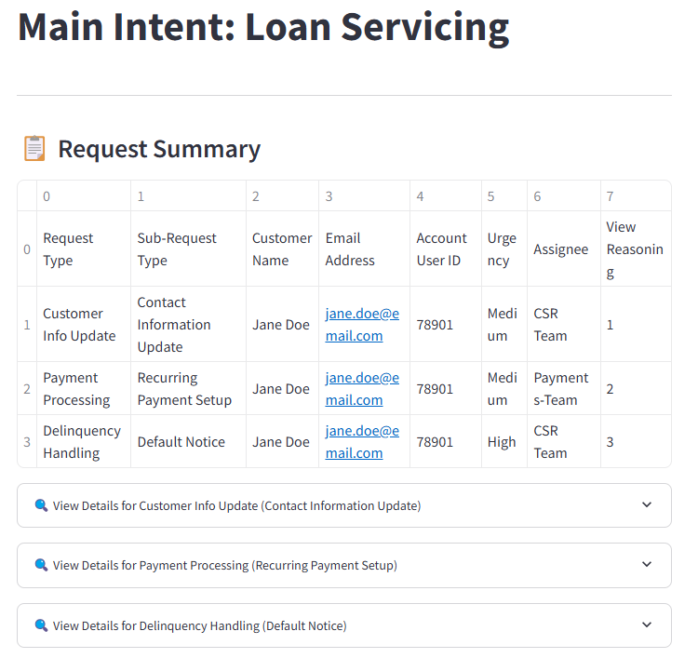

**Major Observation – Key words are not getting extracted from the email into the JSON payload. Nee to change the prompt for this.**

**Modified Prompt Results**

**Key words are now getting extracted**

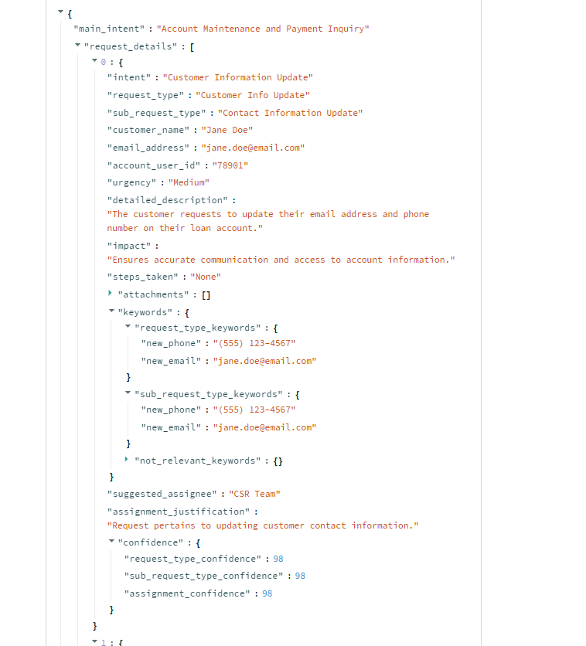

**Email Subject:** Loan Payoff Inquiry & Collateral Substitution

**Email Body:**

Hello,

I need information on:

1. My current loan payoff amount and final statement.
2. Replacing my existing collateral with a different asset.
3. My credit card balance and next payment due date (irrelevant).
4. Rewards points available on my checking account (irrelevant).

My collateral details:

* Current Collateral ID: COLL789
* New Collateral Address: 123 New Street, NY
* Substitution Approval Date: May 10, 2025

Regards,  
Michael Lee  
Account: 54321

**Expected Classification & Assignment:**

* Loan Closure/Payoff - Full Payoff Request → Loan-Servicing-Team (High confidence)
* Collateral Management - Collateral Substitution → Loan-Servicing-Team (High confidence)
* NOT RELEVANT Keywords: ("credit card balance", "rewards points")

