Testing

**1.Testcase 1: Sample Email with out attachment**

Dear Mr. Johnson,

I hope you are doing well.

I would like to kindly request a detailed breakdown of recent transactions for the following account:

* **Account Name**: ABC Holdings Ltd.
* **Account Number**: 456789123
* **Transaction Period**: February 1, 2025 – March 15, 2025

We are specifically looking to review entries associated with recent settlements, including any allocations to principal and interest components during this period. Additionally, if you could advise on the standard processing timelines for such transactions and provide any related reports or reconciliation tools, it would be greatly appreciated.

Please let me know if you require any further information from our side.

Thank you for your assistance.

Best regards,  
Michael Stevens  
Finance Manager  
ABC Holdings Ltd.  
michael.stevens@abcholdings.com

Output

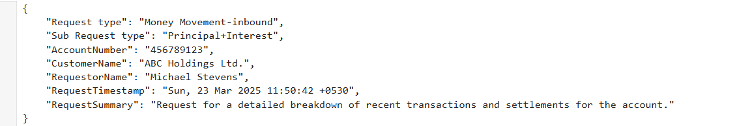

**2.TestCase2:Sample Email with out attachment**

Dear Ms. Parker,

I hope you are doing well.

We are preparing to initiate a payment related to recent activities involving a foreign currency transaction from the following account:

* Account Name: XYZ Enterprises Ltd.
* Account Number: 789654321

Could you please provide the necessary instructions and relevant details to ensure smooth processing on your end? If there are any specific requirements, cut-off times, or documentation needed for this transaction, kindly advise.

Your assistance is appreciated, and we look forward to your guidance to complete this process efficiently.

Best regards,  
Daniel Morgan  
Treasury Specialist  
XYZ Enterprises Ltd.  
daniel.morgan@xyzenterprises.com  
+1 (555) 987-6543

**Output**

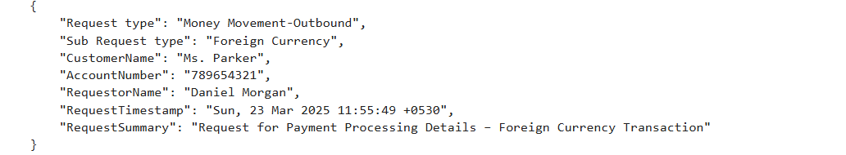

**3.Testcase3: Sample Email with attachment**

Dear Lending Service Team,

We request an adjustment to be made to our loan account with  attached details

Please let us know if any additional details are required.

Best Regards,  
John Doe  
Finance Manager, ABC Corporation  
Phone: (123) 456-7890  
Email: john.doe@abccorp.com



Content of the attachment

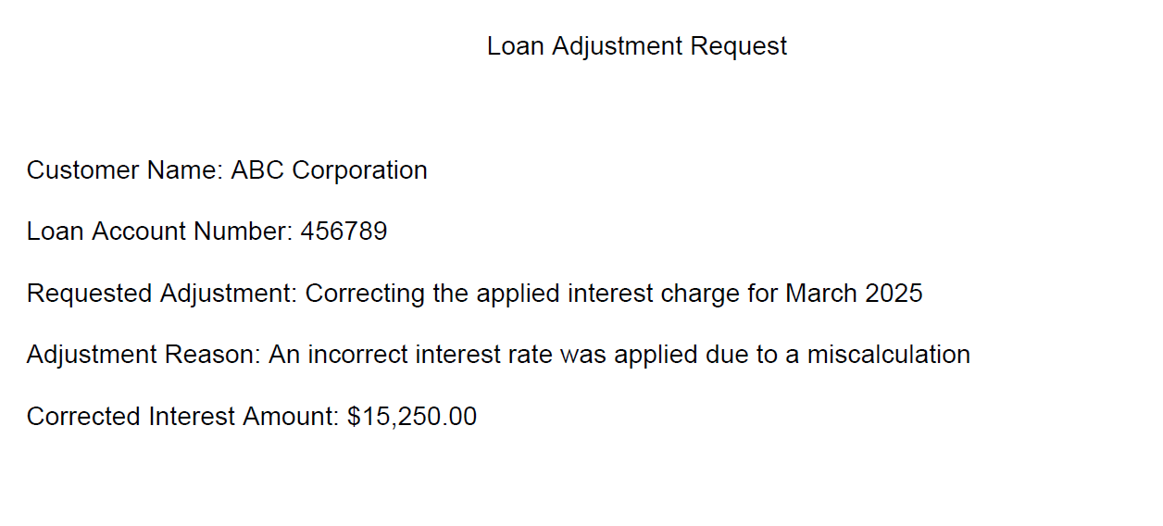

**Output**

