**Test Scenario 1** : Home page of our application where it allow users to upload the e-mail documents

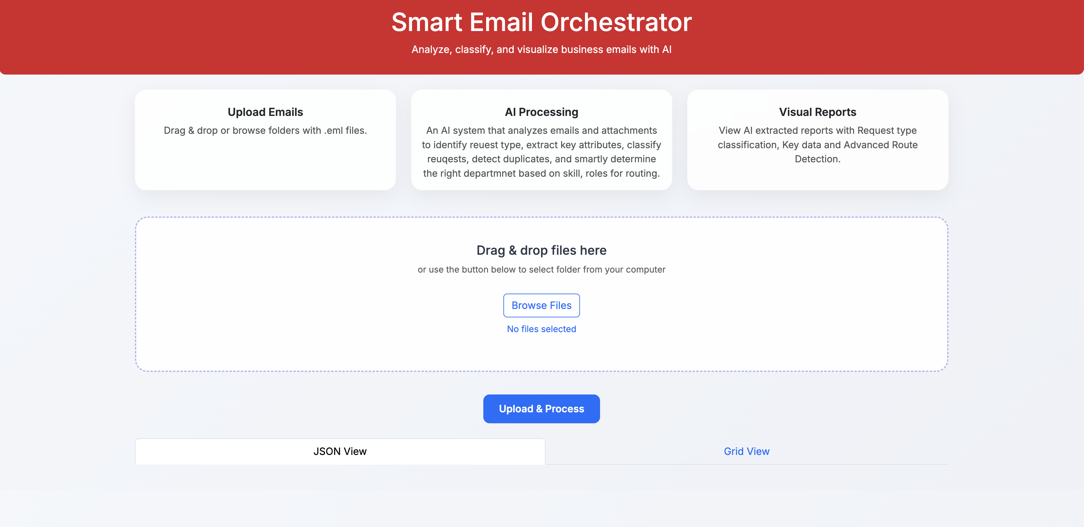

**Test Scenario 2** : Uploading entire folder of mails

Step1 : select the folder where we have mails

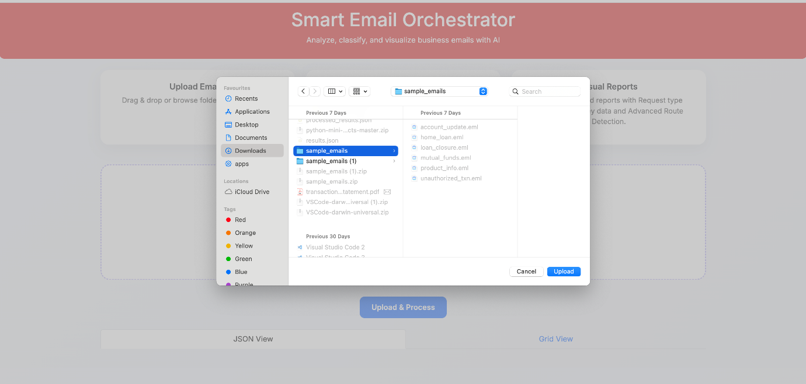

Step 2 : Identify the files count which are uploaded

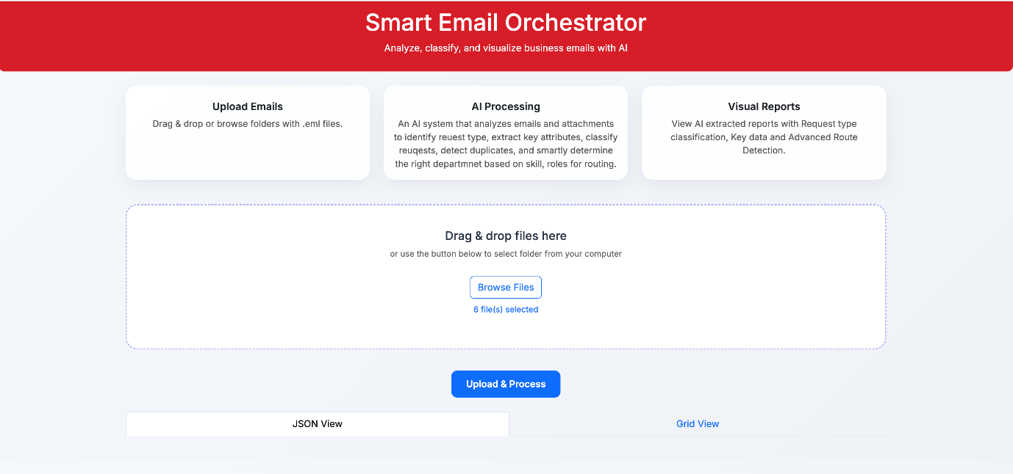

Step 3 : Processing results by Using LLM

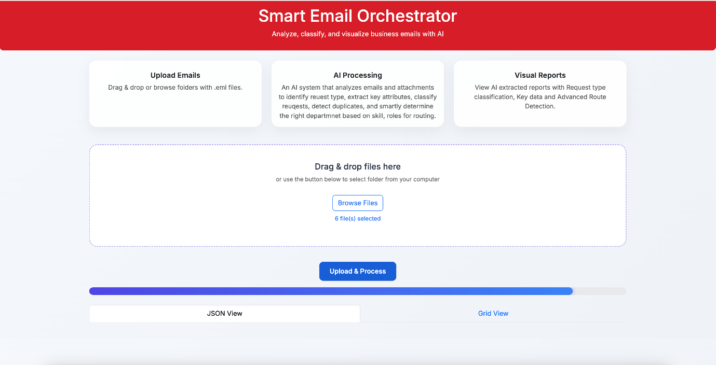

Step 4 : Result shown in JSON format

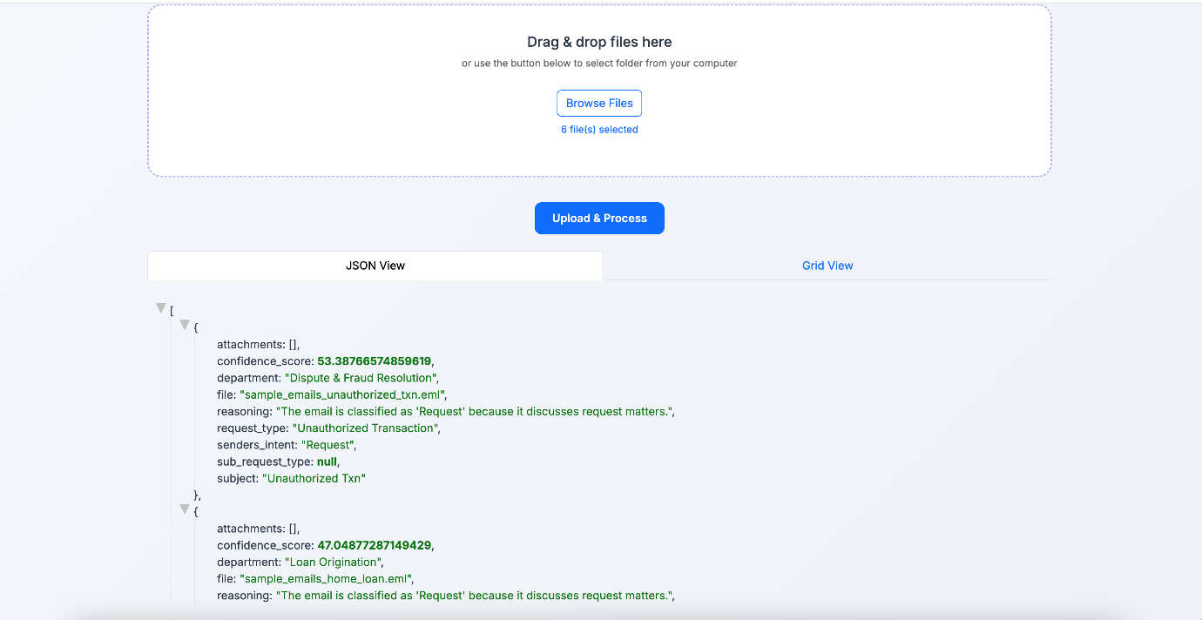

Step 5 : Results shown in Grid

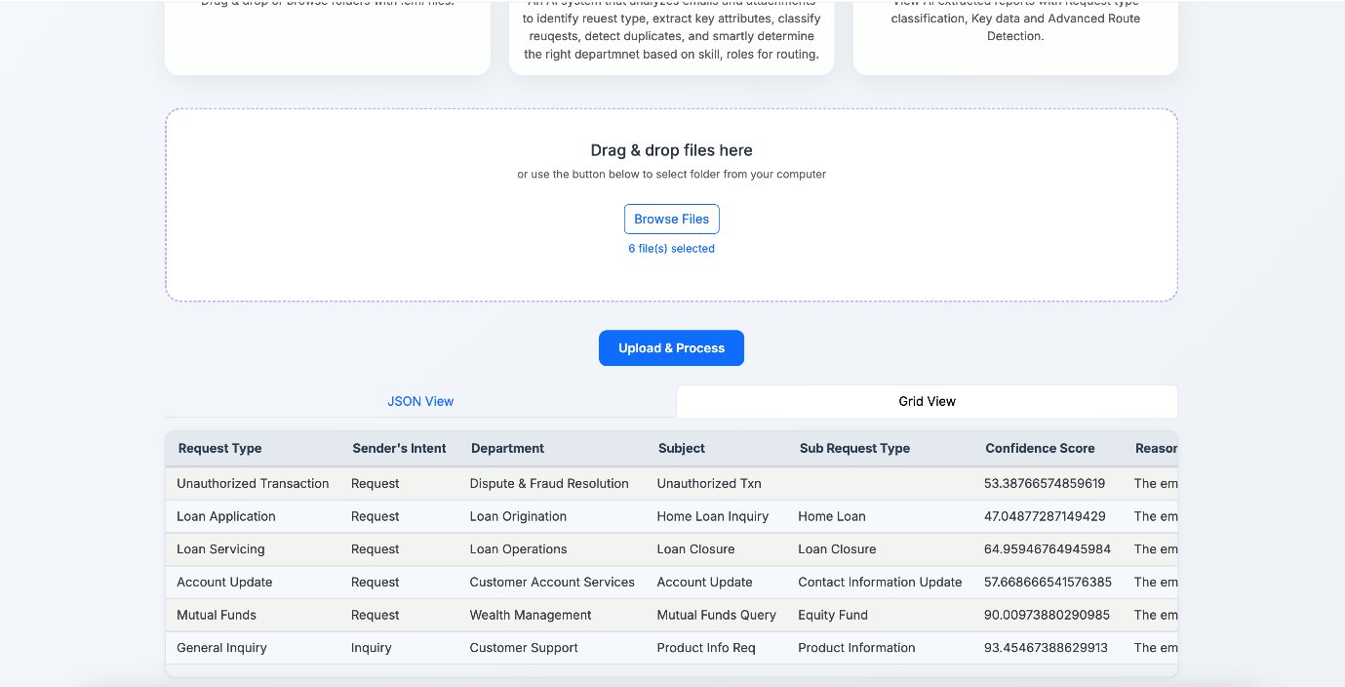

**Test Scenario 3** : Validating the duplicate mails

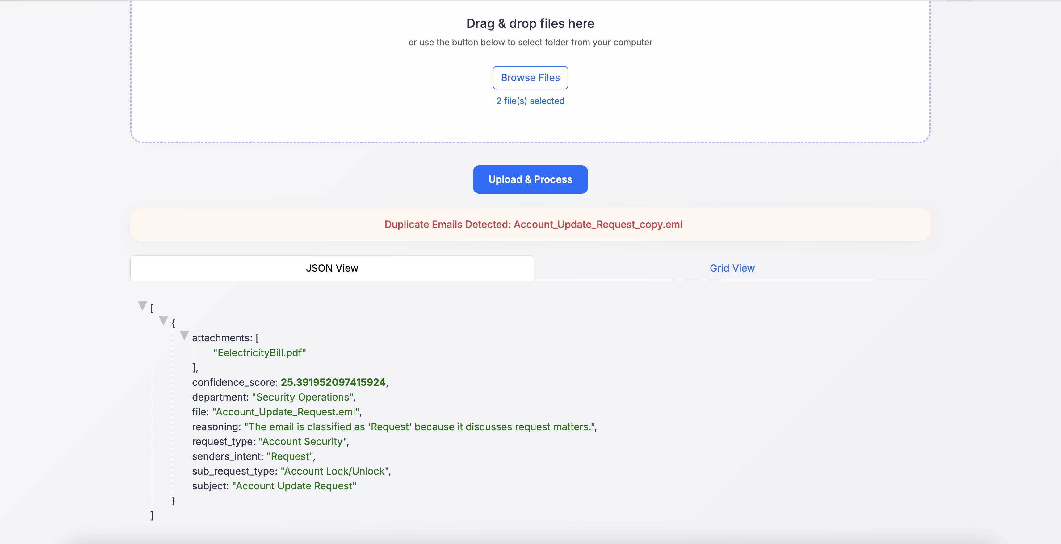

**Test Scenario 4** : Extracting the key attributes from Email Body (Configured in config.json)

