**Email Processing Application Screenshots**

**Current implementation screenshots:**

**All Classified Emails:** Each row has been shown with highest confidence score based on priority, context and intent from each processed mail object in below screenshot.

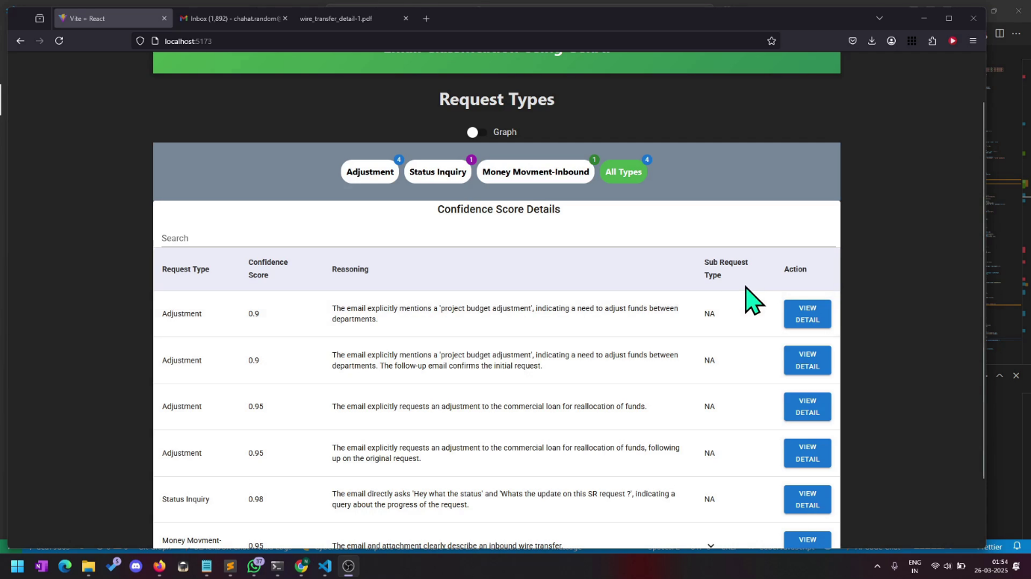

**Classified Emails:** Each processed email all important attributes details will be shown in below screenshot.

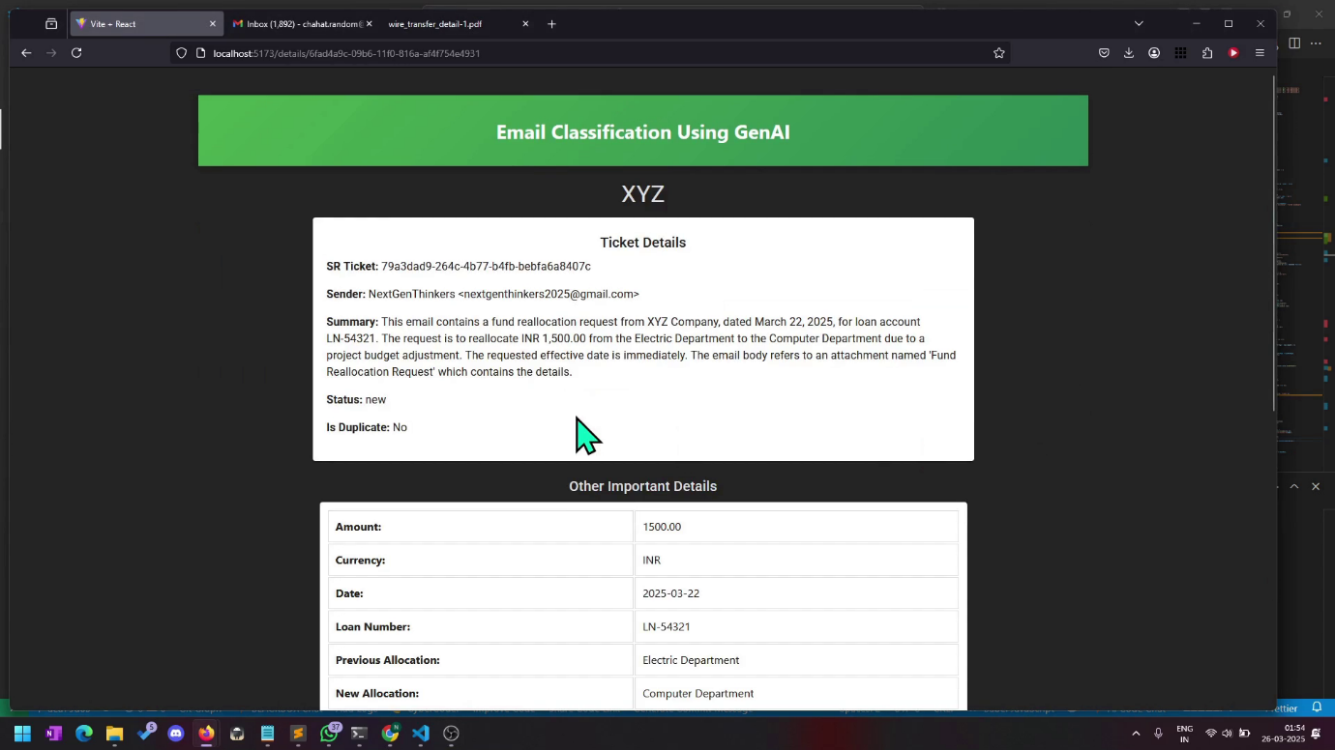

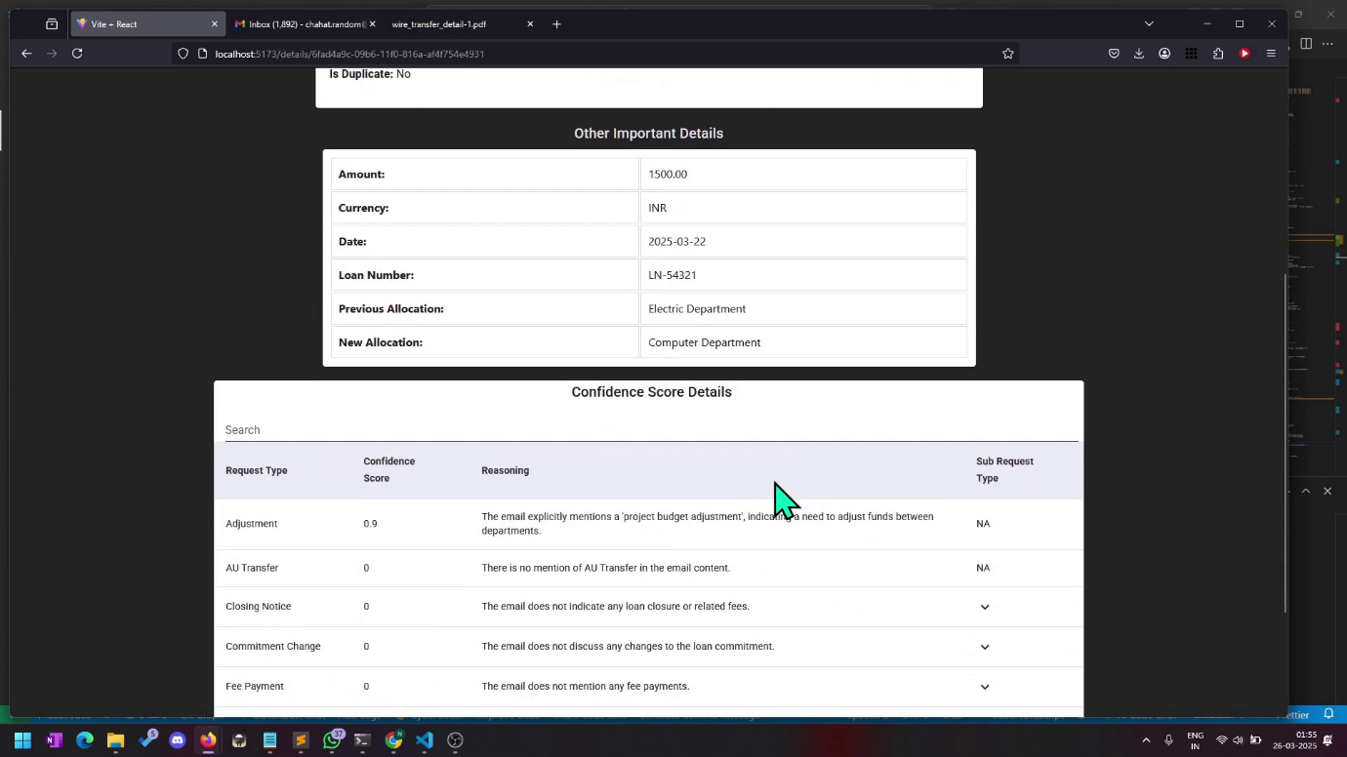

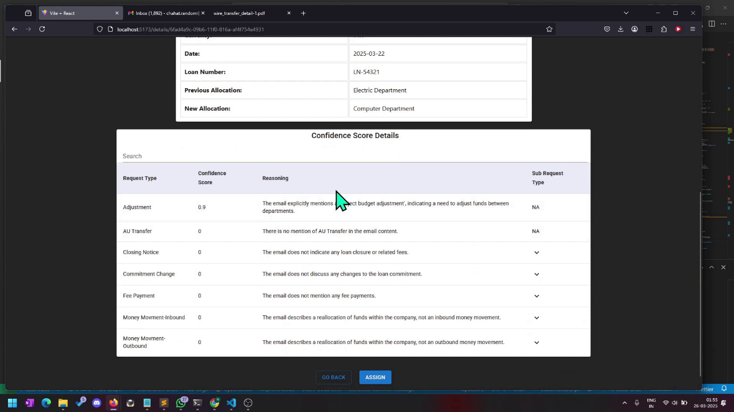

**Feature Enhancements**

**Dashboard**: Implemented but not yet integrated with the solution)

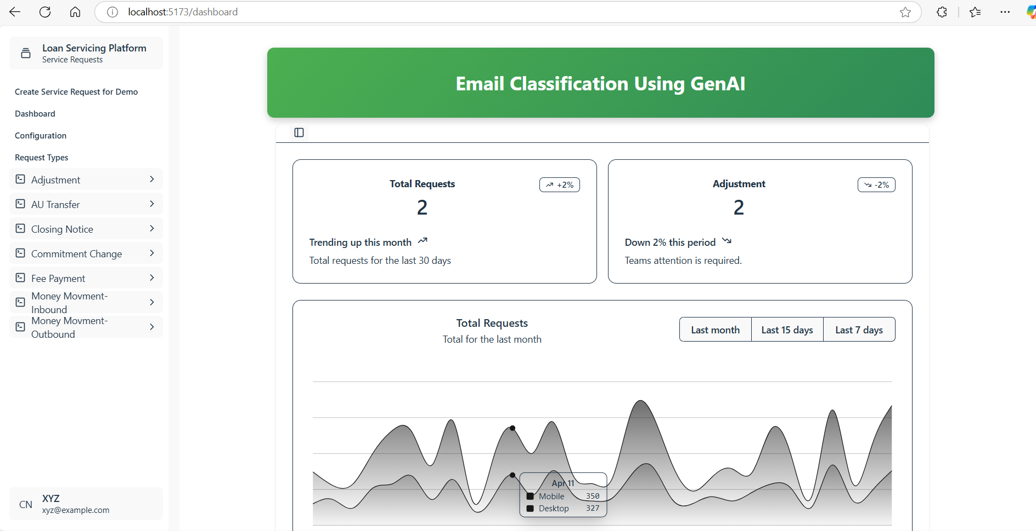

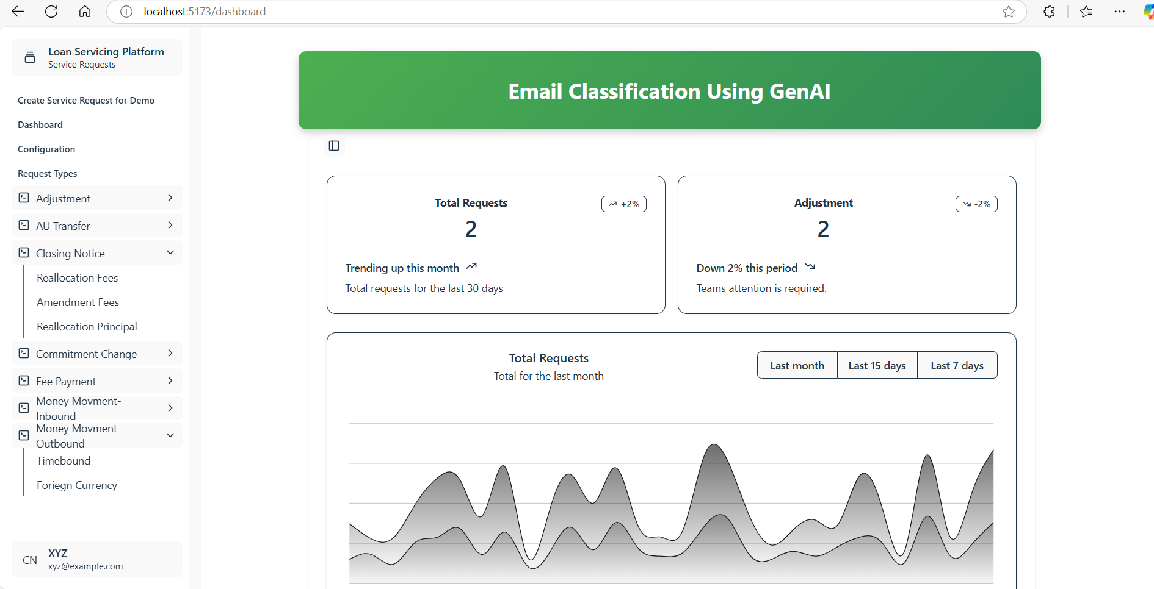

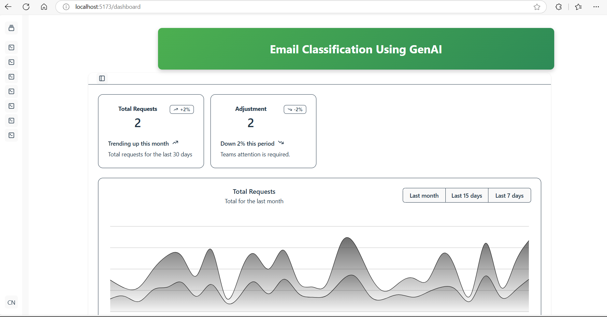

**Create Service Request:**

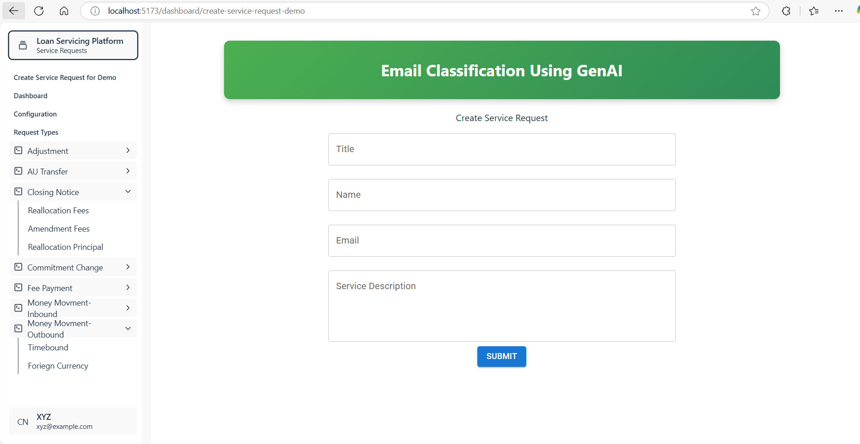

**Email Classifications Details**: Currently only right-side section view is implemented as part of the solution.

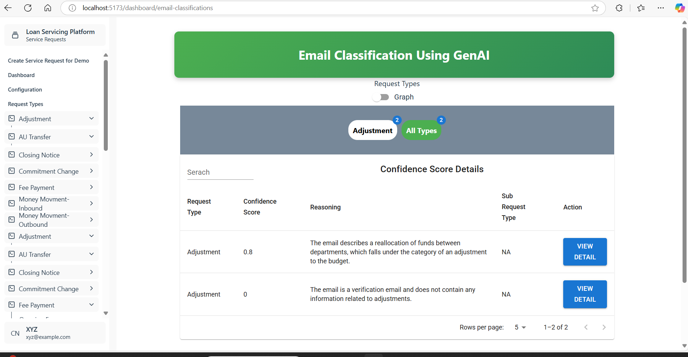

**Email Other Attribute Details:** Currently only right-side view is implemented as part of the solution.

