# Design Flows

User Query → Gradio → MCP Registry → Specialized Agent → LangGraph (for device search) → RAG System → Back to Specialized Agent → Back to MCP Registry → Back to Gradio → User

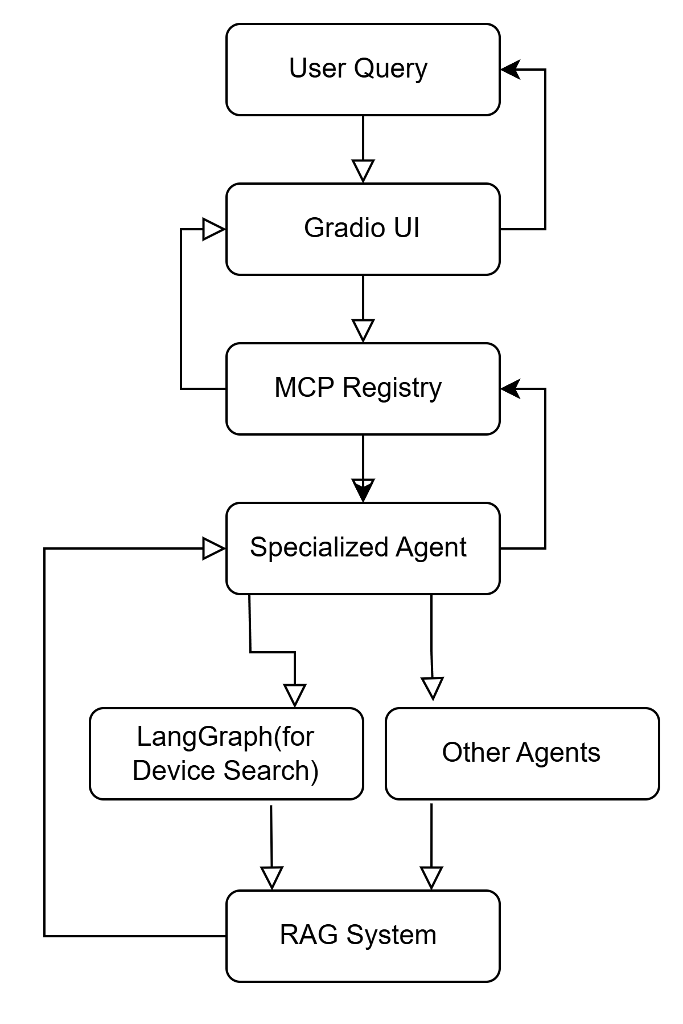

## Complete Query Flow walkthrough with an Example

1. **On Device Search tab** :
2. **Type**: 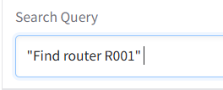

User Input Processing

User types "Find router R001" in the Device Search tab

Gradio interface captures this and sends it to the MCP system

MCP Registry routes the query to the Device Search Agent

1. **Knowledge Retrieval**:

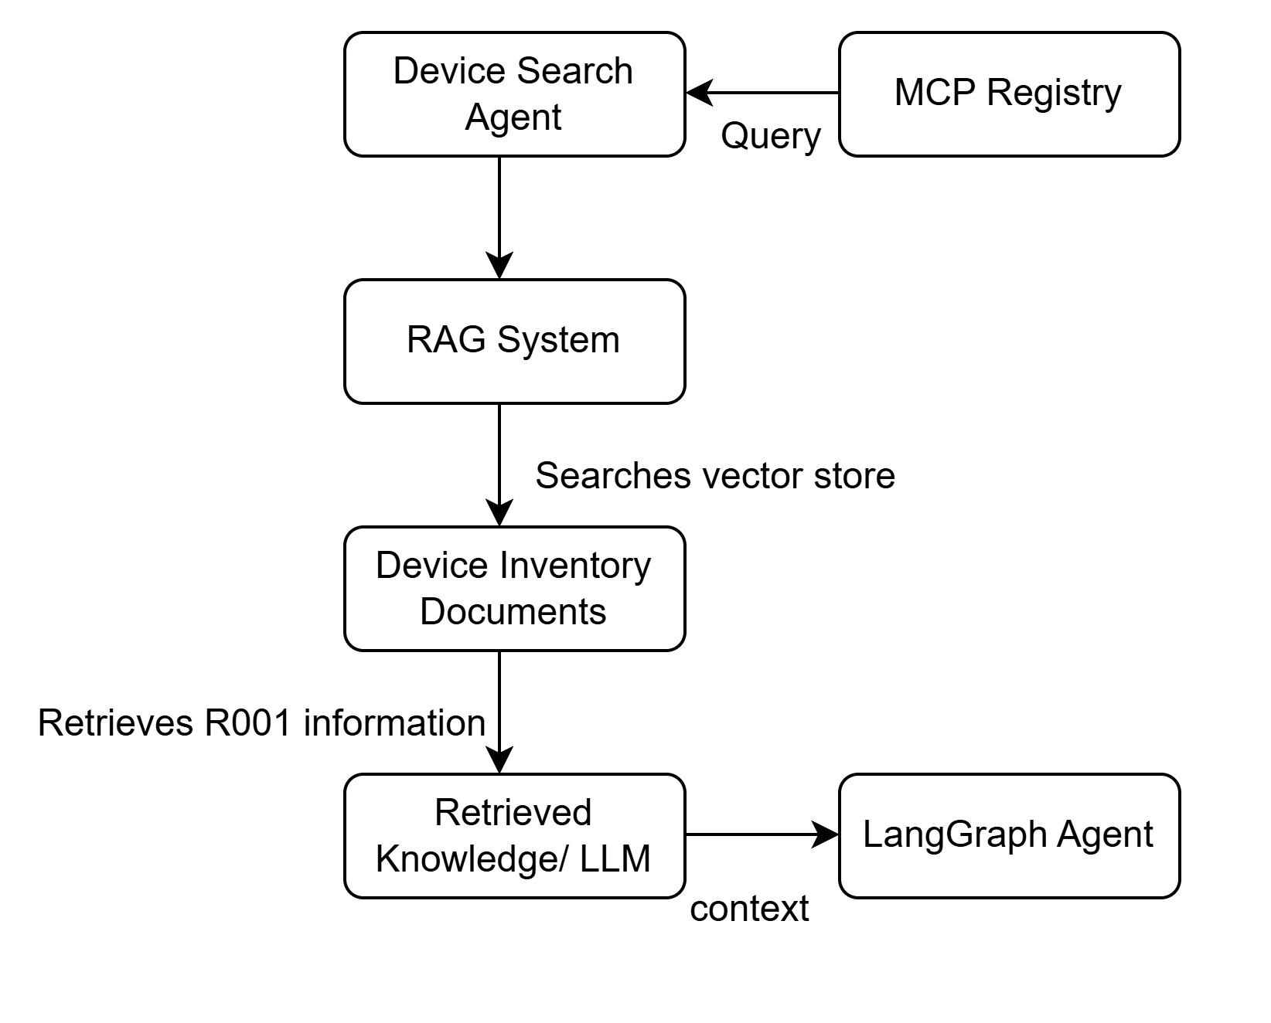

Retrieved Document Content:

- Device ID: R001

Name: core-router-01

Type: router

Status: active

Location: NYC

Importance: critical

Description: Primary core router for east region datacenter

Connected to: WAN001, S001A, S001B

1. **LangGraph Processing Workflow**

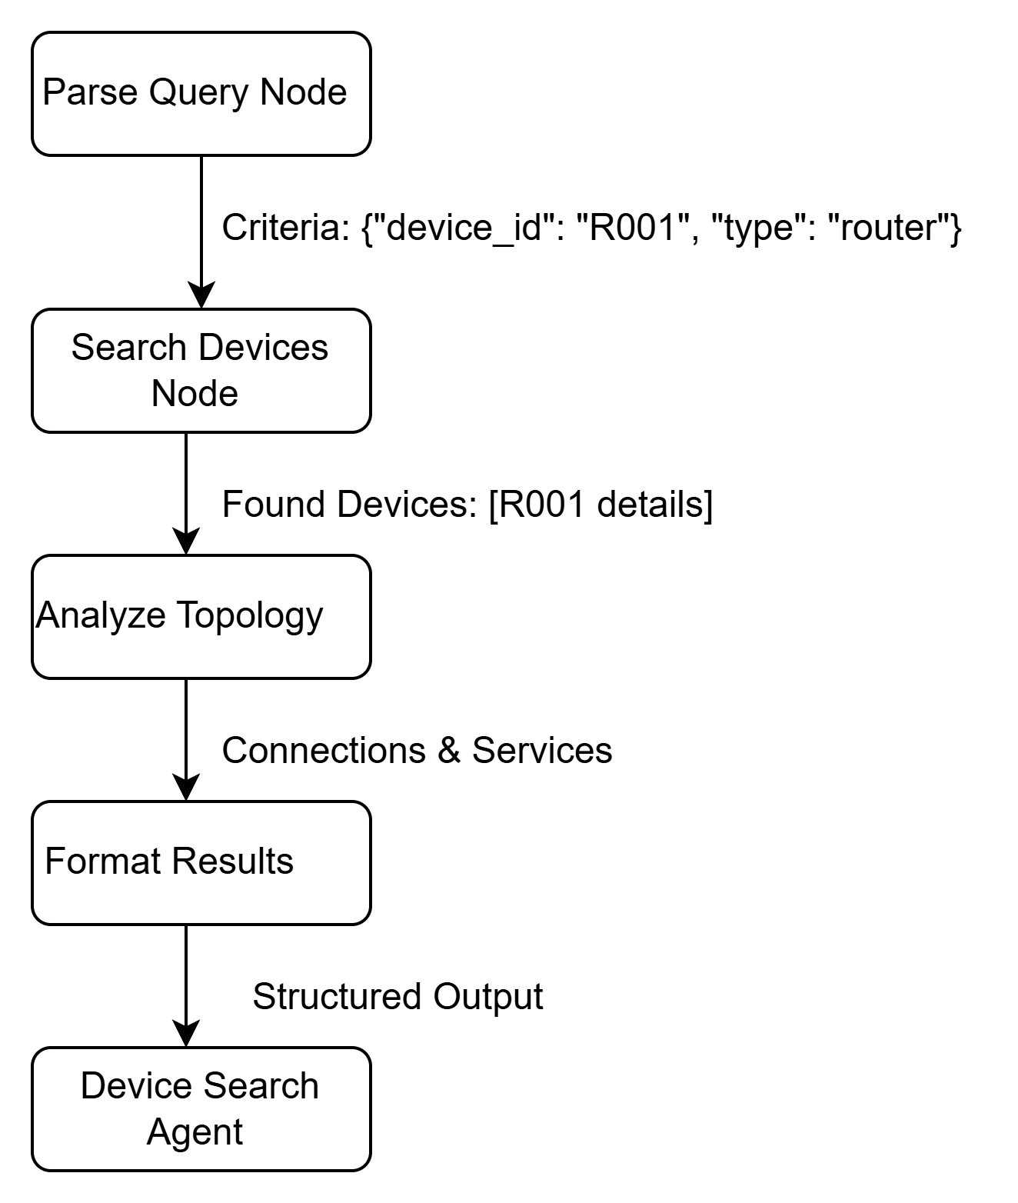

1. **LLM Invocation for Device Search**

Prompt to LLM:

* You are a network topology expert who can search and find devices in a network.
* Search for network devices matching these criteria:

{"description": "Find router R001"}

Use this information from our knowledge base:

*Device ID: R001*

*Name: core-router-01*

*Type: router*

*Status: active*

*Location: NYC*

*Importance: critical*

*Description: Primary core router for east region datacenter*

*Connected to: WAN001, S001A, S001B*

* Generate a list of found devices with these EXACT properties...

**LLM Response:**

*[*

*{*

*"ci_id": "R001",*

*"name": "core-router-01",*

*"ci_type": "router",*

*"status": "active",*

*"location": "NYC",*

*"importance": "critical"*

*}*

*]*

1. **Topology Analysis Processing**

Upstream Connections:

Identifies WAN001 as the upstream connection

Generates structured data for this device

Downstream Connections:

Identifies S001A and S001B as downstream connections

Generates structured data for these devices

Affected Services:

Determines Customer Portal and VPN Access depend on R001

Creates service impact data

1. **Context Updates**

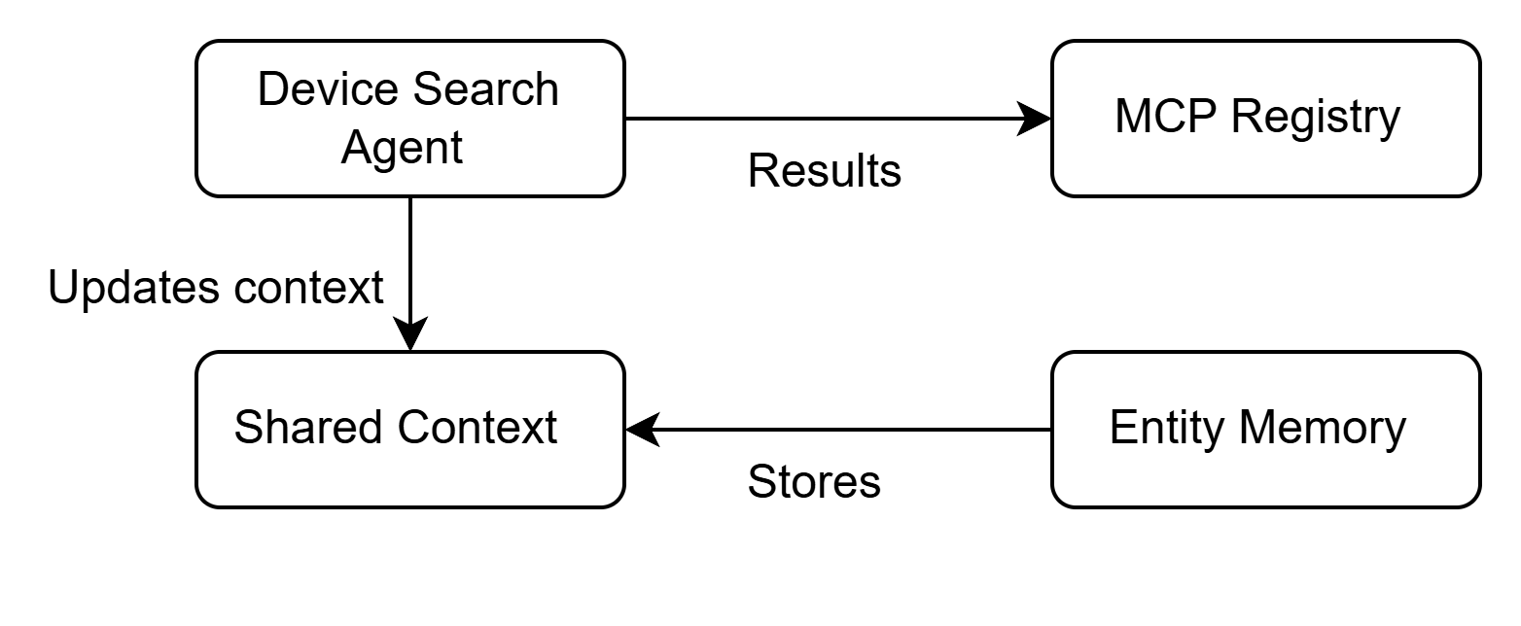

The device R001 is stored in entity memory

Conversation history is updated

Last agent type is recorded

1. **Response Formatting and Display**

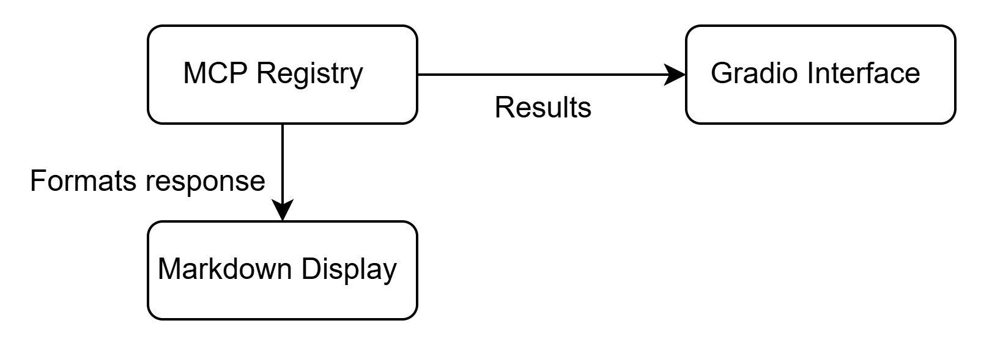

**Final Output:**

*##* ***Device Search Results***

*###* ***Found 1 Device***

*- **core-router-01** (router)*

*- ID: R001*

*- Status: active*

*- Location: NYC*

*- Importance: critical*

*###* ***Upstream Connections***

*\*\*core-router-01** connects to:*

*- wan-edge-01 (router)*

*###* ***Downstream Connections***

*\*\*core-router-01** connects to:*

*- distribution-switch-cor-a (switch)*

*- distribution-switch-cor-b (switch)*

*###* ***Affected Services***

*- **Customer Portal** (Criticality: high)*

*- **VPN Access** (Criticality: medium)*

*## Sources:*

*-* ***Document 1 for device_inventory***

*\*Processed by device_search agent (device-search-IDP)\**