**GEN AI - Integrated Platform Environment (IPE)**

After running the development server, open the link http://localhost:5173/ in web browser (e.g., Chrome, Firefox). Start the server from within Visual Studio Code by using the terminal or the relevant commands

http://localhost:5173/

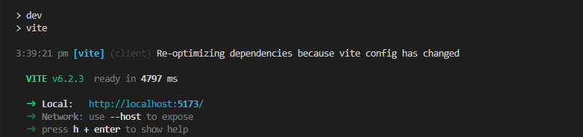

The application has two menu options: **Dashboard** and **Incidents**.

By default, the application will redirect to the **Dashboard** link, where it will display graphs related to the incidents that are currently available.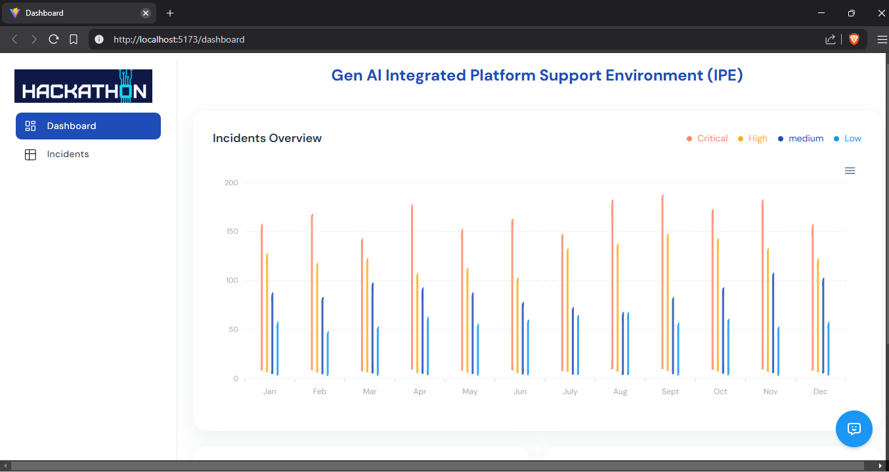

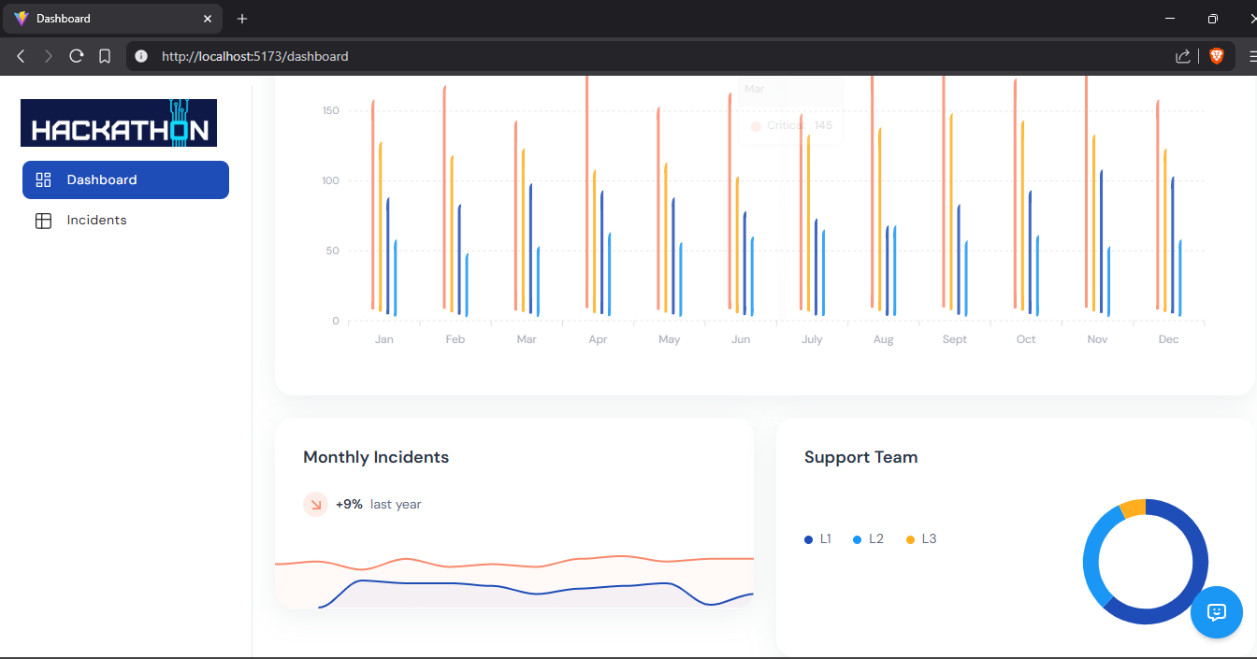

in the Incidents tab, a list of all incidents will be displayed. Currently, we are using raw data from JSON dataset.

There are two options available: **Action** and **Bot** for each and every active row. In the **Action** tab, clicking on it will check the incident and perform the required actions for the particular CI , such as health checks and executing scripts. In the **Bot** tab, it will analyse the data for similar incidents and retrieve the relevant information.

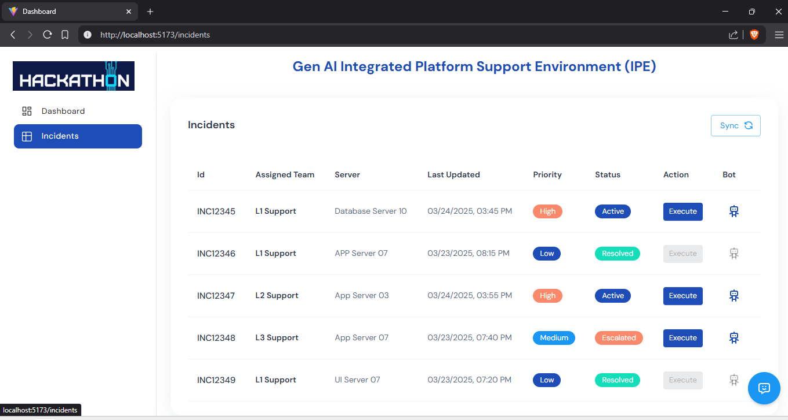

Action Click for one of the incident.

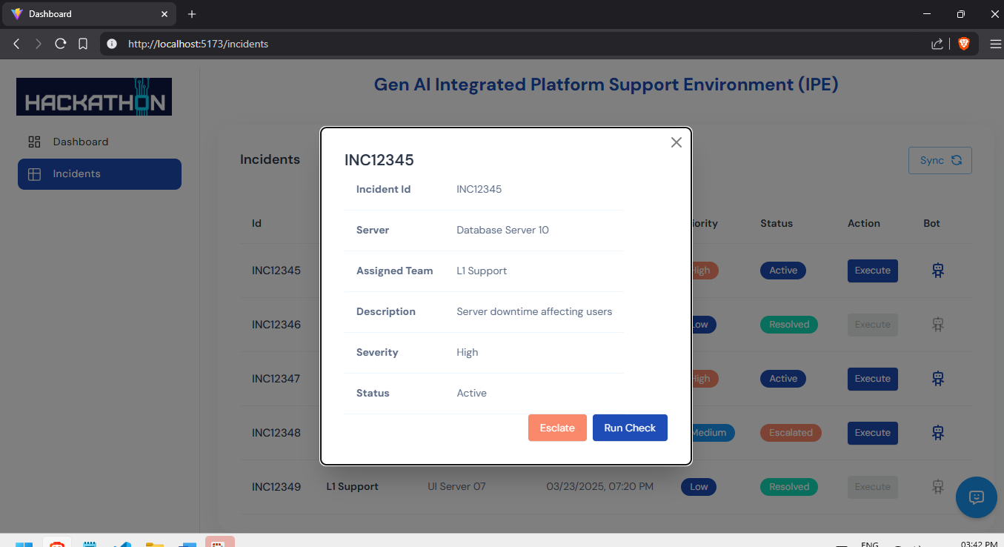

Ideally, when we click on 'Run Check,' it will perform the action items based on the incident instructions for the corresponding CI (Configuration Item) and if click on escalate it will escalate to next level.

Bot :

If we click on the Bot link, it will display similar incidents and provide suggestions based on related incidents.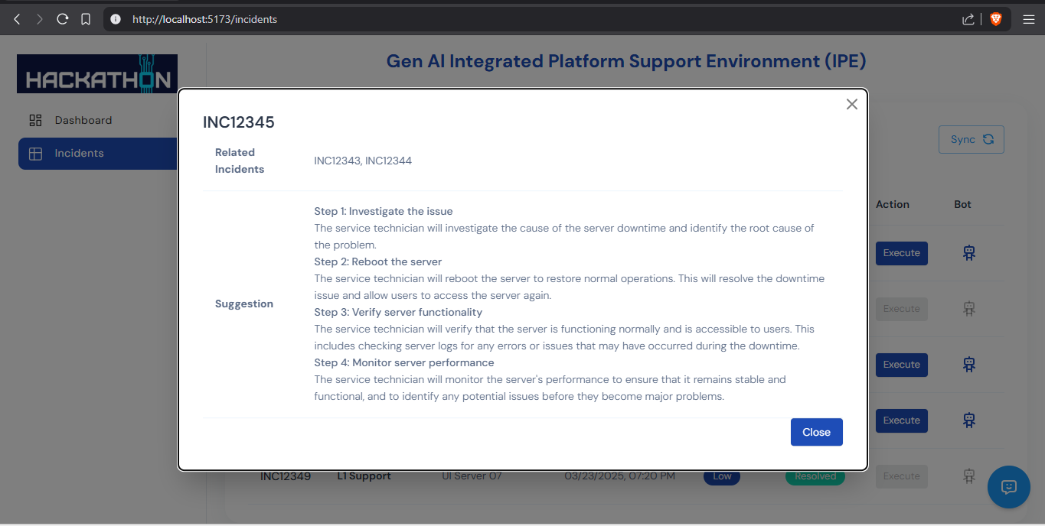

Below (Lower and right), we have an '**Ask Me Anything'** chatbot available for both the Incidents and Dashboard menus, where we can ask any questions, and it will connect to OpenAI to retrieve the required data.

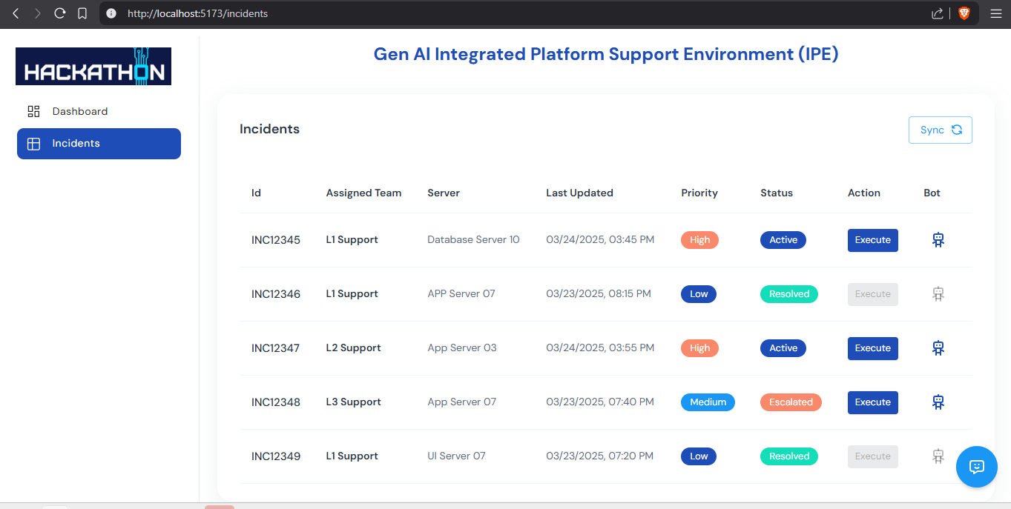

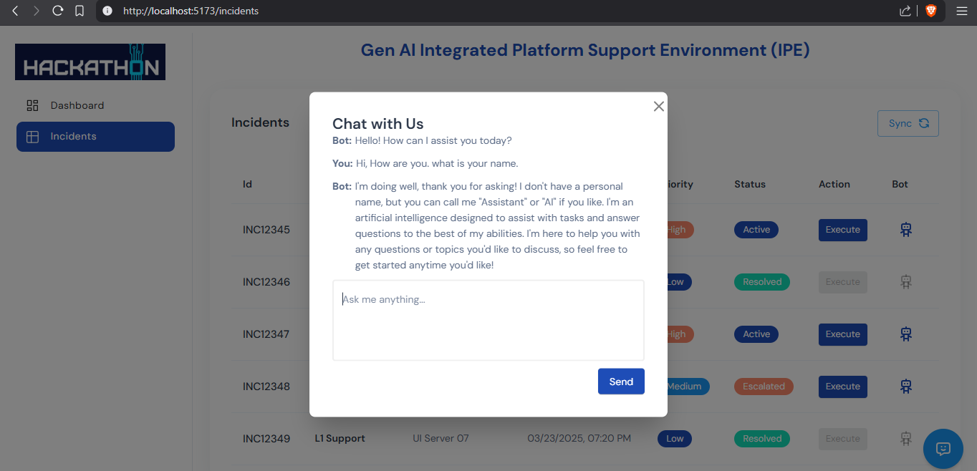

**Conclusion**

In this hackathon project, we successfully developed and integrated a platform that enhances the analysis of incidents using advanced AI capabilities. Through the creation of the **Incidents** and **Dashboard** tabs, along with the **Action** and **Bot** functionalities. The **Ask Me Anything** chatbot further enhances user experience by providing quick access to relevant data through OpenAI's API..