Smarter Reconciliation and Anomaly Detection System - Runbook

🔧 Project Overview

This project provides a FastAPI-powered real-time and batch anomaly detection system for financial reconciliation data. It integrates ML models, LLMs for categorization/resolution, WebSockets for live updates, and email notifications.

🗂️ Project Structure

econ_anomaly_detection/

├── api/

│ ├── __init__.py

│ ├── anomalydetection.py

│ ├── models.py

│ └── websocket_manager.py

├── config/

│ └── config.yaml

├── data/

│ └── generated_reconciliation_data.csv

├── models/

│ ├── isolation_forest_model.pkl

│ ├── kmeans_model.pkl

│ └── label_encoder.pkl

├── modules/

│ ├── data_ingestion.py

│ ├── data_preparation.py

│ ├── model_layer.py

│ ├── llm_integration.py

│ ├── data_persistence.py

│ ├── data_validation.py

│ ├── agentic_ai.py

│ └── utils.py

├── scripts/

│ └── model_training.py

└── ui/

└── ui_integration.py

└── reatime_streaming.py

└── batch_update.py

🚀 How to Run

1. Setup Environment

Go to src folder which is checkout from github

https://github.com/ewfx/sradg-ai-innovators/tree/main/code/src

python -m venv venv

source venv/bin/activate # Linux/macOS

venv\Scripts\activate # Windows

pip install -r requirements.txt

2. Configure the App

Edit config/config.yaml with proper email credentials, paths, and thresholds.

Example:

paths:

data_file: data/generated_reconciliation_data.csv

anomaly_output: output/detected_anomalies_{timestamp}.csv

log_file_name: logs/recon_anomaly_detection_{timestamp}.log

data_validation:

quantity_threshold: 10

email:

sender: your_email@gmail.com

password: your_password

recipient: recipient@example.com

api_keys:

openai: YOUR_OPENAI_API_KEY

3. Model Training

Run the following command:

python .\scripts\model_training.py

output

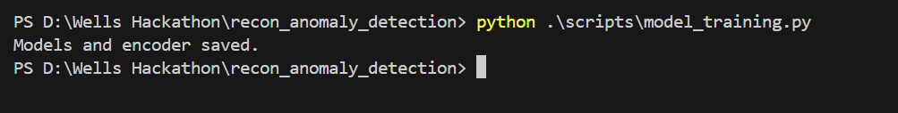

4. Run the API

uvicorn api.anomalydetection:app --reload

# Or if renamed

uvicorn api.anomalydetection:app --reload

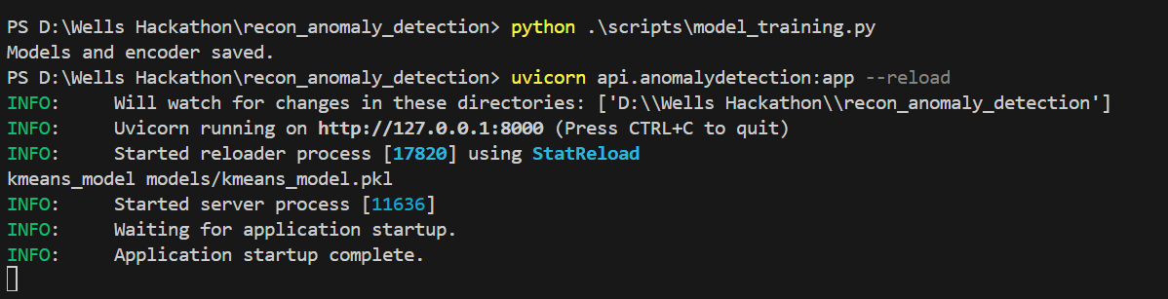

4. Test API Endpoints

- POST /realtime_anomaly/ – Detect anomaly in a single record

- POST /batch_anomaly/ – Detect and categorize batch data

- GET /health – Check app status

- WS /ws – Real-time WebSocket anomaly updates

Go to src/ui folder then run the following comments to test the real time reconciliation anomaly detection.

python .\batch_update.py

**Output:**

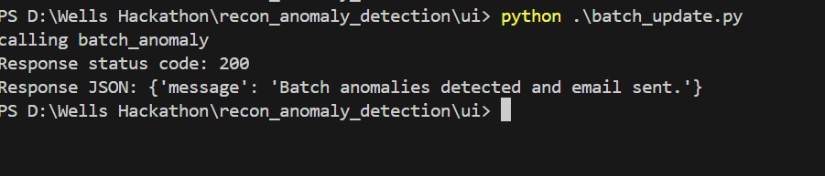

**Server side out put**

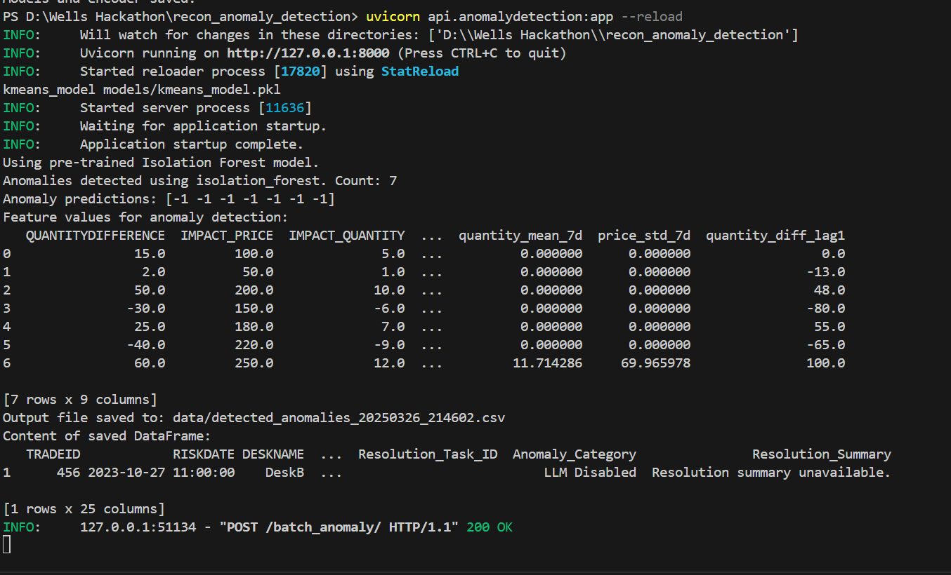

Output file available: src/data/detected_anomalies_20250326_214602.csv

**Also above output file will send through email to configured users**

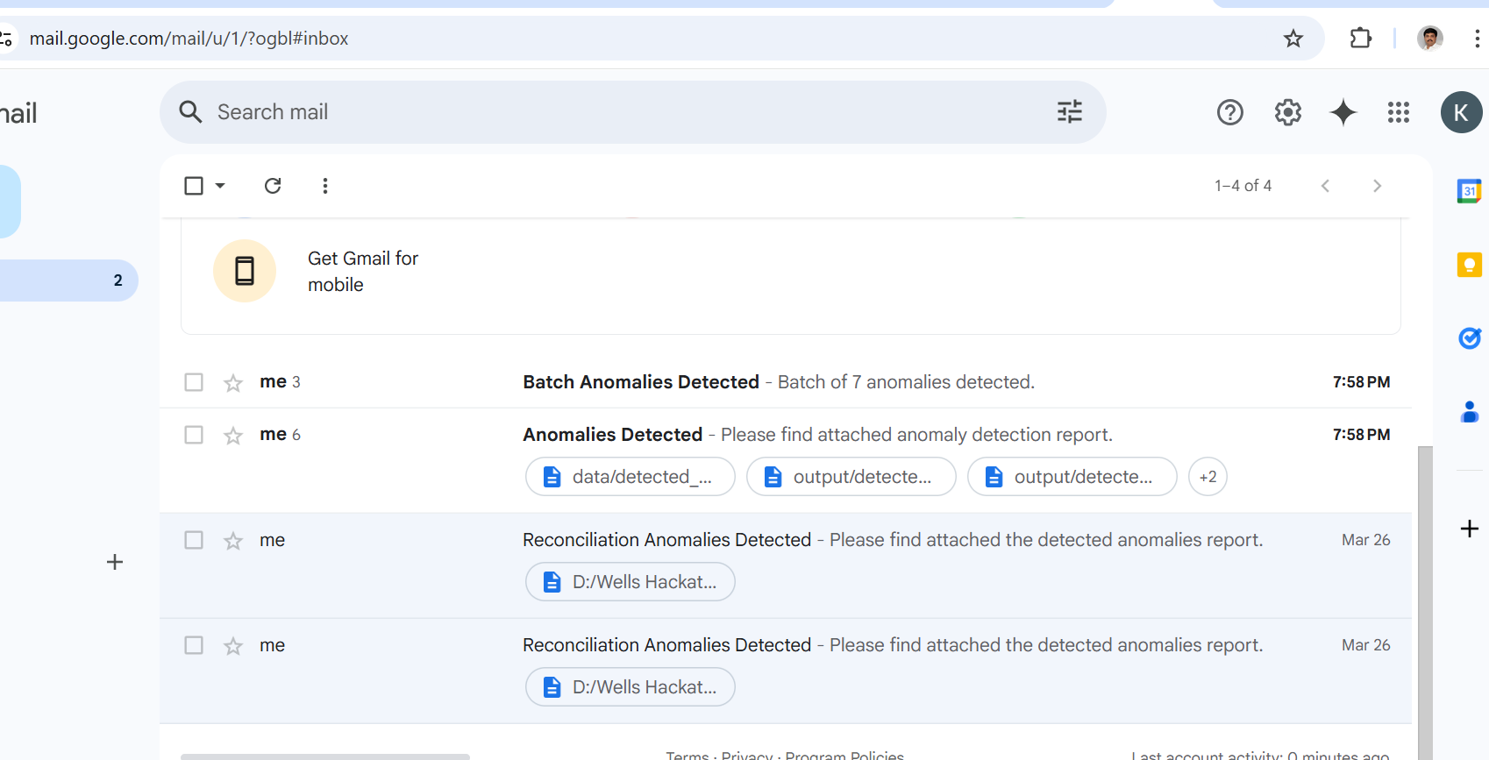

**Logfile available : src/logs/ recon_anomaly_detection.log**

**Explore other anomalies as well**

**Src/ui> python reatime_streaming.py**

**Src/ui> ui_integration.py**

If needed please change the test data in the above file and verify it.

💼 Usage Examples

Realtime Example:

POST /realtime_anomaly/

{

        "TRADEID": 123,

        "RISKDATE": "2023-10-26T10:00:00",

        "DESKNAME": "DeskA",

        "QUANTITYDIFFERENCE": 15.0,

        "IMPACT_PRICE": 100.0,

        "IMPACT_QUANTITY": 5.0,

        "COMMENT": "Data entry error"

    },

Batch Example:

POST /batch_anomaly/

[

{

        "TRADEID": 123,

        "RISKDATE": "2023-10-26T10:00:00",

        "DESKNAME": "DeskA",

        "QUANTITYDIFFERENCE": 15.0,

        "IMPACT_PRICE": 100.0,

        "IMPACT_QUANTITY": 5.0,

        "COMMENT": "Data entry error"

    },

    {

        "TRADEID": 456,

        "RISKDATE": "2023-10-27T11:00:00",

        "DESKNAME": "DeskB",

        "QUANTITYDIFFERENCE": 2.0,

        "IMPACT_PRICE": 50.0,

        "IMPACT_QUANTITY": 1.0,

        "COMMENT": "Rounding error"

    },

      {

    "TRADEID": 789,

    "RISKDATE": "2024-03-20T14:30:00",

    "DESKNAME": "DeskC",

    "QUANTITYDIFFERENCE": 50.0,

    "IMPACT_PRICE": 200.0,

    "IMPACT_QUANTITY": 10.0,

    "COMMENT": "Large quantity difference, potential manual error"

  },

  {

    "TRADEID": 101,

    "RISKDATE": "2024-03-21T09:15:00",

    "DESKNAME": "DeskA",

    "QUANTITYDIFFERENCE": -30.0,

    "IMPACT_PRICE": 150.0,

    "IMPACT_QUANTITY": -6.0,

    "COMMENT": "Negative impact, review required"

  },

    {

    "TRADEID": 202,

    "RISKDATE": "2024-03-22T11:45:00",

    "DESKNAME": "DeskB",

    "QUANTITYDIFFERENCE": 25.0,

    "IMPACT_PRICE": 180.0,

    "IMPACT_QUANTITY": 7.0,

    "COMMENT": "Unusual quantity difference, needs investigation"

  },

    {

    "TRADEID": 303,

    "RISKDATE": "2024-03-23T13:20:00",

    "DESKNAME": "DeskC",

    "QUANTITYDIFFERENCE": -40.0,

    "IMPACT_PRICE": 220.0,

    "IMPACT_QUANTITY": -9.0,

    "COMMENT": "Significant negative impact, immediate review"

  },

  {

    "TRADEID": 404,

    "RISKDATE": "2024-03-24T10:00:00",

    "DESKNAME": "DeskA",

    "QUANTITYDIFFERENCE": 60.0,

    "IMPACT_PRICE": 250.0,

    "IMPACT_QUANTITY": 12.0,

    "COMMENT": "Extremely high quantity difference, urgent review"

  }

]

🧠 LLM & Agentic AI

- llm_integration.py uses OpenAI/Gemini to categorize anomalies & generate summaries.

- agentic_ai.py can apply feedback or auto-resolution logic.

📬 Notifications

Sends an email with the CSV report when anomalies are detected.

🧹 Cleanup / Cache Issues

If FastAPI app behaves unexpectedly:

find . -type d -name "__pycache__" -exec rm -r {} +

find . -name "*.pyc" -delete

PowerShell:

Get-ChildItem -Recurse -Include "__pycache__" | Remove-Item -Recurse -Force

Get-ChildItem -Recurse -Include "*.pyc" | Remove-Item -Force

🛠️ Model Training

python scripts/model_training.py

📈 Future Enhancements

We developed all features which are requested in the hackathon problem statement, don’t have more time to develop more features, will develop it, if provide the time.

-Kafka & Redis Integration

- Database integration (PostgreSQL/MongoDB)

- UI dashboard for monitoring

- Power BI Reports Generation

- Docker containerization

- CI/CD pipeline

- Feedback learning loop API