1. Initially form will be loaded as follows

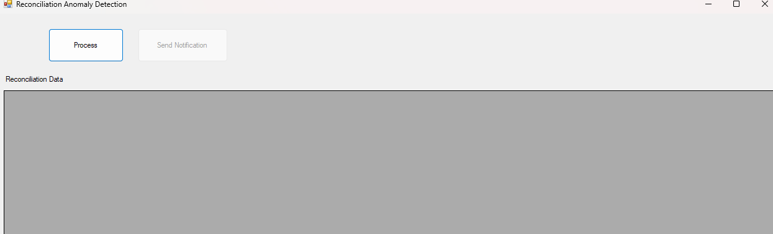

1. Click on Process button will show the reconciliation data as follows.

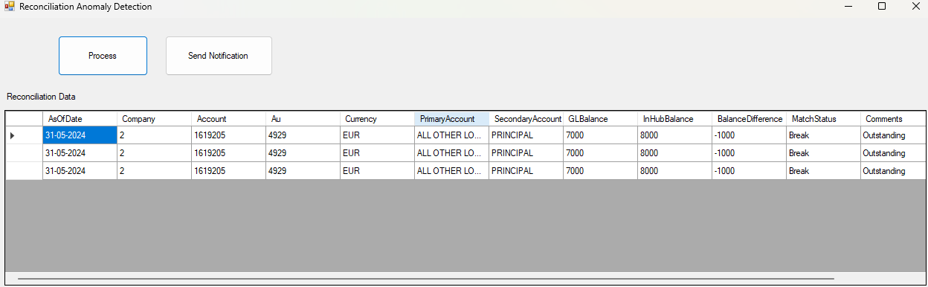

1. “Send Notification” button will be automatically activated. Click on ”Send Notification” will create the incident and popup will show the ”Incident# xxxx created “

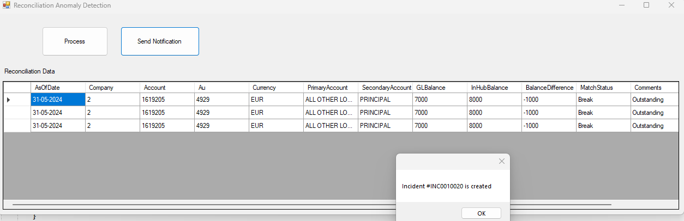

1. Incident will be having the anomalies information in the description field as shown below

