1.Registered in service now for creating an app. Following is the screenshot for managed instance

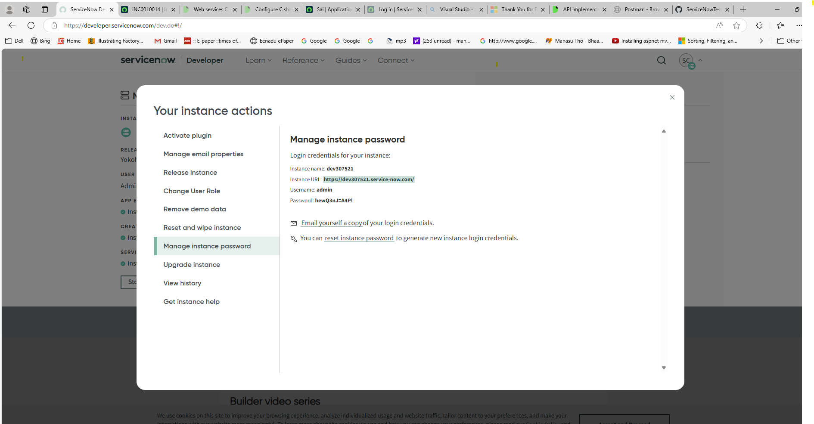

2. Create an app in the application registry under System Auth as follows.

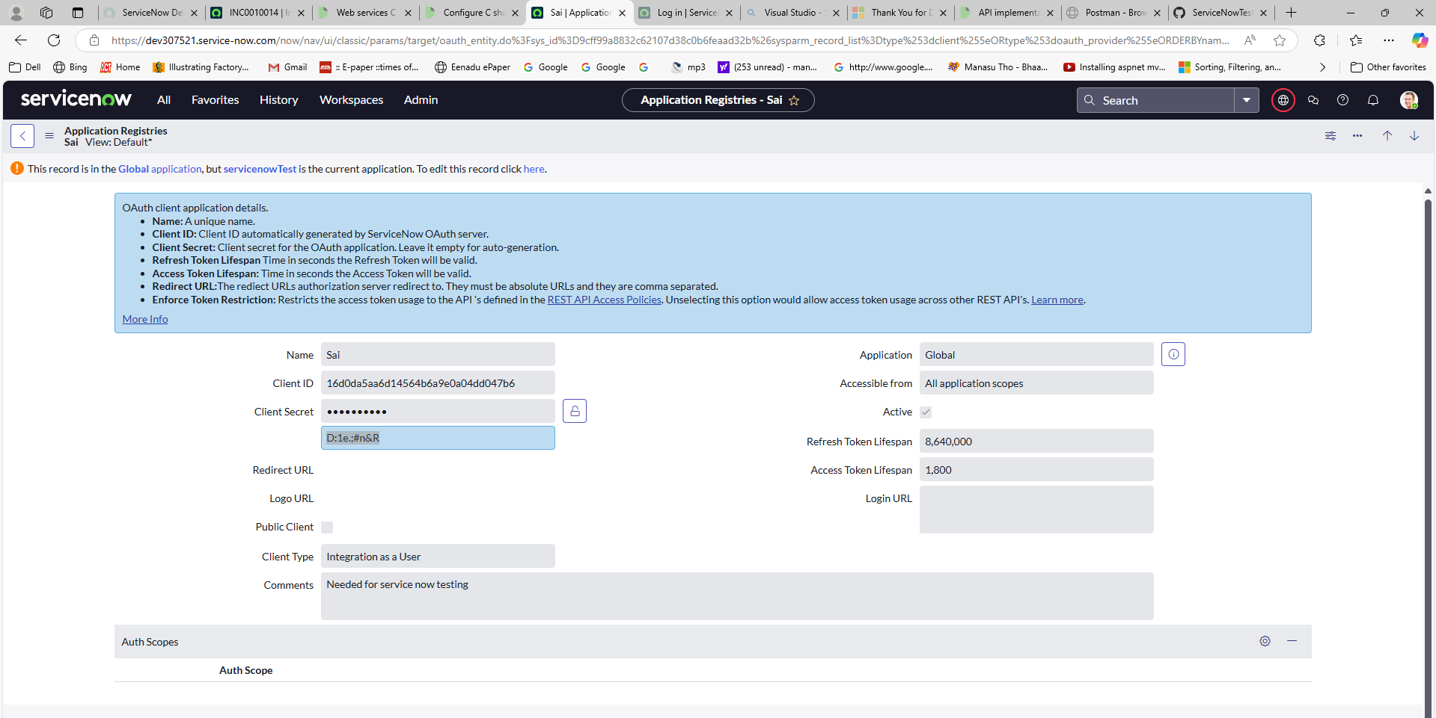

3. Code has created an incident with an attachment as follows.