This is a test.

|  |  |
| --- | --- |
| Harvard, Mount | 14420 |
| Rainier, Mount | 14410 |
| Blanca Peak | 14345 |
| "North Massive" | 14340 |

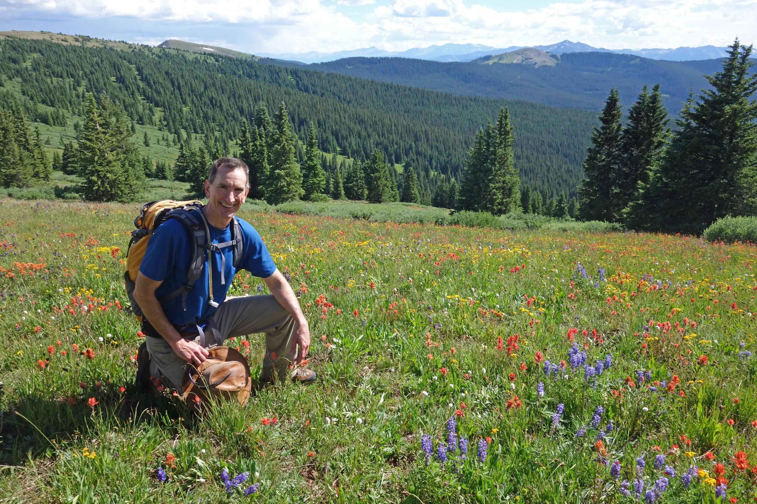

Test page 2