Question 1

a)
/*
* Tells the joke for the current joke.
*
* @see #getCurrentJoke()
*/
public void tellJoke()
{
System.out.printf("Joker\t%s\n", KnockKnock.getJokeStart());
KnockKnock.pause(400);
System.out.printf("Joker\t%s\n", this.getSetup());
KnockKnock.pause(400);
System.out.printf("Joker\t%s\n", this.getPunchline());

}

/*
* Moves on to the next joke.
*/
private void nextJoke()
{
this.jokeNum = this.jokeNum + 1;
}

/*
* Called when a thread starts executing this class.
*/
@Override
public void run()
{
for (KnockKnock knockKnock : JOKES)
{
this.tellJoke();
this.nextJoke();
}
}

b)
package tma03q1;

/**
* Acts as the listener in the telling of a knock knock joke.
* @author Edward Wilde
* @see KnockKnock
* @see Joker
*/
public class Listener implements Runnable
{
private final static String NAME = "Listener";

/*
* Called when a thread runs this object
*/
@Override
public void run()
{
for (int i=0; i < 4; i++)
{
KnockKnock.pause(500);
this.getJoke();
}
}

/*
* Response to the current joke being asked.
*/
private void getJoke()
{
System.out.printf("%-10s%s\n", NAME, KnockKnock.getFirstResponse());
KnockKnock.pause(200);
System.out.printf("%-10s%s\n", NAME, KnockKnock.getSecondResponse("Don't know"));
}
}

c)
Code listing for Main.java:
package tma03q1;

/**
*
* @author Edward Wilde
* Created on 26th March 2013
*/
public class Main
{
public static void main(String[] args)
{
Joker joker = new Joker();
joker.start();

Listener listener = new Listener();
Thread listenerThread = new Thread(listener);
listenerThread.start();
}
}

Output from running the program:
Joker Knock knock!
Joker Mabel
Listener Who's there?
Listener Don't know who?
Joker Mabel is ringing.
Joker Knock knock!
Joker Wendy
Listener Who's there?
Listener Don't know who?
Joker Wendy cows come home.
Joker Knock knock!
Listener Who's there?
Joker Stoat
Listener Don't know who?
Joker Stoatily different person.
Joker Knock knock!
Listener Who's there?
Joker Dee
Listener Don't know who?
Joker Delighted to meet you.

At the moment the conversation between the Joker and the Listener is out of sequence. For example, when telling the first joke, the Joker replies to the question “Who’s there?” before the initial “Knock knock!” question has been answered by the Listener. This is due to the fact that there has been no attempt to synchronize the threads. Threads must be synchronized and told to wait until it is their turn to answer a question. Synchronization could be achieved using a logical token that is held by a thread and released when they expect an answer, or alternatively some of the java synchronization primitives such as wait(), notifiy() and notifyAll() could be used to achieve the same outcome.

d)
Code listing for KnockKnock1.java:
package tma03q1;

/**
*
* @author Edward Wilde
*/
public class KnockKnock1 extends KnockKnock
{
private static boolean jokersTurn = true;

/**
* Construct a knock knock joke with a particular setup and punchline
* @param aName the setup, usually someone's name
* @param aPunchline the punchline
*/
public KnockKnock1(String aName, String aPunchline)
{
super(aName, aPunchline);
}

/**
* @return the jokersTurn
*/
public static synchronized boolean isJokersTurn() {
return jokersTurn;
}

/**
* @param aJokersTurn the jokersTurn to set
*/
public static synchronized void setJokersTurn(boolean aJokersTurn) {
jokersTurn = aJokersTurn;
}
}

Code listing for Joker1.java:
package tma03q1;

/**
*
* @author Edward Wilde
*/
public class Joker1 extends Joker
{
/**
* Wait until it's the jokers turn to proceed.
*/
private void waitForMyTurn()
{
while(!KnockKnock1.isJokersTurn())
{
KnockKnock1.pause(100);
}
}

/**
* Tells a line of the joke, by waiting first until it's the jokers turn.
* @param line of the joke to tell.
* @param changeTurn if true, changes the turn to enable a reply.
*/
private void tellJokeLine(String line, boolean changeTurn)
{
this.waitForMyTurn();
System.out.printf("%-10s%s\n", NAME, line);

if (changeTurn)
{
KnockKnock1.setJokersTurn(false);
}
}

/**
* Tells the entire joke, based on the current joke number.
*/
@Override
public void tellJoke()
{
this.tellJokeLine(KnockKnock.getJokeStart(), true);
this.tellJokeLine(this.getSetup(), true);
this.tellJokeLine(this.getPunchline(), false);
}
}

Code listing for Listener1.java:
package tma03q1;

/**
* Acts as the listener in the telling of a knock knock joke.
* @author Edward Wilde
* @see KnockKnock
* @see Joker
*/
public class Listener1 implements Runnable
{
private final static String NAME = "Listener";

private Joker joker;

/**
* @param joker telling the joke.
*/
public Listener1(Joker joker)
{
this.joker = joker;
}

/**
* Wait until it's the listeners turn to proceed.
*/
private void waitForMyTurn()
{
while(KnockKnock1.isJokersTurn())
{
KnockKnock1.pause(100);
}
}

/*
* Called when a thread runs this object
*/
@Override
public void run()
{
for (int i=0; i < this.joker.getNumOfJokes(); i++)
{
this.getJoke();
}
}

/*
* Response to the current joke being asked.
*/
private void getJoke()
{
this.getJokeLine(KnockKnock.getFirstResponse());
this.getJokeLine(KnockKnock.getSecondResponse(this.joker.getSetup()));
}

private void getJokeLine(String line)
{
this.waitForMyTurn();
System.out.printf("%-10s%s\n", NAME, line);
KnockKnock1.setJokersTurn(true);
}
}

It is necessary to add the synchronize keyword to both the getter and setter methods for jokerTurn in order to serialize access to shared state, namely the Boolean field jokersTurn. It is important to serialize access to this shared piece of state in order to avoid a race condition.
“Race conditions arise in software when separate computer processes or threads of execution depend on some shared state. Operations upon shared states are critical sections that must be mutually exclusive. Failure to obey this rule opens up the possibility of corrupting the shared state.”
Wikipedia, 2013. Race condition. [Online] Available at http://en.wikipedia.org/wiki/Race_condition#Software [Accessed 27th April 2013]
In our program failure to serialize access to this Boolean field could in some circumstances result in an out of order conversation being played out.

Question 2

a)

i)
Extract from output:
Ferry trip: 1
Ferry crossing EASTBOUND...
Traveller 3 EASTBOUND arrives
Passenger 3 EASTBOUND boards
Ferry arrives at opposite bank

The above extract highlights one issue with the current code. Passengers can board the ferry whilst it’s crossing.
ii)
public synchronized void board(Passenger passenger)

public synchronized void cross()

Extract from output:
Ferry trip: 1
Ferry crossing EASTBOUND...
Traveller 4 WESTBOUND arrives
Traveller 5 EASTBOUND arrives
Ferry arrives at opposite bank
Passenger 1 alights
Passenger 2 alights
Passenger 3 alights
Passenger 5 EASTBOUND boards
Passenger 4 WESTBOUND boards
Traveller 6 WESTBOUND arrives
Passenger 6 WESTBOUND boards

From the above extract you can see that although passengers arrive during the ferry crossing, none board until the ferry arrives at the opposite bank.

iii)
public synchronized void board(Passenger passenger) throws InterruptedException
{
while(this.getDirection() != passenger.getDirection())
{
System.out.println("Passenger " + passenger.getPassengerID()
+ " waiting at " + passenger.getDirection());
this.wait();
}

System.out.println("Passenger " + passenger.getPassengerID()
+ " " + passenger.getDirection() + " boards");
this.passengerList.add(passenger);

}

public synchronized void cross()
{
System.out.println("Ferry crossing " + getDirection() + "...");
System.out.println("Passengers on board " + this.passengerList.size());
delay(2000);
System.out.println("Ferry arrives at opposite bank");
for (Passenger eachTraveller : passengerList)
{
System.out.println("Passenger " + eachTraveller.getPassengerID() + " alights");
}
passengerList.clear();
swapDirection();

this.notifyAll();
}

iv)
public synchronized void board(Passenger passenger) throws InterruptedException
{
while(this.getDirection() != passenger.getDirection() ||
this.isFerryFull())
{
System.out.println("Passenger " + passenger.getPassengerID()
+ " waiting at " + passenger.getDirection());
this.wait();
}

this.AddPassenger(passenger);
}

private synchronized void AddPassenger(Passenger passenger)
{
System.out.println("Passenger " + passenger.getPassengerID()
+ " " + passenger.getDirection() + " boards");
this.passengerList.add(passenger);
}

private synchronized boolean isFerryFull()
{
return this.passengerList.size() >= 2;
}

Extract from output:
West bound passenger kept waiting, ferry not at west bank
East bound passenger kept waiting, ferry full
Correct maximum number of passengers per trip
Traveller 1 EASTBOUND arrives
Passenger 1 EASTBOUND boards
Traveller 2 WESTBOUND arrives
Passenger 2 waiting at WESTBOUND
Traveller 3 EASTBOUND arrives
Passenger 3 EASTBOUND boards
Traveller 4 WESTBOUND arrives
Passenger 4 waiting at WESTBOUND
Traveller 5 EASTBOUND arrives
Passenger 5 waiting at EASTBOUND
Ferry trip: 1
Ferry crossing EASTBOUND...
Passengers on board 2
Traveller 6 WESTBOUND arrives
Traveller 7 EASTBOUND arrives
Traveller 8 WESTBOUND arrives
Traveller 9 EASTBOUND arrives
Traveller 10 WESTBOUND arrives
Ferry arrives at opposite bank
Passenger 1 alights
Passenger 3 alights
Passenger 5 waiting at EASTBOUND
Passenger 4 WESTBOUND boards
Passenger 2 WESTBOUND boards
Passenger 10 waiting at WESTBOUND
Passenger 9 waiting at EASTBOUND
Passenger 8 waiting at WESTBOUND
Passenger 7 waiting at EASTBOUND
Passenger 6 waiting at WESTBOUND
Ferry trip: 2
Ferry crossing WESTBOUND...
Passengers on board 2
As you can see from the above annotated output, the program is operating correctly. Passengers can only board from the correct bank, and a maximum of two passengers per trip is enforced.
b)
Assuming a thread waits for a particular condition to occur, when the condition has been meet the thread is woken up and scheduled to run. However there is no guarantee that in the time between the condition being met and the thread scheduled to run and actually running that the condition still holds true. A loop pattern neatly solves this problem by checking the condition is still valid after a woken thread is rescheduled and run:
while(conditionNotMet)
{
this.wait();
}
// execute task.

This loop pattern protects against spurious wakeups and having the condition change between wake up and actually running of the thread. Below is the implementation of this pattern in my code, taken from the board(Passenger) method:

while(this.getDirection() != passenger.getDirection())
{
System.out.println("Passenger " + passenger.getPassengerID()
+ " waiting at " + passenger.getDirection());
this.wait();
}

Question 3

a)

i)

EPT - ENCRYPT Protocol

Summary
This protocol allows for clients to request encryption and decryption services. A client can send the server a string to encrypt specifying optionally specifying the algorithm to use. The client can also ask the server to decrypt a string previously encrypted.

Requests
Each request sent from the client to the server will be null terminated. A null termination string can be created in java by ending the string with \0, effectively adding byte 0 to the end.
String output = "ENCRYPT\nalgorithm: DES\nClient-Name: MyPC-Thread01\nMY SECRET PHRASE\0";

Responses
The will also terminate responses using a null terminated string.
A typical interaction between the client and the server can be seen below. Here the client connects to the server, encrypts a string and disconnects.
Note because it was a requirement of the question to send a special character at the end of a request or response this method has been choose. Otherwise I might have used a header, such as content-length to indicate to a client or a server when they had finished receiving either a request or response.
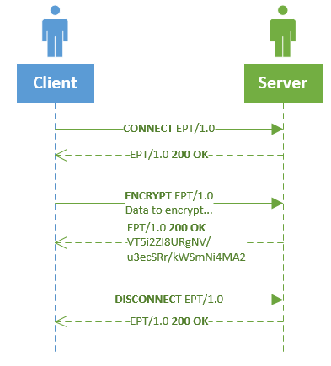
Aspects of this protocol has been influenced by my admiration of HTTP. In particular I have used the same header mechanism and using response codes to allow the client to determine the outcome of a request

ii)

Headers
VERB | HEADER
ALL  Can be used with all request types | Client-Name |  | Specifies the name of the client requesting services
ENCRYPT  DECRYPT | Algorithm |  | Specifies the name of the algorithm to use
Verb  Interaction name and meaning to client |  | Client and server method names |  | Client message to server | Server action, response to client
CONNECT  Connects to the server |  | Client  doConnect()  Sever  doConnect() |  | “CONNECT EPT/1.0” | Creates a new session for the client.  Sends back a 200 success message  “EPT/1.0 200 OK”
LIST  Lists all types of encryption methods the server supports |  | Client  doList()  Sever  doList() |  | “LIST EPT/1.0” | If client is connected  Sends back comma separated list of supported encryption algorithms with a 200 OK response  Otherwise sends back a 401 not connected response
ENCRYPT  Encrypts response body.  Optional header to specify algorithm. See headers. |  | Client  doEncrypt()  Sever  doEncrypt() |  | ENCRYPT EPT/1.0  Data to encrypt... | If client is connected sends back an encrypted string with a 200 OK response  Otherwise sends back a 401 not connected response
DECRYPT |  | Client  doDecrypt()  Sever  doDecrypt() |  | DECRYPT EPT/1.0  VT5i2ZI8URgNV/u3  ecSRr/kWSmNi4MA2 | If client is connected sends back a decrypted string with a 200 OK response  Otherwise sends back a 401 not connected response
DISCONNECT |  | Client  doDisconnect()  Sever  doDisconnect() |  | DISCONNECT EPT/1.0 | If client is connected, disconnects and sends 200 OK response  Otherwise sends back a 401 not connected response

b)

i)

Changes to existing classes
StartClient.java
package client;

import client.console.ClientConsole;
import client.ui.Application;
import core.protocol.exceptions.MessageException;
import java.util.logging.*;

/**
* Title: StartClient class
* Description: Runs the console or UI application.

* @author Edward Wilde
*/

public class StartClient
{
public static void main(String[] args) throws MessageException
{
boolean loadUI = false;
if (args.length > 0)
{
if (args[0].equals("--ui"))
{
loadUI = true;
}
}

if (!loadUI)
{
ClientConsole console = new ClientConsole();
try
{
console.run();
}
catch (MessageException ex)
{
Logger.getLogger(StartClient.class.getName()).log(Level.SEVERE, null, ex);
}
}
else
{
javax.swing.SwingUtilities.invokeLater(new Runnable() {
@Override
public void run()
{
Application application = new Application();
application.setVisible(true);
}
});
}
}
}

Comments:
All lines in this class have changed. I have made it possible to run either the console or GUI application, by passing in a command line argument. The project file I included in the zip with this TMA has two run configurations, the default one loads the UI and the ‘console’ run configuration allows testing of the console application.

ClientConsole.java (renamed from Client.java)
package client.console;

import client.core.*;
import core.protocol.Request;
import core.protocol.Response;
import core.protocol.exceptions.MessageException;
import java.io.*;
import java.util.*;
import java.util.logging.*;

/**
* Title: Client console class
* Description: Drives the console application handles input from the user
* and sends requests to the server.
*
* @author M257 Edward Wilde
*/
public class ClientConsole implements IEncryptionSessionListener
{
private static final Logger logger = Logger.getLogger(ClientConsole.class.getName());
private EncryptionSession session;
private boolean terminated;

public ClientConsole()
{
this.session = new ConsoleSession(this);
}

public void run() throws MessageException
{
//set up connection to the server
try
{
this.session.connectToServer();

readKeyBoardHelper();

this.session.closeStreams();

}
catch (IOException e)
{
System.out.println("Exception in client run " + e);
}
}

private void readKeyBoardHelper() throws MessageException
{
Scanner sc = new Scanner(System.in);

System.out.println("Keyboard helper is waiting for input (use quit to end)");

terminated = false;
while(!terminated)
{
String next = sc.nextLine().toUpperCase();
this.session.doCommand(this.session.createClientCommand(next));
}
}

@Override
public void onDoQuit()
{
this.terminated = true;
}

@Override
public void onWarn(String message)
{
logger.log(Level.WARNING, message);
}

@Override
public void onError(String message)
{
logger.log(Level.SEVERE, message);
}

// These methods were added after the console application was written
// during refactoring for the GUI. If I had time would come back and
// refactor the console app. Although it still works, just not elegantly.
@Override
public void beforeRequestSend(Request request){}

@Override
public void afterResponseReceived(Response currentResponse){}
}

Comments:
All lines of this class have been altered. The responsibility of this class is now to act as a bridge between the console, interacting with a client encryption session. This abstraction allows me to share common code between console and gui applications. The code common to both console and gui applications, such as connecting to the server, creating requests and following interaction is encapsulated in the abstract class EncryptionSession given below:
package client.core;

import core.protocol.*;
import core.protocol.exceptions.MessageException;
import java.io.*;
import java.net.*;
import java.util.*;
import java.util.logging.*;

/**
* Encapsulates core interaction between a client session and the server.
* @author Edward Wilde
*/
public abstract class EncryptionSession
{
private static final int SERVER_PORT_NUMBER = 3000;
private static final Logger logger = Logger.getLogger(EncryptionSession.class.getName());

//Streams used for communicating with server
private InputStream is;
private OutputStream os;
private PrintWriter toServer;
private BufferedReader fromServer;
private Socket socket; // Socket to server

private IResponseFactory responseFactory;
private Response currentResponse;
private boolean connected;
private final IEncryptionSessionListener listener;

public EncryptionSession(IEncryptionSessionListener listener)
{
this.responseFactory = new ResponseMessageFactory();
this.connected = false;
this.listener = listener;
}

//this method creates a socket on the local host to
//the specified port number, for communications with the server
public void connectToServer()
{
try
{
//this is a portable way of getting the local host address
final InetAddress SERVER_ADDRESS = InetAddress.getLocalHost();
System.out.println("Attempting to contact " + SERVER_ADDRESS);

socket = new Socket(SERVER_ADDRESS, SERVER_PORT_NUMBER);
openStreams();
}
catch (IOException e)
{
String message = String.format(
"Trouble contacting the server: %n%s" +
"Perhaps you need to start the server?%n" +
"Make sure they're talking on the same port?", e);
this.listener.onError(message);
}
}

private void openStreams() throws IOException
{
final boolean AUTO_FLUSH = true;
this.is = socket.getInputStream();
this.fromServer = new BufferedReader(new InputStreamReader(is));
this.os = socket.getOutputStream();
this.toServer = new PrintWriter(os, AUTO_FLUSH);
}

// close streams to server
public void closeStreams() throws IOException
{
this.toServer.close();
this.os.close();
this.fromServer.close();
this.is.close();
this.socket.close();
}

private Request createRequest(Verb verb)
{
Request request = new Request();
String hostName = "Unknown";
try
{
hostName = java.net.InetAddress.getLocalHost().getHostName();
} catch (UnknownHostException ex)
{
logger.log(Level.SEVERE, null, ex);
}

request.setVerb(verb);
request.getHeaders().add(new Header("Client-Name", hostName));

return request;
}

public ClientCommand createClientCommand(String value)
{
if (value == null || value.length() == 0)
{
return ClientCommand.UNKNOWN;
}

int indexOfFirstSpace = value.indexOf(" ");

String commandName = value.substring(0,
indexOfFirstSpace == -1 ? value.length() : indexOfFirstSpace);

try
{
return ClientCommand.valueOf(commandName);
}
catch (IllegalArgumentException exception)
{
return ClientCommand.UNKNOWN;
}
}

public void doCommand(ClientCommand clientCommand) throws MessageException
{
switch(clientCommand)
{
case CONNECT:
this.doConnect();
break;
case LIST:
this.doList();
break;
case DISCONNECT:
this.doDisconnect();
break;
case ENCRYPT:
this.doEncrypt();
break;
case DECRYPT:
this.doDecrypt();
break;
case QUIT:
if (this.isConnected())
{
this.doDisconnect();
}

this.doQuit();
break;
case HELP:
this.doHelp();
break;
case UNKNOWN:
default:
this.listener.onError(String.format("Unknown command:%s%n", clientCommand.getName()));
break;
}
}

public void doConnect() throws MessageException
{
if (this.isConnected())
{
this.listener.onWarn("Already connected.");
return;
}

this.doRequestResponse(Verb.CONNECT);
if (this.currentResponse.getStatusCode() == StatusCode.OK)
{
this.connected = true;
}
}

public void doDisconnect() throws MessageException
{
if (!this.checkConnected())
{
return;
}

this.doRequestResponse(Verb.DISCONNECT);

if (this.currentResponse.getStatusCode() == StatusCode.OK)
{
this.connected = false;
}
}

public void doList() throws MessageException
{
if (!this.checkConnected())
{
return;
}

this.doRequestResponse(Verb.LIST);

if (this.currentResponse.getStatusCode() == StatusCode.OK)
{
System.out.println(this.currentResponse.getBody());
}
}

public abstract void doHelp();
public abstract String GetInputFromUser();

public void doEncrypt() throws MessageException
{
if (!this.checkConnected())
{
return;
}

String userInput = this.GetInputFromUser();
Request request = this.createRequest(Verb.ENCRYPT);
request.setBody(userInput);
this.doRequestResponse(request);

if (this.currentResponse.getStatusCode() == StatusCode.OK)
{
System.out.println(this.currentResponse.getBody());
}
}

public void doDecrypt() throws MessageException
{
if (!this.checkConnected())
{
return;
}

String userInput = this.GetInputFromUser();
Request request = this.createRequest(Verb.DECRYPT);
request.setBody(userInput);
this.doRequestResponse(request);

if (this.currentResponse.getStatusCode() == StatusCode.OK)
{
System.out.println(this.currentResponse.getBody());
}
}

private void doRequestResponse(Verb verb) throws MessageException
{
this.doRequestResponse(this.createRequest(verb));
}

private void doRequestResponse(Request request) throws MessageException
{
request.setCorrelationToken(UUID.randomUUID().toString());
this.listener.beforeRequestSend(request);

this.currentResponse = this.SendRequest(request);
this.currentResponse.setCorrelationToken(request.getCorrelationToken());

this.HandleResponse(this.currentResponse);
this.listener.afterResponseReceived(this.currentResponse);
}

private Response SendRequest(Request request) throws MessageException
{
toServer.print(String.format("%s%n", request.toString()));
toServer.flush();
logger.log(Level.INFO, String.format("Send request: %s%n",
request.toStringFirstLine()));

return responseFactory.createResponse(fromServer);
}

private void HandleResponse(Response response)
{
if (response.getStatusCode() != StatusCode.OK)
{
logger.log(Level.SEVERE, String.format("Error %s%n%s",
response.getStatusCode(),
response.getBody()));
}
else
{
logger.log(Level.INFO, response.toStringFirstLine());
}
}

private boolean checkConnected()
{
if (!this.isConnected())
{
this.listener.onWarn("Please CONNECT first.");
}

return this.isConnected();
}

/**
* @return the connected
*/
public boolean isConnected()
{
return connected;
}

public void doQuit()
{
this.listener.onDoQuit();
}
}

Comment:
In the above core client interaction class, when it need to get something from the user interface or inform the interface of a change in state, it does so via the IEncryptionSessionListener interface. The listener maybe a console application (client.console.ClientConsole) or a gui application (client.ui.Application). Below is the code listing for IEncryptionSessionListener:
package client.core;

import core.protocol.Request;
import core.protocol.Response;

/**
* Client application should implement this interface to respond to
* interactions during an encryption session.
* @author EddieDesk
*/
public interface IEncryptionSessionListener
{
/**
* Inform the interface of a warning condition
* @param message containing the warning.
*/
void onWarn(String message);

/**
* Inform the user interface of an error condition.
* @param messagecontaiing the error condition.
*/
void onError(String message);

/**
* Inform the user interface that the quit command has been
* send to the server and the client application should now quit.
*/
void onDoQuit();

/**
* Called before a request is sent to the server
* @param request to be sent to the server.
*/
void beforeRequestSend(Request request);

/**
* Called after a response has been received from the server.
* @param response received.
*/
void afterResponseReceived(Response response);
}
Server.java
package server;

import core.protocol.*;
import core.protocol.exceptions.*;
import core.security.*;
import java.io.*;
import java.net.*;
import java.util.HashMap;
import java.util.logging.*;

/**
* Title: Server class
* Description: Responsible for handling client connections.
*
*
* @author M257 Edward Wilde
*/
public class Server
{
private ServerSocket serverSocket;
private Socket socket;

// use a high numbered non-dedicated port
private static final int PORT_NUMBER = 3000;
private static final String MESSAGE_TO_CLIENT = "Hello client. This is the server.";
private static final Logger logger = Logger.getLogger(Server.class.getName());

// constructor
public Server()
{
System.out.println("...Server starting up");
try
{
// create a ServerSocket object to listen on the port
serverSocket = new ServerSocket(PORT_NUMBER);
}
catch (IOException e)
{
System.out.println("Trouble with ServerSocket on port " + PORT_NUMBER
+ ": " + e);
}
} // end constructor

//This method is used to start the server and perform a single
//interaction with a single client using the processHello method.
public void run()
Change made to support multiple client concurrently
{
try
{
while(true)
{
// wait for a connection request
socket = serverSocket.accept();
System.out.println("...Connection established");
new Thread(new EncryptionSession(socket)).start();
}
}
catch (IOException e)
{
System.out.println("Trouble with a connection " + e);
}
}

} // end class

Using collection classes in the server
The are a few instances were I have used collection classes in the server component of the system. For example in Verb.java a map is used to associated a name of verb with an instance of that verb. The listing below illustrates this:
package core.protocol;

import java.util.HashMap;
import java.util.Map;

/**
*
* @author Edward Wilde
*/
public enum Verb
{
CONNECT("CONNECT", "Create a new encryption session."),
DISCONNECT("DISCONNECT", "End an encryption session."),
LIST("LIST", "Lists the supported algorithms"),
ENCRYPT("ENCRYPT", "Encrypts the request body"),
DECRYPT("DECRYPT", "Decrypts the request body");

private final String name;
private final String description;
private static final Map<String, Verb> nameToVerbMapping;

static
{
nameToVerbMapping = new HashMap<String, Verb>(values().length);
for(Verb verb : values())
{
nameToVerbMapping.put(verb.name, verb);
}
}

private Verb(String name, String description)
{
this.name = name;
this.description = description;

}

public static Verb getVerb(String value) throws IllegalArgumentException
{
if (!nameToVerbMapping.containsKey(value))
{
throw new IllegalArgumentException(
String.format("Value %s not a known verb", value));
}

return nameToVerbMapping.get(value);
}

/**
* @return the name
*/
public String getName() {
return name;
}

/**
* @return the description
*/
public String getDescription() {
return description;
}
}

Interactions

Connection interaction
The initial connection interaction is handled by the CONNECTION client command. The client sends a connection request and the server will respond with a 200 OK if everything succeeded. To execute this command in the GUI select the CONNECT option or from the console type CONNECT.

Help interaction
This interaction is covered by the client command HELP, to execute this command in the GUI select the HELP option from the combo box or from the console simply type help.

Quit interaction
This interaction is implemented by the QUIT client command. The client sends a QUIT request which will be acknowledged by the server with a 200 OK response. After which the server will close the connection with the client. In the GUI select the QUIT option or in the console type QUIT.
For brevity I have not included every classes added, however they are attached as part of this TMA. It should be noted that I created a sperate project TMA03Q3Core which contains classes used to implement the encryption protocol which are mostly used by both TMA03Q3Client and TMA03Q3Server packages.

Interaction with multiple lines of communication from the server side
Both DECRYPT (depending on input data) and LIST commands send multiple lines of text from the server to the client.

Issues
One problem I had during the development of this application involved the processing of socket streams between client and server.
Periodically data would be left over in the client stream after the termination token. To remove the problem I found it necessary to read up to the end of the stream. This is highlighted below in a method found in core.protocol.MessageFactory:
protected String readMessageRaw(BufferedReader reader)
{
StringBuilder builder = new StringBuilder();
String buffer;

try {
while (!(buffer = reader.readLine()).endsWith("\u0000"))
{
builder.append(String.format("%s%n", buffer));
}

// read off any data left after termination
while (reader.ready())
{
reader.read();
}

builder.append(buffer);

} catch (IOException ex) {
logger.log(Level.SEVERE, null, ex);
return null;
}

String result = builder.toString();
logger.log(Level.INFO, String.format("Read raw message: %s", result));
return result;
}

b) ii)
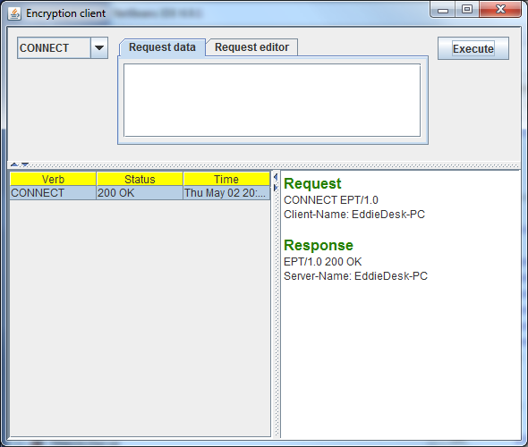
Choose command to send to server
Request send to server
Response from server
Send command to server
Figure 1Sending the connect command to the server. 200 OK is a successful execution of the request
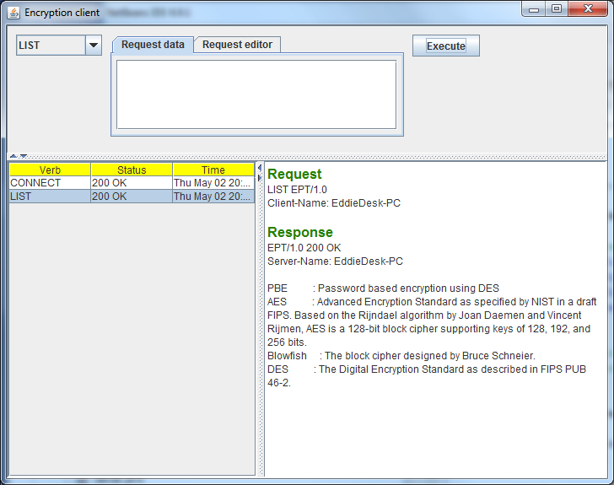
Figure 2Result of sending the list command to the server. Note multiple lines of text in the response
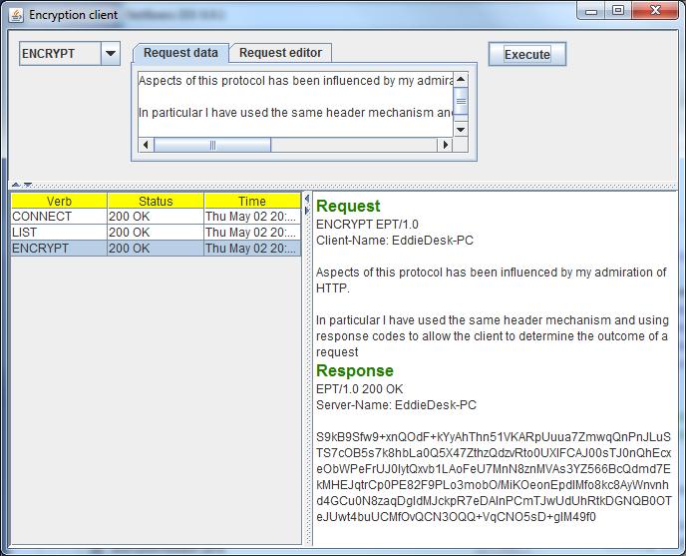
Command such as encrypt and decrypt require data to be sent alongside the command to the server. This is entered in the request data tab. Note this can be multiple lines of text.
Figure 3 Result of sending the encrypt command to the server.
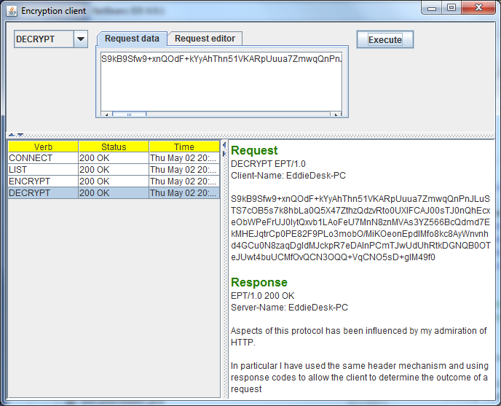
Figure 4Result of sending the decrypt command to the server.
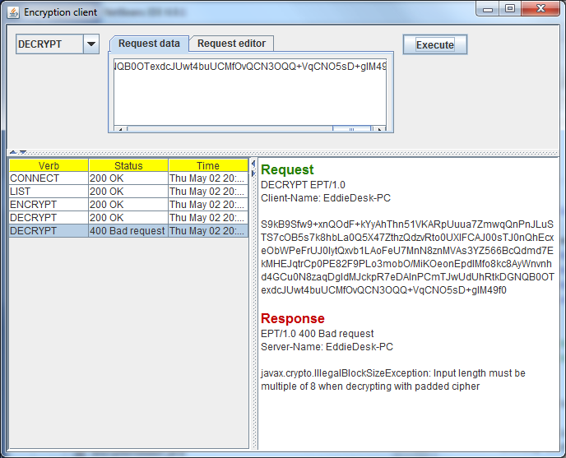
Figure 5 Result of invalid data being sent in a request. Here I inserted random characters to create invalid data in the request data tab.
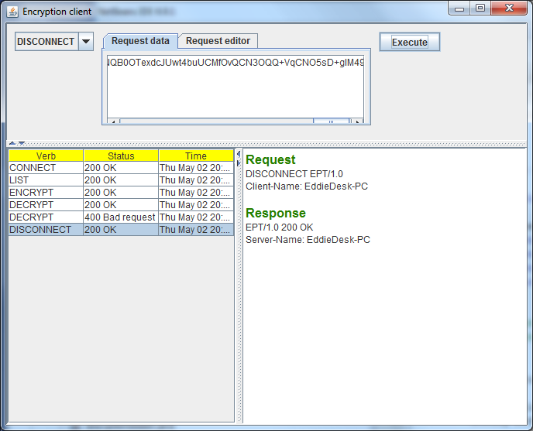

GUI Application description
The application can be used by selecting a command from the combo box in the top pane and clicking the execute button. Reponses from the server are displayed in the panel below. Command ENCRYPT and DECRYPT require input from the user. This input data can be entered into the request data tab. The request editor tab functionality has not been entirely completed. At the moment you can preview the request before it is sent to the server. The intention was to alllow the user to manually edit and craft a request, thereby making it easier to test error conditions. However I did not get time to complete this.
I created the GUI application by splitting the interface into 2 JPanels. The top one Composer.java was responsible for displaying the request and the bottom JPanel ResultViewer.java handled the display of the responses from the server.
The code for the GUI application can be found in the client.ui pacakge in part of the TMA03Q3Client project.

Testing for robustness and correct input data
Error checking for incorrect input was handled mainly by the core protocol classes, with checked exceptions being thrown when input validated these conditions.
For example if a verb was missing from the request header an invalid message exception is thrown.
protected void validateVerb() throws InvalidMessageException
{
// Validate verb is present
String[] lines = this.message.getRawMessage().split(NEWLINE);
int indexOfSpace = lines[0].indexOf(' ');
if (indexOfSpace == -1)
{
throw new InvalidMessageException(
"Message start with a verb",
StatusCode.BAD_REQUEST);
}
}
Extract from RequestMessageFactory.java
Testing of the core protocol classes was carried out using a test driven approach, this can be found in the core.tests package in the TMA03Q3Core project, below is an extract of one such test classes:
package core.tests;

import core.protocol.*;
import core.protocol.exceptions.*;
import org.junit.runners.JUnit4;
import org.junit.runner.RunWith;
import org.junit.Test;
import static org.hamcrest.CoreMatchers.*;
import static org.junit.Assert.*;
/**
*
* @author Edward Wilde
*/
@RunWith(JUnit4.class)
public class RequestMessageFactoryTests {
public static final String SIMPLE_CONNECT = "CONNECT EPT/1.0\u0000";
public static final String MULTLINE_LINE_REQUEST = String.format(
"CONNECT EPT/1.0%n" +
"Client-Name: Frodo%n" +
"Algorithm: DES%n" +
"%n" +
"Body of message\u0000");

@Test
public void should_parse_verb() throws InvalidMessageException
{
Request request = new RequestMessageFactory().createRequest(SIMPLE_CONNECT);

assertThat(request.getVerb(),is(Verb.CONNECT));
}

@Test
public void should_parse_protocol_version() throws InvalidMessageException
{
Request request = new RequestMessageFactory().createRequest(SIMPLE_CONNECT);

assertThat(request.getVersion(),is(1.0f));
}

@Test
public void should_parse_protocol_version_with_multiline_request() throws InvalidMessageException
{
Request request = new RequestMessageFactory().createRequest(MULTLINE_LINE_REQUEST);

assertThat(request.getVersion(),is(1.0f));
}

@Test
public void should_parse_headers_count() throws InvalidMessageException
{
Request request = new RequestMessageFactory().createRequest(MULTLINE_LINE_REQUEST);

assertThat(request.getHeaders().size(),is(2));
}

@Test
public void should_parse_header_name() throws InvalidMessageException
{
Request request = new RequestMessageFactory().createRequest(MULTLINE_LINE_REQUEST);

assertThat(request.getHeaders().get(0).getName(),is("Client-Name"));
}

@Test
public void should_parse_header_value() throws InvalidMessageException
{
Request request = new RequestMessageFactory().createRequest(MULTLINE_LINE_REQUEST);

assertThat(request.getHeaders().get(1).getValue(),is("DES"));
}

@Test
public void should_parse_request_body() throws InvalidMessageException
{
Request request = new RequestMessageFactory().createRequest(MULTLINE_LINE_REQUEST);

assertThat(request.getBody(), is("Body of message"));
}

@Test(expected=InvalidMessageException.class)
public void request_without_null_termination_throws_invalid_message_exception() throws InvalidMessageException
{
Request request = new RequestMessageFactory().createRequest("CONNECT EPT/1.0");
}

@Test(expected=InvalidMessageException.class)
public void request_without_verb_invalid_message_exception() throws InvalidMessageException
{
Request request = new RequestMessageFactory().createRequest("EPT/1.0\u0000");
}

@Test(expected=InvalidMessageException.class)
public void request_without_version_throws_invalid_message_exception() throws InvalidMessageException
{
Request request = new RequestMessageFactory().createRequest("CONNECT EPT\u0000");
}

@Test(expected=InvalidMessageException.class)
public void request_with_invalid_version_throws_invalid_message_exception() throws InvalidMessageException
{
Request request = new RequestMessageFactory().createRequest("CONNECT EPT/3z\u0000");
}

@Test(expected=InvalidMessageException.class)
public void request_with_unsupport_version() throws InvalidMessageException
{
Request request = new RequestMessageFactory().createRequest("CONNECT EPT/0.9\u0000");
}

@Test(expected=InvalidMessageException.class)
public void request_that_is_empty_throws_invalid_message_exception() throws InvalidMessageException
{
Request request = new RequestMessageFactory().createRequest("");
}
}

