Your goal in this assignment is to create a simple calculator application using Java Swing, modeled after the kind you might find in any operating system or phone.

The goal of this project is to demonstrate the knowledge required to build a sufficient GUI and perform the work needed by JDBC (Java Database Connectivity) and similar libraries to connect a GUI to a database. It is not a test of general programming competency.

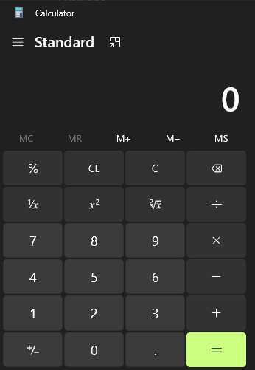

Your application does not need to have this many features, however. Your calculator must meet the following minimum requirements

* Have 10 number buttons for the numbers 0-9
* Have 4 function buttons for +, -, \*, /
* Have 1 function button for = that performs the calculation
* A display area for displaying the result of the calculation
  + The exact component that you use to display the result is left to you but it must accurately display the result
* Is capable of adding, subtracting, multiplying, or dividing two numbers; be they positive or negative.
  + Your program should be able to accept any number of reasonable size (at least five digits each)
* Your calculator should be able to perform multiple calculations per execution.
  + This means that you should not have to shut down and restart the calculator in order to perform a new calculation.
  + You may achieve this functionality by adding in a reset or clear button, or by automatically resetting the appropriate values when needed

Your calculator does not need to be able to parse full expressions. It only needs to be able to handle two numbers of any reasonable length (at least 5 digits each).

Each button must be displayed, functional, and intractable by the end user to count for credit in this assignment.

You should handle division by zero by checking if the second number is zero and, if so, then displaying NaN.

You are to submit your code in the form of a .java file.