Above time meets the current (system) time, below popup will be rise in the taskbar.

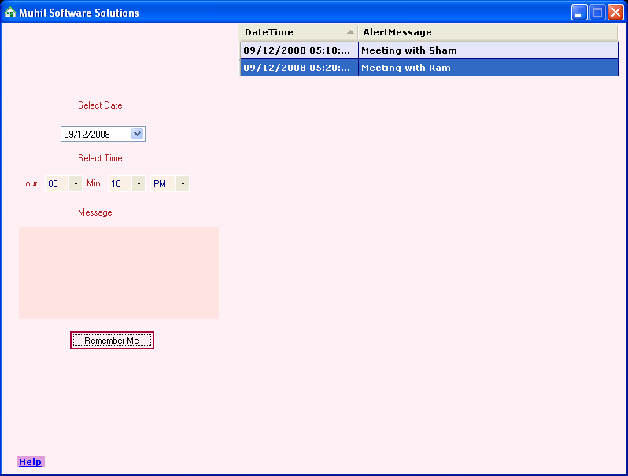

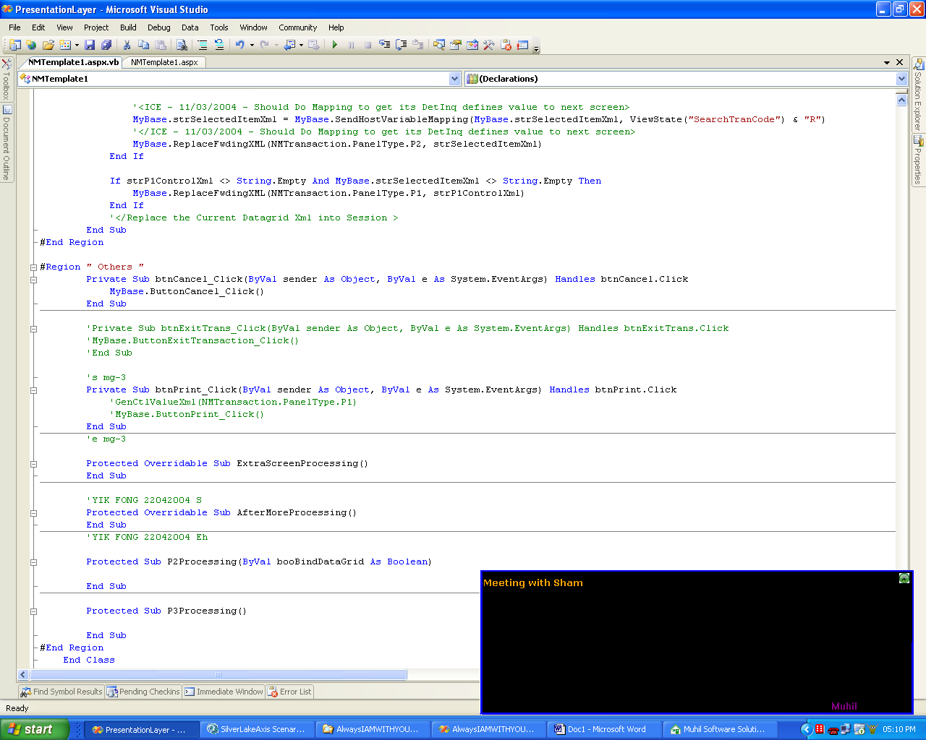

Edit Existing Message
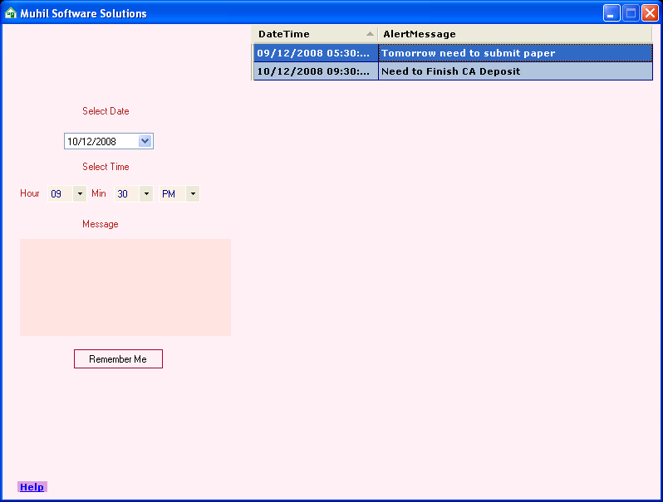

double click the particular message, edit the information and enter.
Select Row and Press Delete button for Delete the information.
