Media Library
Power | Main Menu | Main Controls | Media Controls | Basic controls | TV Controls
1.Power |  | 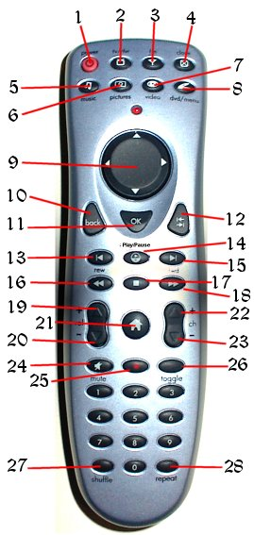
2.TV | Flip to TV
3.FM Radio | Flip to Radio
4.Close | Close current component
5.Music | Flip to Music Library
6.Pictures | Flip to Picture Library
7.Video | Flip to Media Library
8.DVD | Flip to DVD interface
9.Directional Pad | Select Category / Media
10.Back | Go up a level of sub categories
11.OK | Show selected media’s information
12.Go | Go down a level of sub categories
13.Back one
14.Play/Pause
15. Forward one
16.Rewind
17. Stop
18. Fast Forward
19.Volume Up | Volume Up
20.Volume Down | Volume Down
21.Home | Flip to Home screen
22.Channel Up
23.Channel Down
24.Mute | Volume Mute
25.Record
26.Toggle | Toggle remote functionality
27. Shuffle | Shuffle and play selected category
28. Repeat

© Copyright 2004 SCTV

