TV
Power | Main Menu | Main Controls | Media Controls | Basic controls | TV Controls
1.Power |  | 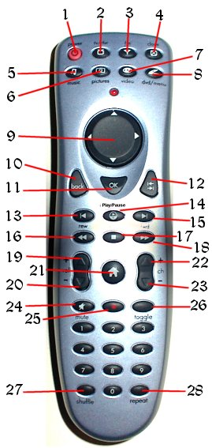
2.TV | Flip to TV
3.FM Radio | Flip to Radio
4.Close | Close current component
5.Music | Flip to Music Library
6.Pictures | Flip to Picture Library
7.Video | Flip to Media Library
8.DVD | Flip to DVD interface
9.Directional Pad | Scroll through TV listing information
10.Back | Previous Channel
11.OK | Show / Hide current show information
12.Go | Go to show displayed in show information
13.Back one | View Favorites
14.Play/Pause | Add to Favorites
15. Forward one | View Future Air Dates
16.Rewind
17. Stop | Remove from Favorites
18. Fast Forward
19.Volume Up | Volume Up
20.Volume Down | Volume Down
21.Home | Flip to Home screen
22.Channel Up | TV Channel Up
23.Channel Down | TV Channel Down
24.Mute | Volume Mute
25.Record | Add to Record Schedule
26.Toggle | Toggle remote functionality
27.Shuffle
28.Repeat

© Copyright 2004 SCTV

