Remote
Power | Main Menu | Main Controls | Media Controls | Basic controls | TV Controls
1.Power | Power | 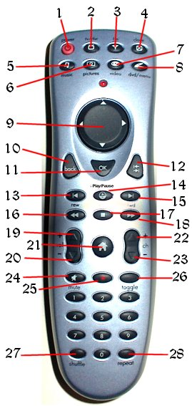
2.TV | Flip to TV
3.FM Radio | Flip to Radio
4.Close | Close current component
5.Music | Flip to Music Library
6.Pictures | Flip to Picture Library
7.Video | Flip to Media Library
8.DVD | Flip to DVD interface
9.Directional Pad | Main Navigation
10.Back | Go to a previous item
11.OK | Show info about an item
12.Go | Go to a selected item
13.Back one | Play previous media item
14.Play/Pause | Play / Pause toggle
15. Forward one | Play next media item
16.Rewind | Slow play rate
17. Stop | Stop playing
18. Fast Forward | Speed up play rate
19.Volume Up | Volume Up
20.Volume Down | Volume Down
21.Home | Flip to Home screen
22.Channel Up | TV Channel Up
23.Channel Down | TV Channel Down
24.Mute | Volume Mute
25.Record | Record media
26.Toggle | Toggle remote functionality
27.Shuffle
28.Repeat

© Copyright 2004 SCTV

