Video
Power | Main Menu | Main Controls | Media Controls | Basic controls | TV Controls
1.Power |  | 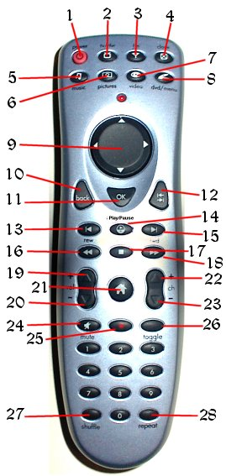
2.TV | Flip to TV
3.FM Radio | Flip to Radio
4.Close | Close current component
5.Music | Flip to Music Library
6.Pictures | Flip to Picture Library
7.Video | Flip to Media Library
8.DVD | Flip to DVD interface
9.Directional Pad
10.Back
11.OK | Show current media’s information
12.Go
13.Back one | Play previous file
14.Play/Pause | Play/Pause current file
15. Forward one | Play next file
16.Rewind | Slow play rate
17. Stop | Stop current file
18. Fast Forward | Speed up play rate
19.Volume Up | Volume Up
20.Volume Down | Volume Down
21.Home | Flip to Home screen
22.Channel Up
23.Channel Down
24.Mute | Volume Mute
25.Record
26.Toggle | Toggle remote functionality
27. Shuffle | Shuffle and play files in current play list
28. Repeat | Repeat the file that is playing

© Copyright 2004 SCTV

