Kabóca Guesthouse

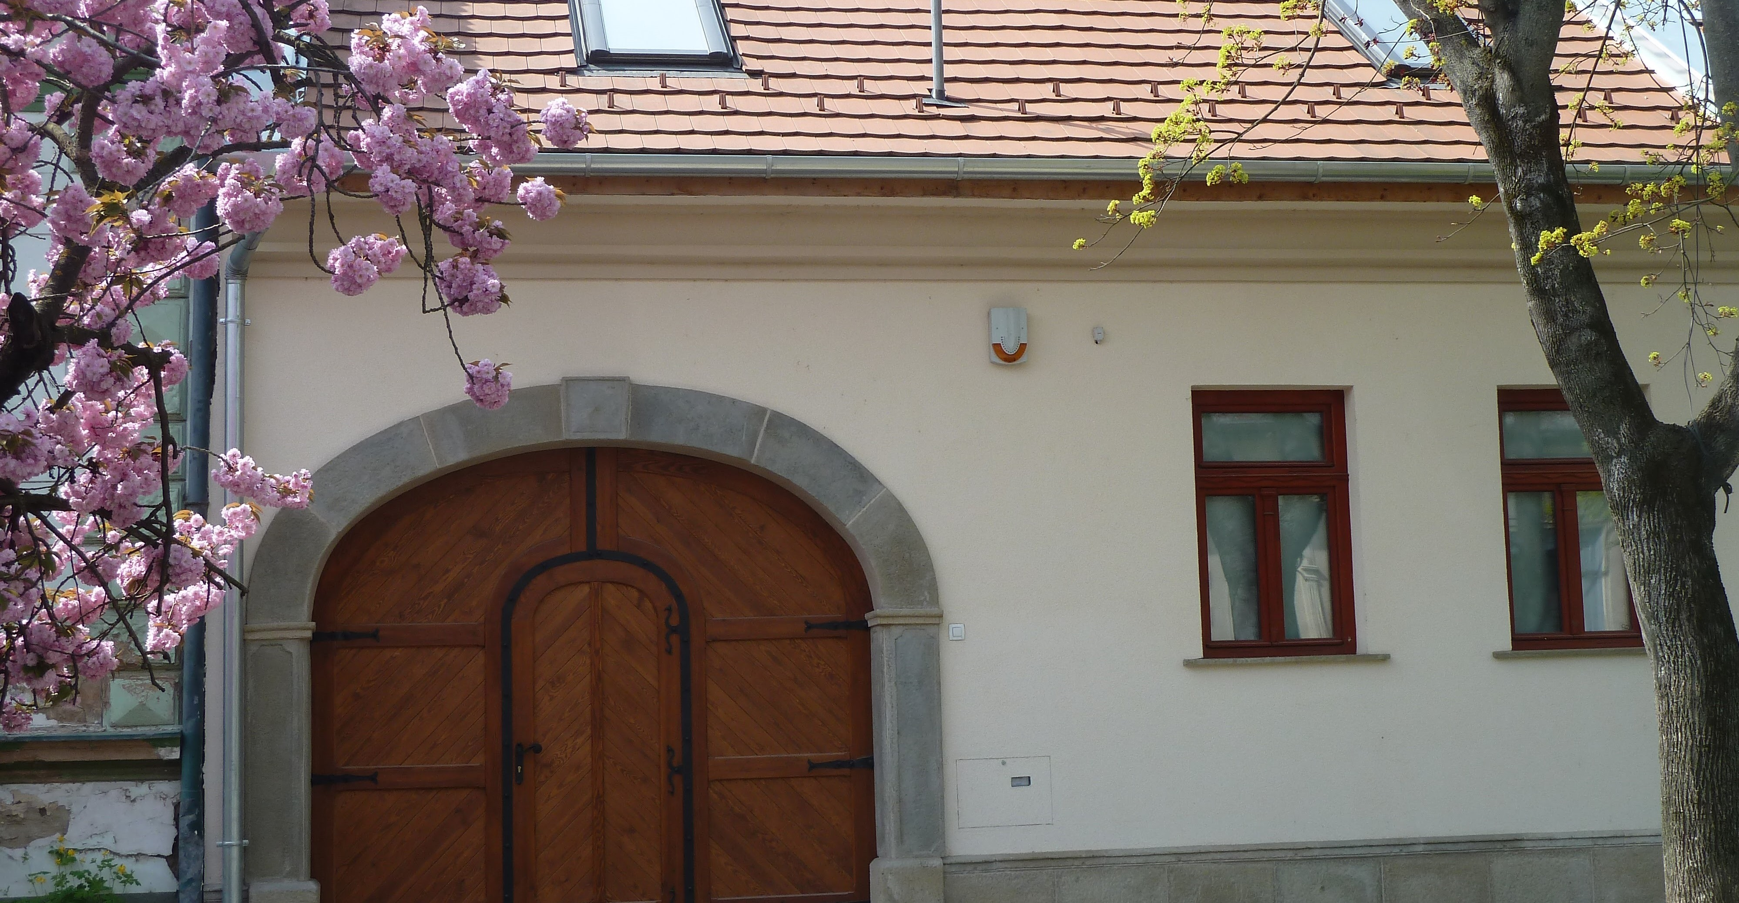
House Rules and Information
for Our Guests

Kabóca Guesthouse
House Rules and Information for Our Guests

Dear Guests,
We are delighted to welcome you to our place – we hope you will have a pleasant and memorable experience at Kabóca Guesthouse. The following information will help ensure your stay is smooth and comfortable.
📞 Contact and Assistance
The hosts are available 24 hours a day:
- Pellet Philippe: +36 30 493 2559 (also on WhatsApp)
- Vass Ildikó: +36 30 384 6843 (also on WhatsApp)
Website: www.kabocavac.hu (Hungarian, English and French)
The hosts live in the neighbouring house and are generally available for any questions or assistance.
🕒 Arrival and Departure
Check-in: from 3:00 PM
Check-out: by 10:00 AM at the latest
Upon arrival:
Please call one of the phone numbers above to receive the keys, get a tour of the house, and complete the condition report.
In case of late arrival or if the hosts are unavailable, the keys can be retrieved from a key safe mounted on the gate.
Upon departure:
Please call us to return the keys and carry out the condition check.
If the hosts are unavailable, the keys can also be placed back in the key safe.
🏡 Use of the Guesthouse
The guesthouse accommodates 6 people. Two additional guests may sleep on the sofa in the living room.
The house and garden are entirely at our guests’ disposal.
The cellar may only be used with prior agreement.
The chapel is open to our guests for prayer; all other activities in the chapel are not permitted.
Bed linen and towels are provided; for stays longer than one week, fresh linen and towels will be supplied.
An iron and ironing board are available on request.
Shoe cleaning kit is available on request.
Please roll up the garden-side terrace awning every evening before going to bed, and also in case of wind or storm.
Before departure, please leave the house in good order and do the dishes; final cleaning will be carried out by us.
🛎️ Services available on request
– Breakfast can be provided on request between 6:30 and 10:00. Details and prices are available on our website.
– Upon request, we can provide a brazier for cauldron cooking, along with a 20-liter cauldron and firewood.
– Daily cleaning is available upon request for an additional fee.
– Bicycles are available upon request (at your own risk).
– We are happy to provide rackets and shuttlecocks for badminton.
⚠️ House Rules
Pets are not allowed.
Smoking is prohibited inside the house. Smoking is only permitted on the terrace or in the garden.
After 9:30 PM, loud parties and disruptive noise are not permitted to preserve the peace of the neighbourhood.
Please close all doors and windows when leaving the property.
🗑️ Waste Management (Recyclable and General Waste)
Plastic bags are available under the kitchen sink:
– Black or blue bags for general (non-recyclable) waste,
– Transparent bags for recyclable waste (paper, cardboard, plastics).
Please place filled general waste bags in the black bin located next to the gate.
Waste collection takes place on Wednesdays. Please place the bin and the recyclable waste bags out on the street on Wednesday morning, and return the bin to the yard after collection.

🚨 Safety
For the protection and safety of our guests, smoke detectors are installed in the bedrooms and in the main room on the ground floor, along with a carbon monoxide detector in the main room.
In case of alarm, please evacuate the house immediately and go into the garden or the street.
In case of fire outbreak, a powder fire extinguisher is located behind the piano.
🛡️ Legal Regulations
In accordance with Hungarian regulations, all guests must be registered in the national tourism accommodation registry (NTAK). Guests may complete their registration online beforehand or at check-in.
Personal data is processed in accordance with applicable laws; the Privacy Policy is available on our website.
🗺️ Visits and excursions in the area
We have listed several suggestions for visits and excursions in the region on our website. Please have a look if you would like to discover the local attractions.
ℹ️ Additional Information
Furniture and equipment located in the house and garden may not be moved without the hosts’ permission.
Please report any damage immediately and compensate if necessary.
📌 Legal Notice
Kabóca Guesthouse is a private accommodation operated by private individuals in accordance with applicable Hungarian laws.

