ГУАП

КАФЕДРА № 43

ОТЧЕТ   
ЗАЩИЩЕН С ОЦЕНКОЙ

ПРЕПОДАВАТЕЛЬ

|  |  |  |  |  |
| --- | --- | --- | --- | --- |
|  |  |  |  | Щекин С.В. |
| должность, уч. степень, звание |  | подпись, дата |  | инициалы, фамилия |

|  |
| --- |
| ОТЧЕТ ПО ЛАБОРАТОРНОЙ РАБОТЕ № 5 |
| **Работа со списками, текстурой и NURBS-поверхностями** |
| по дисциплине: Компьютерная графика |
|  |
|  |

РАБОТУ ВЫПОЛНИЛ

|  |  |  |  |  |  |
| --- | --- | --- | --- | --- | --- |
| СТУДЕНТ ГР. | 4134к |  |  |  | Костяков Н.А. |
|  |  |  | подпись, дата |  | инициалы, фамилия |

Санкт-Петербург 2022

**Цель работы**

Вывести сложный трехмерный объект, сохранить его в виде списка и размножить в виде нескольких копий различного масштаба на экране путем повторного вывода списка. Выводимые объекты располагаются над рельефом, задаваемым NURBS-поверхностью. Наложить текстуру на выводимые объекты, сцена должна быть освещена, необходимо предусмотреть возможность включения эффекта тумана (при помощи клавиатуры или мыши).

**Листинг**

**Main.cpp**

#include <iostream>

#include <cmath>

#include <GL/glut.h>

#define STB_IMAGE_IMPLEMENTATION

#include "stb_image.h"

#define W_WIDTH 1280

#define W_HEIGHT 720

// camera

double angle_x = 0.0;

double angle_y = -5000.0;

float lx = 0.0f, ly = 0.0f, lz = -1.0f;

float x = 0.0f, y = 0.0f, z = 10.0f;

int refreshMills = 60;

float fraction = -0.5f;

float fraction_angle = 0.1f;

float light_fraction = -0.5f;

bool use_mouse = true;

bool forward = false;

bool back = false;

bool left = false;

bool right = false;

// nurbs

const int size_numb_x = 4;

const int size_numb_y = 4;

GLfloat ctlpoints[size_numb_x][size_numb_y][3];

GLfloat knots[size_numb_x + size_numb_y] = {

0.0, 0.0, 0.0, 0.0,

1.0, 1.0, 1.0, 1.0

};

int showPoints = 0;

GLUnurbsObj* theNurb;

// lihgt

GLfloat ambientColor_light[] = { 0.8, 0.8, 0.8, 1.0 };

GLfloat diffuseColor_light[] = { 1, 1, 1, 1.0 };

GLfloat emis_light[] = { 1.0, 1.0, 1.0, 1.0 };

// GLfloat light_position[4] = {10.0, 5.0, -10.0, 1.0};

GLfloat light_position[4] = { 30.0, 10.0, 0.0, 1.0 };

GLfloat light_direction[3] = { 0.0, 0.0, 0.0 };

float mat_dif_light[] = { 1.0f, 1.0f, 1.0f, 1.0 };

// texture

GLuint theTorus;

GLuint texture;

// fog

bool fog_bool = false;

GLuint filter;

GLuint fogMode[] = { GL_EXP, GL_EXP2, GL_LINEAR };

GLuint fogfilter = 0;

GLfloat fogColor[4] = { 0.5f, 0.1f, 0.1f, 1.0f };

void fog_on() {

glEnable(GL_FOG); // Включает туман (GL_FOG)

glFogi(GL_FOG_MODE, fogMode[fogfilter]);// Выбираем тип тумана

glFogfv(GL_FOG_COLOR, fogColor); // Устанавливаем цвет тумана

glFogf(GL_FOG_DENSITY, 0.05f); // Насколько густым будет туман

glHint(GL_FOG_HINT, GL_DONT_CARE); // Вспомогательная установка тумана

glFogf(GL_FOG_START, 1.0f); // Глубина, с которой начинается туман

glFogf(GL_FOG_END, 5.0f); // Глубина, где туман заканчивается.

}

// functions

void move() {

// camera

if (forward) {

z -= lz * fraction;

x -= lx * fraction;

y -= ly * fraction;

}

if (back) {

z += lz * fraction;

x += lx * fraction;

y += ly * fraction;

}

if (left) {

z += lx * fraction;

x -= lz * fraction;

}

if (right) {

z -= lx * fraction;

x += lz * fraction;

}

}

void keyUp(unsigned char key, int xx, int yy) {

switch (key) {

// camera

case ('w'):

forward = false;

break;

case ('s'):

back = false;

break;

case ('a'):

left = false;

break;

case ('d'):

right = false;

break;

// fog

case ('f'):

fog_bool = !fog_bool;

if (fog_bool) glDisable(GL_FOG);

else glEnable(GL_FOG);

break;

// включить (выключить курсор)

case ('g'):

use_mouse = !use_mouse;

break;

// выход

case 27:

//glutDestroyWindow ( Win.id );

exit(0);

break;

}

}

void keyDown(unsigned char key, int xx, int yy) {

switch (key) {

// camera

case ('w'):

forward = true;

break;

case ('s'):

back = true;

break;

case ('a'):

left = true;

break;

case ('d'):

right = true;

break;

}

}

double sensivity = 0.001;

void gen(int size) {

theTorus = glGenLists(1);

glNewList(theTorus, GL_COMPILE);

glRotatef(90.0, 1.0, 0.0, 0.0);

for (int i = 1; i < 5; i++) {

// glRotatef(i * 50, 0.0, 1.0, 0.0);

glTranslatef(0.0f, 2 * size, 0.0f);

glEnable(GL_TEXTURE_2D);

glTexParameteri(GL_TEXTURE_2D, GL_TEXTURE_MAG_FILTER, GL_NEAREST);

glTexParameteri(GL_TEXTURE_2D, GL_TEXTURE_MAG_FILTER, GL_NEAREST);

glBindTexture(GL_TEXTURE_2D, texture);

if (i == 1 or i==2) {

glBegin(GL_QUADS);

glTexCoord2f(0.0f, 0.0f); glVertex3f(1.0f, 1.0f, -1.0f);

glTexCoord2f(0.0f, 1.0f); glVertex3f(-1.0f, 1.0f, -1.0f);

glTexCoord2f(1.0f, 1.0f); glVertex3f(-1.0f, 1.0f, 1.0f);

glTexCoord2f(1.0f, 0.0f); glVertex3f(1.0f, 1.0f, 1.0f);

glTexCoord2f(0.0f, 0.0f); glVertex3f(1.0f, -1.0f, 1.0f);

glTexCoord2f(0.0f, 1.0f); glVertex3f(-1.0f, -1.0f, 1.0f);

glTexCoord2f(1.0f, 1.0f); glVertex3f(-1.0f, -1.0f, -1.0f);

glTexCoord2f(1.0f, 0.0f); glVertex3f(1.0f, -1.0f, -1.0f);

glTexCoord2f(0.0f, 0.0f); glVertex3f(1.0f, 1.0f, 1.0f);

glTexCoord2f(0.0f, 1.0f); glVertex3f(-1.0f, 1.0f, 1.0f);

glTexCoord2f(1.0f, 1.0f); glVertex3f(-1.0f, -1.0f, 1.0f);

glTexCoord2f(1.0f, 0.0f); glVertex3f(1.0f, -1.0f, 1.0f);

glTexCoord2f(0.0f, 0.0f); glVertex3f(1.0f, -1.0f, -1.0f);

glTexCoord2f(0.0f, 1.0f); glVertex3f(-1.0f, -1.0f, -1.0f);

glTexCoord2f(1.0f, 1.0f); glVertex3f(-1.0f, 1.0f, -1.0f);

glTexCoord2f(1.0f, 0.0f); glVertex3f(1.0f, 1.0f, -1.0f);

glTexCoord2f(0.0f, 0.0f); glVertex3f(-1.0f, 1.0f, 1.0f);

glTexCoord2f(0.0f, 1.0f); glVertex3f(-1.0f, 1.0f, -1.0f);

glTexCoord2f(1.0f, 1.0f); glVertex3f(-1.0f, -1.0f, -1.0f);

glTexCoord2f(1.0f, 0.0f); glVertex3f(-1.0f, -1.0f, 1.0f);

glTexCoord2f(0.0f, 0.0f); glVertex3f(1.0f, 1.0f, -1.0f);

glTexCoord2f(0.0f, 1.0f); glVertex3f(1.0f, 1.0f, 1.0f);

glTexCoord2f(1.0f, 1.0f); glVertex3f(1.0f, -1.0f, 1.0f);

glTexCoord2f(1.0f, 0.0f); glVertex3f(1.0f, -1.0f, -1.0f);

glEnd();

}

else if (i==3)

{

glTranslatef(-2.0f, 0.0f ,0.0f);

glBegin(GL_QUADS);

glTexCoord2f(0.0f, 0.0f); glVertex3f(1.0f, 1.0f, -1.0f);

glTexCoord2f(0.0f, 1.0f); glVertex3f(-1.0f, 1.0f, -1.0f);

glTexCoord2f(1.0f, 1.0f); glVertex3f(-1.0f, 1.0f, 1.0f);

glTexCoord2f(1.0f, 0.0f); glVertex3f(1.0f, 1.0f, 1.0f);

glTexCoord2f(0.0f, 0.0f); glVertex3f(1.0f, -1.0f, 1.0f);

glTexCoord2f(0.0f, 1.0f); glVertex3f(-1.0f, -1.0f, 1.0f);

glTexCoord2f(1.0f, 1.0f); glVertex3f(-1.0f, -1.0f, -1.0f);

glTexCoord2f(1.0f, 0.0f); glVertex3f(1.0f, -1.0f, -1.0f);

glTexCoord2f(0.0f, 0.0f); glVertex3f(1.0f, 1.0f, 1.0f);

glTexCoord2f(0.0f, 1.0f); glVertex3f(-1.0f, 1.0f, 1.0f);

glTexCoord2f(1.0f, 1.0f); glVertex3f(-1.0f, -1.0f, 1.0f);

glTexCoord2f(1.0f, 0.0f); glVertex3f(1.0f, -1.0f, 1.0f);

glTexCoord2f(0.0f, 0.0f); glVertex3f(1.0f, -1.0f, -1.0f);

glTexCoord2f(0.0f, 1.0f); glVertex3f(-1.0f, -1.0f, -1.0f);

glTexCoord2f(1.0f, 1.0f); glVertex3f(-1.0f, 1.0f, -1.0f);

glTexCoord2f(1.0f, 0.0f); glVertex3f(1.0f, 1.0f, -1.0f);

glTexCoord2f(0.0f, 0.0f); glVertex3f(-1.0f, 1.0f, 1.0f);

glTexCoord2f(0.0f, 1.0f); glVertex3f(-1.0f, 1.0f, -1.0f);

glTexCoord2f(1.0f, 1.0f); glVertex3f(-1.0f, -1.0f, -1.0f);

glTexCoord2f(1.0f, 0.0f); glVertex3f(-1.0f, -1.0f, 1.0f);

glTexCoord2f(0.0f, 0.0f); glVertex3f(1.0f, 1.0f, -1.0f);

glTexCoord2f(0.0f, 1.0f); glVertex3f(1.0f, 1.0f, 1.0f);

glTexCoord2f(1.0f, 1.0f); glVertex3f(1.0f, -1.0f, 1.0f);

glTexCoord2f(1.0f, 0.0f); glVertex3f(1.0f, -1.0f, -1.0f);

glEnd();

glTranslatef(2.0f, 0.0f, 0.0f);

glBegin(GL_QUADS);

glTexCoord2f(0.0f, 0.0f); glVertex3f(1.0f, 1.0f, -1.0f);

glTexCoord2f(0.0f, 1.0f); glVertex3f(-1.0f, 1.0f, -1.0f);

glTexCoord2f(1.0f, 1.0f); glVertex3f(-1.0f, 1.0f, 1.0f);

glTexCoord2f(1.0f, 0.0f); glVertex3f(1.0f, 1.0f, 1.0f);

glTexCoord2f(0.0f, 0.0f); glVertex3f(1.0f, -1.0f, 1.0f);

glTexCoord2f(0.0f, 1.0f); glVertex3f(-1.0f, -1.0f, 1.0f);

glTexCoord2f(1.0f, 1.0f); glVertex3f(-1.0f, -1.0f, -1.0f);

glTexCoord2f(1.0f, 0.0f); glVertex3f(1.0f, -1.0f, -1.0f);

glTexCoord2f(0.0f, 0.0f); glVertex3f(1.0f, 1.0f, 1.0f);

glTexCoord2f(0.0f, 1.0f); glVertex3f(-1.0f, 1.0f, 1.0f);

glTexCoord2f(1.0f, 1.0f); glVertex3f(-1.0f, -1.0f, 1.0f);

glTexCoord2f(1.0f, 0.0f); glVertex3f(1.0f, -1.0f, 1.0f);

glTexCoord2f(0.0f, 0.0f); glVertex3f(1.0f, -1.0f, -1.0f);

glTexCoord2f(0.0f, 1.0f); glVertex3f(-1.0f, -1.0f, -1.0f);

glTexCoord2f(1.0f, 1.0f); glVertex3f(-1.0f, 1.0f, -1.0f);

glTexCoord2f(1.0f, 0.0f); glVertex3f(1.0f, 1.0f, -1.0f);

glTexCoord2f(0.0f, 0.0f); glVertex3f(-1.0f, 1.0f, 1.0f);

glTexCoord2f(0.0f, 1.0f); glVertex3f(-1.0f, 1.0f, -1.0f);

glTexCoord2f(1.0f, 1.0f); glVertex3f(-1.0f, -1.0f, -1.0f);

glTexCoord2f(1.0f, 0.0f); glVertex3f(-1.0f, -1.0f, 1.0f);

glTexCoord2f(0.0f, 0.0f); glVertex3f(1.0f, 1.0f, -1.0f);

glTexCoord2f(0.0f, 1.0f); glVertex3f(1.0f, 1.0f, 1.0f);

glTexCoord2f(1.0f, 1.0f); glVertex3f(1.0f, -1.0f, 1.0f);

glTexCoord2f(1.0f, 0.0f); glVertex3f(1.0f, -1.0f, -1.0f);

glEnd();

glTranslatef(2.0f, 0.0f, 0.0f);

glBegin(GL_QUADS);

glTexCoord2f(0.0f, 0.0f); glVertex3f(1.0f, 1.0f, -1.0f);

glTexCoord2f(0.0f, 1.0f); glVertex3f(-1.0f, 1.0f, -1.0f);

glTexCoord2f(1.0f, 1.0f); glVertex3f(-1.0f, 1.0f, 1.0f);

glTexCoord2f(1.0f, 0.0f); glVertex3f(1.0f, 1.0f, 1.0f);

glTexCoord2f(0.0f, 0.0f); glVertex3f(1.0f, -1.0f, 1.0f);

glTexCoord2f(0.0f, 1.0f); glVertex3f(-1.0f, -1.0f, 1.0f);

glTexCoord2f(1.0f, 1.0f); glVertex3f(-1.0f, -1.0f, -1.0f);

glTexCoord2f(1.0f, 0.0f); glVertex3f(1.0f, -1.0f, -1.0f);

glTexCoord2f(0.0f, 0.0f); glVertex3f(1.0f, 1.0f, 1.0f);

glTexCoord2f(0.0f, 1.0f); glVertex3f(-1.0f, 1.0f, 1.0f);

glTexCoord2f(1.0f, 1.0f); glVertex3f(-1.0f, -1.0f, 1.0f);

glTexCoord2f(1.0f, 0.0f); glVertex3f(1.0f, -1.0f, 1.0f);

glTexCoord2f(0.0f, 0.0f); glVertex3f(1.0f, -1.0f, -1.0f);

glTexCoord2f(0.0f, 1.0f); glVertex3f(-1.0f, -1.0f, -1.0f);

glTexCoord2f(1.0f, 1.0f); glVertex3f(-1.0f, 1.0f, -1.0f);

glTexCoord2f(1.0f, 0.0f); glVertex3f(1.0f, 1.0f, -1.0f);

glTexCoord2f(0.0f, 0.0f); glVertex3f(-1.0f, 1.0f, 1.0f);

glTexCoord2f(0.0f, 1.0f); glVertex3f(-1.0f, 1.0f, -1.0f);

glTexCoord2f(1.0f, 1.0f); glVertex3f(-1.0f, -1.0f, -1.0f);

glTexCoord2f(1.0f, 0.0f); glVertex3f(-1.0f, -1.0f, 1.0f);

glTexCoord2f(0.0f, 0.0f); glVertex3f(1.0f, 1.0f, -1.0f);

glTexCoord2f(0.0f, 1.0f); glVertex3f(1.0f, 1.0f, 1.0f);

glTexCoord2f(1.0f, 1.0f); glVertex3f(1.0f, -1.0f, 1.0f);

glTexCoord2f(1.0f, 0.0f); glVertex3f(1.0f, -1.0f, -1.0f);

glEnd();

glTranslatef(-2.0f, 0.0f, 0.0f);

}

else if (i == 4) {

glutSolidTeapot(2);

}

;

}

glRotatef(-90.0, 1.0, 0.0, 0.0);

glTranslatef(0.0f, -2 * size, 0.0f);

glEndList();

}

void mouseMove(int xx, int yy) {

if (use_mouse) {

angle_x -= (W_WIDTH / 2 - xx) * sensivity;

if ((angle_y + (W_HEIGHT / 2 - yy) * sensivity < -4998.3) && (angle_y + (W_HEIGHT / 2 - yy) * sensivity > -5001.3)) {

angle_y += (W_HEIGHT / 2 - yy) * sensivity;

}

lx = sin(angle_y) * sin(angle_x);

ly = -cos(angle_y);

lz = -sin(angle_y) * cos(angle_x);

glutWarpPointer(

W_WIDTH / 2,

W_HEIGHT / 2

);

}

}

void init_surface(void) {

int u, v;

int m = 50; // 2

for (u = 0; u < size_numb_y; u++) {

for (v = 0; v < size_numb_x; v++) {

ctlpoints[u][v][0] = m * ((GLfloat)u - 1.5);

ctlpoints[u][v][1] = m * ((GLfloat)v - 1.5);

if ((u == 1 || u == 2) && (v == 1 || v == 2))

ctlpoints[u][v][2] = 3.0;

// else

// ctlpoints[u][v][2] = -1.0;

}

}

}

void display(void) {

glLoadIdentity();

move();

gluLookAt(x, y, z,

x + lx, y + ly, z + lz,

0.0f, 1.0f, 0.0f);

glClear(GL_COLOR_BUFFER_BIT | GL_DEPTH_BUFFER_BIT);

glClearColor(0.5f, 0.1f, 0.1f, 1.0f);

glPushMatrix();

glEnable(GL_DEPTH_TEST);

glEnable(GL_BLEND);

glBlendFunc(GL_SRC_ALPHA, GL_ONE_MINUS_SRC_ALPHA);

glLightfv(GL_LIGHT0, GL_DIFFUSE, diffuseColor_light);

glLightfv(GL_LIGHT0, GL_AMBIENT, ambientColor_light);

glLightfv(GL_LIGHT0, GL_EMISSION, emis_light);

glLightfv(GL_LIGHT0, GL_POSITION, light_position);

glLightfv(GL_LIGHT0, GL_SPOT_DIRECTION, light_direction);

glTranslatef(light_position[0], light_position[1], light_position[2]);

glMaterialfv(GL_FRONT, GL_DIFFUSE, mat_dif_light);

glutSolidSphere(0.2, 32, 32);

glTranslatef(-light_position[0], -light_position[1], -light_position[2]);

glTranslatef(0.0f, 0.0f, 0.0f);

glRotatef(-90.0, 1.0, 0.0, 0.0);

gluBeginSurface(theNurb);

glDisable(GL_TEXTURE_2D);

glBindTexture(GL_TEXTURE_2D, texture);

gluNurbsSurface(theNurb,

size_numb_x + size_numb_y, knots, size_numb_x + 1.13*size_numb_y, knots,

size_numb_x * 2, 3, &ctlpoints[0][0][0],

4, 4, GL_MAP2_VERTEX_3);

gluEndSurface(theNurb);

glTranslatef(10.0f, 0.0f, 0.0f);

glCallList(theTorus);

glTranslatef(10.0f, 0.0f, -10.0f);

glScaled(2,2,2);

glCallList(theTorus);

glTranslatef(10.0f, 0.0f, -10.0f);

glScaled(2, 2, 2);

glCallList(theTorus);

glTranslatef(10.0f, 0.0f, -10.0f);

glScaled(2, 2, 2);

glCallList(theTorus);

glPopMatrix();

glDisable(GL_TEXTURE_2D);

glFlush();

}

void init(void) {

glClearColor(0.0, 0.0, 0.0, 0.0);

glEnable(GL_MAP2_VERTEX_3);

glMapGrid2f(20, 0.0, 1.0, 20, 0.0, 1.0);

glEnable(GL_DEPTH_TEST);

glShadeModel(GL_FLAT);

}

void reshape(int w, int h) {

glMatrixMode(GL_PROJECTION);

glLoadIdentity();

gluPerspective(40.0, (GLfloat)w / h, 1, 100.0);

glMatrixMode(GL_MODELVIEW);

glLoadIdentity();

glViewport(0, 0, (GLsizei)w, (GLsizei)h);

}

void timer(int value) {

glutPostRedisplay();

glutTimerFunc(1000 / refreshMills, timer, 0);

}

int main(int argc, char** argv) {

std::cout << "HELLO WORLD" << std::endl;

glutInit(&argc, argv);

glutInitDisplayMode(GLUT_RGB | GLUT_DEPTH);

glutInitWindowPosition(150, 50);

glutInitWindowSize(W_WIDTH, W_HEIGHT);

glutCreateWindow("nurbs");

glutReshapeFunc(reshape);

glutDisplayFunc(display);

glutSetKeyRepeat(GLUT_KEY_REPEAT_OFF);

int width, height, nrChannels;

unsigned char* data = stbi_load("side.png", &width, &height, &nrChannels, 0);

glGenTextures(1, &texture);

std::cout << texture << std::endl;

glBindTexture(GL_TEXTURE_2D, texture);

glTexParameterf(GL_TEXTURE_2D, GL_TEXTURE_MIN_FILTER, GL_LINEAR);

glTexParameterf(GL_TEXTURE_2D, GL_TEXTURE_MAG_FILTER, GL_LINEAR);

glTexImage2D(GL_TEXTURE_2D, 0, GL_RGBA, width, height, 0, GL_RGBA, GL_UNSIGNED_BYTE, data);

// stbi_image_free(data);

init();

fog_on();

gen(1);

init_surface();

GLfloat mat_diffuse[] = { 0.9, 0.9, 0.9, 1.0 };

GLfloat mat_specular[] = { 0.5, 0.5, 0.5, 1.0 };

GLfloat mat_emission[] = { 0.5, 0.5, 0.5, 1.0 };

// GLfloat mat_specular[] = { 0.0, 0.0, 0.0, 1.0 };

GLfloat mat_shininess[] = { 128.0 };

glMaterialfv(GL_FRONT, GL_DIFFUSE, mat_diffuse);

glMaterialfv(GL_FRONT, GL_SPECULAR, mat_specular);

glMaterialfv(GL_FRONT, GL_EMISSION, mat_emission);

glMaterialfv(GL_FRONT, GL_SHININESS, mat_shininess);

glEnable(GL_LIGHTING);

glEnable(GL_LIGHT0);

glEnable(GL_DEPTH_TEST);

glEnable(GL_AUTO_NORMAL);

glEnable(GL_NORMALIZE);

theNurb = gluNewNurbsRenderer();

gluNurbsProperty(theNurb, GLU_SAMPLING_TOLERANCE, 30.0);

gluNurbsProperty(theNurb, GLU_DISPLAY_MODE, GLU_FILL);

gluNurbsProperty(theNurb, GLU_AUTO_LOAD_MATRIX, false);

glutKeyboardFunc(keyDown);

glutKeyboardUpFunc(keyUp);

glutPassiveMotionFunc(mouseMove);

glutTimerFunc(0, timer, 0);

glutMainLoop();

return 0;

}

**Результат работы программы**

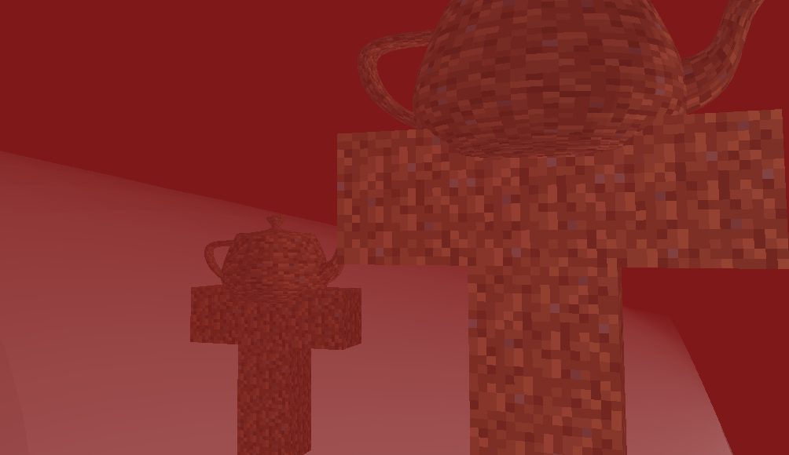

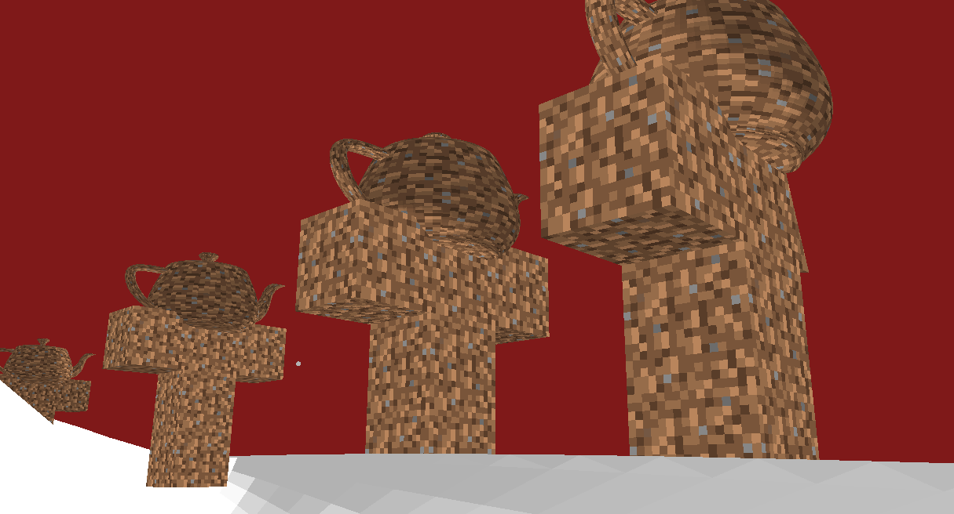

Вывод

Я освоил работу с nurb поверхностями и листами объектов