**Design Document**

Deloitte Social Media Crawler

Adam Ramkissoon

Clark Hardaway

Eric Peterson

**1. Overview**

**1.1 Introduction**

In government and business there is a growing need to include social media checks as part of the background investigation process. Manually checking multiple social media sites can be labor intensive and prone to significant human error. Therefore, this project aims to create a tool that would automate this process and to provide much more accurate results based on an applicant’s social media history.

**1.2 Scope**

**2. High-Level Design**

**2.1 High-Level Component Design**

(insert component diagram)

|  |  |
| --- | --- |
| **Component** | **Description** |
| Twitter Bootstrap | A bootstrap template will be used to implement the user interface. |
| Facebook Javascript SDK | This SDK will be utilized to implement the ‘Log In w/ Facebook’ functionality and to generate authorization tokens. |
| Registration Interface | Custom information gathering for creating an applicant profile that can easily be accessed via public API. |
|  |  |
|  |  |
|  |  |

|  |  |
| --- | --- |
| **Component** | **Related Requirements ID (See Req Doc)** |
| e.g., Twitter Bootstrap | e.g., 100, 200, 300, 400, 600, 700, 800, 1000 |
|  |  |
|  |  |
|  |  |
|  |  |
|  |  |

**2.2 Activity Diagrams**

There will be two primary user roles for this system: Applicant and Administrator. There will be a view for each role. These can be expanded as time allows. For now, there will be one universal administrator user.

**2.2.1 – Applicant Activity Diagram**

Applicants must log in with Facebook via the Facebook Javascript SDK in order to generate an authorization token. New applicants will be taken to a registration page to create a simple profile. After the profile is created, the user must log out.



**2.2.2 – Administrator Activity Diagram**

Administrator(s) will generally access the system via API calls but for simplicity we will create a global administrator user with a username and password login system. Administrative users will be able to review the alerts assigned by the system to applicant profiles. If time allows, detailed information on the nature of alerts flagged by the system will be available for each profile.



**2.3 Class Diagram**

(describe class diagram)

(insert class diagram)

**2.4 Sequence Diagram**

This is a high level overview of how Administrators and Applicants interact with the system and the Facebook components utilized to complete the applicant profile.



**3. User Interface Design**

**3.1 UI Description**

The user interface is simple. Applicants will log in using Facebook to generate an authorization token. Once that is obtained the system conducts the search on the authorized profile. There will be a small optional information collection screen (not really necessary but added to give this document some bulk). Administrators will be able to view the scores of all the applicants. The system automatically takes care of everything else.

**3.2 UI Mockup**

**3.2.1 – Login Screens**

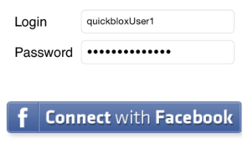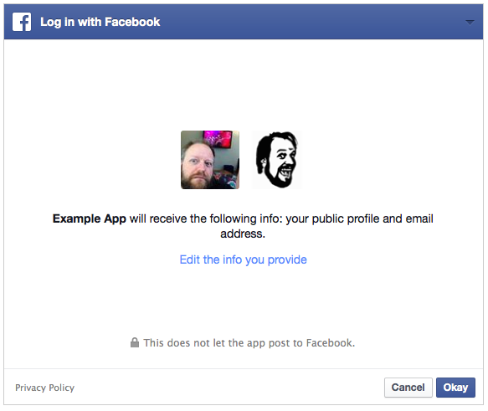

**3.2.2 – New User Information Collection Screen**

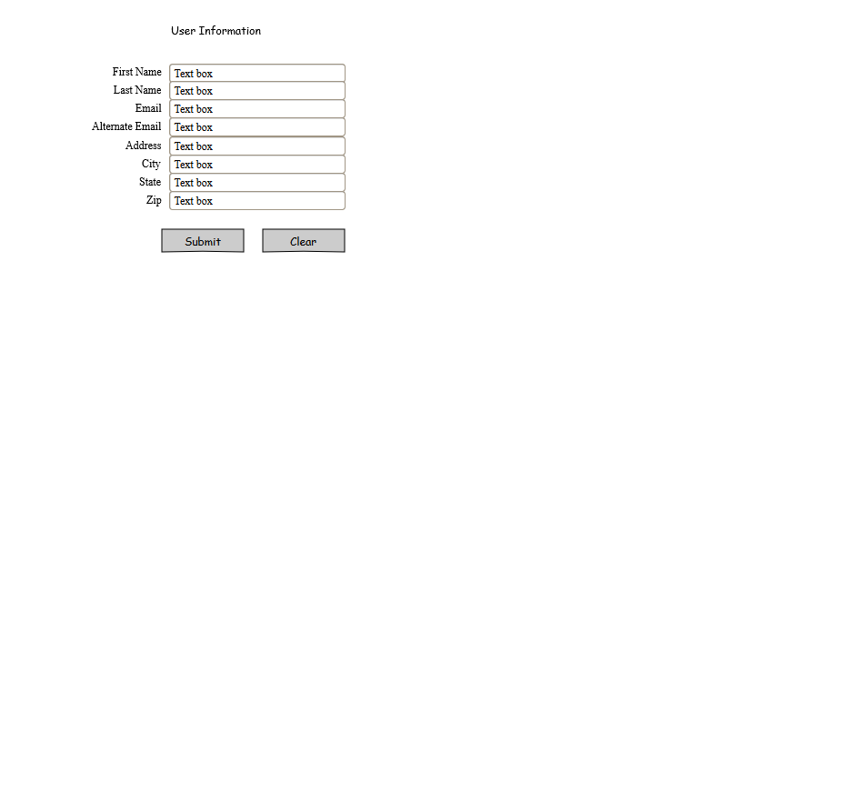

**3.2.3 – Administrator View**

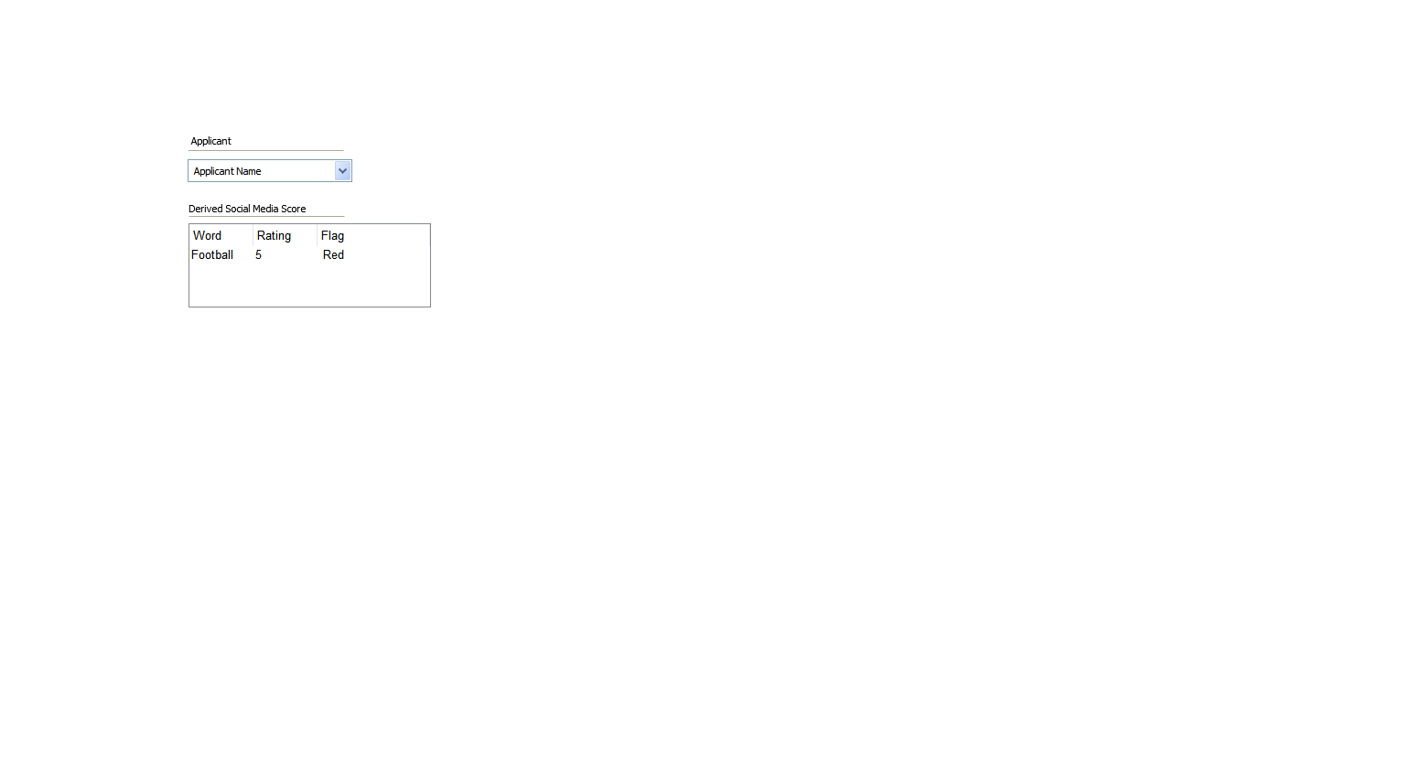

**4. Data Design**

**4.1 Program Data**

A very simple MySQL database will be used to store user profiles and social media alert levels. This will contain only one table to store applicant profiles.

**4.2 Data Formats**



**5. Non-Functional Design**

**5.1 Security**

Security for applicants will be provided by the Facebook authentication system.

**5.2 Performance**

The performance of the system is determined by how quickly the Facebook Graph API can query applicant profiles. Both applicants and administrators should experience no lag or waiting time and nearly all of the computing is done on Facebook’s side.