**1. What is our independent variable? What is our dependent variable?**

* The independent variable is the congruency of color and word (incongruent, congruent). The dependent variable is the time it takes to name the ink colors in the list

**2. What is an appropriate set of hypotheses for this task? What kind of statistical test do you expect to perform? Justify your choices.**

The set of hypotheses are:

H0: μC = μI

(where H0 is the null hypothesis, μC is the population mean for congruent condition and μI is the population mean for incongruent conditon)  
This null hypothesis states that there is no difference in population means between the two two tests (congruent and incongruent words)

Ha: μC < μI

(where Ha is the alternative hypothesis)

The alternative hypothesis states that the population mean of the incongruent condition is significantly larger than then populaion mean of the congruent condition. The time it takes to complete the task is longer when the color of the word and the word itself are not the same.

I will expect to perform the one-tailed dependent t-test for paired samples because each subject is assigned to two tests (congruent and incongruent words). We want to know if the population mean of incongruent test times is greater than the population mean of congruent test times. It is assumed by the test that the data is normally distributed, with a ratio scale of measurement (time) The subjects are randomly sampled from the population and each subject was measured for both conditions.

**3. Report some descriptive statistics regarding this dataset. Include at least one measure of central tendency and at least one measure of variability.**

**Congruent**

**Mean:** 14.05  
**STD:** 3.56 **Median:** 14.36

**Incongruent**

**Mean:** 22.02  
**STD:** 4.80 **Median:** 21.02

**4. Provide one or two visualizations that show the distribution of the sample data. Write one or two sentences noting what you observe about the plot or plots.**

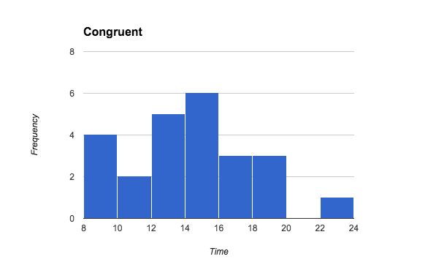

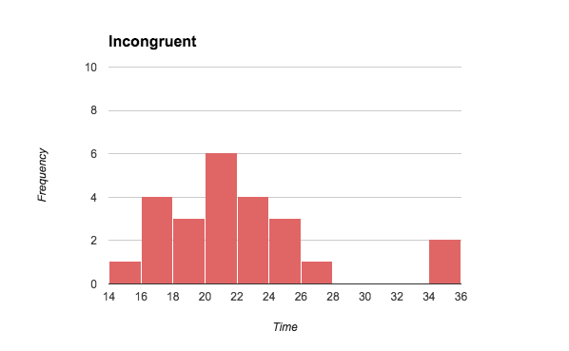

* Both histogram plots have a shape of a normal distribution, where the maximum frequency appears in the center of each distribution. There appears to be some outliers with high times in the “Incongruent” distribution.

**5. Now, perform the statistical test and report your results. What is your confidence level and your critical statistic value? Do you reject the null hypothesis or fail to reject it? Come to a conclusion in terms of the experiment task. Did the results match up with your expectations?**

* The mean difference is 7.965
* The standard deviation of the difference is 4.865
* The t-statistic for this paired t-test is 8.021
* The α level is 0.05, with the confidence level = 0.95
* With 23 degrees of freedom, the critical statistical value is 1.714
* We reject the null hypothesis since the determined p value is extremely small (p < 0.0001).
* We accept the hypothesis that it takes longer to complete the task when the color of the word and the word itself are not the same. Therefore, the results did match up to my expectations.

**6. Optional: What do you think is responsible for the effects observed? Can you think of an alternative or similar task that would result in a similar effect? Some research about the problem will be helpful for thinking about these two questions!**

* An incongruent word distracts your brain from recognizing the actual color of the word, thereby increasing response time.
* Another similar task is by presenting face pictures and words pertaining to emotion. The words can be congruent or incongruent with the pictures.