**1. Introduction**

A technology consultant has partnered with the Maryland state and local governments, as well as Maryland’s humane societies and vets, to revolutionize the process by which homeless pets are matched with foster families and placed in permanent homes.

This is the software system proposal document for the Pet Forever Home project sponsored by the Maryland state and local governments.

This project is being undertaken by the COSC-412 Group 1 development team. The team is comprised of undergraduate students majoring in Computer Science at Towson University.

**1.1 Project Overview**

Currently there is no centralized website for placing pets through the state into permanent homes. Instead many different organizations have their own, often outdated websites. This project will be an all in one portal that will link all adoption facilities making it more accessible for users to find pets to adopt. There will be information pertaining to each pet at each location, information about how to adopt, about the adoption facilities, instructions on general care for pets, a donation portal, and social media awareness. This all-inclusive website will also allow for adoption facilities to post information about pets up for adoption with high quality photos and videos.

**1.2 Project Deliverables**

* Requirements
* Use Cases
* SPMP (This document)
* Repo Link
* Design Documents
  + HLA
  + Class/Component Diagram
  + Interface Diagram

**1.3 Evolution of the SPMP**

Proposed changes and new versions of the software project are announced on Discord and Trello and will be available to all project members.

**1.4 Reference Materials**

GitHub: <https://github.com/>

**1.5 Definitions and Acronyms**

* API: Applications Programming Interface
* UML: Unified Modeling Notation
* OOD: Object-oriented design
* QA: Quality Assurance
* HLA: High-level architecture

**2. Project Organization**

**2.1 Process Model**

The project uses an OOD approach and uses UML and flowcharts for the development of the web application. The development process is organized in several activities. The members of the project are one organized team with various roles and responsibilities. The web application is under github and links to the documentation can be found there.

**2.2 Organizational Structure**

**2.3 Organizational Interfaces**

|  |  |
| --- | --- |
| **Team Member** | **Contact Information** |
| **Jacob Adelstein** | **jadels4@students.towson.edu** |
| **Eddie Woods** | **ewoods6@students.towson.edu** |
| **Samuel Efesoa** | **sefeso1@students.towson.edu** |

**2.4 Project Responsibilities**

* Team Responsibilities
  + Discovery Phase
    - Test different technologies and tools
    - Design the infrastructure and plan the deployments of the project
    - Requirements and use cases
  + Design
  + Development
    - QA
    - Release preparation
* Eddie Woods
  + UI/UX
  + Database Design and Implementation
  + Front-End
* Jacob Adelstein
  + Front-End
  + Back-End
* James Garrison
* Samuel Efesoa
  + Back-end development

**3. Managerial Process**

**3.1 Management Objectives and Priorities**

Management will oversee all priorities, prioritizing team and individual tasks, and deliverable scheduling. Management will review and approve all deliverables and assign changes if necessary. Management will oversee the use and changes in requirements with the development team and client. Management will decide and enforce the budget with the client and developers.

**3.2 Assumptions, Dependencies, and Constraints**

* Assumptions
  + Each project member will attend weekly meetings
  + Each project member will be available to provide accurate timelines for individual deliverables
  + Management will be able to provide insight on budget limitations
  + Management will have consistent and clear communication with the client
  + Each project member will be able to perform exceptionally respective to their job duties
  + Each project member will have clear and consistent communication with the team and management
* Constraints
  + The project will be finished by July 21, 2021
  + Each deliverable will be final submitted by July 21, 2021
  + The budget will be maintained equal or less to what the client has set
  + Appropriate and efficient tools will be used
  + Appropriate licensing will be used
* Dependencies
  + The completion of the SPMP (This document), use cases, and requirements are completed before the start of the project
  + Design, planning, and review of documentation are completed at the start of the project
  + The design review, use cases, requirements, and tool selection will be used as a guideline for the project
  + The structure of the website will be the start of the project
    - To buy or create

**3.3 Risk Management**

* Allow flexibility for the development team to be able to build and implement their own design if the budget is reached
* Have constant communication with the client to provide constant prototypes and receive daily feedback to prevent dissatisfaction at the end of the project
* Have weekly code reviews and QA tests to prevent delays in development

**3.4 Staffing Plan**

* The development team consists of: Eddie Woods, Jacob Adelstein, Samuel Efesoa, James Garrison, and Andrew Flemming. Each person on the team will be assigned roles for each segment of the project. Everyone will play a critical and crucial role in the progression of the project.

**3.5 Monitoring and Controlling Mechanisms**

* Cost performances
* Variances of the project’s time duration
* Influencing the factors that will cause a change in the project’s course

**3.6 Managing Change**

* Create request for change
  + Review and assess the request
* Plan the change with development team
* Discuss the change with stakeholders
* Test the change
* Create change proposal
* Implement changes
  + Review the changes performance
* Close the changing process with development team and stakeholders

**4. Technical Process**

**4.1 Methods, Tools, and Techniques**

* Computing Environment
  + Operating Systems: Ubuntu/Windows/MACOS
* Source Code Control
  + Github
* Languages
  + JS
  + SQL
* Design Methodology
  + Agile
* Design Tools
  + Figma

**4.2 Software Documentation**

This project will use Github for all documentation and source code. Trello and discord will be used for scheduling documentation and task assignments. Text and blackboard will be used for revision, review, and approval of documentation.

**4.3 Project Support Functions**

The documentation will take place through GitHub. A .txt file will be pushed to GitHub where all project documentation will take place. Throughout the project, each team member will be expected to update the documentation file when changes are made to the project.

**5. Description of Work Packages**

**5.1 WBS**

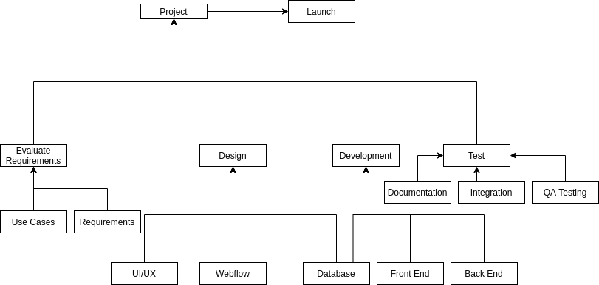

**5.2 Gantt Chart**

