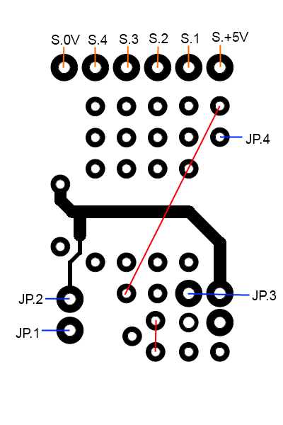
Using a BS-1 PCB for driving 2-4 color signals.

Build instructions

- Place 2 wires on the PCB. They are colored red on the image to the right.
- Place the following parts:
  - U1
  - R2..R5
  - C1
- Connect 4 wires from the PCB to an MGV50 (or connector). They are colored blue on the image to the right.
- Connect the signal to the PCB. They connections are colored orange.

