Run MAIN.m code
In folder …\Example\ should be file: filename_PresegBscan.jpg
Open filename_PresegBscan.jpg GIMP program and prepare presegmentation

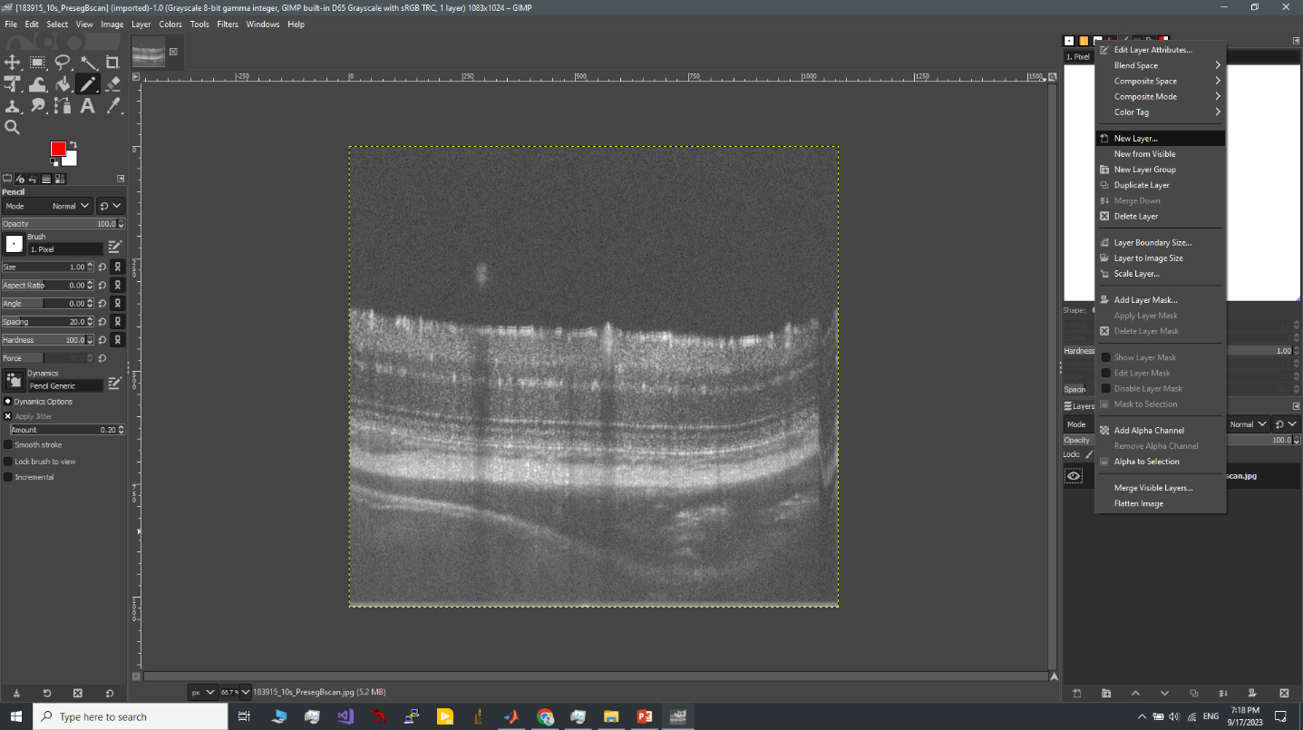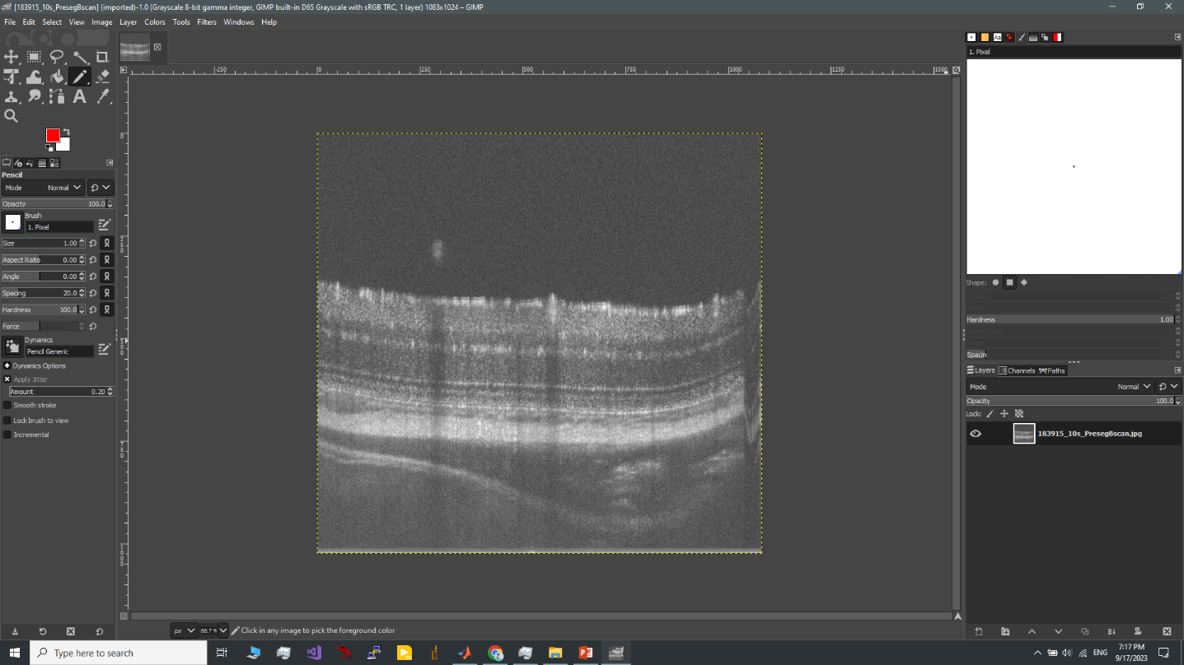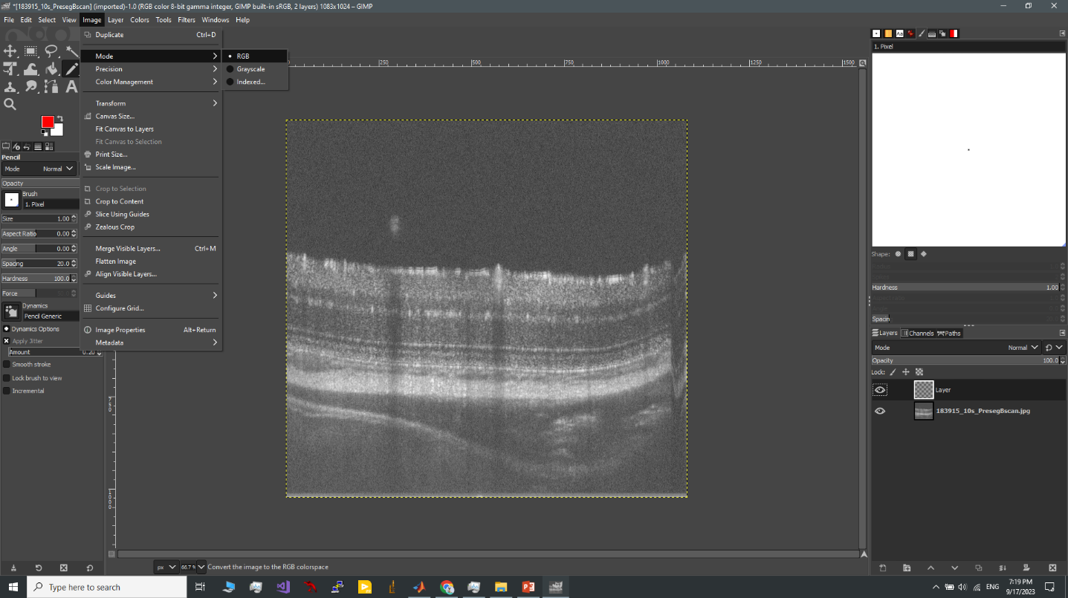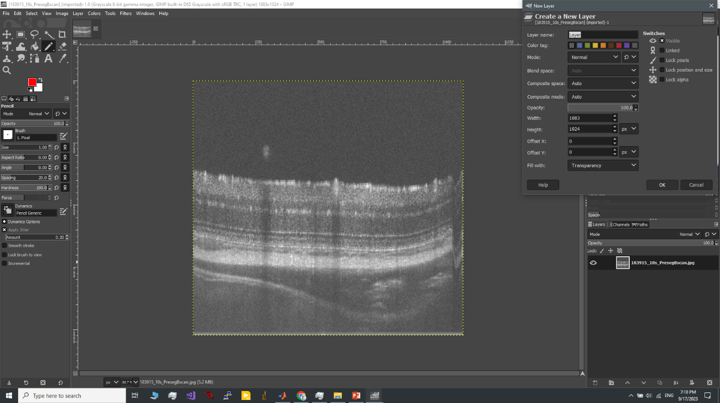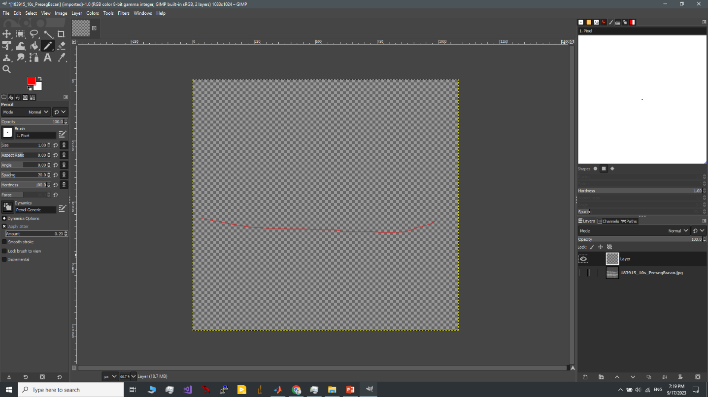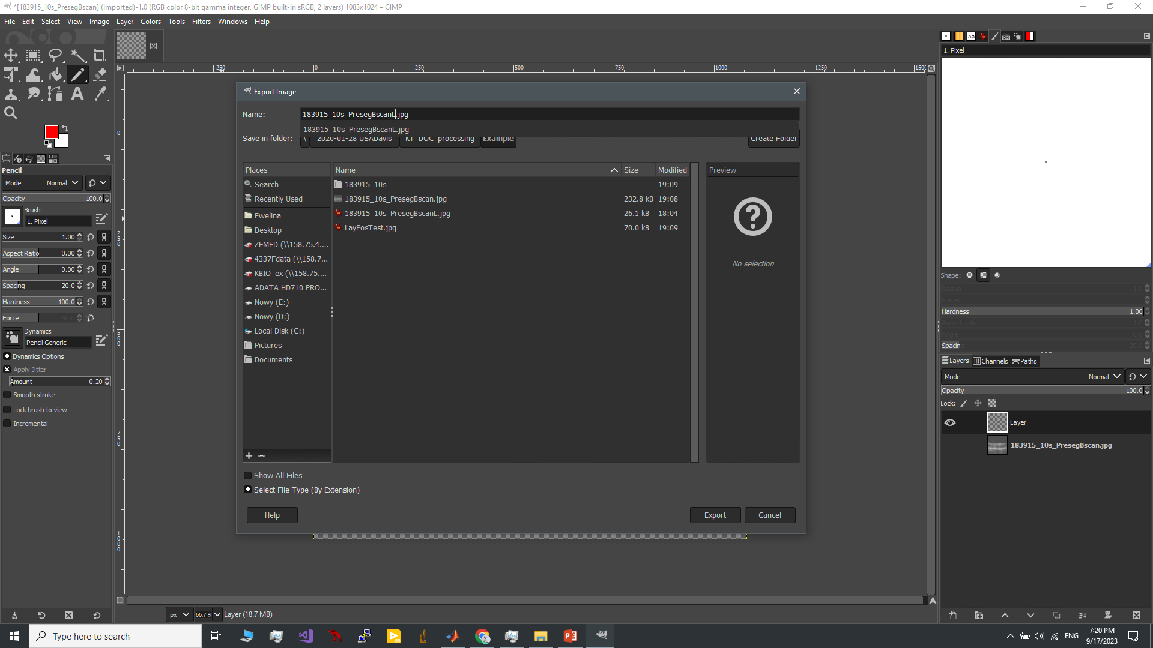

Export your segmentation …\Example\filename_PresegBscanL.jpg
Run MAIN.m

