Juniper seed transfer procedure
Anika Rao prepared this procedure for the autumn archive handover. Accept only dry, labelled packets; quarantine any packet whose seal or moisture record is uncertain.

Intake checks
Record the packet mass before sealing. Repeat the measurement if the scale was moved.
Apply the same mass rule after repacking¹. The reused note defines one rule for both steps.
Quarantine packets showing condensation. Anika reviews the quarantine shelf each Friday.
The retention schedule is documented in the archive handbook.
Reference: Archive handbook section 4

Packing sequence
- Weigh the dry packet.
  - Inspect the inner sleeve.
  - Record any tear before replacing it.
- Seal the packet and attach its label.
Table 1. Acceptance limits for the dry packet handover.
Acceptance checks
Material | Mass tolerance | Moisture ceiling
Juniper | ±0.03 g | 8.0%
Rowan | ±0.05 g | 9.5%
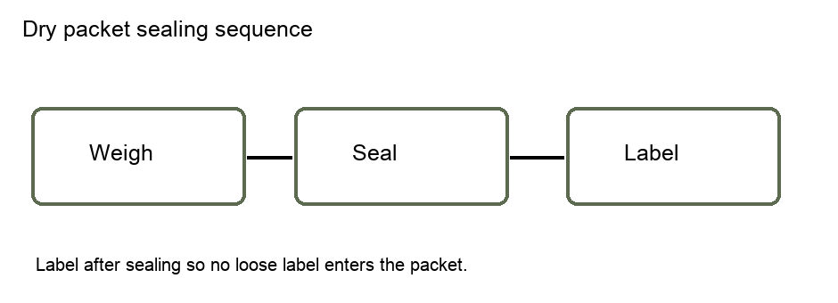
Figure 1. Label placement follows sealing; the three boxes show the required order.

Transfer verification
- Compare the destination code with the manifest.
  - Read the code aloud to the receiving clerk.
- Sign only after both counts agree.
The second sequence deliberately restarts at 1. A disagreement blocks transfer until the manifest is corrected.

Packet readiness
The saved native chart shows 24 ready packets and 6 quarantined packets. These are the source counts, not a forecast.

Figure 2. Cached native chart of packet readiness at the handover.
Do not return quarantined packets to the ready shelf without a new moisture record.

Mass rule: use the dry mass in grams, rounded to two decimal places; include the inner sleeve but exclude the outer label.
Quarantine rule: condensation includes visible droplets or a damp inner sleeve, even when the packet mass is acceptable.
Retention schedule: keep a signed handover record for 18 months after the transfer date.

