Harbor water-saving pilot
Decision: extend the pilot to Pier B on 15 October 2026. Owner: Mira. The chart is evidence, not decoration.
Site | Before | After
Pier A | 120 L/day | 72 L/day
Pier B | Pending | Pending
Water use before and after
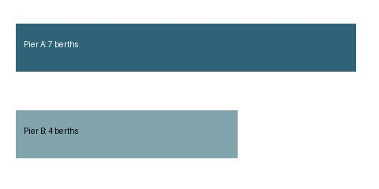
Same chart for operations handoff

