Titan Setup Instructions Simplified

ONE TIME ONLY Installation
Install GIT
https://git-scm.com/downloads
Install CUDA Toolkit 10.0
https://developer.nvidia.com/cuda-10.0-download-archive?target_os=Windows&target_arch=x86_64&target_version=10&target_type=exenetwork
Install Visual Studio 2015
Install Windows SDK 10
https://developer.microsoft.com/en-us/windows/downloads/windows-10-sdk/
====================================================================
Optional (if you have two versions of CUDA)
Set Environment Variables.
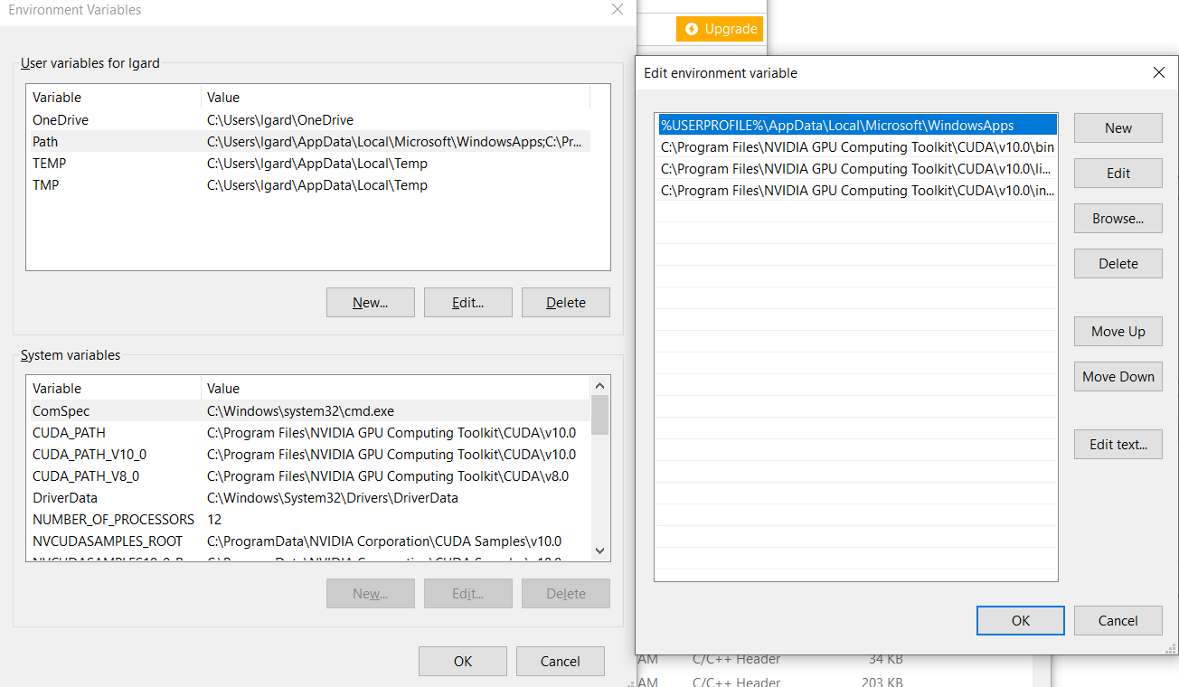

C:\Program Files\NVIDIA GPU Computing Toolkit\CUDA\v10.0\bin
C:\Program Files\NVIDIA GPU Computing Toolkit\CUDA\v10.0\libnvvp
C:\Program Files\NVIDIA GPU Computing Toolkit\CUDA\v10.0\include
Install vcpkg
Open up a command line:
In the lower left window beside the magnifying glass, type Run:
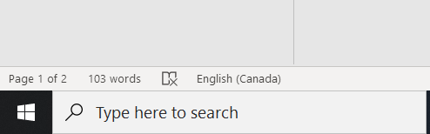
Run <enter>

Then type cmd then OK.
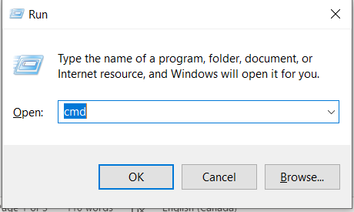
You will get a Command window:
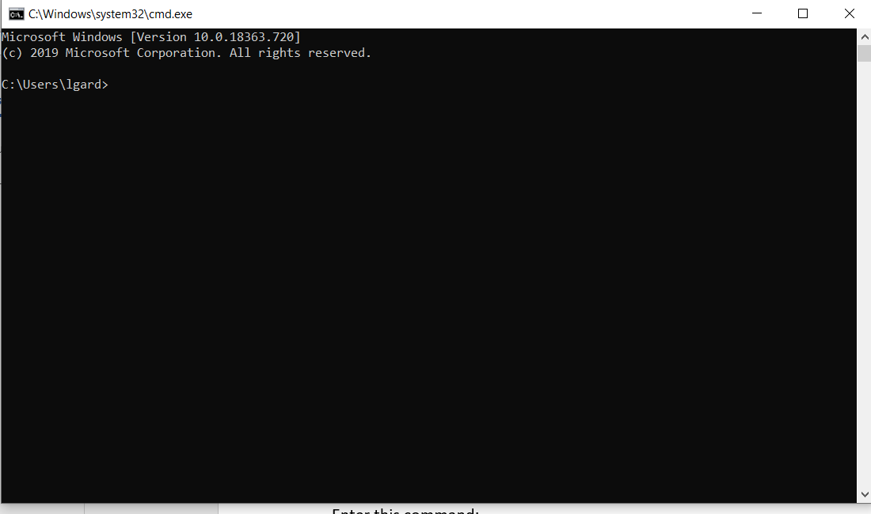
Navigate to C:/ Type cd.. <enter> cd.. <enter> to navigate to the main C:/ directory.
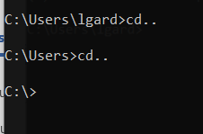

Download vcpkg
Enter this command (or copy and paste):
git clone https://github.com/Microsoft/vcpkg.git
Navigate to c:/vcpkg/
Enter this command (or copy and paste):
bootstrap-vcpkg.bat
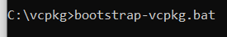
{wait for messages build to complete}
Install vcpkg
Then enter this command:
vcpkg integrate install

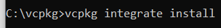
Download Titan
Navigate back to main C:/ drive {cd..}
Enter this command:
git clone https://github.com/jacobaustin123/Titan.git
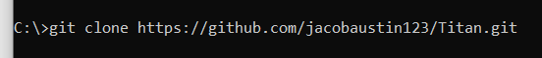
The project will be downloaded to c:/Titan/

Using window file explorer…
Copy the titan folder in the C:/Titan/vcpkg
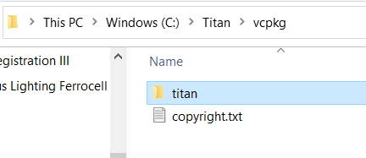

And paste into the c:/vkpkg/ports folder
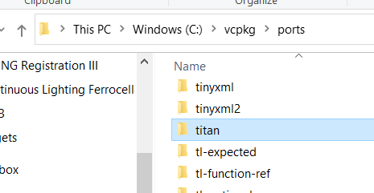

Install Titan
Using the command line, navigate back to the vkpkg folder {cd vcpkg }.
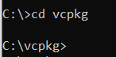
Enter this command:
vcpkg install -–head --triplet x64-windows titan

This will build the Titan Toolkit optimized for your system.

