Gilberto Lopez

Mason Various

Team: Fighting Mongoose

Assignment 4

10/21/2014

**Pivotal Tracker**

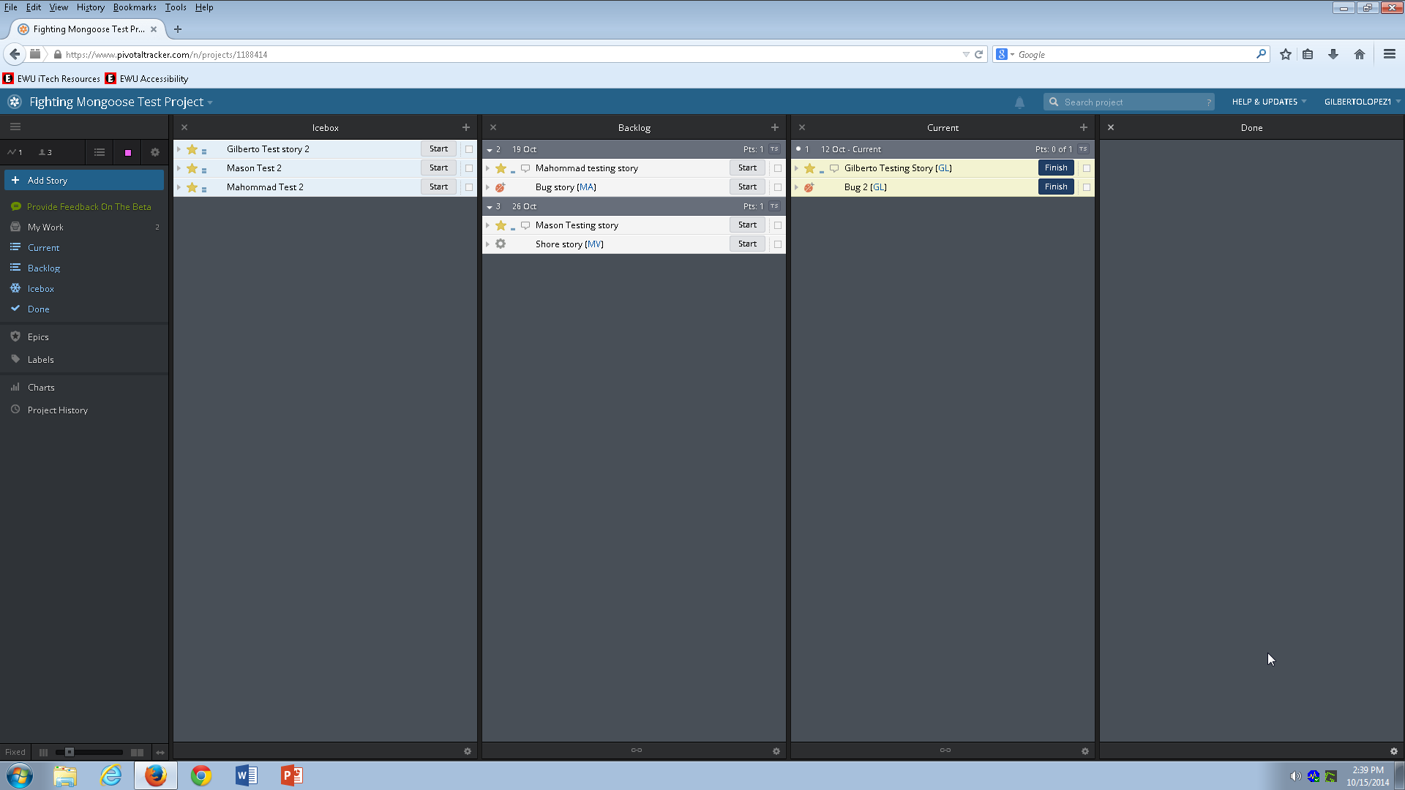

Created stories and assigned them to team. Some are in the icebox and others are in the backlog in a prioritized order. Higher priority go on top and lower priority go bottom. Also, got some stories started in the current stage.

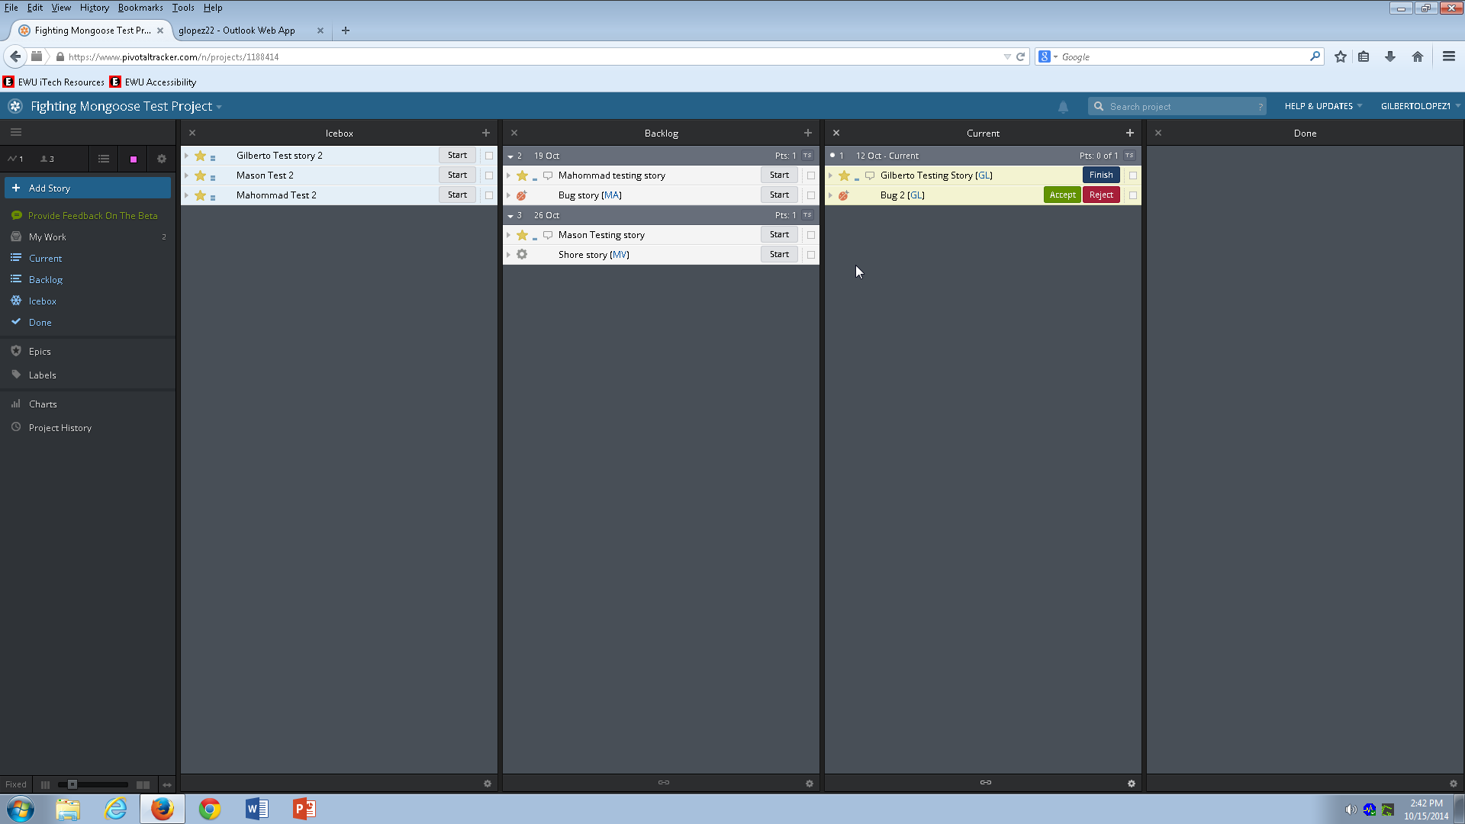

Started a bug fix for this project.

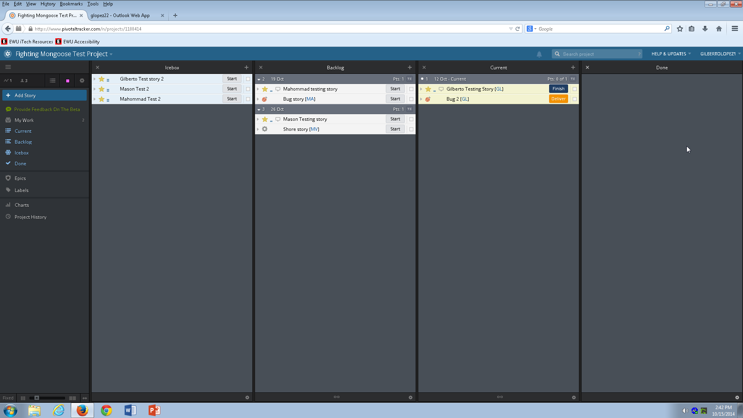

Bug got accepted but not delivered yet.

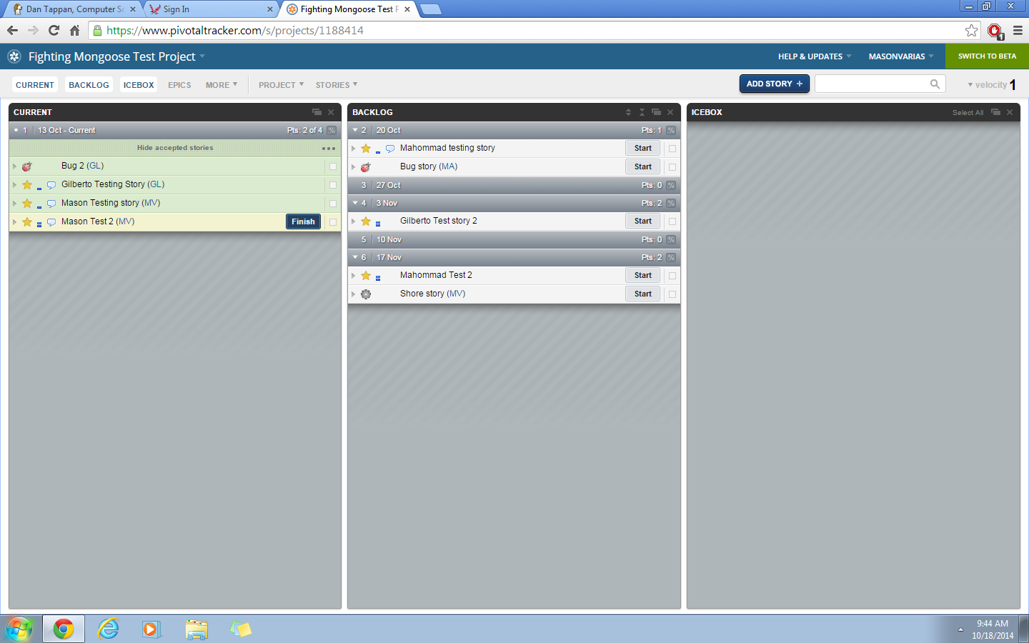

Mason started “Mason Test 2” as well as delivered “Mason Testing story”

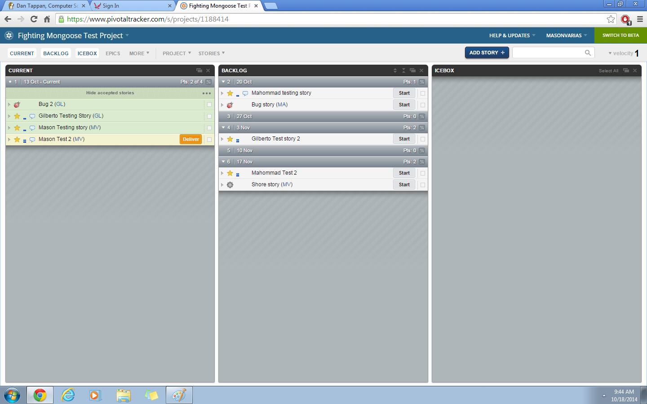

“Mason Test 2” has been finished but has not yet been delivered

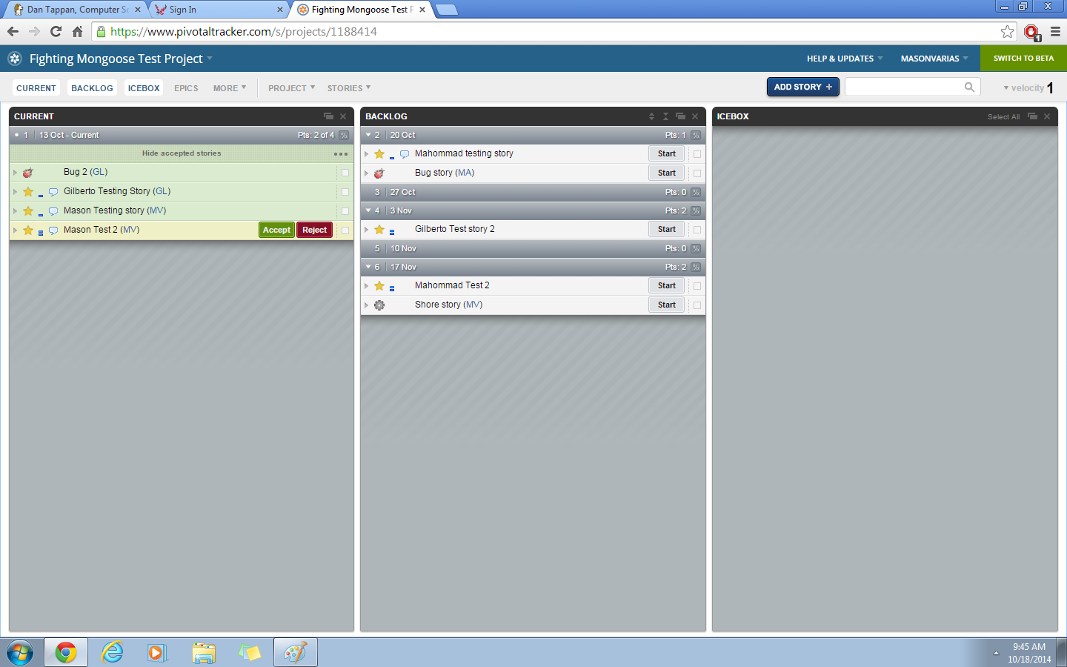

“Mason Test 2” has been delivered but has not yet been accepted

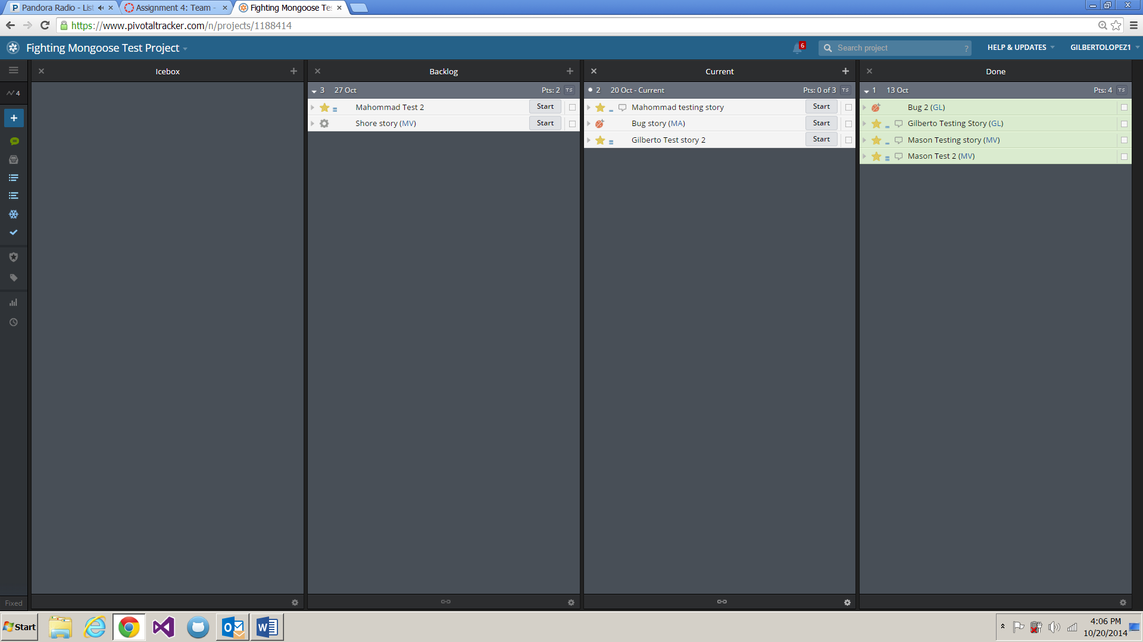

“Mason Test 2” has been accepted. First completed iteration has been 4 points in total.