Fighting Mongoose

Gilberto Lopez

Mason Varias

**Git Hub**

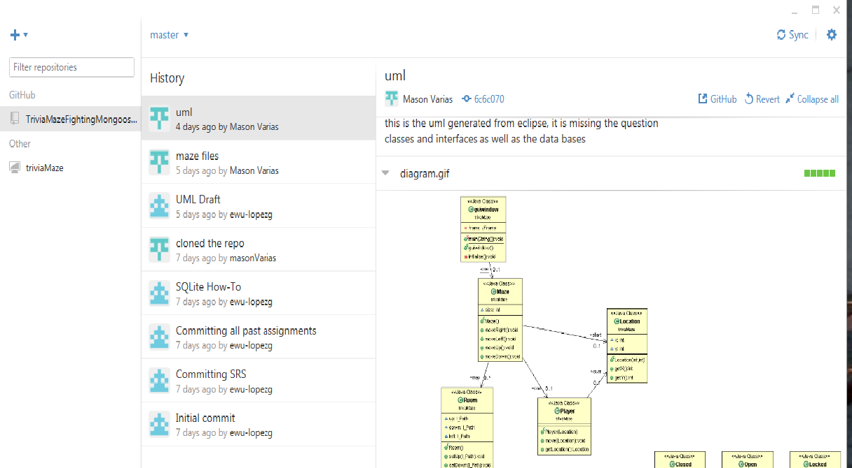

**Finished Stories**

**Maze Class**

