Mason was here...

Trivia Maze
Version 1.0

Approved By:
____________________________ ___________________________

Program Manager Quality Assurance

REVISION HISTORY
Revision | Version | Description of Change | Changed By | Effective Date
1 | 1.0 | Template | GL | 11/05/2014
2
3

Note: Some areas of this template suggest including the requirement ID with the design element. This could create additional work in updating the design document if there are subsequent requirements changes. If you are using an automated requirements repository, it is better to include only the design element ID in the document. The requirement can be located using traceability from the design element to the requirement if the repository is well-maintained. The compliance matrix can be printed with requirement and design IDs as well as the requirements text to assist the reader.

There may be more sections in this template than desired in your SDD. Some may be removed, changed, or merged depending on your system or organizational requirements.

Ludwig Consulting Services, LLC
TABLE OF CONTENTS
1 INTRODUCTION 6
1.1 Overview 6
1.2 Scope 6
1.3 Background 6
1.4 References 6
1.5 Assumptions and Constraints 6
1.6 Document Overview 7
2 METHODOLOGY 7
2.1 System Design Framework 7
2.2 System Design Alternatives 8
2.3 Risks 8
2.4 Updated Requirements Compliance Matrix 8
3 ROLES AND RESPONSIBILITIES MATRIX 8
4 SYSTEM DESCRIPTION 8
4.1 System Software Architecture 8
4.2 System Technical Architecture 9
4.3 System Hardware Architecture 9
4.4 External Interfaces 9
5 SUBSYSTEM SPECIFICATIONS 10
5.1 Subsystems 10
6 TECHNICAL SPECIFICATIONS 13
6.1 Module 13
7 DATA ARCHITECTURE 13
7.1 Database and File Architecture 13
7.2 Data Dictionary 14
7.3 Data Conversion 14
8 SECURITY 15
8.1 User Level Permissions 15
8.2 Control Points 15
8.3 Vulnerabilities 15
9 OPERATIONAL CONSIDERATIONS 15
9.1 Audit Trail 15
9.2 Recoverability 16
9.3 Failure Contingencies 16
9.4 System Availability 16
9.5 Capacity 16
9.6 Performance and Timing 16
9.7 Data Retention 17
9.8 Error Handling 17
9.9 Validation Rules 17
9.10 Conventions/Standards 17
9.11 Adaptability 17
APPENDIX A - ACRONYM LIST 18
APPENDIX B – GLOSSARY 19
APPENDIX C – REQUIREMENTS COMPLIANCE MATRIX 20

List of Exhibits
Exhibit 3: Sample Subsystem Diagram 10
Exhibit 4: Sample Module Diagram 11
Exhibit 5: Sample Sub Module Diagram 11
Exhibit 6: Sample Sub Module Diagram with Web Page Template 12
Exhibit 7: Sample User Interface Page 12
Exhibit 8: Data Element Matrix 12

INTRODUCTION
In this Trivia Maze game the objective it to move from a starting location of the maze to the end. In order for the user to move throughout the maze, they must pass through a door. They will need to answer a question correctly in order to open the door and move throughout the maze. If they answer incorrectly, then the door becomes locked and they must find another route. If there is no way to reach the end, the game ends and they lose.

METHODOLOGY
Describe the approach used to develop the components of the SDD. If a particular methodology was followed, name it. This section is often omitted from an SDD.

System Design Framework
The design effort transforms the detailed, defined requirements into complete, detailed specifications that direct development and testing. Design decisions detail how the system will meet the defined functional, physical, interface, security, and data requirements. At the end of the design process the design is baselined.
The general system characteristics are defined during design. The operating system is established and the automated system packaged into major design subsystems. Inputs and outputs of each subsystem are defined, interfaces to external systems are designed, and administrative activities are established. Security and auditing needs are also addressed.
A more detailed structure of the system is then created based on the subsystems identified by the general characteristics. Each subsystem is partitioned into one or more design units, or modules. The process is described in a structure chart, flowchart, action diagram, pseudo code, or other acceptable format for each design unit, or module. Detailed logic specifications are written for each module described and data usage is physically defined to the elemental level. Functions requiring user input and approval are completed in this activity.
Throughout the design phase there are a series of check point and review processes. The design is reviewed to verify that it has the following characteristics:
- Is directly traceable to the requirements.
- Describes how the capabilities defined by the requirements will be implemented.
- Describes design considerations such as computer hardware, operating system, and database design.
The SDD includes:
- User, human/computer interface design
- System architecture
- Detailed system design
- Data base design including a physical data model and data dictionary
- External interface design

System Design Alternatives
Discuss viable design alternatives that were considered. If the status quo (current system, no changes) is not viable, state why. This is a concise, high level discussion that points out the major viable alternatives that were discussed during the design process. Discuss the risks and benefits of each, including the assessment of the design review of each alternative achieving the goals discussed in the background.

Risks
-installer
-sql injection
Discuss risks in the design of the system that affect future work and the contingency plans if the risk occurs. Risks should be in the risk register, and this document included in the reference list.

Updated Requirements Compliance Matrix
Functional requirements are baselined after the approval of the Functional Requirements Document (FRD). If requirements must be changed (which can occur at any time during the system life cycle), they must go through the configuration management process. After approval of the change, a minor baseline is created (this is the modified baseline, for example, from version 1.0 to 1.1).
The compliance matrix is updated to add the SDD elements. After the design is approved, it is baselined and any changes to it must also go through the configuration management process. The compliance matrix, updated with design elements, would be attached to the SDD for review and its version identified. As there are possible changes after SDD approval, the reference document section should state the location of the requirements repository (if there is one) so that future system developers can locate the current version. Ideally, the SDD will be updated to reflect changes.

ROLES AND RESPONSIBILITIES MATRIX
The roles and responsibilities of the team are sometimes included in the SDD.

SYSTEM DESCRIPTION
Describe the system in narrative form using non-technical terms.

System Software Architecture
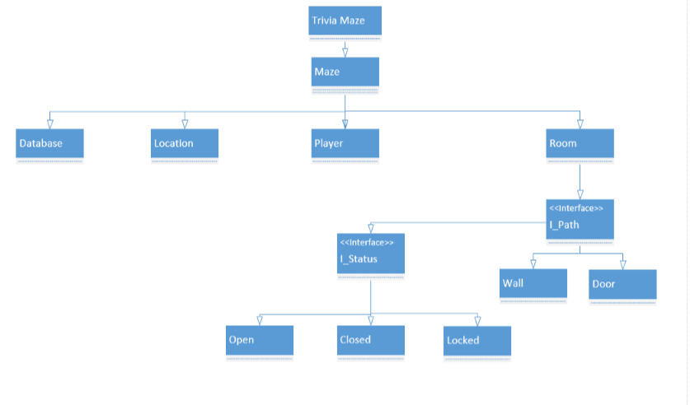

Master List of Modules
List modules in the subsystem and provide a brief description of each module. If there are no modules within the subsystem, this section may be omitted.

Modules
Repeat module sections and subsections as needed to describe the system.

Module Description
Provide a description for each module within the subsystem and explain its function. Use a chart or diagram to show the breakdown of any sub modules that exist within the module. If possible, provide the number for the requirement the module represents.
Exhibit 4: Sample Module Diagram
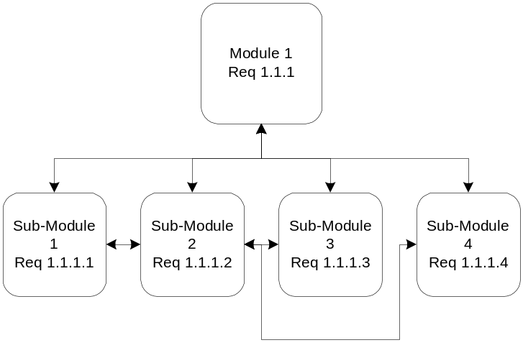
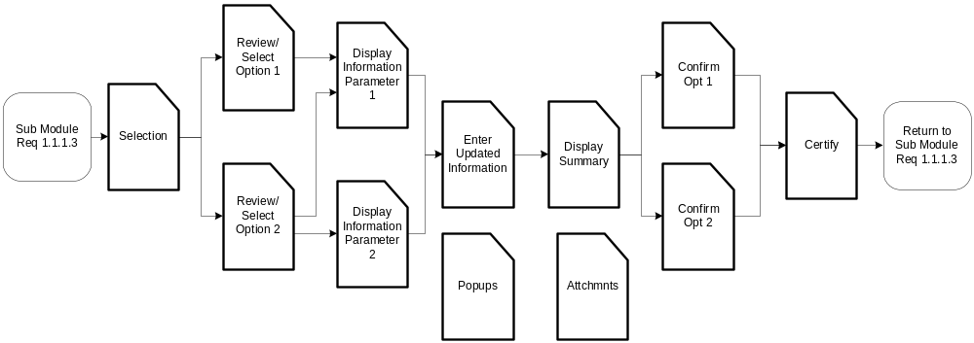
Exhibit 6: Component

Provide a technical description of the component. Repeat this section as needed. Items included in the description are dependent upon the type of component (e.g., stored procedure, template, etc.). For all component types, provide the name, type, definition, location, constraints, and logic (either narrative or pseudo code). Include items such as input parameters, output parameters/result sets, and tables/files accessed as appropriate.

DATA ARCHITECTURE

Database and File Architecture
We will be using SQLite which will store the user name and password as well as the saved files which will save the status of the maze and player location. It will also have a database that holds the questions (true\false, multiple choice)

Describe the final design of the system database management system (DBMS) and the non-DBMS files. This can be included as an appendix.

Database Management System Architecture
A user name will be restricted to a string of size 10 or less and the password will be of type int and restricted to 4 digits. Each save file will have a string to represent the doors and walls (l=locked, o = open, c=closed, w=wall). the player location will be stored as a two digit int with the left most digit representing the row and right most digit representing column.

The question database will store the type of questions(true/false , multiple choice), the question itself as well as the selectable answers and the correct one.

Describe the final design of the database and include the following information (refer to the data dictionary):
- The physical data model including normalized table layouts and an entity relationship diagram (ERD).
- A description of the DBMS schemas, sub-schemas, records, sets, tables storage page sizes, etc.
- Describe database connectivity method (e.g., ODBC).
- Estimate of the database size or volume of data within the file and data pages, including overhead resulting from access methods and free space.
- Definition of the update frequency of the database tables, views, files, areas, records, sets, and data pages. Estimate the number of database transactions.
- Describe how permissions will be accommodated (e.g., user groups).
- List and reference the documentation of the DBMS utility software available to support the use or maintenance of the database.

Data Dictionary
Provide a comprehensive data dictionary detailing data element name, type, length, source, validation rules, maintenance (i.e., create, read, update, and delete capability), data stores, outputs, aliases, null/not null status, and description. This can be included as an appendix.

SECURITY
Security is often an ignored area of a system, being added on rather than built in. In today’s environment, security must be addressed early in the system life cycle. Describe the use and management of integrity and access controls that apply to the physical components such as schema, sub-schema, partitions or physical files, records or tables, sets or relations, and data elements. Provide the security standard the system must meet, e.g., NIST or other standard or point to the security requirements ID numbers based on these standards.

User Level Permissions
Admin
user
Identify user roles and permissions. Describe use of permissions for that particular module, including the user levels that are available, and the authority that grants those permissions. Discuss differences between internal and external use of the module if applicable. List the data that is classified as private and unavailable to the public user.

Control Points
Admin Boolean and password, can edit database
Identify the control points in the system. A control point is an application or a physical device that regulates which users have access to specific information and resources. A firewall is an excellent example of a control point. Additionally, show the relationship of security control points to each other in the system. For example, a proxy or web server may communicate to another server (domain controller) to validate the authentication of users accessing web content on a third server.

Vulnerabilities
Describe potential vulnerabilities that exist in the system. Vulnerability is a design, implementation, or operational condition inherent in the application or system that causes error, loss, or compromise of information or denial of service. Vulnerability may include, but not limited to dialup access, file uploads/downloads, logon screens or public web sites.

Recoverability
Describe the system recovery design, for example, database mirroring, switchover, automatic system re-boot, graceful shutdown/start up, etc. Do not include recovery process steps performed manually by operators or system administrators

Error Handling
Check for user, check for type, password, within range
Describe general error handling routines and procedures. This may include, but is not limited to standard screen and database errors. Also, describe how the system will process application errors and any subsequent interaction with users. Include or reference any standards or conventions that will be used.

Validation Rules
If applicable, describe additional system validation design not addressed in Section 7.2 Data Dictionary or elsewhere.
APPENDICES

APPENDIX A - ACRONYM LIST
Provide the expanded name or title for the acronyms and abbreviations used in the document.

APPENDIX B – GLOSSARY
Provide a glossary of unique or special terms used in the SDD.

APPENDIX C – REQUIREMENTS COMPLIANCE MATRIX
Attached the compliance matrix. Requirements and their unique identifiers appearing in the body of the SDD must appear verbatim in the RCM. If the requirement is deleted or changed, these sections must also be reviewed and possibly updated.

