Building LLM-based Tools to Enhance Learning of Database Query Languages

- Project Statement
The Principal Investigator (PI) will develop innovative Large Language Model (LLM)-based solutions to facilitate and enhance the teaching and the learning of database query languages including Relational Algebra (RA) and SQL. The project aims to make these topics more accessible and engaging for students, fostering a deeper understanding and practical proficiency in database querying.
- Purpose and Scope
Research Question: In database curriculum, Relational Algebra (RA) is an essential topic since it forms the mathematical foundation of relational database systems and provides the basis for understanding query languages like SQL (Structured Query Language). It connects database theory to mathematical concepts and this connection strengthens students' overall analytical skills. However, the differences in abstraction and practical application between SQL and RA pose significant gap and challenges in teaching these two query languages effectively. First, SQL is a declarative language that allows users to specify what data they want without detailing how to retrieve it, while RA is procedural, focusing on a sequence of operations that transforms data step-by-step. Second, SQL is widely used in the industry and is the standard language for querying and managing data. Consequently, students often see SQL as more relevant to their future careers. Relational Algebra, instead, is mainly used in academic contexts to help students understand the theory behind SQL. Third, RA uses symbolic notations (e.g., σ for selection, π for projection, ⋈ for natural join) that can be intimidating to students unfamiliar with mathematical formalism. Unlike SQL, which uses relatively intuitive keywords, RA expressions often feel more abstract and harder to relate to practical tasks. The absence of intuitive tools makes it harder to trace complex RA queries, and the need to mentally track intermediate steps further adds cognitive load. In this project, the PI will investigate feasible solutions to bridge the gap between RA and SQL through visual aids and develop interactive and engaging learning tools to help students better grasp the concepts and relevance.
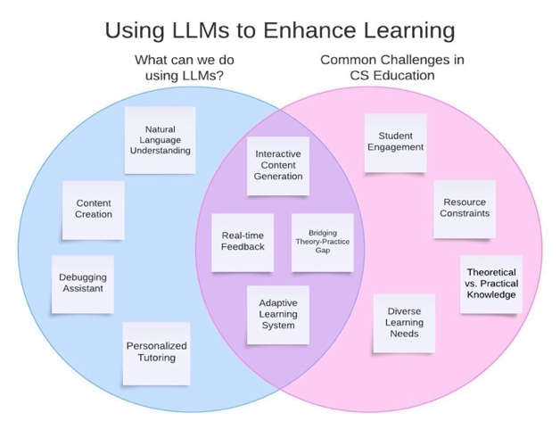
LLM-based Solutions in Education: As technology in Artificial Intelligence advances, there is an increasing demand for innovative solutions to address educational challenges, particularly within Computer Science (CS) disciplines. Large Language Models (LLMs), with their advanced natural language processing capabilities, present a unique opportunity to enhance learning experiences and tackle some common obstacles faced by both educators and students [21]. The figure below illustrates the capabilities of LLMs, the prevalent challenges in CS education, and the ways in which LLMs can help improve the overall educational experience.
One of the key challenges for Computer Science educators is the lack of connections between theoretical knowledge and practical application. Research has shown that LLMs can be highly effective in generating visualization tools to bridge the gap. For instance, Microsoft Research developed the LIDA tool [12], which uses LLMs to create dynamic, grammar-agnostic visualizations. The tool includes modules for summarizing data, generating code for visualization, and creating stylized graphics. Such advancement indicates that LLMs can be powerful assets in educational settings, providing students with adaptive learning aids that visually demonstrate theoretical principles in a way that is both engaging and directly connected to practical tasks.
Student engagement is another challenge in CS education, as many students find the material difficult to grasp. In addition, resource constraints often limit educators' ability to provide individualized support. The diverse learning needs among students require flexible approaches to accommodate various levels of experience and learning styles. LLMs can potentially address these challenges by acting as an interactive and adaptive learning tool to provide real-time feedback and encourage student engagement. Doughty et al. develop an LLM-based system (GPT-4) to produce multiple-choice questions which can be aligned with specific learning objectives for their Python Programming courses [5]. Wei et al. explore chain-of-thought prompting as an applicable method to decompose a challenging math problem into simpler sequential steps [22]. Gao et al. introduce an approach for natural language reasoning using programs as intermediate reasoning steps, which results in an answer that is guaranteed to be accurate, given the correctly predicted programmatic steps [6]. Overall, with these innovative designs, the applications of LLMs for problem-solving in education have made remarkable progress.
Scope of the Project: Although numerous LLM-based solutions have been developed to support education across various domains, there is a lack of research focused specifically on teaching database concepts. Amer-Yahia et al. discuss the advantages and limitations that LLMs have brought to data science and database research and education [1]. They find that language models can streamline the data management process, but these language models present challenges when it comes to data modeling, analytics, and interpretation. Prakash et al. explore the integration of LLMs into undergraduate database systems education by developing an LLM-based virtual tutor in the form of a chatbot [14]. This tutor helps students learn to read and write SQL while visualizing schemas and query results, offering instant feedback and support around the clock. While these existing educational models primarily focus on general SQL coding assistance or broader data management tasks, they fall short in bridging the conceptual gap between Relational Algebra (RA) and SQL, two fundamental database query languages. In this project, the PI proposes an LLM-based educational model that focuses on the mapping between the theoretical constructs of RA and the practical SQL queries via three major components: (1) dual query translation, (2) interactive query visualization, and (3) personalized RA-SQL bridging exercises and feedback.
- Significance and Value
This project focuses on developing LLM-based solutions tailored for educational applications, offering the Principal Investigator (PI) a valuable opportunity to explore cutting-edge techniques in AI and machine learning. The project aligns with the PI’s long-term research objectives and offers significant opportunities for both undergraduate and graduate students to engage directly in the research, allowing them to contribute to the development and refinement of LLM-based educational tools. Beyond the final product, students will gain hands-on experience with advanced AI techniques, equipping them to meet the evolving demands of the tech industry and remain competitive in the job market.
Database query languages are foundational to the database curriculum as they provide essential tools for data interaction and management. Mastery of these query languages equips students with skills for crucial tasks like data retrieval, aggregation, and transformation—key competencies in today’s data-driven world. In addition, the proposed development of LLM-based solutions to teach these concepts aligns with EWU’s commitment to a student-centered approach by integrating adaptive learning experiences tailored to individual needs. Moreover, by fostering a supportive environment where students receive immediate assistance, the project will boost their confidence and motivation. By making complex topics more accessible, the initiative will promote intellectual growth, enhance employability, and support the university’s mission of fostering upward social mobility. Overall, this initiative represents a significant step toward advancing the educational framework at EWU, positioning our students at the forefront of technological advancement and preparing them for successful careers in an increasingly data-driven world.
- Detailed Plans
Research Methodologies: In this section, the PI will discuss the techniques and strategies to effectively implement the three components outlined in Section 2.
Among four commonly used language model architectures, i.e., encoder-decoder [16], encoder-only [4], decoder-only [3], and dual-encoder [8], a dual-encoder model is technically well-suited for Relational Algebra (RA) to SQL query translation (or vice versa) due to the distinct yet semantically related nature of the two query languages. RA and SQL differ in syntax and structure, with RA being procedural and SQL declarative. A dual-encoder architecture allows each query type to be encoded separately, capturing the unique characteristics of each language while mapping their semantic equivalence. By encoding both RA and SQL into a shared latent space, the model can align their operations—such as selection, projection, and joins—despite their surface-level differences. This approach helps the model map the core logic of the two languages efficiently, focusing on meaningful semantic overlap rather than superficial syntactic variations. Moreover, dual encoders offer more interpretability by explaining which parts of an RA query correspond to specific SQL operations, making the translation process clearer. There are several pre-trained dual-encoder models available on Hugging Face as well as OpenAI’s GitHub [8, 15].
To implement interactive query visualization, there is a need to integrate database techniques and visualization tools into the model. A backend connection to the database can be implemented either using ORM frameworks such as SQLAlchemy or native connectors (e.g., psycopg2 for PostgreSQL). FastAPI will be used to interface between the language model, the visualization system, and the database. It can handle query execution requests, receive results, and send data to the frontend for visualization. While there are not many APIs dedicated specifically to visualizing RA or SQL queries, there are several libraries that offer visualization as part of their broader functionality. For instance, dbdiagram.io offers schema diagram generation based on SQL code, providing a visual representation of the database structure.
When it comes to generating personalized exercise questions using language models, the effectiveness of different techniques, e.g., prompt engineering [17, 20] and Retrieval-Augmented Generation (RAG) [18], can vary depending on the specific use case and requirements. Prompt engineering is often the quickest and easiest method to implement for well-defined tasks. However, if we aim for higher relevance and context-specific questions, RAG is a strong choice as it leverages external data effectively. In this project, the PI plans to investigate a hybrid approach that starts with prompt engineering to generate initial questions and then implement RAG to pull in relevant contextual information for those questions.
To create a personalized and engaging learning experience that adapts to each student’s needs, the model will adopt history remember technique to leverage previous interactions, performance data, and preferences to tailor educational contents effectively. At the same time, it is essential to address potential ethical concerns such as data privacy, algorithmic bias, and transparency. This can be achieved by implementing strict data protection measures, auditing AI models for fairness, and incorporating ethical guidelines that prioritize the well-being and privacy of all students. By maintaining a balance between personalization and ethical integrity, we can create a learning environment that is both effective and responsible.

