Detailed Game Specification:  
Pacman’s Revenge

Course: COMP 2659, Winter 2024  
Instructor: Marc Schroeder  
  
Author(s): Amtoj Punia and Evan Wushke  
Last Modified: January 25th, 2024

# 1. General Game Overview

Pacman wants to get **revenge** on the ghosts that have tormented him for years, however, he only has the strength to take on one ghost at a time.

Your main objective is to corner and eat all of the ghosts without getting overpowered.

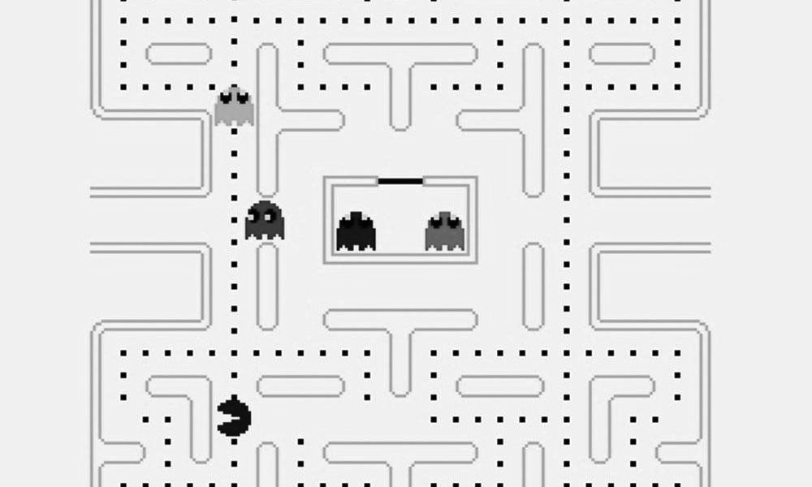

# 2. Game Play Details for Core 1-Player Version

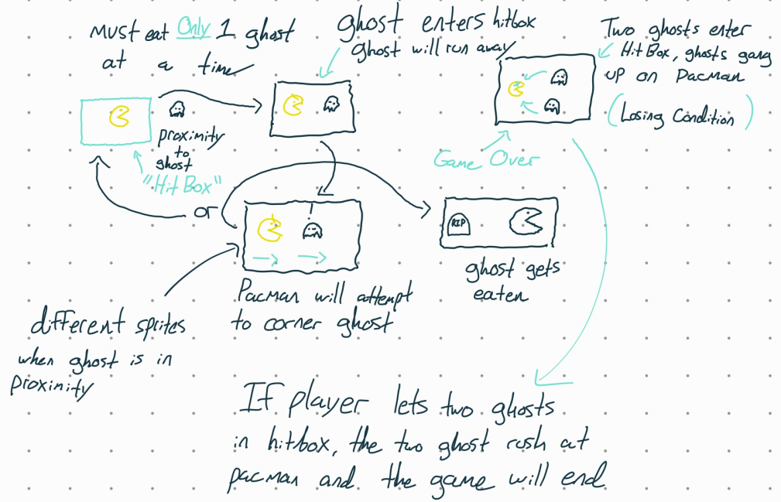

## Objectives and Rules

Pacman Starts in the lower center of the map, ghosts will start in the center and branch off to their respective static paths. There is a visible timer which will start at 0 and will increase in seconds.

The objective is to eat all the ghosts. Ghosts will not change their behavior unless pacman reaches a certain proximity to one of them. Once pacman is close to a ghost, it will attempt to run to the farthest corner of the map relative to its current location. Once the ghost reaches the corner, if pacman is still in the ghost's proximity, it will freeze, if pacman is not there, it will continue along its default path.

Pacman can move in four directions; up, left, down, right. The user will specify a direction using the arrow keys respectively. Pacman moves at a constant velocity of 64 pixels per second. The ghosts have the same velocity as pacman in their default state, and will have a velocity of 72 pixels per second when running away from pacman.

Once the ghost attempts to flee from pacman, he can intercept the ghosts if possible, but two ghosts entering Pacman’s proximity at any point in the game will result in an immediate loss.

Final score is based on the total time taken to eat all the ghosts. A lower time will result in a higher score.

## Objects

|  |  |  |  |
| --- | --- | --- | --- |
| Object or Object Type Name | Properties | Behaviours | Graphical Image |
| Map:  represented as a 2d integer array in this form:  [ [1,2,0,0,0, … ,1],  [0,0,0,2,2, … ,0], …] | * Path (0) (Free space for entities to move freely) * Wall (2)(Physical barrier, no entities can pass through * Corner (1)   (Destination for ghosts when running) | Static, collision  detection changes pacmans velocity to  0hz. (completely stops him in his tracks) | Wall sprite examples |
| Ghost (Default)   * 4 Ghost Entities. * 4 Sprites per ghost in default state matching direction. | * Position (integer pair) * Path (individual to each ghost instance) | * Traversal   ±1 in row  or column  position per in-game clock cycle |  |
| Ghost (Running) | * Position * Path (Current location to farther corner from current position) | * Traversal   ±2 in row  or column  position per in-game clock cycle   * Constant velocity of 72 pixels per second |  |
| Ghost (Freeze) | * Position | * Shivering animation, but no change in position vector |  |
| Pacman (Default) | * Position (integer pair) * Velocity (signed integer pair) * Hitbox   (±3 in row/column vector) | * Traversal   ±1 in row  or column  position per in-game clock cycle.   * Constant velocity of pixels per second |  |
| Pacman (Engraged) | * Same as default Pacman | * Same as default Pacman |  |
| Tombstone | * Generates when pacman eats a ghost at that specific location | * Static once placed, does not interact with any entity |  |

## Physics

There is collision detection in this game as there is a maze that pacman and the ghosts have to follow so there are walls surrounding him. This is to stop the objects from moving through the game environment.

The velocity for the object is constant (i.e pacman always moves at a constant speed) The ghosts can however move at a faster speed (when triggered) and it's just the base constant (64 pixels/second + 8 pixels/second) = 72 pixels/second

## Asynchronous (Input) Events

[Note: keyboard input is required of all games. Additional mouse input is optional for core game play.]

|  |  |  |
| --- | --- | --- |
| Event Name | Triggering Input Event | Description |
| Move down | ‘↓’ key is pressed | -Changes pacmans direction to down |
| Move up | ‘↑’ key is depressed | -Changes pacmans current direction to ‘up’ |
| Move left | ‘**←**’ key is depressed | -Changes pacmans direction to left |
| Move right | ‘**→**’ key is depressed | -Changes pacmans direction to right |

## Synchronous (Timed) Events

|  |  |  |
| --- | --- | --- |
| Event Name | Trigger Timing | Description |
| Pacman moves | 64 pixels per second | Pacman moves in the direction specified by the user at the default speed. |
| Ghost moves (default) | 64 pixels per second | Ghosts have this as their default speed during the whole game. |
| Ghost moves (Running) | 64+n pixels per second (n is just a placeholder for now) | When this is triggered, the ghosts will gain speed (adding a constant to default). |

## Condition-Based (Cascaded) Events

|  |  |  |
| --- | --- | --- |
| Event Name | Triggering Condition | Description |
| Wall collision |  | Pacman will stop |
| Single Proximity |  | A single ghost has entered pacmans Hit box, Pacmans sprite will change and a sound event will occur. |
| Double Proximity  (Game Over) | Can only occur during a Single Proximity event | A second ghost has entered pacmans hit box while single proximity is active, causing pacman to stop moving and the ghosts rush at pacman ending the game (loss) |
| All ghosts cleared  (Win) |  | Final ghost on the board is eaten, pacman stops and the win screen / animation is played. Score is tallied based on elapsed time, where score is inversely proportional to elapsed time. |

## Hypothetical Gaming Session

In "Pacman's Revenge", the game commences with Pacman positioned at the lower center of the maze, with the ghosts originating from the center and moving along their predestined paths. The on-screen timer starts at zero. As Pacman navigates the maze using the arrow keys for movement, the ghosts maintain their standard speed until Pacman nears one. This proximity triggers the ghost to flee towards the farthest corner of the maze. During this phase, the ghost's speed increases slightly, providing a challenge as Pacman tries to intercept it. Upon successfully cornering and consuming a ghost, the ghost will enter its freeze state and pacman can eat it. A tombstone then appears at that location. The player maneuvers Pacman to avoid simultaneous proximity with two ghosts, which would lead to a loss. The gameplay is a strategic blend of anticipation and rapid decision-making, as the player guides Pacman through the maze, isolating and consuming each ghost. The session culminates with the capture of the final ghost, triggering the win screen and score display, based on the total time taken. The lower the time, the higher the score, adding a competitive edge to the game. The game resets with options for replay or exit, concluding the session.

# 3. Game Play Details for Core 2-Player Version

A co-op version of the game with the same mechanics, the only difference is there is a second pacman on the board controlled by another player. The objective stays the same and this time both players have to kill all of the ghosts.

# 4. Sound Effects

|  |  |  |
| --- | --- | --- |
| **Sound Effect Name** | **Brief Description** | **Event which Triggers** |
| Pacman travel sound | The classic pacman sound that is made as the game runs on. | Sound playing any time pacman has a non-zero velocity. |
| Ghost eaten sound | When pacman eats a ghost, a “power up” type sound will be played. | Pacmans position vector matches with a ghosts position vector. |
| Ghost enters hitbox sound  (alert sound) | When a ghost gets within a certain location pacman, an alert sound will be played to indicate to the player that the ghost is close. | When pacman and the ghost enter the same grid location on the map, this sound will be played.  A ghosts (x,y) position is initial within pacmans (x±3 ,y±3) position. (3 by 3 grid section around pacman) |

# 5. Additional Features (Time Permitting)

[Add descriptions here.]

Powerup pickups

Color in the maze and the objects

Intro animation

Ghosts death animation

Tombstone with ghost name on it (RIP Pinky etc.)

Splash Screen