Detailed Game Specification:  
Pacman’s Revenge

Course: COMP 2659, Winter 2024  
Instructor: Marc Schroeder  
  
Author(s): Amtoj Punia and Evan Wushke  
Last Modified: January 25th, 2024

# 1. General Game Overview

Pacman wants to get **revenge** on the ghosts that have tormented him for years, however, he only has the strength to take on one ghost at a time.

Your main objective is to corner and eat all of the ghosts without getting overpowered.

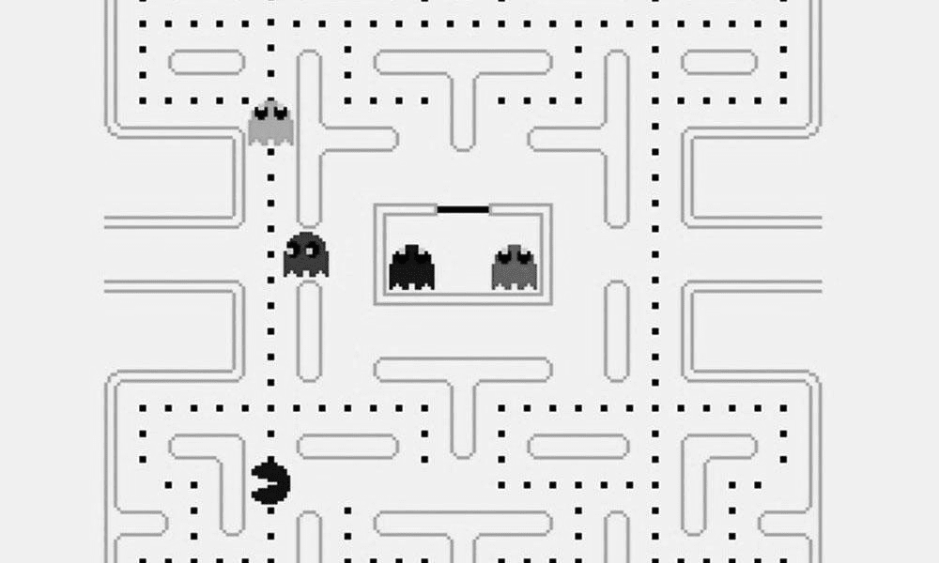

# 2. Game Play Details for Core 1-Player Version

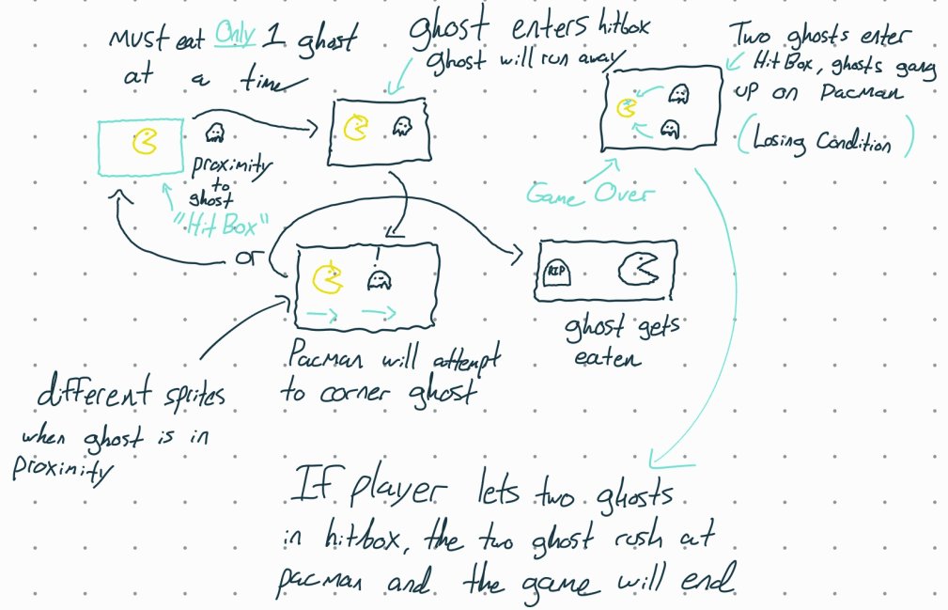

## Objectives and Rules

Pacman Starts in the lower center of the map, ghosts will start in the center and branch off to their respective static paths. There is a visible timer which will start at 0 and will increase in seconds.

The objective is to eat all the ghosts. Ghosts will not change their behavior unless pacman reaches a certain proximity to one of them. Once pacman is close to a ghost, it will attempt to run to the farthest corner of the map relative to its current location. Once the ghost reaches the corner, if pacman is still in the ghost's proximity, it will freeze, if pacman is not there, it will continue along its default path.

Pacman can move in four directions; up, left, down, right. The user will specify a direction using the arrow keys respectively. Pacman moves at a constant velocity of 64 pixels per second. The ghosts have the same velocity as pacman in their default state, and will have a velocity of 72 pixels per second when running away from pacman.

Once the ghost attempts to flee from pacman, he can intercept the ghosts if possible, but two ghosts entering Pacman’s proximity at any point in the game will result in an immediate loss.

Final score is based on the total time taken to eat all the ghosts. A lower time will result in a higher score.

## Objects

|  |  |  |  |
| --- | --- | --- | --- |
| Object or Object Type Name | Properties | Behaviours | Graphical Image |
| Map:  represented as a 2d integer array in this form:  [ [1,2,0,0,0, … ,1],  [0,0,0,2,2, … ,0], …] | * Path (0) (Free space for entities to move freely) * Wall (2)(Physical barrier, no entities can pass through * Corner (1)   (Destination for ghosts when running) | Static, collision  detection changes pacmans velocity to  0hz. (completely stops him in his tracks) | Wall sprite examples |
| Ghost (Default)   * 4 Ghost Entities. * 4 Sprites per ghost in default state matching direction. | * Position (integer pair) * Path (individual to each ghost instance) | * Traversal   ±1 in row  or column  position per in-game clock cycle |  |
| Ghost (Running) | * Position * Path (Current location to farther corner from current position) | * Traversal   ±2 in row  or column  position per in-game clock cycle   * Constant velocity of 72 pixels per second |  |
| Ghost (Freeze) | * Position | * Shivering animation, but no change in position vector |  |
| Pacman (Default) | * Position (integer pair) * Velocity (signed integer pair) * Hitbox   (±3 in row/column vector) | * Traversal   ±1 in row  or column  position per in-game clock cycle.   * Constant velocity of pixels per second |  |
| Pacman (Engraged) | * Same as default Pacman | * Same as default Pacman |  |
| Tombstone  Mouse | * Generates when pacman eats a ghost at that specific location | * Static once placed, does not interact with any entity |  |

## Physics

There is collision detection in this game as there is a maze that pacman and the ghosts have to follow so there are walls surrounding him. This is to stop the objects from moving through the game environment.

The velocity for the object is constant (i.e pacman always moves at a constant speed) The ghosts can however move at a faster speed (when triggered) and it's just the base constant (64 pixels/second + 8 pixels/second) = 72 pixels/second

## Asynchronous (Input) Events

[Note: keyboard input is required of all games. Additional mouse input is optional for core game play.]

|  |  |  |
| --- | --- | --- |
| Event Name | Triggering Input Event | Description |
| Move down | ‘↓’ key is pressed | -Changes pacmans direction to down |
| Move up | ‘↑’ key is depressed | -Changes pacmans current direction to ‘up’ |
| Move left | ‘**←**’ key is depressed | -Changes pacmans direction to left |
| Move right | ‘**→**’ key is depressed | -Changes pacmans direction to right |

## Synchronous (Timed) Events

|  |  |  |
| --- | --- | --- |
| Event Name | Trigger Timing | Description |
| Pacman moves | 140 pixels per 70 frames | Pacman moves in the direction specified by the user at the default speed. |
| Ghost moves (default) | 136 pixels per 70 frames | Ghosts have this as their default speed during the whole game. |
| Ghost moves (Running) | 136+n pixels per second (n is just a placeholder for now) | When this is triggered, the ghosts will gain speed (adding a constant to default). |

## Condition-Based (Cascaded) Events

|  |  |  |
| --- | --- | --- |
| Event Name | Triggering Condition | Description |
| Wall collision | Hitting a wall on the map. | Pacman will stop (delta y = 0 and delta x = 0) |
| Single Proximity | Pacman gets within a certain proximity of a ghost. | A single ghost has entered pacmans Hit box, Pacmans sprite and the ghost sprite will change. |
| Timer runs out  (Game Over) | Can only occur if  the timer reaches 0 | The timer starts from 99 and counts down to 0. If all four ghosts have not been killed then it is a loss. |
| All ghosts cleared  (Win)  Ghost encounter a corner.  Ghost encounters an open location while on its current path  Ghost is killed. | Final ghost is eaten. (no ghosts left)  The ghost detcted that it cannot go on its current path and a wakk collision is detected.    Pacman being within the proximity of a ghost for chase mode. If Pacman is not within their vicinity, the ghost cannot violate their default path.  Pacman touches a ghost sprite. | Final ghost on the map is eaten, pacman stops and the win screen is displayed.  The ghost will just change its y direction for down or up and then right after change its x direction to the open path available and go along it.  The ghosts have default path so they will not randomly chnage unless they are being chased. If this is the case, they will get an optimal direction away from Pacman. This is determined by splitting the screen in four quadrants to determine whether or not a ghost should match pacmans direction.  Once a ghost has avoided Pacman and he is out of their vicinity, there are directional maps and allow them to start back on their orignal paths once they have been offset from it.  (i.e run left if pacman is chasing them while facing left)  A tombstone is plotted on the ghosts current location and the ghost is cleared from the map. This tombstone then becomes a part of the environment and Pacman cannot go past it but the ghosts can. |

## Hypothetical Gaming Session

In "Pacman's Revenge", the game commences with Pacman positioned at the lower center of the maze, with the ghosts originating from the center and moving along their predestined paths. The on-screen timer starts at 99. As Pacman navigates the maze using the W, A, S or D keys for movement, the ghosts maintain their standard speed until Pacman nears one. This proximity triggers the ghost to flee the opposite directions from pacman or it picks an optimal direction based upon a direction map that is given to them if they encounter a wall. During this phase, the ghost's speed increases slightly, providing a challenge as Pacman tries to intercept it. Upon successfully cornering and consuming a ghost, the ghost will be cleared and a tombstone is placed in that location. The player maneuvers Pacman to avoid walls and tombstones as these become apart of the environment once a ghost is killed there. This means that there is a slight chance that the player can lock themselves inside a location on the map and not be able win the game so they must be strategic about this.The session culminates with the capture of the final ghost, triggering the win screen.

# 3. Game Play Details for Core 2-Player Version

A co-op version of the game with the same mechanics, the only difference is there is a second pacman on the board controlled by another player. The objective stays the same and this time both players have to kill all of the ghosts. (Note: This has not been implemented in the game's current version)

# 4. Sound Effects

|  |  |  |
| --- | --- | --- |
| **Sound Effect Name** | **Brief Description** | **Event which Triggers** |
| Pacman travel sound | The classic pacman sound that is made as the game runs on. | Sound playing any time pacman has a non-zero velocity. |
| Ghost eaten sound | When pacman eats a ghost, a “power up” type sound will be played. | Pacmans position matches with a ghosts position. |
| Pacman Intro Sound | Before the game starts, the classic pacman intro plays with all entities stationary and the game will not start until this intro is finished playing . | When the '1 Player' option is selected and the game begins. |

# 5. Additional Features (Time Permitting)

[Add descriptions here.]

Powerup pickups

Color in the maze and the objects

Intro animation

Ghosts death animation

2 player mode