***Documentation Approval Certificate***

This is to certify that for student (Ramaz ) of BS-CS of Computer Science Department Batch Fall 2 have Completed their final year project titled as “Online College shopping system” is checked and approved by supervisor that the documentation submitted by students is according to the format provided by the parental University, University of Baluchistan Quetta.

Supervisor……………………..

Dated………………………….

***Dedication***

“I humbly thank Almighty Allah, the Merciful and the Beneficent, who gave me health, thought and my parents, brother for their never-ending moral support and prayers which also acted as a catalyst in my academic life.

We dedicate this project to our Parents, without their Dua, patience, understanding, support and more of all love; the completion of this work would not have been possible.

***Acknowledgment***

To commence with the great name of Almighty Allah, who is the king of the kings, who provided us the courage to deal with the task of the project. It would be impossible if we did not have the help and blessing of the Great Almighty Allah. We are also quite thankful to our family who brought us to the pinnacle of prosperity by their love cooperation are effective prayer

We express our sincere thanks to the Vice-Chancellor and registrar of UOB, Quetta, for their extending support.

We would also like to express our heartiest thanks to our Dean, “Supervisor name “as the head of the department for their nice technical and moral encouragement and cooperation.

Finally, we would like to dedicate these projects to our parents, who encourage us throughout the project.

***Preface***

*The Proposed Online Shopping System emphasized removing the limitations and problems faced in using the current shopping system. The proposed solution transforms the manual system into an automatic system*

The online shopping System is designed for facilities Admin to keep their data accurate and to minimize word load. The customer using the System will be trained so the system will be better and efficiently used. The processes will be computerized and executed very fast. Due to automation, there will be less human interaction and therefore error chance will be lesser.

Table of Contents

**Chapter1: Introduction** 7

**1.1: Motivation:** 7

**1.2: Purpose:** 7

**1.3: Problem Statement:** 7

**1.4: Objectives:** 8

**1.5: Scope and limitations:** 8

**1.5.1: Product Characteristic and Requirement** 8

**5.2: Project Success Criteria:** 8

**1.6: Document convention:** 9

**Chapter2: System Analysis** 9

**2.1: Existing system and Alternative Solutions** 9

**2.1.1: Existing System** 9

**2.1.2: Alternatives Solutions:** 10

**2.2: Proposed Solution:** 10

**2.2.1: Provide Large Database** 10

**2.2: Technological Report** 10

**2.3: Tools and Framework** 10

**2.4: System Requirement:** 12

**Chapter:3 Functional Requirements** 12

**3.1: Functional Requirements:** 12

**3.1.1: Functional Requirements of the Admin:** 12

**3.1.1: Functional Requirements of Cataloging:** 13

**3.1.2: Functional Requirements of Report Generations** 17

**Chapter 4: System Design** 18

**4.1: Data Flow Diagram** 18

**4.1.1: Administrative Level:**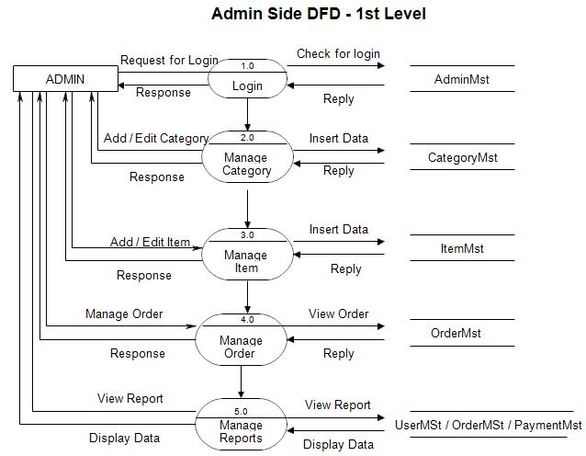 19

**4.3: Entity Relationship Diagram:** 20

**4.4: UML Activity Diagram** 21

**4.5: Use Case and Flow Charts** 21

**4.6: Sequence Diagram** 32

**Chapter5: Interface (user manual)** 38

**Chapter 6: Testing** 40

**1: Verification** 40

**Test case #1.1:** 40

**Test case #1.2:** 41

**Test case #1.3:** 42

**Test case #1.4:** 43

**Chapter6: Conclusion and Future Work** 44

**Conclusion:** 44

**Future Works:** 44

# **Chapter1: Introduction**

## **1.1: Motivation:**

Today All the Work of Balochi handmade embroidery is sell through shops which is very slow and consuming much effort and time. It is Required to design of a computerized Automated Shopping System, to speed up and make it easy to use the system. And sell their Balochi embroidery.

## **1.2: Purpose:**

The purpose to write this documentation is to describe briefly the project Online Shopping System. All the functional and functional requirements are described by consulting the clients in a different session. The document will meet all the requirement definitions of this project.

## **1.3: Problem Statement:**

The Project is to Automate a system that gives excellence of Data storage, customer can Registration, order Records, Order details, Balochi product Details, Customer Details, etc. In short, this project Marge all things about Balochi product shopping.

## **1.4: Objectives:**

* Automate system that gives the excellence of Data storage, customer can Registration, order Records, Order details, Balochi product Details, Customer Details, etc. In short, this project Marge all things about Balochi product shopping.
* Database maintained by this system usually contains the order Records, Order details, Balochi product Details, Customer Details, etc. It focuses on storing and processing (insertion, updating, deleting searching) by using web pages.
* Enter the customer Registration.
* Generate order record.
* Generate customer detail.
* Generate Balochi product details
* Mange All things

## **1.5: Scope and limitations:**

### **1.5.1: Product Characteristic and Requirement**

* User Can maintain their data on daily basis.
* User can Updating Records
* Inserting Records as they want.
* Searching their Records
* Availability of customer Information and order and payments.
* Taking Registration of customers easily.
* Availability of customer order information

### **5.2: Project Success Criteria:**

The main Goal is to complete this project within the required time.it is necessary to complete all the method and steps of development, tested and after all it is being rolled out. If the project takes too little more time than it would be considered a success of project.

## **1.6: Document convention:**

The following are the list of conventions and acronyms used in this document and the project as well:

* **Administrator:**

A login id representing a user with user administration privileges to the software.

* **SQL:**

Structured Query language, used to retrieve information from a database.

* **SQL Server:**

A Sever used to store data in an organized format.

* **Data Flow Diagram:**

It shows the dataflow between the entities**.**

* **Use Case:**

A broad level diagram of the project Showing a basic Overview.

* **Interface:**

Something used to communicate across different mediums.

# **Chapter2: System Analysis**

## **2.1: Existing system and Alternative Solutions**

### **2.1.1: Existing System**

The existing method of handing all Balochi Embroidery is not necessary, customer Registration, order Details, Product Details, Daily basis Update, and Manage shopping Details, Manage payments, etc. It is not maintained and up to Online shopping management. There is no record About Balochi shopping Maintain.

Some of the flaws of the exiting System Are as follows:

* No Proper Records.
* No Data backup
* No Ease of Data search and restriction.
* Heavy Paper Usage
* It no easy to extract any particular’s data

### **2.1.2: Alternatives Solutions:**

Automate system that gives the excellence of Data storage, customer can Registration, order Records, Order details, Balochi product Details, Customer Details, etc. In short, this project Marge all things about Balochi product shopping. Database maintained by this system usually contains the order Records, Order details, Balochi product Details, Customer Details, etc. It focuses on storing and processing (insertion, updating, deleting searching) by using web pages. Enter the customer Registration. Generate order record. Generate customer detail. Generate Balochi product details, Mange All things

## **2.2: Proposed Solution:**

### **2.2.1: Provide Large Database**

The online shopping System Database provides large database storage and saves the records easily and accurately.

### **2.2: Technological Report**

The Online shopping system uses many technologies. The operating requirement is window 10 and a new window is introduced. The computer system requirement is processor more than 2.10 GHz or more, RAM requirement is 2GB or more are compatible for the system.

## **2.3: Tools and Framework**

The tools used in our project are as follow:

* Microsoft Visual Studio (ASP.Net)
* SQL Server
* HTML
* CSS
* Microsoft Visio 2019
* Notepad++

Tools Description and Reason for using them

**ASP.NET for Web Development**

Asp.Net Stand for Active Server Page And ASP.NET is the enhanced version of ASP.

**Following are the reason for using it.**

* ASP.Net framework is complemented by a rich toolbox and designer in Visual Studio integrated Development Environment. Drag and Drop server Controls, and automatic Deployment are just few of the features this powerful tool provides.
* ASP.Net drastically reduce the amount of code required to build large Application.
* Provide Simplicity as ASP.Net make it easy to perform common task, from simple form submission and client authentication to development side configuration.
* The source code in HTML is together they’re for ASP.NET pages are easy to maintain and Write.
* The source code is executed on server his provide a lot of power and flexibility to the web pages.
* Being language in dependent, its allows you to choose language that best apply to your application or partition your application across many languages.
* ASP.Net make for easy Deployment there is no need to register components because the configuration information is built-in.

**C#:**

C# is being used as business logic in this project

Following are some reasons for using for development

* Visual studio net has libraries and automatic code generation, which reduce it development time of an application by 70%.
* Now there is a known need to write thousands of line codes for browser-specific HTML and java scripts, it works like the desktop application you can drag and drop everything you want.
* Vb.net Provide good visibility, if there is an error in your code then it will tell you that you are doing wrong, and it will give you the option of tracepoint to these kinds of future are IDE,
* C# has a common language run time (CLR) with a lot of language including visual J#; visual c++, and javaScript. All these languages provide access to dot Net FrameWork.

## **2.4: System Requirement:**

* **Software:**

Microsoft Visual 2017

SQL Server 2017

MS Visio 2013

* **Hardware:**
* **Operating System:** window 7 or window 8, **10**
* **Processor:**2.30 GHz or higher
* **RAM:**2 GB or more
* **Hard Drive:** 150 GB or more

# **Chapter:3 Functional Requirements**

This section contains all of the functional requirements of the system. It gives a detailed description of the system and all its features:

## **3.1: Functional Requirements:**

This section includes the requirements that specify all the fundamental actions of the software system.

### **3.1.1: Functional Requirements of the Admin:**

**Table 3-1: Admin Login**

|  |  |
| --- | --- |
| Identifier | 101 |
| Title | Admin login |
| Requirement | The system Shall allow the admin to login. |
| Rationale | To perform relevant actions. |
| Restrictions and risks | None |
| Dependencies | None |
| Priority | High |

**Table 3-2: Admin Logout**

|  |  |
| --- | --- |
| Identifier | 102 |
| Title | Admin logout |
| Requirement | The system Shall allow the user to logout from her account. |
| Rationale | To allow admin to logout from system |
| Restrictions and risks | None |
| Dependencies | 101 |
| Priority | High |

**Table 3-3: Admin Add New Account**

|  |  |
| --- | --- |
| Identifier | 103 |
| Title | Add new Account |
| Requirement | The system Shall allow the Admin to add new her account. |
| Rationale | To allow admin to add new account from system |
| Restrictions and risks | None |
| Dependencies | 101 |
| Priority | High |

## **3.1.1: Functional Requirements of Cataloging:**

**Table 3-4: Add customer Registration**

|  |  |
| --- | --- |
| Identifier | 104 |
| Title | Add customer Registration to the database |
| Requirement | The system Shall allow admin to add customer Registration to the database of system. |
| Rationale | To add customer Registration to the database |
| Restrictions and risks | None |
| Dependencies | 101 |
| Priority | High |

**Table 3-5: View customer Registration**

|  |  |
| --- | --- |
| Identifier | 105 |
| Title | View customer Registration |
| Requirement | The system Shall allow admin to view list of customer t Register in database. |
| Rationale | To view all the customer Registration |
| Restrictions and risks | None |
| Dependencies | 101 |
| Priority | Medium |

**Table 3-6: Accept customer Registration**

|  |  |
| --- | --- |
| Identifier | 105 |
| Title | Accept customer Registration. |
| Requirement | The system Shall allow admin to accept customer Registration information received by users to the database. |
| Rationale | To accept customer Registration from users to the database. |
| Restrictions and risks | None |
| Dependencies | 101, 105 |
| Priority | High |

**Table 3-7: Edit customer Registration**

|  |  |
| --- | --- |
| Identifier | 107 |
| Title | Edit customer Registration |
| Requirement | The system Shall allow admin to edit customer Registration received by users in the database. |
| Rationale | To Edit customer Record to the existing |
| Restrictions and risks | None |
| Dependencies | 101 |
| Priority | High |

**Table 3-8: Add Balochi Product Information**

|  |  |
| --- | --- |
| Identifier | 108 |
| Title | Add Balochi product information to the database |
| Requirement | The system Shall allow admin to Balochi product information to the database of system. |
| Rationale | To add Balochi product information to the database |
| Restrictions and risks | None |
| Dependencies | 101 |
| Priority | High |

**Table 3-9: Accept Balochi product Information**

|  |  |
| --- | --- |
| Identifier | 109 |
| Title | Accept Balochi product information |
| Requirement | The system Shall allow admin to accept Balochi product information received by users to the database. |
| Rationale | To accept Balochi product information from users to the database. |
| Restrictions and risks | None |
| Dependencies | 101,108 |
| Priority | High |

**Table 3-10: View Accept Balochi product Information**

|  |  |
| --- | --- |
| Identifier | 110 |
| Title | View Balochi product information |
| Requirement | The system Shall allow admin to view list of accept Balochi product information in database. |
| Rationale | To view all the accept Balochi product information |
| Restrictions and risks | None |
| Dependencies | 101,109 |
| Priority | High |

**Table 3-11: Update Balochi product information**

|  |  |
| --- | --- |
| Identifier | 111 |
| Title | Update Balochi product information |
| Requirement | The system Shall allow operator to update or edit Balochi product information received by users in the database. |
| Rationale | To update Balochi product information to the existing |
| Restrictions and risks | None |
| Dependencies | 109 |
| Priority | High |

**Table 3-12: Add shopping Cart Details**

|  |  |
| --- | --- |
| Identifier | 112 |
| Title | Add shopping cart Details to the database |
| Requirement | The system Shall allow admin to add shopping cart to the database of system. |
| Rationale | To add shopping cart to the database |
| Restrictions and risks | None |
| Dependencies | 101,112 |
| Priority | High |

**Table 3-13: Accept shopping cart details**

|  |  |
| --- | --- |
| Identifier | 113 |
| Title | Accept shopping cart Details to the database |
| Requirement | The system Shall allow admin to accept shopping cart information received by users to the database. |
| Rationale | To accept shopping cart from users to the database. |
| Restrictions and risks | None |
| Dependencies | 112 |
| Priority | High |

**Table 3-14: View shopping cart Details**

|  |  |
| --- | --- |
| Identifier | 114 |
| Title | View shopping cart Details to the database. |
| Requirement | The system Shall allow admin to view list of all shopping cart in database. |
| Rationale | To view all the shopping cart records. |
| Restrictions and risks | None |
| Dependencies | 112 |
| Priority | High |

**Table 3-15: Update shopping cart information**

|  |  |
| --- | --- |
| Identifier | 115 |
| Title | Update shopping cart information |
| Requirement | The system Shall allow operator to update or edit shopping cart information received by users in the database. |
| Rationale | To update shopping cart information to the existing |
| Restrictions and risks | None |
| Dependencies | 112 |
| Priority | High |

**Table 3-16: Search shopping Details**

|  |  |
| --- | --- |
| Identifier | 116 |
| Title | Search Shopping details |
| Requirement | The system Shall allow admin to search list of all Shopping details in database. |
| Rationale | To Search all Shopping details |
| Restrictions and risks | None |
| Dependencies | 122 |
| Priority | High |

### **3.1.2: Functional Requirements of Report Generations**

**Table 3-17: Generate Reports**

|  |  |
| --- | --- |
| Identifier | 117 |
| Title | Generate Report |
| Requirement | The system Shall allow Admin to Generate A report on OSS According to the requirement |
| Rationale | To allow the Admin to generate reports the system. |
| Restrictions and risks | None |
| Dependencies | 130 |
| Priority | High |

# **Chapter 4: System Design**

## **4.1: Data Flow Diagram**

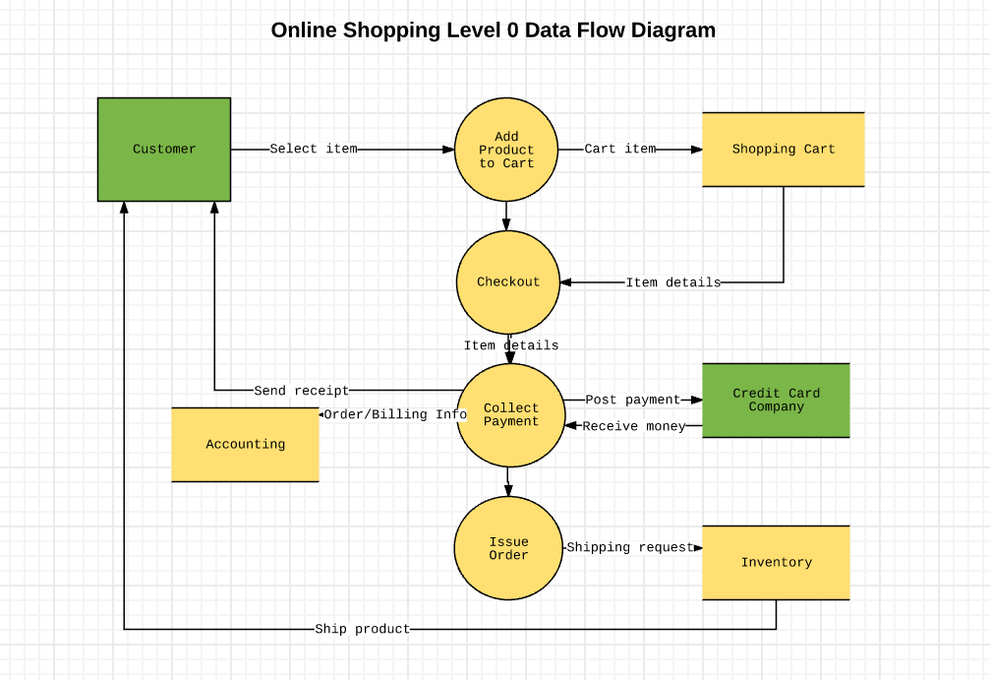

4.1.1: Administrative Level:

## **4.3: Entity Relationship Diagram:**



## **4.4: UML Activity Diagram**



## 

## **4.5: Use Case and Flow Charts**

**1: Profile**

**Table 1.1: Login Use case**

|  |  |  |
| --- | --- | --- |
|  | | |
| **Use case ID:** | **1** | |
| **Use Case Name:** | Login | |
| **Actor(s):** | System Administrator | |
| **Maturity:** | Fill | |
| **Summary:** | Actor Will be able to login to the system | |
| **Basic Corse Event:** | **Actor Action:** | **System action:** |
|  | Actor will be accessing the login form |  |
|  | System will Display the form |
| Actor will fill the fields of the form and click on login form |  |
|  | System Validates each entry according E1,E2. |
|  | System will load the main form according to the privileges assigned to current login User. |
| **Alternative paths:** |  | |
| **Exceptions:** | E1, the actor enters “invalid password “  E2, database not Connect | |
| **Triggers:** | The Actor Selects to Login. | |
| **Assumptions:** | The Actor will be connected to Database Server | |
| **Preconditions:** | The Actor logs in the System. | |
| **Post condition** | The System will load the main form. | |

**Flow Chart Login**



**Login Flow Chart**

**Table1.2: Use case Add Customer Registration information**

|  |  |  |
| --- | --- | --- |
|  | | |
| **Use case ID:** | **2** | |
| **Use Case Name:** | Insert customer Registration information | |
| **Actor(s):** | System Administrator | |
| **Maturity:** | Fill | |
| **Summary:** | Actor Will be able to Insert customer Registration information | |
| **Basic Corse Event:** | **Actor Action:** | **System action:** |
|  | Actor will be accessing the customer Registration information insert” Form. |  |
|  | System will Display the form |
| Actor will fill the fields of the form |  |
|  | System Validates each entry according E1,E2. |
| Actor Will save the entered Record**.** |  |
|  |  | System will save and display the Records.E3 |
| **Alternative paths:** |  | |
| **Exceptions:** | E1,” Fields Missing” Invalid Field” error.  E2, Database Connection Error  E3,”Fill Empty Fields” | |
| **Triggers:** | The Actor Selects to the customer Registration information to insert the record. | |
| **Assumptions:** | The Actor will be connected to Database Server.  The Actor have Privileges to enter the record. | |
| **Preconditions:** | The Actor Will enter the new customer Registration information to the System. | |
| **Post condition** | The System will save the customer Registration information. | |

Flow Chart Customer Registration Records

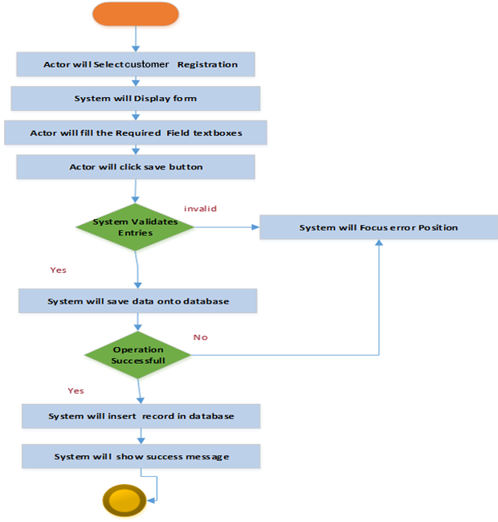

**Table 1. 3: Use case Add Order information**

|  |  |  |
| --- | --- | --- |
|  | | |
| **Use case ID:** | **3** | |
| **Use Case Name :** | Insert order information | |
| **Actor(s):** | System Administrator | |
| **Maturity:** | Fill | |
| **Summary:** | Actor Will be able to Insert order information | |
| **Basic Corse Event:** | **Actor Action:** | **System action:** |
|  | Actor will be access the order information insert” Form. |  |
|  | System will Display the form |
| Actor will fill the fields of the form |  |
|  | System Validates each entry according E1,E2. |
| Actor Will save the entered Record**.** |  |
|  |  | System will save and display the Records.E3 |
| **Alternative paths:** |  | |
| **Exceptions:** | E1,” Fields Missing” Invalid Field” error.  E2, Database Connection Error  E3,”Fill Empty Fields” | |
| **Triggers:** | The Actor Selects to the order information to insert the record. | |
| **Assumptions:** | The Actor will be connected to Database Server.  The Actor have Privileges to enter the record. | |
| **Preconditions:** | The Actor Will enter the new order information to the System. | |
| **Postcondition** | The System will save the order information. | |

**Table 1.4: Flow Add Product Information**

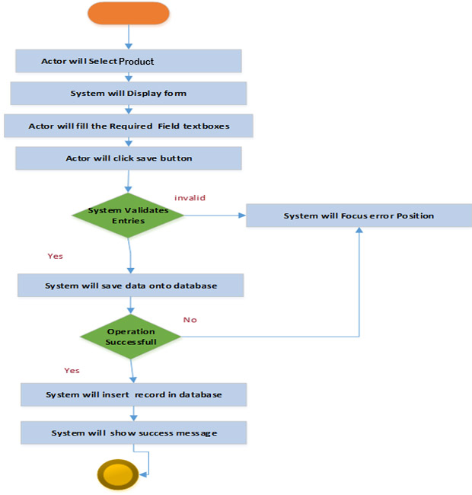

**Table 1.5: Use Case Add Cart Records**

|  |  |  |
| --- | --- | --- |
|  | | |
| **Use case ID:** | **5** | |
| **Use Case Name :** | Insert Cart information | |
| **Actor(s):** | System Administrator | |
| **Maturity:** | Fill | |
| **Summary:** | Actor Will be able to Insert Cart information | |
| **Basic Corse Event:** | **Actor Action:** | **System action:** |
|  | Actor will be access the Cart information insert” Form. |  |
|  | System will Display the form |
| Actor will fill the fields of the form |  |
|  | System Validates each entry according E1,E2. |
| Actor Will save the entered Record**.** |  |
|  |  | System will save and display the Records.E3 |
| **Alternative paths:** |  | |
| **Exceptions:** | E1,” Fields Missing” Invalid Field” error.  E2, Database Connection Error  E3,”Fill Empty Fields” | |
| **Triggers:** | The Actor Selects to the Cart information to insert the record. | |
| **Assumptions:** | The Actor will be connected to Database Server.  The Actor have Privileges to enter the record. | |
| **Preconditions:** | The Actor Will enter the new Cart information to the System. | |
| **Post condition** | The System will save Cart information. | |

Flow Chart of add Cart Products

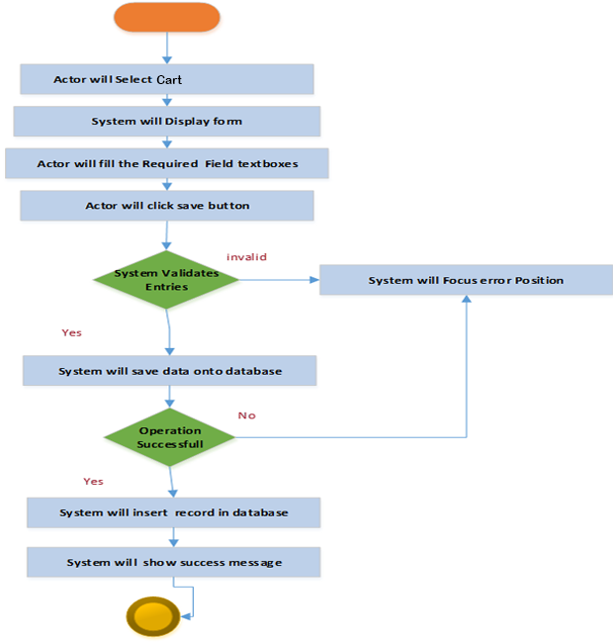

**Table: 1-15: Use Case Update Customer Registration records**

|  |  |  |
| --- | --- | --- |
|  | | |
| **Use case ID:** | **15** | |
| **Use Case Name :** | Update customer Registration information | |
| **Actor(s):** | System Administrator | |
| **Maturity:** | Fill | |
| **Summary:** | Actor Will be able to Update customer Registration information | |
| **Basic Corse Event:** | **Actor Action:** | **System action:** |
|  | Actor will be access the customer Registration information Update |  |
|  | System will Display the form |
| Actor will Select the Desired customer Registration number |  |
|  | System Validates each entry according E1, |
| Actor Will Click the “Show record” in list |  |
|  |  | System will retrieve the fields in textboxes and enable textboxes which are to be updated. |
|  | Actor will Update the Desired Fields. |  |
|  | System will Validate Each entry. E1, E2. |
| When actor will be Satisfied with the Data entered in Field, the Actor will Click “update” Button to Submit Changes. |  |
|  | The System will gather data and submit it to data base |
|  | The System will display a success message.E3 |
| **Alternative paths:** |  | |
| **Exceptions:** | E1,” Fields Missing” Invalid Field” error.  E2, the Actor did not fill the necessary fields,  E3,Database connection error or Database was unable to save changes. | |
| **Triggers:** | The Actor Selects to the customer Registration information to Update the record. | |
| **Assumptions:** | The Actor will be connected to Database Server.  The Actor has logon to the system and have privileges to access the customer Registration records to Update. | |
| **Preconditions:** | The Actor Will logs in the System. | |
| **Post condition** | The System will save the changes to the customer Registration information. | |

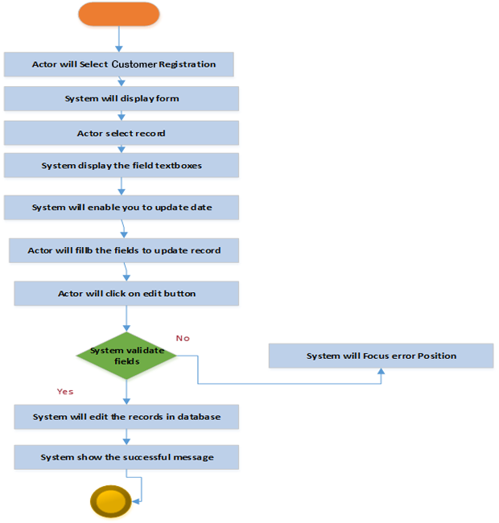

## **4.6: Sequence Diagram**

**1: Customer Registration:**

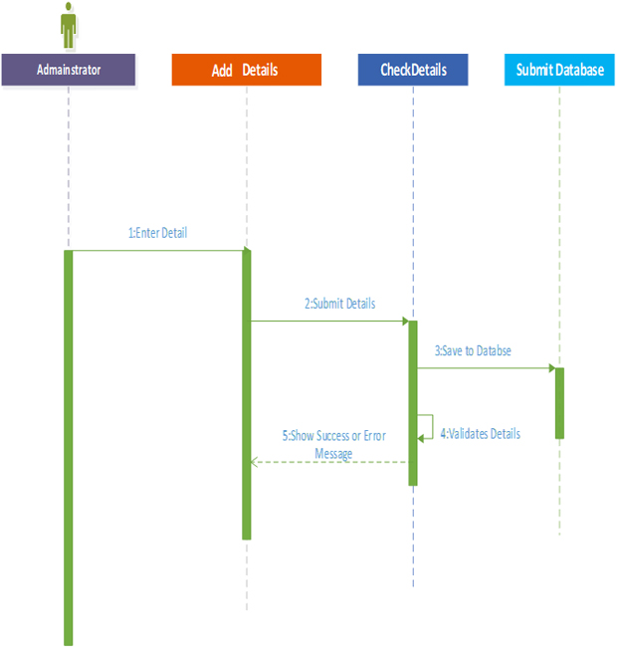**Customer Registration:**

: Sequence Diagram-Student Registration Details Insertion

**2: Shop Manger Details:**



**Sequence Diagram- Shop Manger Detail Insertion**

**3: Product Details:**

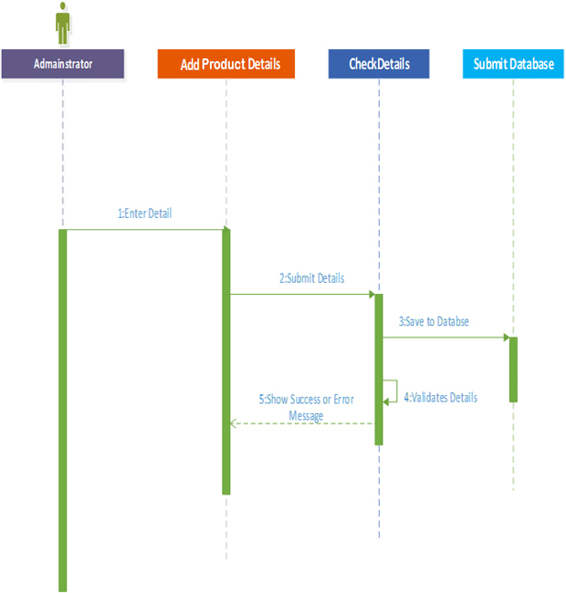

**Sequence Diagram- Product Detail Insertion**

**4: Cart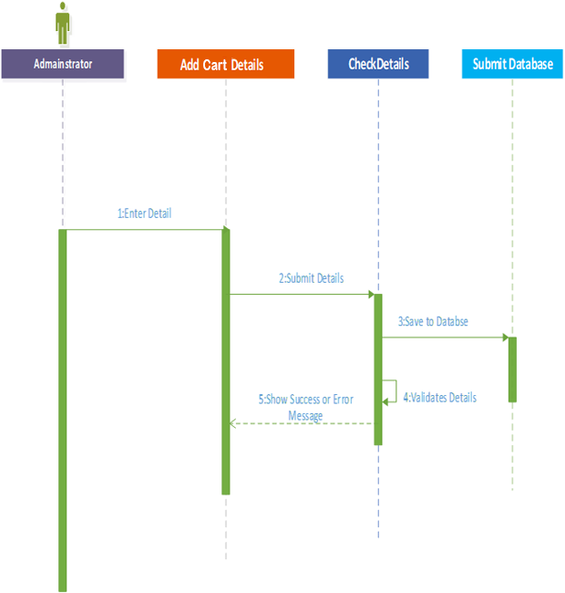 Sequence Diagram- Cart Detail Insertion :**

**Updating**

**1: Customer Registration**



**Sequence diagram customer Registration Updating**

**2: Shop Owner details**



**Sequence Diagram Shop owner details updating**

# **Chapter5: Interface (user manual)**

**Main Page**

**Login Page:**

**Main Manu:**

**Customer Registration Insertion:**

**Designer Records Insertions:**

**Add Products Insertions:**

**Cart Insertions:**

**Check Out Insertion:**

# **Chapter 6: Testing**

## **1: Verification**

Verification **i**s done on each phase and on modules that have been completed so far. They are fully tested to verify that functional requirements of project.

### **Test case #1.1:**

**Table 1-2: Test case Admin Login**

|  |  |
| --- | --- |
| Test ID | 1 |
| Test Name | **Admin login** |
| Precondition | **Application must be opened** |
| Actions | **1: click login icon**  **2: Without entering Username or password or Type click ok**  **3: Enter wrong Username, password or type and click login** |
| Expected Results | **1: A dialog should open with option Username and Password.**  **2: An error Message should be shown to please**  **enter Valid Data** |
| Results | **Pass** |

**Test Description**: This test verifies the Admin can login.

**Testing Environment:** Window 7.

**Tested by: Ramaz**

**Date:**12/27/2020

### **Test case #1.2:**

**Table 1-2: Test case Add New Admin**

|  |  |
| --- | --- |
| Test ID | 2 |
| Test Name | **Add new (Admin) Account** |
| Precondition | **Application must be opened And admin must be logged in** |
| Actions | **1: click login icon**  **2: Choosing Admin than click Registrar button**  **3: without entering admin information click Register.** |
| Expected Results | **1: register admin form should open**  **2: An error Message should be shown to please**  **Select any option admin for entering data.** |
| Results | **pass** |

**Test Description**: This test verifies the Admin to add new admin.

**Testing Environment:** Window 7.

**Tested by:** Essa

**Date:**12/27/2020

### **Test case #1.3:**

**Table 1-2: Test case Admin Logout**

|  |  |
| --- | --- |
| Test ID | 3 |
| Test Name | **logout (Admin)** |
| Precondition | **Application must be opened And admin must be logged in.** |
| Actions | **1: Admin click logout icon** |
| Expected Results | **1: Admin main form should be closed.**  **2: Login textboxes values should be null** |
| Results | **pass** |

**Test Description**: This test verifies the Admin to logout from system.

**Testing Environment:** Window 7.

**Tested by:**

**Date:**12/27/20

### **Test case #1.4:**

**Table 1-2: Test case Customer /Designer/ Admin/ Products Records Entry**

|  |  |
| --- | --- |
| Test ID | 4 |
| Test Name | **Customer /Designer/ Admin/ Products** |
| Precondition | **Application must be opened and Admin must be logged in.** |
| Actions | **1: click Records Entry**  **2: Without entering Records details click “Save” Button.** |
| Expected Results | **1: Record Entry from should open.**  **2: An error Message should be shown to fill out mandatory fields.** |
| Results | **pass** |

**Test Description**: This test verifies the Admin to enter the new Records from the system.

**Testing Environment:** Window 7.

**Tested by:**

**Date:**12/27/2020

# **Chapter6: Conclusion and Future Work**

## **Conclusion:**

The main Objective of my project is to Automate the physical shopping system to Provide easy records maintaining, automated Circulation processes, and reports genratation. We have Developed most of functionalities of any database software including admin panel with control over all activates of the software. My Project is published and available for uses to access as www.Balociculture.com.

## **Future Works:**

As we have Online Balochi Embroidery Shopping system based on software and for future this system can be enhance as make different user and taking all potions large and complete etc.