Singapore Changi Airport, Terminal 1 (Integrated System)
Baggage Handling System (BHS)
Manual Encoding Station (MES)
Detail Design Specification (DDS)

Document Ref. No.: CT1-ITG-DOC-8116-00

 | Prepared By | PGL Internal Review |  |  | PGL Internal Approval | External Review and Approval*
 | Prepared By | Reviewed & Endorsed by: |  |  | PGL Internal Approval | External Review and Approval*
Company / Department | PGL / HLC | PGL / HLC | - | - | - | -
Name | Akurati Ramesh | CHS | - | - | - | -
Position | Software Engineer | Senior  Engineer | - | - | - | -
Signature | - | - | - | - | - | -
Date | 10-Jul-2011 | 28 Jul 2011 | - | - | - | -

Copyright © Pteris Global Limited 2011. All Rights Reserved.

Transmittal, reproduction, dissemination and/or editing of this document as well as utilization of its contents and communication thereof to others without express authorization are prohibited. Offenders will be held liable for payment of damages. All rights created by patent grant or registration of a utility model or design patent are reserved. In case the contractual agreement allows the customer to change the document such changes shall be clearly highlighted and shall name the person changing the document. In any case Pteris Global Limited is not liable for any amendments or changes in the document and any possible consequences there from.

All trademarks and registered trademarks are the property of the respective owners. The use of registered names, trade names, description of goods etc. in this document, even if not specially identified as such, does not imply that such names may be regarded as free in the sense of legislation pertaining to registered trademarks and the protection of trademarks and may therefore be used by anyone.

Responsible for the contents
Pteris Global Limited
Singapore

Revision
Version | Release | Date | Init. | Description
0 | 0.0 | 10-JUL-2011 | AR | Initial version.

Contents
Revision 3
Contents 4
Table of Figures 5
1. Preface 6
1.1 Document Objective 6
1.2 Scope 6
1.3 Audience 6
1.4 Document Limitations 6
1.5 Document Maintenance 6
2. Abbreviations and Acronyms 7
3. Overview 8
3.1 Baggage Scenarios 8
3.2 Manual Encoding Station Application 8
3.3 MES Connection 8
3.4 Bag Tag Format 9
3.4.1 IATA Interline Tag 9
4. MES Screen Layout Schema 10
4.1 Windows Login 10
4.2 MES Main Application Screen Layout 11
4.2.1 Title Bar 12
4.2.2 Logo and Status Area 12
4.2.3 Status Component, Bag Information Component and IATA Code Entry Field 13
4.2.4 Function Keys 14
4.2.5 Last Bag Result 15
5. MES Functionality 16
5.1 MES Functionalities Tasks 16
5.1.1 Valid IATA Tag 16
5.1.2 Invalid IATA Tag 16
5.1.3 Flight Close Out Tag 16
5.1.4 Direct to Flight 16
5.1.5 More than One Flight Available 18
5.1.6 No Flight Found 18
5.1.7 No Information on Bag 18
5.1.8 Direct to DESTINATION 18
5.1.9 Send to Problem Bag 19
5.2 SAC Offline Mode 19
5.3 PLC Offline Mode 19
6. Document References 20

Table of Figures
Figure 4-1: MESOWS Log-on Window 10
Figure 4-2: Basic Screen Layout Schema 11
Figure 4-3: Title Bar Area 12
Figure 4-4: Logo and Status Area 12
Figure 4-5: Information Data and Entry Area 13
Figure 5-1: Flight entry window 17
Figure 5-2: Flight search result 17
Figure 5-3: Racetrack entry dialog box 19

Preface

Document Objective
This document provided the modification of system description of BHS high level control system from Pteris Global Limited (PGL), supplied to Changi International Airport.

The modified sub systems facilitate to manage newly added conveyors and support the existing High Level Control (HLC) system in an airport BHS. It includes new HLC configuration, Manual Encoding System and Intermediate SAC Com.

The approval of this design specification by client is required before the commencement of PGL in-house development work.

Scope
This software design specification provides the functional descriptions of Manual Encoding Station (MES) and its rules.

Audience
This specification is intended for the customer’s decision maker of Changi Airport Group, Singapore (CAG) and Pteris Global Limited (PGL) for this project. This document will serve as the primary foundation for PGL developers to implement the BHS HLC system.

Document Limitations
This document is limited to the design of BHS HLC MES system. And there’s no other external system will be described in this document.

Document Maintenance
This document is the one of the PGL document management document suites and maintained by PGL.

Abbreviations and Acronyms

Item | Meaning
MES | Manual Encoding Station
HBS | Hold Baggage Screening
IATA | International Air Transport Association
MESOWS | Manual Encoding Station for Operator Workstation
OS | Operating System
GUI | Graphical User Interface
PLC | Programmable Logic Control
SAC | Sortation and Allocation Control

Overview
Manual Encoding refers to the process of baggage manual handling performed. This includes identifying bags and giving them a destination.
All baggage that pass through level-3 HBS has to be encoded manually by the MES operator.
There are four (4) Manual Encoding Station Operation Workstation (MESOWS) in Changi International Airport, Terminal 1 Integrated System. These MESOWS are located at each of the Manual Encoding Station (MES) and installed with MES software. These are the main workstations for BHS operators to do manual encoding of the baggage if BHS cannot handle them automatically.

Baggage Scenarios
The bags sorted to Manual Encoding Station could have following scenarios:
- Unknown Item Detected: If an unexpected bag is detected, it will be considered as unknown bag and MES Operator can send to the problem bag output by pressing the button “Problem” or function key “F4”.
- No IATA Code: If the IATA tag is missing or the IATA code cannot be read, MES operator presses the special function key “NoCode” which makes the MES assign a running number to the bag and then followed by enters Flight number information to enable MES for determining the bag’s final destination.
- Flight Close Out Tag: A bag that arrives with a “Flight Close Out Tag” attached should be handled as a normal bag.
- Duplicate IATA Code: if a bag is attached with multi tags, the bag will be sent to MES for manual handling. MES operator will select the correct Tag and scan the selected tag for further handling in MES.
- Invalid IATA Code: If the code entered is not 10 digits long or one or more characters are not 10 digits, the MES operator is prompted to either retype or scan the IATA code or press the special function key “NoCode”. And MES operator needs to follow Flight encoding procedures.
- More than One Flight Available: If more destinations are available for the entered Flight number, the MES operator must manually choose one of available destinations.
- No Flight Found: If the Flight number is not found, an error will be displayed to the MES operator and operator must use another Encoding method such as Encoding by Destination or Problem.
- No Information on Bag: If there is no information on the bag or the MES operator is unable to determine the correct destination for a given bag, MES operator sends the bag to Problem.

Manual Encoding Station Application
The MES application is an application component of Sortation Allocation Control (SAC) system. By using this application, BHS operator is able to manually encode the baggage with a handheld scanner, keyboard or mouse.

The standard graphic screen resolution of MESOWS will be 1024 x 768 pixels. The application can also be run under other higher resolution settings.

MES Connection
There are two (2) connections required for MES operation:
- MES to SAC database – via industrial Ethernet, TCP/IP protocol
- MES to PLC – via industrial Ethernet, TCP/IP protocol

MES communicates to SAC database and PLC through BHS LAN for manual encoding operations. The connection status will be monitored by the MES application and indicated in the connection status area on MES GUI.

Bag Tag Format

IATA Interline Tag
The IATA interline tag is used to give a unique identification (number) to each bag. Its format is defined in IATA Resolution 740: FORM OF INTERLINE BAGGAGE TAG. The IATA interline tag is used for sorting control in BHS.

As per IATA 740, the 10-digit IATA interline tag number is composed as below:
Digit Number | Description
Digit 1 | 0 – for IATA interline tag  1 – for IATA fallback tag
Digit 2-4 | 3-digit numeric airline code (000 for non-airline handling agents)  This part will be used to look up the airline and its allocated sort destination if airline sortation control in BHS is enabled.
Digit 5-10 | 6-digit numeric baggage tag number.

MES Screen Layout Schema
The MES application includes the following screens:
- Windows Login
- MES Main Application Screen Layout

Windows Login
To login to the MESOWS, BHS operator needs to enter the user name and password in the standard windows logon screen.
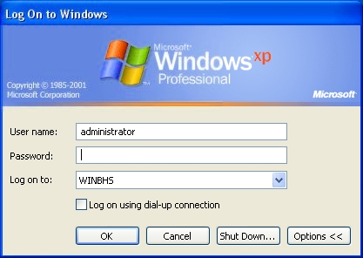
Figure 4-1: MESOWS Log-on Window

MES application will start automatically upon successful login.

Only the authorized users are able to access the functionalities of MES application.

By pressing “Shut Down” button in the above OS log-on window, operator can shut down and power off MES computer after logout from MES application.

MES Main Application Screen Layout
The Manual Encoding Station (MES) screen adopts a layout scheme as shown below in the Figure 4-2. It consists of Title Bar, Logo and Status Area, Status Component, Bag Information Component, IATA Code Entry Field, Function Keys and Last Bag Result as illustrated and described in the Figure and table below.
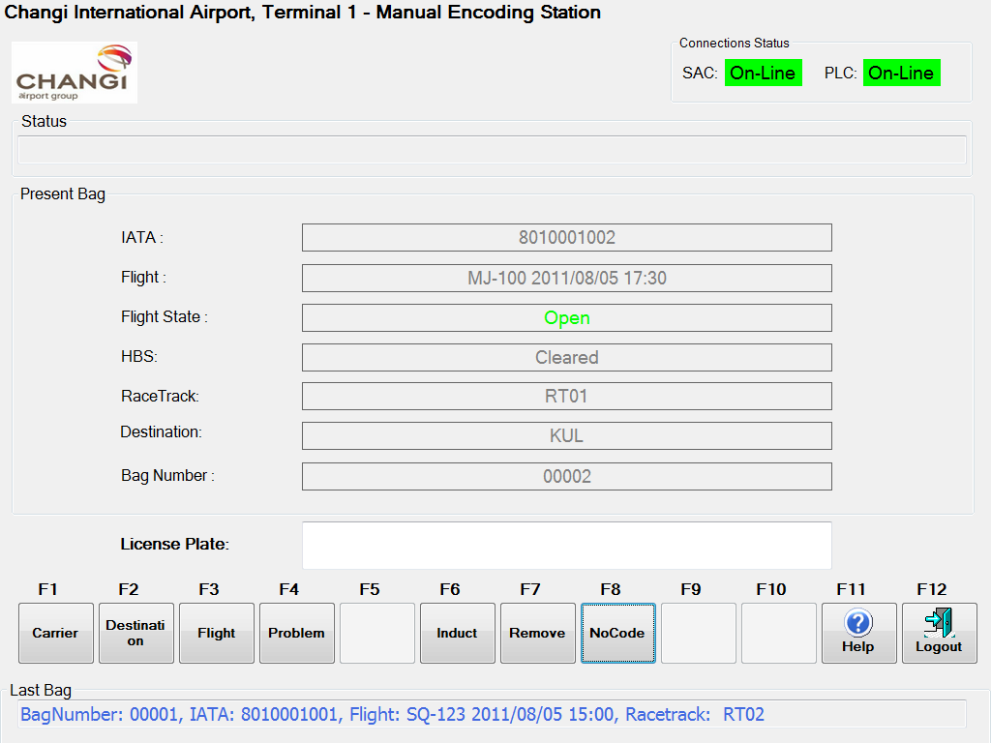
1
2
3
4
5
6
7
Figure 4-2: Basic Screen Layout Schema

The various areas on the MES GUI are as tabulated in the table below:
Section | Name | Description
  1 | Title Bar | The airport name, application name and workstation ID will be displayed on the title bar.
2 | Logo and Status Area | This area shows the airport logo and system connection status.
3 | Status Component | This area shows the error and status information received from the PLC.
4 | Bag Information Component | This area shows all known bag information about the bag currently being encoded.
5  6 | IATA Code Entry Field | The entry field is used to display the IATA code while entering the code using the keyboard.
 | Function Keys | This area allows BHS operator to activate each function to perform each specified task.
7 | Last Bag Result | This area shows the last encoded bag information.
MES will always keep the focus on the edit box of “IATA Code Entry Field” area. The operator can also change the focus simply by moving the mouse on the respective graphic components on MES GUI.

During the bag encoding operation, it is not necessary for the operator to set the focus on the bag tag input field before using the handheld scanner to scan the tag. The tag number detected by the scanner will be automatically recognized and inserted into the bag tag input field.

Title Bar
There are three (3) parts in the Title Bar as below:
- Airport name
- Application name
- MES workstation ID

Figure 4-3: Title Bar Area

Logo and Status Area
There are two sections in the Logo and Status Area as below:
- Airport Logo – The place where the Changi International Airport logo is located in the GUI.
- Connection Status – It consists of all the connection status to the MES workstation by using “On-Line” and “Off-Line” to indicate the connection status. This application is only available when PLC connection status is in online.

Airport Logo
Connection Status

Figure 4-4: Logo and Status Area

Status Component, Bag Information Component and IATA Code Entry Field
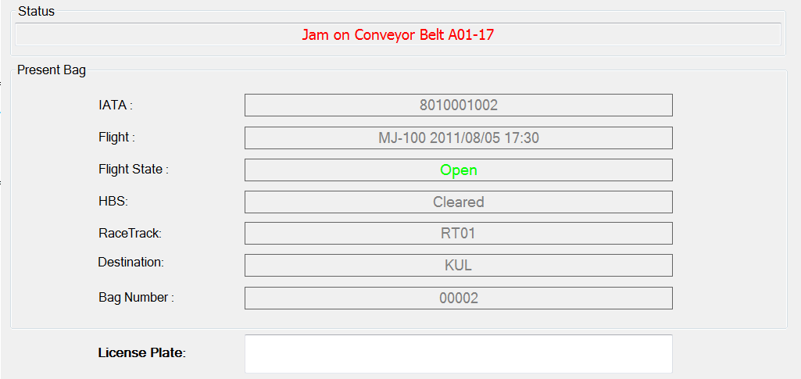
1
2
3
Figure 4-5: Information Data and Entry Area

Section | Name | Description
 | Status Component | This is the area to show the error and status information received from PLC about the bag. Error messages are shown in red color.
 | Bag Information Component | When a bag arrives for encoding, the HBS screening status and the bag number will be presented in the bag information component.  After the IATA code has been entered using the keyboard, scanned using the hand scanner or the NoCode (F8) has been pressed, the ‘IATA’ field will be filled with the entered/generated number. The flight entry dialog box as shown in Figure 5-6: Flight entry window will automatically be shown when the IATA code has been accepted.  The ‘Flight’, ‘Flight State’, ‘Racetrack’ and ‘Destination’ field will be filled if the bag is encoded by flight. Only the ‘Racetrack’ field will be filled if the bag is encoded using one of the function keys: Destination (F2), Problem (F4).  If L3 cleared bag but lost track after diverter to MES, there will not be any status displayed on HBS field.  Bag information is displayed according to a set of rules indicating when the information for a certain bag is to be displayed and when information for the next bag is to be shown. The initial state for the main display is always idle (not displaying any bag information).  When a bag leaves manual encoding, its bag information will be displayed in the main display until a new bag arrives or until the idle period passes. In both cases the bag information for the bag is moved to the status bar at the bottom of the main menu. The idle period is set to 5 seconds.
 | IATA Code Entry Field | The entry field is used to display the IATA code while entering the code using the keyboard or scanned by Handheld scanner. A 10 digits number must be entered before pressing the <enter> key to accept the code. The process by using the hand held scanner is not required to press <enter> key. Only digits (0-9) will be accepted in the field and 10 digits must be keyed in before the <enter> is accepted. If more than 10 digits are entered the extra digits will be ignored.

Function Keys
The function keys are used to execute some command or to get access to a pop-up dialog box. There are nine (9) function keys as below:

Figure 4-6: Function Area

- (F1) Carrier: This is used to show the carrier code, carrier alias code of the airlines in excel sheet format so that the MES operator can refer to it.
- (F2) Destination: Opens the Destination entry dialog box as shown in Figure 5-8: Racetrack entry dialog box. If the bag doesn’t have the flight number but the MES operator knows the racetrack the bag should be sent to, he will use this function key. This function button can also be used for bags that could not be found using the flight function, but is identified to be destined for another terminal. This can be done by sending the bag to the ITTBS destination.
- (F3) Flight: Opens the flight entry dialog box as shown in Figure 5-6: Flight entry window. This function key is used to set the racetrack for the current bag to the flight destination.
- (F4) Problem: Sets the racetrack for the current bag to the configured problem destination. This function will be enabled after an IATA number has been entered. The problem button should only be used when no other destination can be found for the bag.
- (F6) Induct: When a bag is encoded correctly the “Induct” button will be enabled, MES operator must press the button in order for the bag to be transported to its destination.
- (F7) Remove: If operator cannot decide the destination as no enough information for operator to make decision, MES operator may remove the bag from the MES by pressing this button.
- (F8) NoCode: When pressing the “NoCode” button a “running number” is generated for the bag as the IATA code. “Running Number” refers to a 10 digit number which is generated by MES at the start-up and incremented by 1 every time the “NoCode” function key is pressed. This function button is only to be used if there is no readable IATA number on the bag.
- (F11) Help: A Help file is provided within the Manual Encoding Station and it can be activated by clicking on the “Help” button or by “F11” function key. This file consists of the information regarding the usage of this MESOWS.
- (F12) Logout: The MES application will shut down and log off the windows.

When the bag arrives at the MES, only the function keys F1, F8, F11 and F12 will be enabled. When the MES operator presses the function key F8, the function keys F3, F4 and F7 will be enabled and the function key F8 will be disabled. After the MES operator chooses the correct flight, presses <enter> and a valid destination is looked up, only the function key F6 will be enabled. In case no destination is found, only the buttons F1, F3, F4, F7, F11 and F12 will be enabled.

In case of destination, when the bag arrives at the MES, the function keys F1, F2, F11 and F12 will be enabled. When the MES operator scans the tag, flight list will pop-up and the operator needs to press the F2 button to use destination after the F2 button is enabled by the supervisor in the MDS application. After the MES operator chooses the destination and presses <enter>, only the function key F6 will be enabled.

After the bag is encoded successfully using flight, destination or problem encoding modes, all the function keys will be disabled except the function keys F1, F11 and F12.

Last Bag Result
This Last Bag Result consists of Last Bag Message as shown in Figure 4-.

Last Bag Message

Figure 4-7: Status bar Area

The last bag result component will show a short description of the last successfully encoded bag. The information shown is the combined details of what is shown in the bag information component.

MES Functionality

MES Functionalities Tasks
The functionalities tasks available at each Manual Encoding Station (MES) application are as below:

Valid IATA Tag
When the conveyor hands over the control of the bag to the MES and transmits the bag’s GID to the MES, the bag will stop at the MES for MES operator to scan or key in the IATA code. After the operator enters or scans the IATA code, if the tag is valid, the flight dialog box pops up and the MES operator enters the flight number and selects the correct flight number and sends the bag to the sort destination. In case the operator doesn’t know the correct destination for the bag, the operator can send the bag to a particular racetrack by clicking the destination function key. A destination window pops up and the operator can select the racetrack from the drop down list and send the bag to the racetrack. In each of the encode modes i.e., either by Flight or Destination, MES operator need to press the function key “Induct” to dispatch the bag to the sort destination. And the control of the bag is then handed over to conveyor for further processing.

Invalid IATA Tag
When the conveyor hands over the control of the bag to the MES and transmits the bag’s GID to the MES, the bag will stop at the MES for MES operator to scan or key in the IATA code. If the IATA code keyed in is not 10 digits long and one or more characters are not digits, system will prompt operator to re-enter the IATA code or the MES operator can press the special function key “NoCode”. The flight window will pop up as shown in the Figure 5-6: Flight entry window. The MES operator then enters the flight number and selects the correct flight number. A running number will be generated and assigned to the IATA code of the bag. The MES operator then presses the “Induct” function key to dispatch the bag from the MES station and the control of the bag is then handed over to conveyor for further processing.

Flight Close Out Tag
“Flight Close Out Tag” refers to the last bag of the flight. In order to tell the make-up carousel operators this is the last bag of the flight, an empty tub with paper pasted on it will be sent after the last bag. The pasted paper contains the information about the flight number, date, STD or ETD, flight close and total number of bags of the flight. If the tub arrives with the “Flight Close Out Tag” attached, operator will treat this tub as normal bag. As soon as the tub arrives at the MES, MES operator scans or keys in the dummy license plate ‘99999999999’. The flight dialog box pops up and the MES operator enters the flight number and selects the correct flight number to get the sort destination for the tub. The operator then presses the “Induct” function key to send the tub to the sort destination.

Direct to Flight
This function will extract the information which racetrack a bag should be sent to, based on the Flight number printed on the IATA tag attached to the bag. When the bag reaches to the MES station, the operator scans or enters the IATA tag into the MES. If the tag is valid, the flight entry window will be shown automatically as shown in Figure 5-6: Flight entry window.
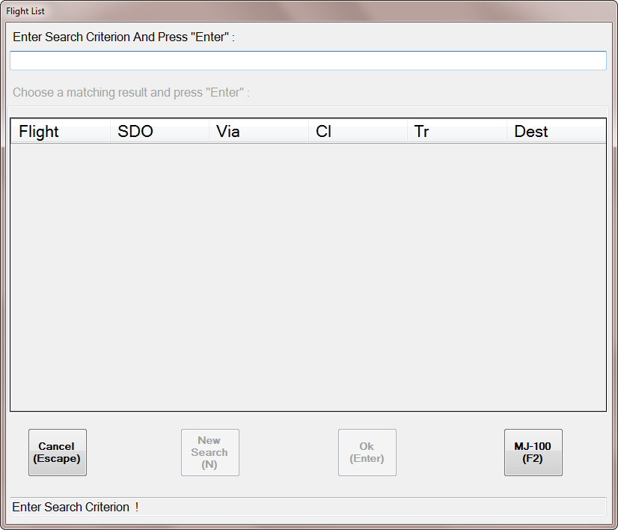
Figure 5-6: Flight entry window

The operator must now enter a 3 or 4 digit flight number and press <Enter>. The MES will search for all flights matching the entered flight number and display them in the result window as shown in the Error: Reference source not found.

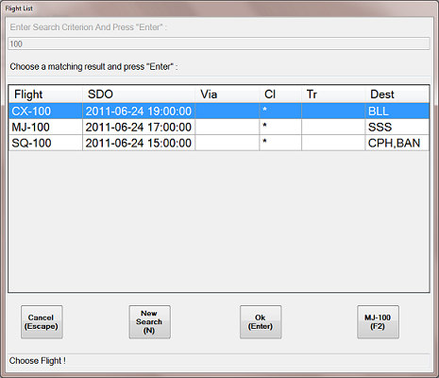
Figure 5-7: Flight search result

The operator must now choose the correct flight from the list using the keyboard <up>/<down> keys and press <Enter> when the wanted flight is highlighted.

The function keys on the flight dialog box are used as follows:
- Cancel: The cancel (or <Esc>) will close the flight dialog box without changing the bag information.
- New Search: If a valid number was entered, but it was not the correct flight number, a new search can be started by pressing the new search button (or ‘n’).
- OK: The OK button will transfer the information from the selected flight to the current bag and close the flight dialog box. All bag information is filled out and the bag is ready to be inducted.
- F2: The <F2> function key will reuse the flight information from the previous bag (flight indicated on the button), and close the flight dialog box. If the operator wants to send the bag to previous destination of the bag, he can use this button.

In case if a wrong flight was selected the first time, or the operator for some other reason wants to enter a flight number from the main window, the flight entry window can also be pop up by pressing the flight function key (F3) and the same procedure is followed as described above to select the flight.

More than One Flight Available
If more than one destination is available for the entered Flight number, MES operator must manually choose one of the available destinations from the Flight List Window as shown in Figure 5-7: Flight search result.

No Flight Found
If the Flight number is not found an error message “No Flight Information” will be displayed to MES operator and the operator must be use other function to determine the correct destination for the bag.

No Information on Bag
If MES operator could not find any information on the bag, then MES operator needs to remove the bag after pressing function key “Remove”.

The Flight number, Flight departure time, time and location of the encoding, time bag was removed from the manual encoding station and the IATA code are reported to the BHS for future reporting.

The remove function is activated by pressing the <F7> function key.

Direct to DESTINATION
If the MES operator is unable to read the flight number printed on the IATA tag but somehow knows the racetrack for the bag, the MES operator can directly specify the racetrack where the bag is destined. This function requires a supervisor to activate it, which is done by enabling the MES setting in the MDS Application. Now the Destination function key is enabled until the supervisor disables the MES setting in the MDS Application.

When the bag reaches to the MES station, MES operator presses the function key “Destination” and selects the Racetrack ID from the dropdown list. In some cases if the MES operator determines that the correct destination for a given bag is in one of the other terminals, the MES selects the ITTBS destination to send the bag to transfer line.

The operator can also press the <F2> function key to pop up the destination dialog box as shown in the Figure 5-8: Racetrack entry dialog box.
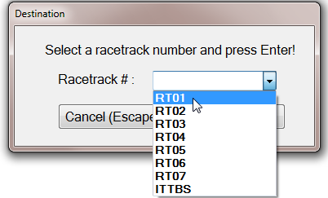
Figure 5-8: Racetrack entry dialog box

After the operator selects the correct racetrack from the dropdown list and presses <enter>, the bag will be sent to the sort destination. If the operator presses the “Cancel” button the destination dialog box will be closed.

Send to Problem Bag
When the bag reached to the MES and the MES operator unable to determine the correct destination for a given bag, the operator presses the function key “Problem” to send the bag to the Problem sort destination.

SAC Offline Mode
When the MES operates in “SAC offline mode” there is no connection to the SAC. But it is still possible to encode the discharge destination for the bag.

PLC Offline Mode
If MES loses contact to the PLC, there is no control of the conveyors. No bags can be transported to or from the MES until MES can communicate with the PLC again.

Document References
Abbreviation | Reference
Tender Specifications | Design, Supply, Installation, Testing and Commissioning of Baggage Handling System for Transfer Hold Baggage Screening at Singapore Changi Airport Baggage Handling System  01_General Specifications (Corrigendum No.1)  02_Product Specifications (Corrigendum No.1)

