Baggage Handling System (BHS)
DETAILED DESIGN SPECIFICATION (DDS)
MANUAL ENCODING STATION (MES)
MIAL-LT-O-N55B-BG-DOC-DDD-004

Journal: MIAL-LT-O-N55B-BG-DOC-DDD-004
Date: 24-SEP-2010
Revision: B
Pages: 35
Initials: PGL

Copyright © Pteris Global Limited 2010. All Rights Reserved.

Transmittal, reproduction, dissemination and/or editing of this document as well as utilization of its contents and communication thereof to others without express authorization are prohibited. Offenders will be held liable for payment of damages. All rights created by patent grant or registration of a utility model or design patent are reserved. In case the contractual agreement allows the customer to change the document such changes shall be clearly highlighted and shall name the person changing the document. In any case Pteris Global Limited is not liable for any amendments or changes by 3rd parties in the document and any possible consequences there from. Any changes made to an approved document, makes the document void, for the document to be valid it needs further review and approval by the relevant parties.

All trademarks and registered trademarks are the property of the respective owners. The use of registered names, trade names, description of goods etc. in this document, even if not specially identified as such, does not imply that such names may be regarded as free in the sense of legislation pertaining to registered trademarks and the protection of trademarks and may therefore be used by anyone.

Responsible for the contents
Pteris Global Limited
Singapore

Revision
Version | Release | Date | Init. | Description
A | 0 | 15-AUG-2010 | CHS | Initial version.
B | 0 | 24-SEP-2010 | XJ/AS/RT | Revised according to review comments of version A from MIAL, L&T, BNP, and Atkins.

Contents
Contents 4
Table of Figures 5
1. Preface 6
1.1 Document Objective 6
1.2 Scope 6
1.3 Audience 6
1.4 Document Limitations 6
1.5 Document Maintenance 6
2. Abbreviations and Acronyms 7
3. Overview 8
3.1 Baggage Scenarios 8
3.2 Manual Enconding Station Application 9
3.3 MES Connection 9
3.4 Bag Tag Format 9
3.4.1 IATA Interline Tag, In-House Tag and Pseudo BSM 9
3.4.2 IATA Fallback Sortation Tag Allocation 10
3.4.3 4-Digit Airport Fallback Allocation 11
3.4.4 4-Digit Airport Special Security Tag Allocation 11
4. MES Screen Layout Schema 12
4.1 Windows Login 12
4.2 MES Main Application Screen Layout 13
4.2.1 Title Bar 14
4.2.2 Logo and Status Area 14
4.2.3 Information and Data Entry Area 15
4.2.4 On-Screen Keypad 18
4.2.5 Toolbar Area 18
4.2.6 Status Bar Area 23
5. MES Functionality 25
5.1 MES Functionalities Tasks 25
5.2 Download Sortation Data from SAC Database to MES 26
5.3 Uploading MES Operation Data to SAC Database 26
5.4 MES Functionalities Requirement without SAC 26
5.5 Operation Mode 27
5.6 Encode mode 27
5.6.1 Encode By Tag 27
5.6.2 Encode By Flight 28
5.6.3 Encode By Sort Destination 29
5.7 Generate Tag 30
5.8 Bag Reoccurrence Alarm 34
5.9 MES Event Logs 34
6. Document References 35
7. Appendix – Index of Function ID 36

Table of Figures
Figure 4-1: MESOWS Log-on Window 12
Figure 4-2: Basic Screen Layout Schema 13
Figure 4-3: Title Bar Area 14
Figure 4-4: Logo and Status Area 14
Figure 4-5: Information Data and Entry Area 15
Figure 4-6: On-Screen Keypad 18
Figure 4-7: Function Area 18
Figure 4-8: Three Types of Operation Mode Shown In Status Area (Current Setting) 19
Figure 4-9: Three Types of Encode Mode Shown In Current Setting of Status Area 19
Figure 4-10: Three Types of Encode Mode Shown In Entry Area 20
Figure 4-11: Current Setting After RUSH Function Key Pressed 20
Figure 4-12: Entry Area for Key In Airline After RUSH Function Key Pressed 20
Figure 4-13: Flight List 21
Figure 4-14: IATA Interline Print Tag 21
Figure 4-15: IATA Interline Print Tag and Generation of Pseudo BSM 22
Figure 4-16: IATA Fallback Tag Generation and Print 22
Figure 4-17: In-House Tag Print and Generation of Pseudo BSM 23
Figure 4-18: Status bar Area 23
Figure 5-1: Entry Area – Encode By Tag 27
Figure 5-2: Entry Area – Encode By Flight 28
Figure 5-3: Multiple Sort Destination Selection 29
Figure 5-4: Entry Area – Encode By Sort Destination 1 29
Figure 5-5: Entry Area – Encode By Sort Destination 2 29
Figure 5-6: IATA Interline Print Tag 30
Figure 5-7: IATA Interline Print Tag and Generation of Pseudo BSM 31
Figure 5-8: IATA Fallback Tag Generation and Print 31
Figure 5-9: In-House Tag Print and Generation of Pseudo BSM 32
Figure 5-10: Pseudo BSM 33
Figure 5-11: Filter Windows 33
Figure 5-12: Tag Format 34

Preface

Document Objective
This document specifies the design of the Manual Encoding Station (MES) application, and it will be the main design document of further development work.

The customer’s approval of this detailed design document is required.

Scope
The scope of this document is to describe the detailed design of the MES based on the requirements stated in the tender document.

Audience
This requirement specification is intended for decision-makers in the Chhatrapati Shivaji International Airport and Pteris Global Engineering Limited (PGL). This document will serve as the primary foundation for PGL developers to implement the MES application.

Document Limitations
This document is limited to the design of the MES; no other system will be described.

Document Maintenance
This document is the one of the PGL document management document suites and maintained by PGL.

Abbreviations and Acronyms

Terms and Abbreviations | Description
ATR | Automatic Tag Reader
BSI | Baggage System Interface.
BSM | Baggage Source Message. Refer to IATA RP 1745
BHS | Baggage Handling System
CUTE | Common Use Terminal Equipment
DCS | Departure Control System.
FIS | Flight Information System.
IATA | International Air Transport Association
IP | Internet Protocol - Communication Protocol
LAN | Local Area Network
MES | Manual Encoding Station
MESOWS | Manual Encoding Station Operation Workstation
PGL | Pteris Global Limited
TCP/IP | Communication Protocol
SAC | Sortation Allocation Control
SDO | Scheduled Date of Operation (Date part of STD)
STO | Scheduled Time of Operation (Time part of STD)
STD | Scheduled Time of Departure

Overview
There are four (4) Manual Encoding Station Operation Workstation (MESOWS) in Chhatrapati Shivaji International Airport BHS. These MESOWS are located at each of the Manual Encoding Station (MES). The MES software will be installed on the MESOWS. These are the main workstations for BHS operators to do manual encoding of the baggage if BHS cannot handle them automatically.

Baggage Scenarios
ID: MES.APP.BagScenarios
Bags routed to Manual Encoding Station could have following scenarios:
Scenario | Description | Handling Process
No Tag | Baggage does not have any tag. | Operator needs to use Encode by Problem to send the bag to Problem Make-up Carousel.
Tag Unreadable by ATR | A Tag is present but scanner fails to read the Tag barcode. | Operator can use one of the ways below:  - Encode by Flight as the airline and flight number stated in the Tag.  - Encode by Sort Destination if the operator knows the baggage flight sort destination.  - Prints new Tag in MES if it is IATA Interline Tag or IATA Fallback Tag followed by Encode by Tag.
No BSM | The BHS system cannot find any BSM to match with the baggage Tag number (IATA tag). | Operator can use one of the ways below:  - Encode by Flight as the airline and flight number stated in the Tag.  - Encode by Sort Destination if the operator knows the baggage flight sort destination.  - Generate and prints In-House Tag in MES followed by Encode by Tag.
Late BSM | The BHS system cannot match any BSM with the baggage Tag number at the time when the baggage is being sorted to MES. But the BHS system can find the matching the BSM with baggage tag at the time the baggage encoded at MES. | Operator needs to use Encode by Tag.
Multiple BSM | The BHS system finds more than one matching BSM with the same Tag number. | Operator needs to use Encode by Tag and select the correct BSM.
Multiple Tags | There is more than one Tags attached on the baggage. | Operator needs to physically look at the tags and choose a correct Tag. Then the operator needs to use Encode by Tag.
Lost Tracking | The baggage is lost tracking at the time of BHS system is making decision after the ATR and before decision point at Manual Encoding line. | Operator needs to use Encode by Tag.
Unknown Flight | There is no flight information found for the baggage. | Operator needs to use Encode by Sort Destination.
No Allocation | There is no allocation found for the baggage. | Operator needs to use Encode by Sort Destination.

Manual Enconding Station Application
The MES application is an application component of Sortation Allocation Control (SAC) system. By using this application, BHS operator is able to manually encode the baggage with a handheld scanner, touch screen, keyboard or mouse.

The standard graphic screen resolution of MESOWS will be 1024 x 768 pixels. The application can also be run under other higher resolution settings.

MES Connection
ID: MES.DB.Connection
There are two (2) connections required for MES operation:
- MES to SAC database
- MES to PLC

During the normal operation mode, MES communicates to SAC database and PLC through BHS LAN for manual encoding operations. In LLC mode, MES will communicate with PLC through BHS LAN for operation.

The connection status will be monitored by the MES application and indicated in the connection status area on MES GUI.

Bag Tag Format

IATA Interline Tag, In-House Tag and Pseudo BSM
The IATA interline tag is used to give a unique identification (number) to each bag. Its format is defined in IATA Resolution 740: FORM OF INTERLINE BAGGAGE TAG. The IATA interline tag is used for sorting control in BHS.

As per IATA 740, the 10-digit IATA interline tag number is composed as below:
Digit Number | Description
Digit 1 | 0 – for IATA interline tag  1 – for IATA fallback tag
Digit 2-4 | 3-digit numeric airline code (000 for non-airline handling agents)  This part will be used to look up the airline and its allocated sort destination if airline sortation control in BHS is enabled.
Digit 5-10 | 6-digit numeric baggage tag number.

The electronic IATA interline tag information and passenger information (e.g. passenger class, onward transfer, etc.) will be produced by airport CUTE/DCS system and sent to BHS in BSM as defined in IATA Recommended Practice 1745 - Baggage Services Messages.
If bag arrives to MES but the BSM of its IATA interline tag has not been received by BHS, MES operator can create a “Pseudo BSM” for the tag. And then use the pseudo BSM for code conversion. The pseudo BSM of IATA Interline tag will always be overwritten by the actual BSM received from CUTE/DCS.

The airport in-house labeling tag could be produced at MES for bags that have no IATA Interline tag, fallback tag or special security tag attached. In-house labeling tag is 10-digit number tag that has the same format as IATA Interline tag, except the value of first digit is not 0 and 1. When in-house tag is printed out from MES tag printer, its “Pseudo BSM” is created by MES and saved into the SAC database. The pseudo BSM of in-house tag will be used for code conversion.

The last 6 digits of the In-House tag will not be reset when the power to the MES is disconnected, operator logs out or the MES software is updated. All the in-House tags printed from four (4) different MES will be unique number tag for six (6) month time.

The pseudo BSM created from MES will be uploaded into SAC database as well.

IATA Fallback Sortation Tag Allocation
The IATA Fallback Sortation tag may be attached to the checked in baggage when:
- Demand tags with a license plate Sortation (IATA) barcode are temporarily unable to be produced;
- Communications interruptions temporarily prevent delivery of Baggage Source Message (BSMs) to the Sortation system;
- Manual baggage tags are issued without supporting BSMs.

The fallback Sortation tag used by airport must comply with the rules stated in IATA RECOMMENDED PRACTICE 1740b: LICENCE PLATE FALLBACK SORTATION TAG.

As per the IATA RP1740b, Fallback Sortation tag barcode number has ten digits. The format of ten digit fallback tag number is illustrated as follows:
Digit Number | Description
Digit 1 | Always 1 for fallback tag
Digit 2-4 | 3-digit numeric airline code (000 for non-airline handling agents)
Digit 5-8 | 4-digit numeric airport code  It is used to differentiate the fallback tag from current airport and the fallback tag that comes from other airport, in case the passenger did not take out the old fallback tag.  If the airport code in the fallback Sortation tag is not the same as the current airport code, this fallback Sortation tag will be classified as the invalid fallback tag and will be ignored by BHS Sortation control system.
Digit 9-10 | 2-digit numeric departure makeup unit indicator. BHS will use it to look up the baggage sortation destination.

4-Digit Airport Fallback Allocation
4-digit airport fallback tags could be used at same scenarios as IATA fallback tag:
- Demand tags with a license plate sortation barcode are temporarily unable to be produced;
- Communications interruptions temporarily prevent delivery of Baggage Source Message (BSMs) to the sortation system;
- Manual baggage tags are issued without supporting BSMs.

The 4-digit airport fallback format is illustrated as follows:
Digit Number | Description
Digit 1 | Always 0 for airport fallback tag  First digit is used to differentiate 4-digit airport fallback tag and 4-digit airport special security tag.
Digit 2-4 | 3-digit running numeric of sort destinations (001 for make-up carousel 1, 002 for make-up carousel 2, etc.)

4-Digit Airport Special Security Tag Allocation
The 4-digit special security tag could be used when BHS is running in “LLC Only” mode, e.g. the HLC system is unavailable. Bag with special security tag attached is required to clear the screening of minimum HBS security level defined in the security tag.

The special security tag contains two types of information as below.
Digit Number | Description
Digit 1 | Always 9 for airport special security tag  First digit is used to differentiate 4-digit airport fallback tag and 4-digit airport special security tag.
Digit 2 | Identifier of minimum HBS security screening level (e.g. 1 for Level 1, 2 for Level 2, 3 for Level 3, etc.);
Digit 3-4 | 2-digit running numeric of sort destinations (e.g. 01 for make-up carousel 1, 02 for make-up carousel 2, etc.)

MES Screen Layout Schema
The MES application includes the following screens:
- Windows Login
- MES Main Application Screen Layout

Windows Login
To login to the MESOWS, BHS operator needs to enter Domain user name and password in the standard windows logon screen.
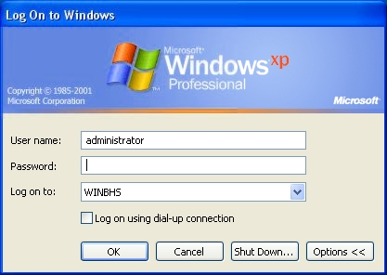
Figure 4-1: MESOWS Log-on Window

MES application will start automatically upon successful login.

Only the authorized users are able to access the functionalities of MES application.

The creating and assigning of user groups will be done in Departure Allocation application. Please refer to MIAL-LT-O-N55B-BG-DOC-DDD-009-A document for details.

The MES workstation will initiate an automatic workstation logging off if the system is idle for fifteen minutes (configurable) and the operator has not logged off. This is to prevent log on from extending across operator shift changes.

By pressing “Shut Down” button in the above OS log-on window, operator can shut down and power off MES computer after logout from MES application.

MES Main Application Screen Layout
ID: MES.GUI.Layout
The Manual Encoding Station (MES) screen adopts a layout scheme as shown below in the Figure 4-2. It consists of Title Bar, Logo and Status Area, Information Data and Entry Area, Functions Area and Status Bar Area as illustrated and described in the Figure and table below.
1
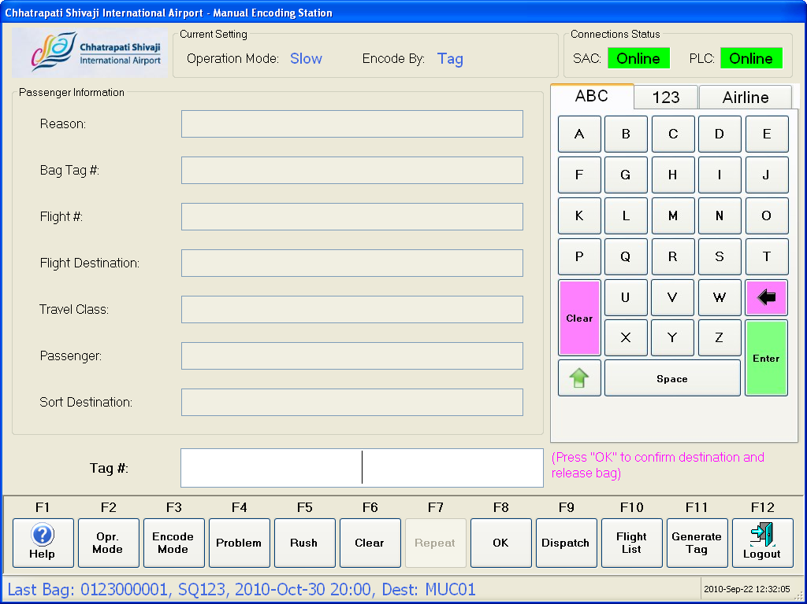
2
3
4
5

Figure 4-2: Basic Screen Layout Schema

The various areas on the MES GUI are as tabulated in the table below:
Section | Name | Description
 | Title Bar | The airport name and application name will display on the title bar.
 | Logo and Status Area | This area shows the airport logo, current settings and system connection status.
 | Information and Data Entry Area | This area shows information for the encoded baggage, keyboard, data entry and instruction message.
 | Toolbar Area | This area allows BHS operator to activate each function to perform each specified task.
 | Status Bar Area | This area shows the last encoded information and current timestamp.
MES will always keep the focus on the edit box of “Information and Data Entry” area. The operator can also change the focus simply by touching the respective graphic components on MES GUI touch screen.

During the bag encoding operation, it is not necessary for the operator to set the focus on the bag tag input field before using the handheld scanner to scan the tag. The tag number detected by the scanner will be automatically recognized and inserted into the bag tag input field.

Title Bar
There are two (2) parts in the Title Bar as below:
- Airport name
- Application name.

Figure 4-3: Title Bar Area

Logo and Status Area
There are three sections in the Logo and Status Area as below:
- Airport Logo – The place where the Chhatrapati Shivaji International Airport logo is located in the GUI.
- Current Setting – The area is to show the Operation Mode (Fast / Medium / Slow) and Encode By (Tag / Flight / Destination).
- Connection Status – It consists of all the connection status to the MES workstation by using “Online” and “Offline” to indicate the connection status. This application is only available when PLC connection status is in online.

Airport Logo
Current Setting
Connection Status

Figure 4-4: Logo and Status Area

Information and Data Entry Area
1
2
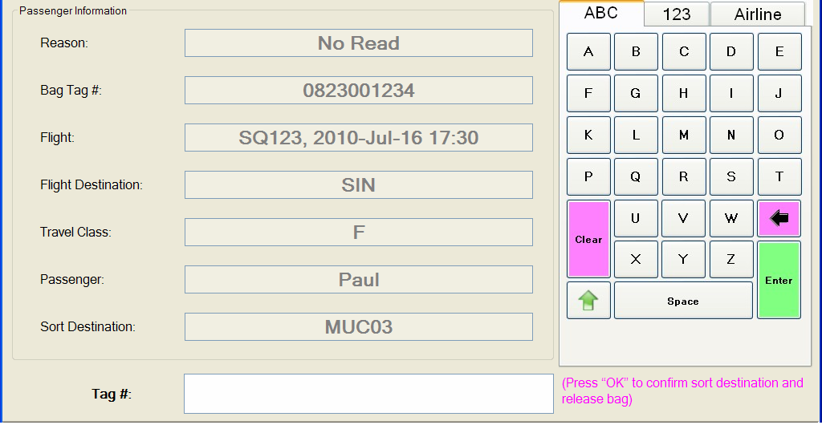
3
4

Figure 4-5: Information Data and Entry Area

Section | Name | Description
 | Passenger Information | This is the area to show all the related baggage information of the encoded bag. The information displays as shown in the Figure 4-5.  ID: MES.GUI.ReasonMessage  - Reason – Shows the reason why the baggage came to MES if known. It will only show when MES to SAC is connected. Possible reasons will be as below:  - No Read – When ATR cannot read the Baggage Tag Number.  - No BSM – When BHS did not receive any BSM for the Baggage Tag Number.  - Late BSM – When the BSM comes in late.  - Unknown Flight – When no flight is found in BHS for the baggage.  - Multiple Baggage Tag – When multiple Baggage Tags are detected by ATR.  - No Allocation – When BHS system cannot find any allocation for the baggage.  - Unknown Baggage – When the baggage is lost tracking and becomes unknown baggage.  - Multiple BSM – When BHS system detects multiple BSM for a particular baggage.  - Bag Tag # – Shows the scanned or keyed in bag tag number if known, it can be either 4 digits Security Tag, 4 digits Fallback Tag, IATA Fallback Tag, IATA Interline Tag or In-house tag.  - Flight – Shows the Airline, Flight number and STD. (if known)  - Flight Destination – Shows the Flight destination. (if known)  - Travel Class – Shows the travel class for the passenger. (if known)  - Passenger – Shows the Passenger name. (if known)  - Sort Destination – Shows the sort destination after encoding. If this field is empty after encoding mean it cannot find sort destination for the encoded bag.  The information displayed in this area will disappear automatically when the next bag arrives to MES. And the information will be moved to last encoded bag information display area on the status bar.
 | Keyboard | Please refer to chapter 4.2.4 for keypad layout design.  It is possible for the operator using the hand held scanner to scan a permanent fixed “OK” barcode as an alternative method of confirming data entry.
 | Entry Area | The area is to let user to scan or key in the Bag Tag number, Airline and Flight number, and sort destination as shown in the Figure 4-5. All the keyed in data must press keyboard “Enter” button to let the system to search the sort destination except for the tag number scanned by Handheld Scanner.  When Encode Mode is Encode by Tag, the entry labelling will show “Tag #:”  The validation of the Tag Number of IATA Interline [RP1740a] and IATA Fallback Tag [RP1740b], In-house Tag will follow the rules below:  - Direct key in 10 digits Tag Number.  The validation of the Tag Number of 4 digits Security Tag and 4 digits Fallback Tag will follow the rules below:  - Direct key in 4 digits Tag Number.  When Encode Mode is Encode by Flight, the entry labelling will show “Flight #:”.  Flight data can be entered as either:  - [2-3 char airline designator] + [space] + [1-4 digit flight number], e.g.: “SQ 123” or;  - [2-3 char airline designator] + [space] + [1-4 digit flight number] + [space] + [0-1 char suffix], e.g.: “SQ 123 K” or;  - [1-4 digit flight number] e.g.: “123” or;  - [1-4 digit flight number] + [space] + [0-1 char suffix] e.g.: “123 K”.  The Flight Number search will follow the rules below:  - All flights that are “numerically equal” to the entered flight number are included. For instance, if “1” is entered then flights with flight number “1”, “01”, “001” or “0001” will be included.  - Only production allocations with an open and/or close time within the time between –6 hours and +24 hours.  When Encode Mode is Encode by Flight, the entry labelling will show “Sort Dest.:” as showed in the above.  Sort Destinations are validated using the following rules:  - Sort Destination data can be entered as:  <last digits or last 2 digits destination number>  E.g. “3” -> “MUC02” or “02” -> “MUC02”  If less than 2 digits are entered, the data is prefixed with “0” up to 2 digits.  - The destination data can use the destination name like “MUC02”.
 | Instruction Message | This is the place to display the instruction message. The possible instruction message under the entry box are as below:  - Enter Tag # – When it is in Tag Mode.  - Enter Flight # – When it is in Flight Mode.  - Enter Sort Destination – When it is in Destination Mode.  - Enter Airline – When RUSH function key is pressed.  - Encoding successful – When the baggage is successfully encoded and released.  - Press “OK” to confirm destination and release bag – When operation mode is in “MEDIUM” and destination has been determined.  - Press “OK” to confirm destination – When operation mode is in “SLOW” and destination has been confirmed by an operator.  - Press “OK” to confirm release bag – When operation mode is in “SLOW” and destination has been confirmed by an operator.  - Unknown airline code – When an operator enters invalid airline code.  - Unknown flight – When an operator enters invalid flight number  - Enter alpha numeric only – When an operator enters numerical characters in field which only accepting alphanumerical characters.  - Enter numeric only – When an operator enters alphanumerical characters in field only accepting numerical character.  - Encode using correct tag – When MES detects others than 4 digits and 10 digits tag number which were encoded in Encode by Tag.  - Release Pending – Displayed whenever another keyboard entry of information has been keyed in and the bag has not been released after a minute (configurable).  - Bag has returned to MES for ? times – To notify MES operator bag with same IATA interline tag has returned to MES for more than preconfigured bag reoccurrence limit.

On-Screen Keypad
ID: MES.GUI.Keyboard
There are three (3) types on-screen keypads provided in MES application.
- Alphabetic keypad
- Symbolic keypad
- Airline code keypad

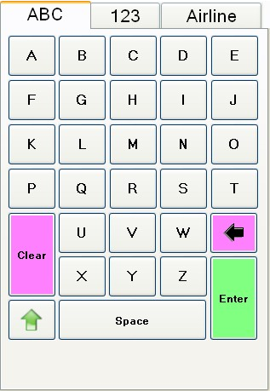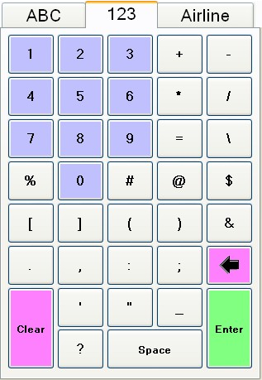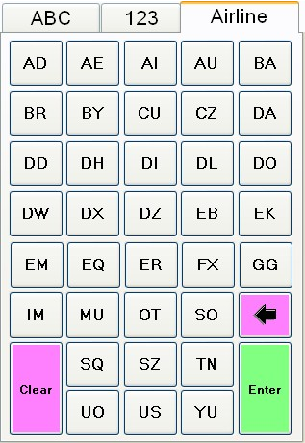
Figure 4-6: On-Screen Keypad

Alphabetic and symbolic keypads are used for MES operator to enter bag tag number, flight number, and sort destination during different manual encoding modes. Airline code keypad provides 2-character airline codes shortcuts for the operator to key in airline code with single button click. MES operator can switch among these three (3) keypads by clicking on the individual tab title area on the touch screen.

The Airline code keypad provides thirty five (35) keys for mapping 2-character airline codes which can be configured from Departure Allocation application. Please refer to DA-DDS for more details. The selected airlines to be assigned to the function key will be downloaded to each MES when each MES starts up.

Toolbar Area
The Toolbar Area consists of twelve (12) function keys as below:
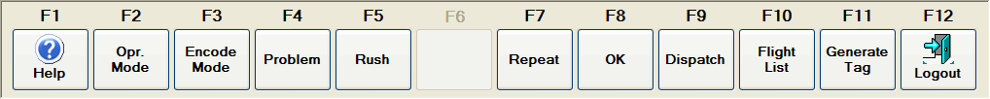
Figure 4-7: Function Area

- (F1) Help: A Help file is provided within the Manual Encoding Station and it can be activated by clicking on the “Help” button or by “F1” function key. This file consists of the information regarding the usage of this MESOWS.
- (F2) Operation Mode: Toggles between Fast, Medium or Slow mode to provide the ability for different operation mode usage. When it is toggled to “Fast Mode”, the Status Area of Operation Mode also will show “Fast” as shown in Figure 4-8. It is the same if it is toggled to “Medium” or “Slow” as shown in Figure 4-8 and .

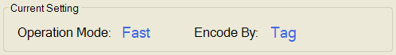
1
2
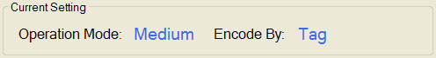
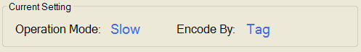
3
Figure 4-8: Three Types of Operation Mode Shown In Status Area (Current Setting)

- (F3) Encode Mode: Toggles between Tag, Flight or Destination mode to provide the ability for different encoding mode usage. When it is toggled to “Encode by Tag”, the Current Setting “Encode By” of the Status Area is “Tag” as shown in Figure 4-9 and the Entry Area as showed in Figure 4-10 allows operator to scan or key in the tag number. It is the same if toggled to “Encode by Flight” as shown in Figure 4-9and Figure 4-10to allow operator to key in the airline and flight number. If it is toggled to “Encode by Sort Destination”, it will show as Figure 4-9and Figure 4-10 to allow operator to key in the sort destination.

1
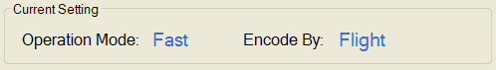
2
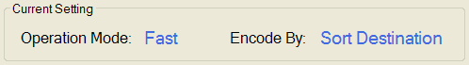
3
Figure 4-9: Three Types of Encode Mode Shown In Current Setting of Status Area

1
2
3
Figure 4-10: Three Types of Encode Mode Shown In Entry Area

- (F4) Problem: The destination of the baggage is set as Problem Bag Destination for problem baggage handling.

- (F5) Rush: This function key is used to send baggage to Rush destination based on the airline. Once this function key is pressed, the Current Setting for “Encode By:” will show “Rush” as showed in Figure 4-11 and the Entry Area will show as in Figure 4-12 to allow operator to enter the airline.

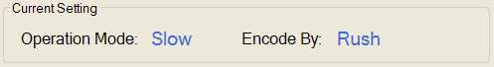
Figure 4-11: Current Setting After RUSH Function Key Pressed

Figure 4-12: Entry Area for Key In Airline After RUSH Function Key Pressed

- (F6): None.
ID: MES.GUI.Encoding.Repeat
- (F7) Repeat: Allows operator to repeat sending with last encoded data or destination. It is only applied to Encode by Flight, Encode by Destination, Encode by Problem and Encode by Rush.
- (F8) OK: This function key is used for sort destination confirmation in Medium and Slow Operation Mode.
ID: MES.GUI.Encoding.Dispatch
- (F9) Dispatch: Dispatches the baggage from MES.
ID: MES.GUI.FlightAllocation.View
ID: MES.GUI.FlightAllocation.Filter
- (F10) Flight List: It will pop-up a new window to display all the active flight allocations as shown in Figure 4-13. It is just a read only table and operator can filter to show all the records or records of one hour to 9 hours. Flight list can be sorted individually by flight #, STD, destination city or sort destination with mouse click on the each column header.
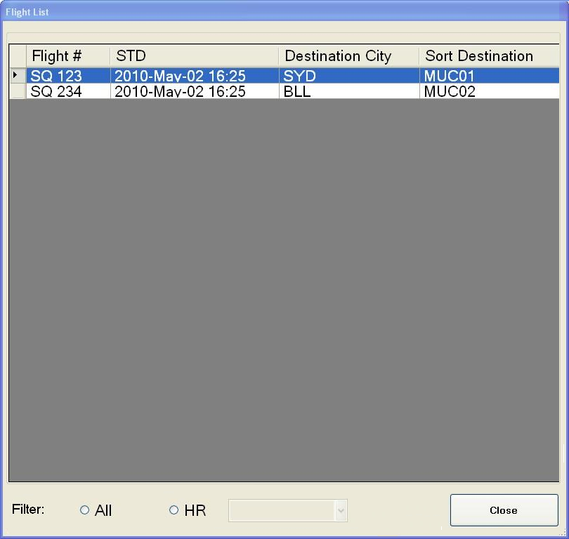
Figure 4-13: Flight List

- (F11) Generate Tag: A label will be generated and printed. When the operator presses this function key, it will pop-up a new window as shown in the Figure 4-14. The operator can select one of the three types (IATA Interline, IATA Fallback or In-house) of tags to generate and print as shown in the Figure 4-14 or Figure 4-15, Figure 4-16, and Figure 4-17.
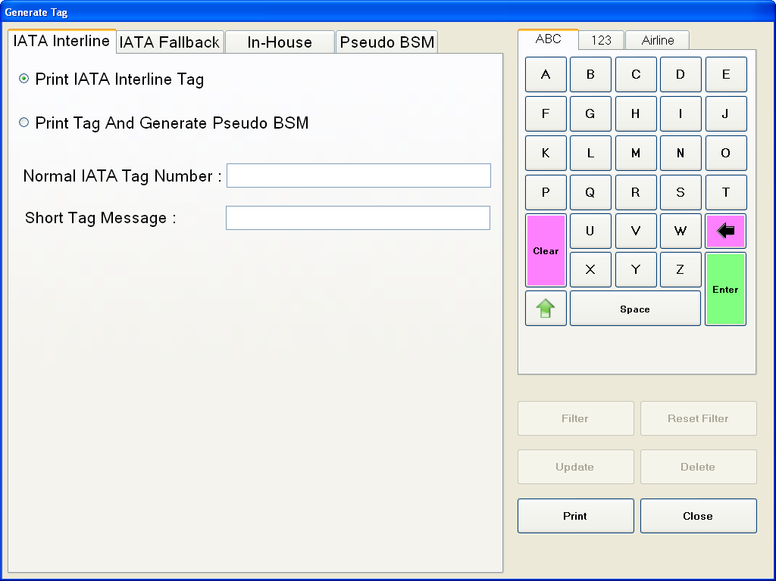
Figure 4-14: IATA Interline Print Tag

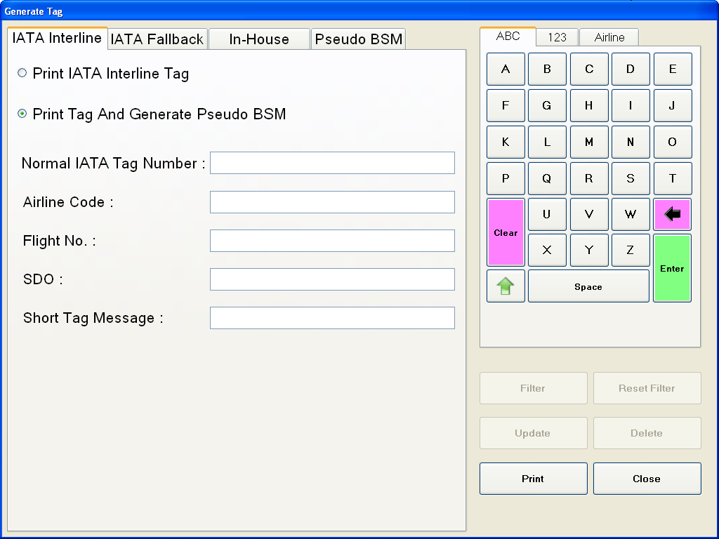
Figure 4-15: IATA Interline Print Tag and Generation of Pseudo BSM

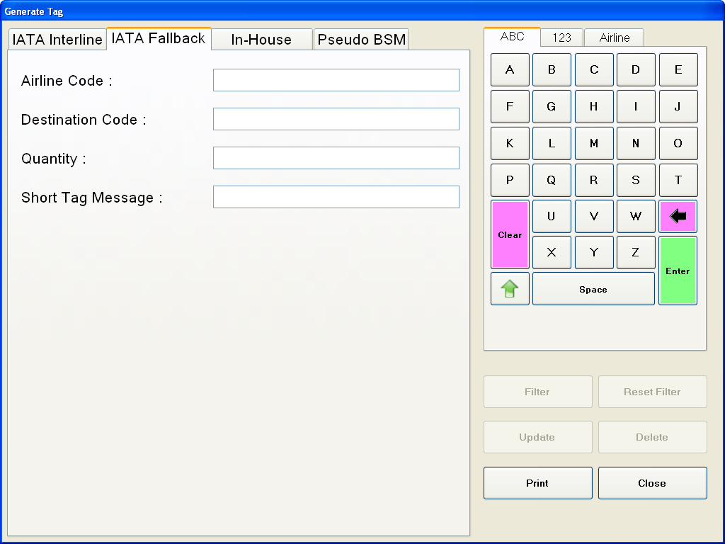
Figure 4-16: IATA Fallback Tag Generation and Print

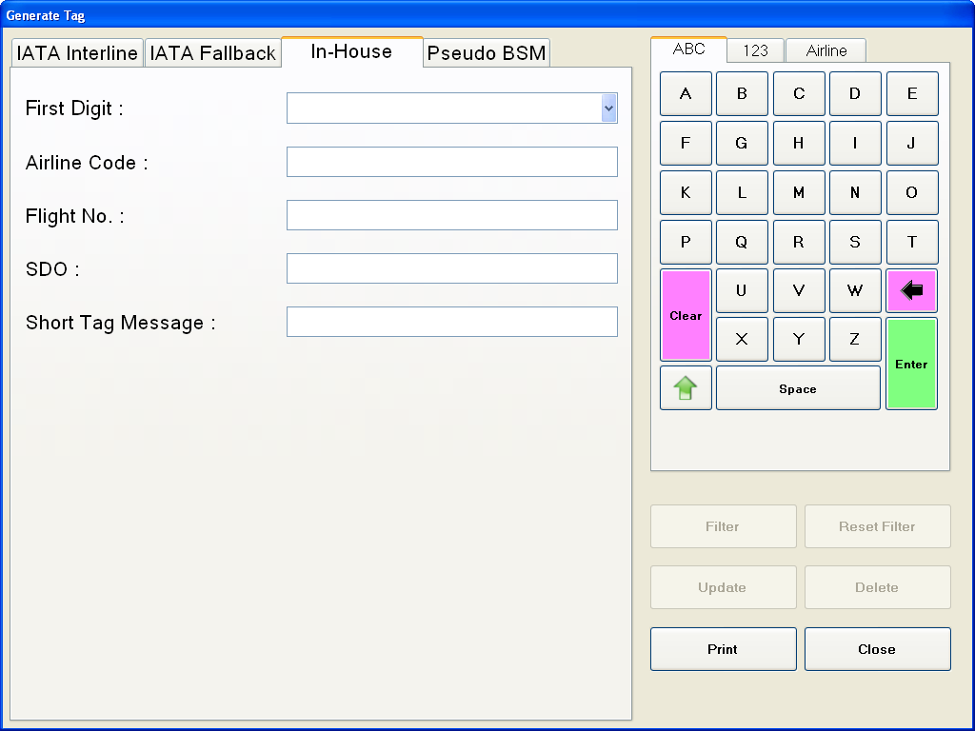
Figure 4-17: In-House Tag Print and Generation of Pseudo BSM

ID: MES.GUI.Logout
- (F12) Logout: The MES application will shut down and log off the windows.

Status Bar Area
ID: MES.GUI.StatusBar
This Status Bar Area consists of Last Bag Message and Current Timestamp as shown in Figure 4-18.

Last Bag Message
Current Timestamp

Figure 4-18: Status bar Area

When the next bag arrives MES, the information currently displayed in “Passenger Information” area will become last encoded bag information and moved to last baggage display area. Previous information displayed in the last bag area will be replaced.

MES Functionality

MES Functionalities Tasks
The functionalities tasks available at each Manual Encoding Station (MES) application are as below:
ID: MES.GUI.Encoding.Tag
- Encode by Tag (License Plate) – For the readable baggage tag (4 Digits Security Tag, 4 Digits Fallback Tag, IATA Fallback Tag, IATA Interline Tag and In-house Tag), operator can directly use a handheld scanner to scan or key in the tag number of the baggage. The MES application will look for the destination of this tag number and if the destination can be found, this destination will be used for encoding. Otherwise, the operator needs to use other functionalities.
ID: MES.GUI.Encoding.Flight
- Encode by Flight – When the system cannot be encoded by Tag, and the operator does know the airline and the flight number, the operator can key in the airline and select the flight number or key in the flight number and select the airline. If nothing can be shown in the selection either the airline or the flight number, a message will be shown in the message box as no flight number is for the airline keyed in or no airline for the flight number keyed in. This means that this functionality will not able to encode and the operator will need use other functionalities.
ID: MES.GUI.Encoding.Destination
- Encode by Destination – If neither encoding by Tag nor encoding by Flight can be done, the operator can use this functionality to encode the baggage. It will send the baggage to the encoded destination.
ID: MES.GUI.Encoding.Problem
- Encode by Problem Bag Destination – If the operator is unable to handle the baggage, this baggage will be treated as a problem bag. So the baggage will be encoded by Problem Bag Destination and sent to Problem Bag Destination for further handling.
ID: MES.GUI.Encoding.Rush
- Encode by Rush Destination – If the operator does know the baggage flight is in rush period, the operator can use this functionality for encoding. If the system is unable to find the rush destination as no allocation was done in the departure allocation, a message will be shown in the message box stating that no allocation can be found. Then the operator will need to use other functionalities.
- Generate and Print Tag – If the Tag label attached on the baggage is damaged or unreadable by the scanner, a new tag label can be printed and attached to the baggage after removing the damaged or unreadable tag. Other than this, it also can generate and print for the Fallback tag and In-House tag.
- Preview Active Flight List – It can display all active flights (opened allocation and future allocation which the entire flight allocation was done in the Departure Allocation application) with respective sort destinations.
- Bag Reoccurrence Limit Alarm – If the bag with same IATA interline tag returns to the MES more than bag reoccurrence limit (configurable, default is 3 times), notification message will be shown to MES operator and alarm will be turned on in MDS.

Download Sortation Data from SAC Database to MES
ID: MES.DB.Upload
ID: MES.DB.Download
MES maintains a local database for determining the destination of manual encoding bags in case of HLC is not available for short period. The data stored in the MES local database includes:
- BSM received in last 10 minutes (configurable);
- Flight and its allocations within the time period from last 3 hours to future 3 hours;
- Bag minimum security policy settings;
- Function allocations;
- IATA Fallback tag mapping;
- 4-digit airport fallback tag mapping;
- 4-digit special security tag mapping;
- Airline mapping;

A fresh copy of above data will be downloaded from SAC production database and stored into MES location database in two scenarios:
- At the MES application startup time, after MES-OWS to SAC database connection is opened;
- During MES application running time, whenever the connection between MES to SAC database is recovered from interruption;

During the normal operation of MES, MES application will check the SAC database changes and download the updated data once any change is detected.

For the closed flight allocation, the data will only be kept in MES for 6 hours. This means that in MES, the flight allocation data will always be kept for 6 hours after the flight allocation is closed, for all current opened flight allocations and for future active flight allocations.

Uploading MES Operation Data to SAC Database
MES stores data in a local database during the HLC is not available, includes:
- MES operation event log
- Historical message log

A fresh copy of above data will be uploaded to SAC historical database and stored into after MES-OWS to SAC database connection is opened;

During the normal operation of MES, MES application will automatically upload the above data into SAC historical database.

MES Functionalities Requirement without SAC
If the HLC is not available, the following functionalities will take effect as described below:
- Encode by Tag (License Plate) – This Encode Mode is limited to IATA Tag which includes the last 10 minutes (configurable) received BSMs and has downloaded Flight Allocation, Fallback Tag, Security Tag
- Encode by Flight – MES will able to process the baggage by Flight and this Encode is limited to the flight in the downloaded flight allocation.
- Encode by Destination – MES will be able to process the baggage by Destination and this Encode will be the same as per normal.
- Encode by Problem Bag Destination – MES will be able to process the baggage by Problem Bag Destination and this Encode will be same as per normal.
- Encode by Rush Destination – MES will be able to process the baggage by Rush Destination but limited to the airline in the downloaded Airline Allocation.
- Generate and Print Tag – MES will be able to process the printing tag as per normal except
  - Print Tag and Generate Pseudo BSM for Tab named “IATA Interline”, this means Pseudo IATA Interline BSM will be unable to print without SAC.
  - Printing In-House Tag for Tab named “In House” which is needed to produce pseudo BSM and save into SAC database. This mean In-House Tag will unable to print without SAC.
  - Only previous Pseudo BSM either IATA Interline or In House before SAC down, will be able to view and printing Tags will be disabled when without SAC.
- Reason (Status Area) – MES will not show the reason why the baggage comes to MES.
- Preview Active Flight List – Only the active flight allocations downloaded before the connection between SAC and MES is down will show in here.

Operation Mode
ID: MES.GUI.OperationMode

ID: MES.GUI.OperationMode.Fast
When the MES is in the “Fast” mode, the baggage will be immediately released after the baggage is successfully encoded.

ID: MES.GUI.OperationMode.Medium
When the MES is in the “Medium” mode, the baggage will be released after the baggage has been successfully encoded and the operator has pressed “OK” (F8) Function key to confirm.

ID: MES.GUI.OperationMode.Slow
When the MES is in the “Slow” mode, the baggage will be released after the baggage has been successfully encoded and the operator has pressed “OK” (F8) Function key to confirm, then followed by pressing Function Key “Dispatch” (F9) to confirm to release the baggage.

Encode mode
This Encode Mode consists of:
- Encode by Tag
- Encode by Flight
- Encode by Sort Destination

Encode By Tag
When Encode Mode is Encode by Tag, the entry labelling will show “Tag #:” as shown in the Figure 5-19.

Figure 5-19: Entry Area – Encode By Tag

The validation of the Tag Number of IATA Interline [RP1740a] and IATA Fallback Tag [RP1740b], In-house Tag will follow the rules below:
- Direct key in 10 digits Tag Number.

The validation of the Tag Number of 4 digits Security Tag and 4 digits Fallback Tag will follow the rules below:
- Direct key in 4 digits Tag Number.

When HLC or connection to HLC is faulty (turning to LLC mode), the BSMs of newly check-in bags will not be able to access by MES. Hence, it is not possible for MES to encode this bag by IATA interline tag. But it can still be encoded by flight or destination.

Encode By Flight
When Encode Mode is Encode by Flight, the entry labelling will show “Flight #:” as showed in the Figure 5-20.
Figure 5-20: Entry Area – Encode By Flight

Flight data can be entered as either:
- [2-3 char airline designator] + [space] + [1-4 digit flight number], e.g.: “SQ 123” or;
- [2-3 char airline designator] + [space] + [1-4 digit flight number] + [space] + [0-1 char suffix], e.g.: “SQ 123 K” or;
- [1-4 digit flight number] e.g.: “123” or;
- [1-4 digit flight number] + [space] + [0-1 char suffix] e.g.: “123 K”.

The Flight Number search will follow the rules below:
- All flights that are “numerically equal” to the entered flight number are included. For instance, if “1” is entered then flights with flight number “1”, “01”, “001” or “0001” will be included.
- Only production allocations with an open and/or close time within the time between –6 hours and +24 hours.

ID: MES.GUI.Encoding.Flight.MultipleAllocation
If an encoded flight has more than one possible sort destinations (multiple flight allocation created for the flight), below window will pop up for the operator to select the designated destination to forward the bag.
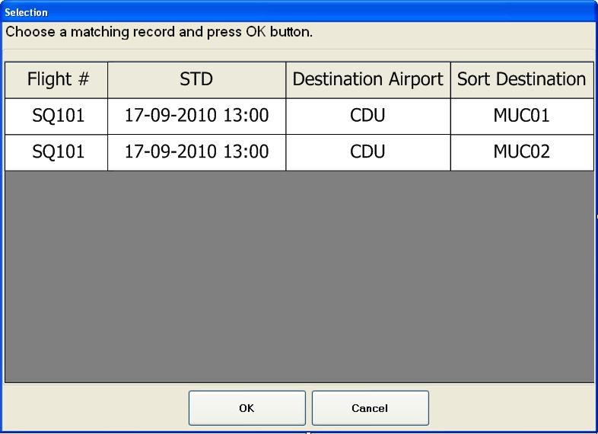
Figure 5-21: Multiple Sort Destination Selection

When HLC or connection to HLC is faulty (turning to LLC mode), encode by flight is still possible by using MES local flight and allocation data tables for a certain period. After that certain period, if there is no any new flight and allocation downloaded to MES, encode by flight operation will be no longer possible. In this scenario, operator still can encode the bag by sort destination mode.

Encode By Sort Destination
When Encode Mode is Encode by Destination, the entry labelling will show “Sort Dest.:” as showed in the Figure 5-22 or Figure 5-23.

Sort Destinations are validated using the following rules:
- Sort Destination data can be entered as:
<last digits or last 2 digits destination number>
E.g. “3” -> “MUC02” or “02” -> “MUC02” (shown in Figure 5-22)
If less than 2 digits are entered, the data is prefixed with “0” up to 2 digits.

Figure 5-22: Entry Area – Encode By Sort Destination 1

The destination data can use the destination name like “MUC02” shown in Figure 5-23.

Figure 5-23: Entry Area – Encode By Sort Destination 2

Encode by destination operation is still possible during LLC mode.

Generate Tag
ID: MES.GUI.Tag
When the button “Print” is pressed (as shown in Figure 5-24, Figure 5-25, Figure 5-26, Figure 5-27) and a confirmation box will pop-up to double confirm. Once the operator confirms, it will automatically print the tag and show a message in pop-up window for information of successful or unsuccessful printing (IATA Interline, IATA Fallback or In-house) and successful or unsuccessful generated the pseudo BSM (only for IATA Interline if applied and In-house). These pseudo IATA Interline and In-house BSM will be created and sent to SAC once the Tag is successfully printed.

Figure 5-24: IATA Interline Print Tag

If bag arrives to MES but the BSM of its IATA interline tag has not been received by BHS, MES operator can create a “Pseudo BSM” for the tag. And then use the pseudo BSM for code conversion. The pseudo BSM of IATA Interline tag will always be overwritten by the actual BSM received from CUTE/DCS.

Figure 5-25: IATA Interline Print Tag and Generation of Pseudo BSM

Figure 5-26: IATA Fallback Tag Generation and Print

The airport in-house labelling tag could be produced at MES for bags that have no IATA Interline tag, fallback tag or special security tag attached. In-house labelling tag is 10-digit number tag that has the same format as IATA Interline tag, except the value of first digit is not 0 and 1. When in-house tag is printed out from MES tag printer, its “Pseudo BSM” is created by MES and saved into the SAC database. The pseudo BSM of in-house tag will be used for code conversion

Figure 5-27: In-House Tag Print and Generation of Pseudo BSM

The operator is allowed to print IATA Interline Tag as showed in Figure 5-24, or print IATA Interline Tag and generated pseudo BSM if the bag is No BSM as showed in Figure 5-25. Besides that, operator is allowed to print IATA Fallback Tag as showed in Figure 5-26 and In-House Tag as showed in Figure 5-27. For these three types of Tags printing, operator is allowed to key in short message. This short message limited up to 50 characters.

ID: MES.GUI.BSM
The IATA Interline and In-house pseudo BSMs will show in tab named “Pseudo BSM” in table list as showed in the Figure 5-28. Operator can select radio button “IATA Interline BSM” or “In-house BSM” and the table will list out accordingly. The table for these two types of pseudo BSM contains “Tag No.”, “Airline”, “Flight”, “STD” and “Description”. Operator is allowed to update the Airline, Flight, STD and Description, delete or print for each pseudo BSM by selecting each data row which the operator wants to change. The “Update”, “Delete” and “Print” buttons will be enable when a row is selected. The text boxes below the tables will show the data according to the selected row. If an operator wants to change the data, the operator can change the values of the text boxes. Once the updating, deleting or printing is done, a message box will pop-up to inform the operator whether it is successful or not.

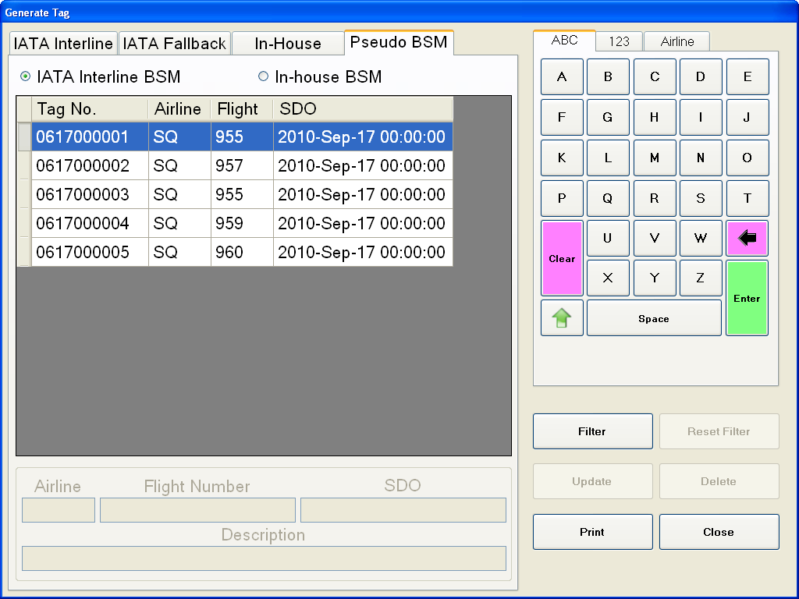
Figure 5-28: Pseudo BSM

This Pseudo BSM table also allows filtering by clicking on the “Filter” button as showed in the Figure 5-28. A new window will pop-up as showed in the Figure 5-29 to allow filtering based on “Airline”, “Flight” or “STD”. After the filtering is done, the “Filter” button will be disabled and “Reset Filter” button will be enabled. As the “Reset Filter” button is enabled, it means that the table now in filtering mode. If the “Reset” button is enabled and “Reset Filter” is disabled, it means that now the table is not in filtering mode.
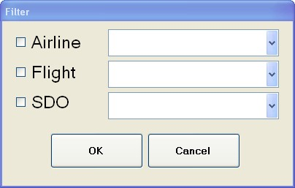
Figure 5-29: Filter Windows

Once the tag printed, it will look like shown in Figure 5-30 with the dimension 5.5cm x 10cm. The airport name will be printed at the top of the tag like showed in Figure 5-30 . It will be followed by barcode as in Figure 5-30. The Figure 5-30 is the place while the operator keyed short message when generating tag in “Enter Short Tag Message” box. The bottom of tag is the place to indicate the type of the tag – IATA, Fallback or In-House as showed in Figure 5-30.

5.5 cm
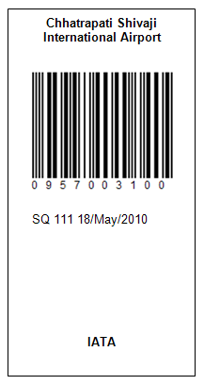
1
2
3
4
10cm
Figure 5-30: Tag Format

Bag Reoccurrence Alarm
After MES operator scans the bag tag if MES detects the bag with same IATA interline tag has returned to the MES more than preset bag reoccurrence limit (configurable, default is 3 times), “Bag has returned to MES for ? times” notification message will be shown to MES operator in “Instruction Message” area. An alarm will be turned on in MDS also.

Bag reoccurrence alarm will only apply to those bags have IATA interline tag or 10-digit in-house tag attached. The reoccurrence count will be updated when bag returns to any of the four (4) MES.

MES Event Logs
ID: MES.GUI.Logs
MES application will capture and record all operation actions into SAC database. The operation actions include:
- System user login and logout
- Encoded action including Encode by Tag, Flight, Destination, Problem Bag Destination and Rush Destination.
- Tag Printing
- In-house BSM update and delete.

Document References
Abbreviation | Reference
[Tender Specification] | Mumbai International Airport Pvt Ltd, Chhatrapati Shivaji International Airport, CSIA Expansion, Baggage Handling System, Ref: MIAL-HT-O-N55B-BG-DOC-004, Rev I

Appendix – Index of Function ID
ID: MES.APP.BagScenarios 8
ID: MES.DB.Connection 9
ID: MES.GUI.Layout 13
ID: MES.GUI.ReasonMessage 15
ID: MES.GUI.Keyboard 18
ID: MES.GUI.Encoding.Repeat 20
ID: MES.GUI.Encoding.Dispatch 20
ID: MES.GUI.FlightAllocation.View 20
ID: MES.GUI.FlightAllocation.Filter 20
ID: MES.GUI.Logout 23
ID: MES.GUI.StatusBar 23
ID: MES.GUI.Encoding.Tag 25
ID: MES.GUI.Encoding.Flight 25
ID: MES.GUI.Encoding.Destination 25
ID: MES.GUI.Encoding.Problem 25
ID: MES.GUI.Encoding.Rush 25
ID: MES.DB.Upload 26
ID: MES.DB.Download 26
ID: MES.GUI.OperationMode 27
ID: MES.GUI.OperationMode.Fast 27
ID: MES.GUI.OperationMode.Medium 27
ID: MES.GUI.OperationMode.Slow 27
ID: MES.GUI.Encoding.Flight.MultipleAllocation 28
ID: MES.GUI.Tag 30
ID: MES.GUI.BSM 32
ID: MES.GUI.Logs 34

